CmpE 321 Project #3

Internet DVD Shop

Database Design Document

INSTRUCTOR | Taflan I. Gündem
STUDENT | Emin Şenay
STUDENT ID | 2002103907
YEAR | 2006/2nd Term

Index

Conceptual Design 3
Scope 3
Transactions 3
Entities and Relationships 3
Properties and Domains 4
Primary Keys 5
Rules 5
Entity-Relationship Diagram 5
Logical Design 6
Base Relations 6
Normalization 6
User Views 6
Physical Design 7
SQL Scripts 7
Customer Table 7
DVD Table 7
Administrator Table 8
Order Table 8
Views 8
Operations 9

Conceptual Design

Scope

This document is about a web database application project about an internet DVD shop. In this shop both film and music DVDs are sold. Database will contain all necessary information about these two kinds of DVD’s. There are two types of users of the application of this project, users and administrators. Administrator of the shop has the full control over DVD’s. She can modify, add or delete the DVD’s. Users can search the database and buy the DVD they want to.

Transactions

The application of this project should have these functionalities:

- The administrator of the internet shop should be able to log on to the site by providing his user name and password and add/delete/modify DVDs.
- New customers should register to the internet shop by entering their personal information and providing a username and password.
- The registered customers should log on to the portal by providing their usernames and passwords in order to purchase DVDs.
- Registered customers should be able to update their personal information.
- Registered customers should be able to search for film or music DVDs by providing the title of the film or music album, or the singer of the music album.
- Registered customers should be able to add the DVDs they choose to their shopping basket. The total cost should be changed accordingly and presented to the customer.
- Registered customers should be able to delete the DVDs they choose from their shopping basket. The total cost should be changed accordingly and presented to the customer.
- Registered customers with items in their shopping basket can check out and make a purchase by submitting their credit card information.
- Registered customers should be able to track the status of their order.

The database must support these transactions in order to satisfy the requirements:

- Add a new DVD.
- Delete DVD’s.
- Modify the DVD.
- Add a user.
- Modify the user information.
- Search DVD’s according to the title of the film or music album, or singer of the music album.
- Add a new DVD to the shopping basket.
- Delete a DVD from the shopping basket.

Entities and Relationships

3 entities are used for this project. These are customer, DVD and administrator. There is only one relationship named as “order” which connects customer and DVD.

Properties and Domains

The properties and their domains are given below:

Entity administrator:

Property | Type | Description
username | Varchar(20) | username of the administrator
password | Varchar(20) | password of the administrator
email | Varchar(30) | e-mail address of the administrator

Entity customer:

Property | Type | Description
username | Varchar(20) | username of the customer
password | Varchar(20) | password of the customer
name | Varchar(20) | real name of the customer
email | Varchar(30) | e-mail address of the customer
telephone | char(10) | telephone number of the customer
address | Varchar(70) | Address of the customer

Entity DVD:

Property | Type | Description
dvd_id | Integer | Unique identification number of the dvd
type | Tinyint | type of the dvd. If 0, music dvd, else film dvd
title | Varchar (20) | Title of the dvd
country | Varchar (20) | Country of the film or music
year | Year (4) | Release year of the dvd.
duration | Time | Total time of the film or album
imagefile | Varchar (30) | Internet link which contains the cover image of the dvd
quantity | Integer | Number of available dvd’s
producer | Varchar (20) | Producer name of the film
singer | Varchar (20) | Singer name of the music
main_actors | Varchar (100) | Main actors in the film
price | Integer | Price of the DVD

Relationship order:

Property | Type | Description
order_id | Integer | Unique identification number of the order
quantity | Integer | number of ordered dvd with the given id and username
status | Tinyint | status of the order (for example; packing -> 1, shipping ->2 etc.)
order_date | Date | date of order
ship_date | Date | date of shipment

Primary Keys

For the administrator and the customer entity, the primary key is “username”. For the DVD entry, the primary key is dvd_id. For the order, the primary key is order_id.

Rules

Cardinality: A customer can order more than one DVD and a DVD can be ordered by more than one customers.

Domain restrictions:

- Maximum numbers of characters are given in parenthesis for each property in the entities and relationships part.

- Some of the integer domains cannot be negative numbers. These domains must be unsigned:
In customer entity: telephone (telephone number cannot be negative)
In DVD entity: dvd_id, type, quantity, price (identification numbers are positive numbers, type can be 0 or 1, quantity and price is at least 0)
In order relationship: order_id, quantity, status (identification numbers are positive numbers, nobody can order less than 0 dvd’s, status can only be positive numbers)

- In customer entity, email field must be unique. One e-mail is assumed to be used by only one customer.

- Some of the domains cannot be null. These are:
In customer entity: All domains. The system needs all the fields of the customer.
In DVD entity: Domains except the domains of singer, main_actors, music, director, scenarist, price and imagefile. Written properties except “price” and “imagefile” are either not used in music dvd’s or film dvd’s. Price can be null if the quantity of the dvd is 0. In the shop, some DVD’s may not have cover images to display. All of the other properties are used in both music dvd’s and film dvd’s.
In administrator entity: username
In order relationship: The ship_date property can be null because when user first gives the order, it cannot be shipped immediately and cannot be known the date of shipment. The other properties cannot be null since they must be assigned to some value when an order is given.

Referential integrity constraints: There are no foreign keys in the entities. However, a table will be created for the order relationship. In this relationship, dvd_id and username fields will be foreign keys. The integrity is set to restrict on delete because the administrator must not delete the dvd which is ordered. On the other hand, administrator can modify all dvd’s, so the integrity id set to cascade on update.

Entity-Relationship Diagram

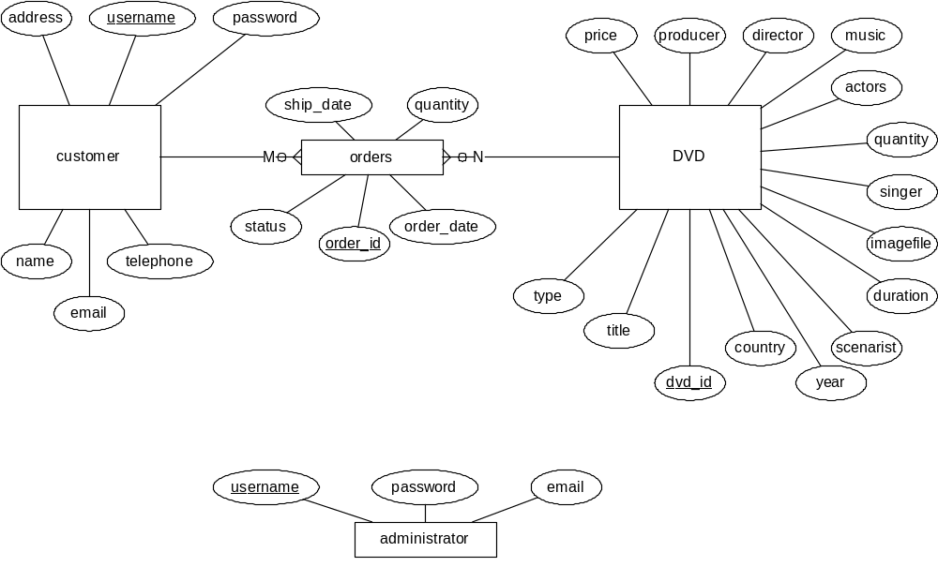

Logical Design

Base Relations

All entities and relationships are converted into tables. The corresponding table names are customer, order, DVD and administrator. Primary keys of the tables are the properties underlined in the e-r diagram. The foreign keys of the order relation are dvd_id, which is a primary key in DVD table, and username, which is a primary key in customer table.

Normalization

Except the key attributes, there are no functional dependencies. All attributes in each relation depends on only the corresponding primary key. As a result, the design is automatically in BCNF and 4NF.

User Views

Two user views are used to separate film dvd’s from music dvd’s. The first view is named as musicDVD which has only the necessary info for music dvd’s. The required fields from the DVD table are dvd_id, title, country, year, duration, imagefile, quantity, producer, singer, price and type. Main_actor, music, director and scenarist fields are not necessary. The second view is named as filmDVD. It is like musicDVD view. It requires dvd_id, title, country, year, duration, imagefile, quantity, producer, main_actor, music, director, scenarist, price and type fields and it does not require singer field.

Physical Design

The relations are given below:

customer (username, password, name, email, telephone, address)

DVD (dvd_id, type, title, country, year, duration, imagefile, quantity, producer, singer, main_actors, music, director, scenarist, price)

administrator (username, password, email)

order ( order_id, username, dvd_id, quantity, status, order_date, ship_date)

Primary keys are underlined, foreign keys are written in italic.

A user can give more than one order in one time. When the user adds a new order, all non-approved orders must be displayed and total price must be shown. For each new dvd added to the shopping basket, all non-approved orders must be selected from the database, so it is good to have an index on the username in the “order” table. Also, user can search dvd’s with the name of the singer or name of the title, so these two fields in the database are also indexed.

SQL Scripts

SQL scripts are created for MySQL.

create database dvdshop;
use dvdshop;

Customer Table

Create table customer (
username Varchar(20) NOT NULL,
password Varchar(20) NOT NULL,
name Varchar(20) NOT NULL,
email Varchar(20) NOT NULL,
telephone Char(10) NOT NULL,
address Varchar(70) NOT NULL,
UNIQUE (email),
Primary Key (username)
) ENGINE = InnoDB;

DVD Table

Create table DVD (
dvd_id Int UNSIGNED NOT NULL AUTO_INCREMENT,
type Tinyint UNSIGNED NOT NULL,
title Varchar(20) NOT NULL,
country Varchar(20) NOT NULL,
year Year(4) NOT NULL,
duration Time NOT NULL,
imagefile Varchar(30),
quantity Int UNSIGNED NOT NULL,
producer Varchar(20) NOT NULL,
price Int UNSIGNED,
singer Varchar(20),
main_actors Varchar(100),
music Varchar(20),
director Varchar(20),
scenarist Varchar(20),
Index titleindex (title),
Index singerindex (singer)
Primary Key (dvd_id)
) ENGINE = InnoDB;

Administrator Table

Create table administrator (
username Varchar(20) NOT NULL,
password Varchar(20),
email Varchar(20),
Primary Key (username)
) ENGINE = InnoDB;

Order Table

Create table orders (
order_id Int UNSIGNED NOT NULL AUTO_INCREMENT,
username Varchar(20) NOT NULL,
dvd_id Int UNSIGNED NOT NULL,
quantity Int UNSIGNED NOT NULL,
status Tinyint UNSIGNED NOT NULL,
order_date Date NOT NULL,
ship_date Date,
Primary Key (order_id,username,dvd_id),
Index userindex (username),
Foreign Key (username) references customer (username) on delete restrict on update cascade,
Foreign Key (dvd_id) references DVD (dvd_id) on delete restrict on update cascade
) ENGINE = InnoDB;

Views

CREATE VIEW
musicDVD(dvd_id, title, country, year,
duration, imagefile, quantity, producer,
singer, price, type)
AS
SELECT
dvd_id, title, country, year,duration,
imagefile, quantity, producer, singer,
price, type
FROM DVD
WHERE
type = 0;

CREATE VIEW
filmDVD(dvd_id, title, country, year,
duration, imagefile, quantity, producer,
main_actors, music, director, scenarist,
price, type)
AS
SELECT
dvd_id, title, country, year,duration,
imagefile, quantity, producer,
main_actors, music, director, scenarist,
price, type
FROM DVD
WHERE
type = 1;

Operations

- The administrator of the internet shop should be able to log on to the site by providing his user name and password and add/delete/modify DVDs.

Examples:

Select username from administrator
where password = (entered password)

insert into musicdvd(`dvd_id`, `title`, `country`, `year`, `duration`, `imagefile`, `quantity`, `producer`, `singer`, `price`, `type`)
values (10, 'wq', 'asd', 2003, '00:45:00', '', 4, 'emin', 'ayse', 5, 0);

insert into filmdvd(`dvd_id`, `title`, `country`, `year`, `duration`, `imagefile`, `quantity`, `producer`, `main_actors`, `music`, `director`, `scenarist`, `price`, `type`)
values (123, 'sdffsd', 'sdfdsf', 2000, '01:00:00', 'tyu', 12, 'sdfdsf', 'sdffs , kjhkj , khkjhkj', 'xcvxcv', 'xcvxcv', 'xcvxvcxvc', 132, 1);

delete FROM filmdvd where dvd_id = (id number of the dvd);

delete FROM musicdvd where dvd_id = (id number of the dvd);

update filmdvd
set dvd_id = 125, country = 'Turkey'
where dvd_id = 124;

update musicdvd
set dvd_id = 12, country = 'Turkey'
where dvd_id = 1;

- New customers should register to the internet shop by entering their personal information and providing a username and password.

Example:

insert into customer
values ('emin', '12345', 'Emin Senay', 'esenay@boun.edu.tr', '5321234567',
'bogazici universitesi superdorm ogrenci yurdu');

- The registered customers should log on to the portal by providing their usernames and passwords in order to purchase DVDs.

Example:

Select username from customer
where password = (entered password)

- Registered customers should be able to update their personal information.

Example:

update customer
set password = '321', telephone = '5053213232'
where username = 'emin';

- Registered customers should be able to search for film or music DVDs by providing the title of the film or music album, or the singer of the music album.

Examples:

SELECT * FROM musicdvd
where title = 'wq';

SELECT * FROM filmdvd
where title = 'asd';

SELECT * FROM musicdvd
where singer = 'ayse';

- Registered customers should be able to add the DVDs they choose to their shopping basket. The total cost should be changed accordingly and presented to the customer.

Example:

insert into orders
values (1,'emin',125,1,1,'2006-06-02 00:00:00',null);

- Registered customers should be able to delete the DVDs they choose from their shopping basket. The total cost should be changed accordingly and presented to the customer.

Example:

delete from orders
where username = 'emin' and dvd_id = 125;

- Registered customers with items in their shopping basket can check out and make a purchase by submitting their credit card information.

Example:

update orders
set status = 2
where username = 'emin' and dvd_id = 125;

- Registered customers should be able to track the status of their order.

Example:

SELECT title, status, order_date, ship_date FROM orders o, dvd d
where o.username = 'emin' and o.dvd_id = d.dvd_id;

