CMPE 360 HW#2 REPORT

- The Matlab code of the question is given with the other page. When the code is executed, corresponding convergence results are given below:

For √3 (the positive real root):
|g1’(x*)| =2.4641
|g2’(x*)| =0.1547
|g3’(x*)| =0.5

For -√3 (the negative real root):
|g1’(x*)| =4.4641
|g2’(x*)| =2.1547
|g3’(x*)| =0.5

From these results, we can see that the g1(x) function is not locally convergent to the real roots, because the corresponding absolute value is larger than 1. g2(x) function is locally convergent to the positive real root and it is divergent to the negative real root. Finally, g3(x) function is locally convergent to both of the real roots.
In the positive root, the second function finds the root in 6 iterations with the tolerance 0.0001 and the initial X₀. With the same tolerance value, third function finds the positive root with 4 iterations of X₁. So, it can be said that the third function converges faster to the real root than the second function. The iteration results are as follows:

For g2(x):
1.6667 1.7407 1.7307 1.7323 1.7320 1.7321
For g3(x):
2.0000 1.7500 1.7321 1.7321

The initial X₀ point is taken as 1 for the positive root and -2 for the negative root.

The graphs of three functions are given with g(x) = x. From these graphs, the convergence behaviors of the functions can easily be seen.

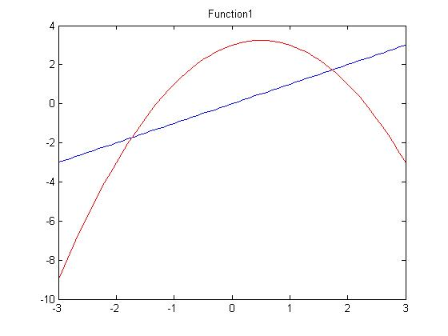
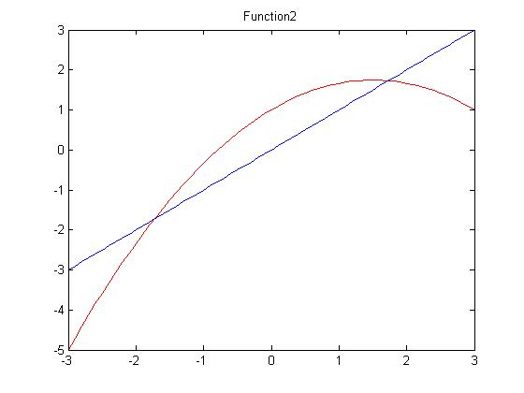
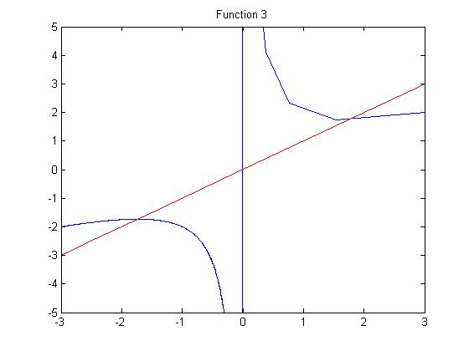

- The Bisection method cannot be applied to this function. There is not an interval [a,b] such that f(a) and f(b) have opposite signs, that is to say, the graph of the function is tangent to the x-axis, which means the function never gets values under 0. However, for Bisection method to be applied, the function f(x) must get negative values for some x.

fixedpointdemo.m

func1 = [-1,1,3];
func2 = [-1/3,1,1];
func3_1 = [1,0,3];
func3_2 = [2,0];
deriv1 = polyder(func1);
deriv2 = polyder(func2);
[deriv3_quo,deriv3_div] = polyder(func3_1,func3_2);

%check the convergence of the functions
value1 = abs(polyval(deriv1,sqrt(3)));
value2 = abs(polyval(deriv2,sqrt(3)));
value3 = abs(polyval(deriv3_quo/deriv3_div,sqrt(3)));
value4 = abs(polyval(deriv1,-sqrt(3)));
value5 = abs(polyval(deriv2,-sqrt(3)));
value6 = abs(polyval(deriv3_quo/deriv3_div,-sqrt(3)));

[plus_res1,plus_res2,plus_res3] = fixedpoint(1,0.0001);
[minus_res1,minus_res2,minus_res3] = fixedpoint(-2,0.0001);

fixedpoint.m

function [k,l,m] = fixedpoint(Xzero,tolerance)
Xone = -Xzero^2 + Xzero + 3;
Xtwo = (-Xzero^2 / 3) + Xzero + 1;
Xthree = (Xzero^2 + 3 ) / (2*Xzero);
Xones = Xone;
Xtwos = Xtwo;
Xthrees = Xthree;
temp = Xzero;
while abs(Xone - Xzero) > tolerance
Xzero = Xone;
Xone = -Xzero^2 + Xzero + 3;
Xones = [Xones,Xone];
end
Xones
%plot(Xones);
XZero = temp;
%Xtwo
while abs(Xtwo - Xzero) > tolerance
Xzero = Xtwo;
Xtwo = (-Xzero^2 / 3) + Xzero + 1;
Xtwos = [Xtwos,Xtwo];
end
Xtwos
XZero = temp;
%Xthree
while abs(Xthree - Xzero) > tolerance
Xzero = Xthree;
Xthree = (Xzero^2 + 3 ) / (2*Xzero);
Xthrees = [Xthrees,Xthree];
end
Xthrees

k = Xone;
l = Xtwo;
m = Xthree;

