Page 102 Computer Problem 2.9(a)

Matlab code of the problem is given below. Here is the output of the code:

firstrow =

Columns 1 through 9

1.0000 1.0000 1.0000 1.0000 1.0000 0.9999 0.9992 2.2204 0

Column 10

0

secondrow =

Columns 1 through 9

1.0000 1.0000 1.0000 1.0000 1.0000 1.0000 1.0000 1.0000 1.0000

Column 10

1.0000

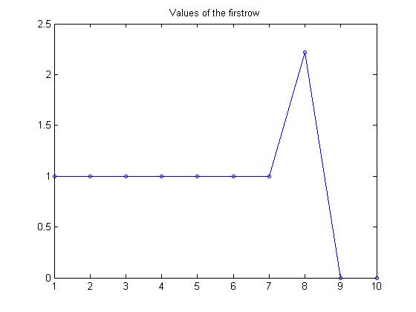
The second row of the solution never changes; however first row of the solution gets erroneous values after the fifth column. That is to say, the accuracy of the solution does not change until ε gets the value 10⁻¹². Starting from that value, the accuracy of the result falls down. The rounding in floating point system of computers causes this problem.

LUFact.m

function [x] = LUFact(A,b)
[rows cols] = size(A);
L = eye(rows);
U = zeros(rows,cols);
x = zeros(rows,1);
y = zeros(rows,1);
for k=1:rows-1
if A(k,k) == 0
break;
end;
for i=k+1:rows
L(i,k) = A(i,k)/A(k,k);
end;
for j=k+1:rows
for i=k+1:rows
A(i,j) = A(i,j)-L(i,k)*A(k,j);
end;
end;
end;
U = A;
for i=1:rows
for j=1:i-1
U(i,j)=0;
end;
end;
for j=1:rows
if L(j,j) == 0
break;
end;
y(j) = b(j)/L(j,j);
for i=j+1:rows
b(i)=b(i)-L(i,j)*y(j);
end;
end;
temp = y;
for j=rows:-1:1
if U(j,j) == 0
break;
end;
x(j) = y(j)/U(j,j);
for i=1:j-1
y(i) = y(i) - U(i,j)*x(j);
end;
end;
y = temp;

LUFactDemo.m
for i = 1:10
e(i) = [10^(-2*i)];
end
for i=1:10
A = [e(i) 1
1 1];
b = [1+e(i);2];
z = LUFact(A,b);
firstrow(i)= z(1);
secondrow(i)=z(2);
end;
firstrow
secondrow

