CMPE 360

HOMEWORK #6

DOĞA ERCAN AKOL 2002102155
EMİN ŞENAY 2002103907
FERHAT DOĞAN 2002104168

23 may 2006

QUESTION #1:

a)

To illustriate the QR algorithm with shifts, I use Example 4.15 to easily compare my results.

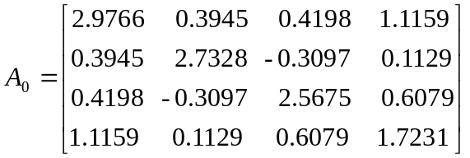
I use the rightmost-bottom value as shift for the first iteration 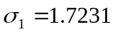. Computing QR factorization of the resulting shifted matrix 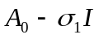, forming the reverse product, and then adding back the shift. I continue my iterations with this procedure until convergence rate;

b)

We have been expecting that diagonal entries are very close to the eigenvalues. First diagonal enty that shows the full accuracy is the rightmost, then the second rightmost and so on. Therefore finally we check the accuracy of the leftmost entry to stop.
We should use the leftmost entry while controlling the convergence rate and our condition is to get the same leftmost element with subsequent 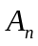 and 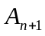.
Finally we get

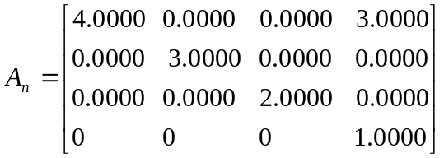

which has eigenvalues (diagonal entries) 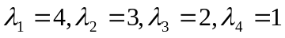.

MATLAB implementation of functions used in QUESTION #1

QRIteration.m
function [A] = QRIteration(original)
A = original;
[NumRow,NumCol] = size(original);

while (1)
sigma = A(NumRow,NumCol);
first_elm = A(1,1);
temp = sigma*eye(NumRow,NumCol);
[Q,R] = gram_schmidt(A-temp,NumRow,NumCol);
A = R*Q + temp;
first_elm_new = A(1,1);

if (first_elm_new == first_elm)
break;
end
end

gram_schmidt.m
function [ Q, R ] = gram_schmidt ( A, m, n )

for k=1:n
Q(:,k)=A(:,k);

for j=1:(k-1)
R(j,k)=Q(:,j)'*A(:,k);
Q(:,k)=Q(:,k)-R(j,k)*Q(:,j);
end

Qk2=0;

for i=1:m
Qk2=Qk2+Q(i,k)*Q(i,k);
end

Qk2=sqrt(Qk2);
R(k,k)=Qk2;

if R(k,k)==0
break;
end

Q(:,k)=Q(:,k)/R(k,k);
end

QUESTION #2:

a) As I did in question #1, I use the Example 4.11 to easily compare my results.

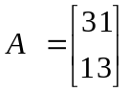

dominant Eigenvalue = 4.0000

corresponding eigenvector = 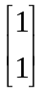

k | 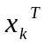 | 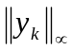
1 | [0.3276 4.4286] | 0
2 | [0.3975 1.0000] | 13.6136
3 | [0.6453 1.0000] | 3.3975
4 | [0.8054 1.0000] | 3.6453
5 | [0.8977 1.0000] | 3.8054
6 | [0.9475 1.0000] | 3.8977
7 | [0.9734 1.0000] | 3.9475
8 | [0.9866 1.0000] | 3.9734
9 | [0.9933 1.0000] | 3.9866
10 | [0.9966 1.0000] | 3.9933
11 | [0.9983 1.0000] | 3.9966
12 | [0.9992 1.0000] | 3.9983
13 | [0.9996 1.0000] | 3.9992
14 | [0.9998 1.0000] | 3.9996
15 | [0.9999 1.0000] | 3.9998
16 | [0.9999 1.0000] | 3.9999
17 | [1.0000 1.0000] | 3.9999
18 | [1.0000 1.0000] | 4.0000
19 | [1.0000 1.0000] | 4.0000
20 | [1.0000 1.0000] | 4.0000

b)

I create deflated matrix by using method of householder.

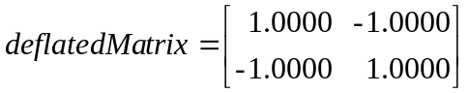

apply power iteration again to compute the second largest eigenvalue and eigenvector of the same matrix.

second Eigenvalue = 2.0000
corresponding eigenvector = 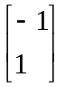
k
1 | [2.6866 -0.2082] | 0
2 | [1.0000 -1.0000] | 2.8948
3 | [1.0000 -1.0000] | 2.0000
4 | [1.0000 -1.0000] | 2.0000

MATLAB implementation of functions used in QUESTION #2

powerIteration.m
function [largest,vector] = powerIteration(A)

[numRows numCols] = size(A);
%tol determines how close we are to the solution
tol = 100;
%x0 is the first arbitrary vector
%We use normal random variables with mean 3 and stdev 2
%to prevent a nonzero vector
x0= random('Normal',3,2,numRows,1);

%x is the array where x0, x1, ... eigenvectors are stored
x = zeros(numRows,1);
%y is the temporary vector that we normalize than assign to x
y = zeros(numRows,1);

x(:,1) = x0;

counter = 2;
max_y(1) = 0;

%continue loop until convergence
while tol > 0
y = A*x(:,counter-1);
[max_y(counter), index] = max(abs(y));
%max_y holds the norm values at each iteration
max_y(counter) = y(index);
%normalization
x(:,counter) = y / y(index);
tol = abs(max_y(counter) - max_y(counter-1));
counter = counter + 1;
end
%return result
largest = max_y(counter-1);
vector = x(:,counter-1);

householderDeflation.m
function [deflated] = householderDeflation(A,lambda1,x1)

[numRows numCols] = size(A);
%find modulus of x1
norm = 0;
for k=1:numCols
norm = norm + x1(k) * x1(k);
end
norm = sqrt(norm);
%normalize vector such that ||vector|| = 1
x1 = x1/norm;
%create deflated matrix
deflated = A - lambda1 * x1 * x1';

main.m
clear;
%Matrix whose modulus of largest and second largest
%eigenvalues goes here
A = [ 3 1
1 3];
%initialize matrix before run
%compute largest eigenvalue by power iteration
[largestEV,corVector1] = powerIteration(A);
%create deflated matrix by using method of householder
deflatedMatrix = householderDeflation(A,largestEV,corVector1);
%after deflation first eigenvalue is now zero so
%with power iteration we find second largest
[secondEV, corVector2] = powerIteration(deflatedMatrix);

QUESTION #3:

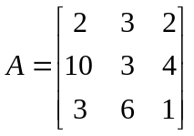

applying procedure on Question #1 ;

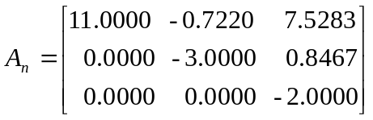

which has eigenvalues (diagonal entries) 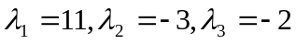.

applying procedure on Question #2 ;

dominant Eigenvalue = 11.0000

corresponding eigenvector = 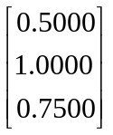

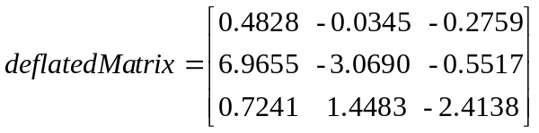

apply power iteration again to compute the second largest eigenvalue and eigenvector of the same matrix.

second Eigenvalue = -3.0000
corresponding eigenvector = 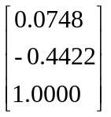
We have a problem in that point because although we find the second largest eigenvalue (absolute value) true, we cannot find the exact corresponding eigenvector.
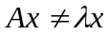 where is second largest eigenvalue andis the corresponding eigenvector.
We said this approximate eigenvalue because of the machine precision, therefore we find approximate eigenvector. We can use shift to improve our algorithm.

in MATLAB

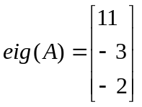
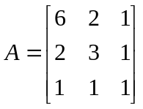

applying procedure on Question #1 ;

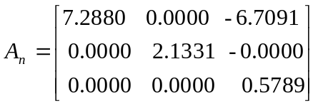

which has eigenvalues (diagonal entries) .

applying procedure on Question #2 ;

dominant Eigenvalue = 7.2880

corresponding eigenvector = 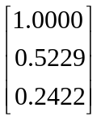

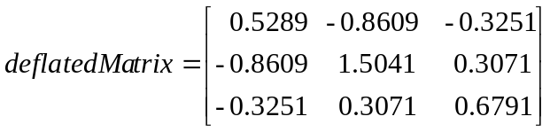

apply power iteration again to compute the second largest eigenvalue and eigenvector of the same matrix.

second Eigenvalue = 2.1331
corresponding eigenvector = 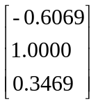

in MATLAB

