<Project Name>
Design Document
Version <1.1>

INSTRUCTOR | LEVENT AKIN
STUDENT | EMİN ŞENAY
STUDENT ID | 2002103907
YEAR | 2004/2nd TERM

Revision History
Date | Version | Description | Author
<21.04.2004> | <1.0> | <Main SDD> | <Emin Şenay>
<01.05.2004> | <1.1> | <Some changes in classes> | <Emin Şenay>

Table of Contents
1. Introduction 4
1.1 Purpose 4
1.2 Scope 4
1.3 Definitions, Acronyms, and Abbreviations 4
1.4 References 4
1.5 Overview 4
2. Software Interface Design 5
2.1 User Interface 5
2.2 Dynamic Models of System Interface 5
3. Internal Module Design 7
3.1 Class Diagram 7
3.2 Class Descriptions 8
3.2.1 Class <Patient> 8
3.2.2 Class <QueType> 11
3.2.3 Class <Unit> 14
3.2.4 Class <Statistics> 17

4. Flow Diagram 23

Design Document

Introduction

Purpose
This software document is prepared to explain the CMPE PROJECT #3 “Medical Clinic Simulation”, so people who is interested in modifying or inspecting the program can easily get related data and can easily understand the detailed design of the program.
The purpose of this document is to provide all details of the Software Interface Design (SID), and Internal Module Design (IMD) for Medical Clinic Simulation. The SID focuses on the user interfaces and the high level module interfaces, and the IMD focuses on the low level description of the implementation classes and all their attributes and methods.
There are some changes in version 1.1. Some functions of the classes are redefined and some members and functions added to some classes.

Scope
This program is about the “Medical Clinic Simulation” program. Medical clinic has following specifications:
- There are 8 units in the clinic whose names are INT (Internal Medicine), CAR (Cardiology), SUR (Surgeon), PSY (Psychiatry), ORT (Orthopedics), DER (Dermatology), ENT (Ear, Nose and Throat) and RAD (Radiology).
- A new patient will come to the clinic by a random time and will go a random unit by the patent arrival ratio of the units.
- Some of the units (INT, CAR, SUR, and ORT) can send the patient to the radiology unit.
- Patients will wait in the queue when there is a patient in their units. However, patients coming from the radiology unit will enter their appropriate units before normal patients.
This simulation will work up to the end of the given day and then will print statistics of the patients to the file “Medsim.out”.

Definitions, Acronyms, and Abbreviations

References
C How to Program, Deitel&Deitel, 3rd Edition
C++ Plus Data Structures, Nell Dale, 3rd Edition

Overview
The rest of the document is designed as following: Second part of the design document will be about the software interface design. The program will be explained using user interface and sequence diagrams. Part 3 is about internal module design and will contain class diagrams and detailed information about classes. Part 4 contains the flow diagram of the software.

Software Interface Design

User Interface

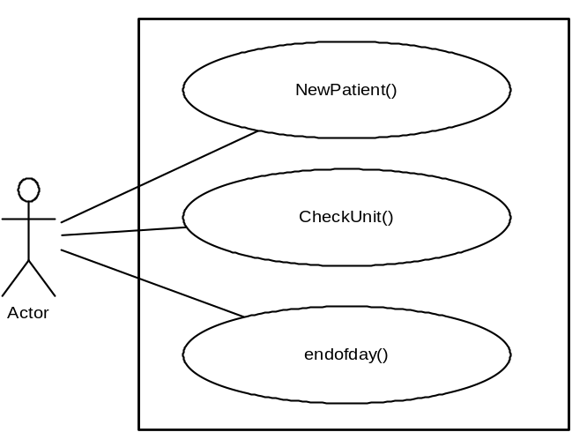

Dynamic Models of System Interface
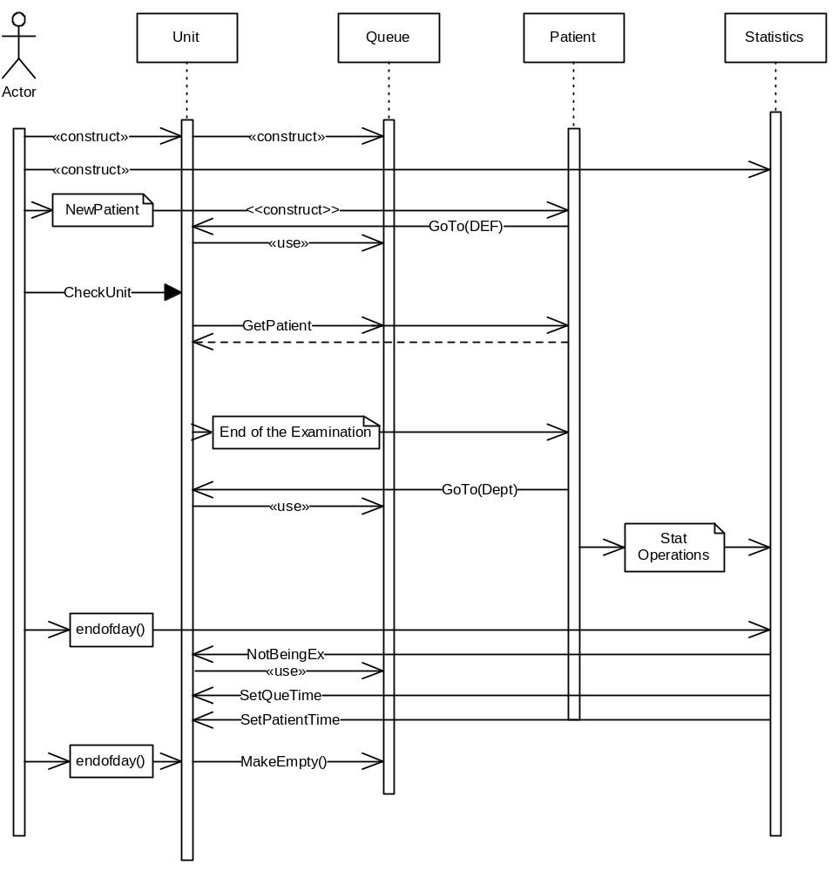

Internal Module Design

Class Diagram
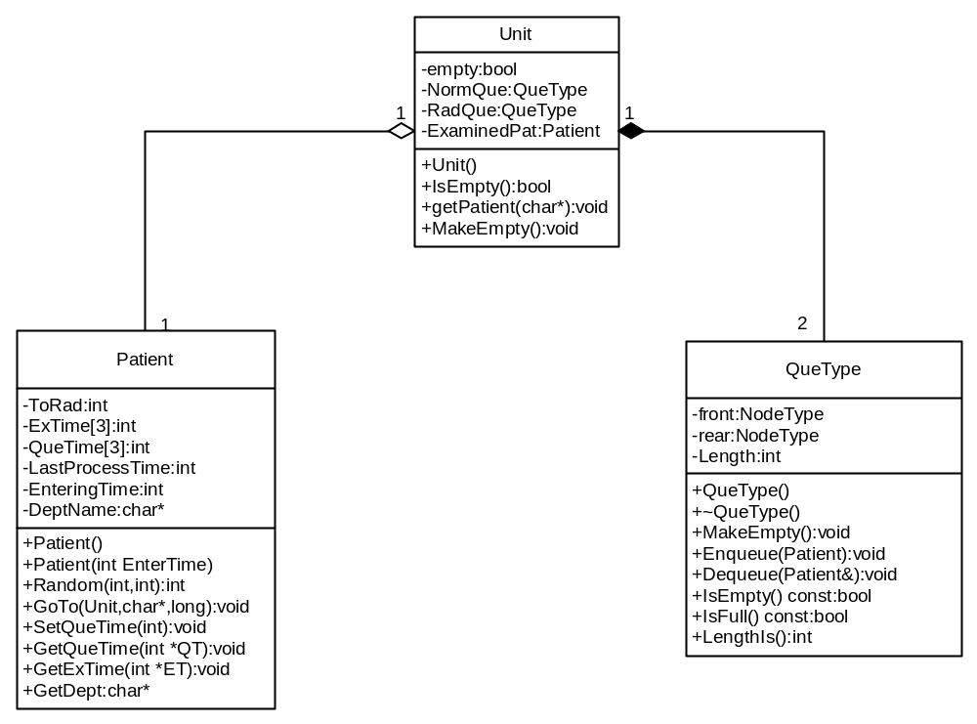

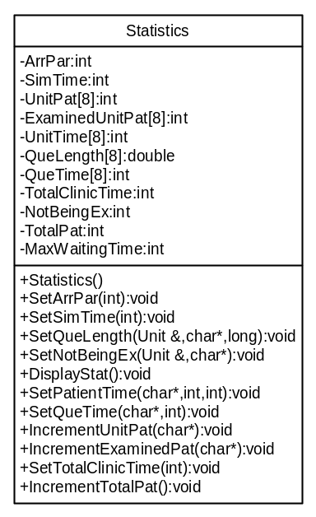

Class Descriptions

Class <Patient>

3.2.1 | Patient
 | 3.2.1.1 | Class decomposition
 |  |  |  | Inherited classes: -
 |  |  |  | Aggregated classes: -
 |  |  |  | Associated classes: Unit, QueType
Data members:
int ToRad: The possibility of the patient to go the radiology unit.
int ExTime[3]: Examination times of the patient.
int LastProcessTime: Will store time when patient enters or exits his unit.
int EnteringTime: Patient’s entering time to the clinic.
char* DeptName: Will store patient’s first unit being examined.
int QueTime[3]: Patient’s waiting times in queues.
Member functions:
Patient():Default constructor.
Patient(long int EnterTime): Constructor.
void GoTo(Unit &Dept, char* UName, long int Time): Patient will go the specified unit and start to wait in the queue.
char* GetDept(): Will return the department name.
void SetQueTime (long int Time, char* UName): Will set the queue time of the patient.
void GetQueTime(int *QT): Will get the queue time of the patient.
int Random (int min, int max): Will generate random numbers within the given range.
void GetExTime (int* ET): Will get the examination duration of the patient.
 | 3.2.1.2 | Function Decomposition
 |  |  |  | Function Name: Patient
 |  |  |  | Return Type: None
 |  |  |  | Input parameter: None
 |  |  |  | Output parameter: None
 |  |  |  | Files accessed: None
 |  |  |  | Files changed: None
 |  |  |  | Caller: Unit::Unit()
 |  |  |  | Pre: None.
 |  |  |  | Post: Class is constructed.
 |  |  |  | Algorithm (Description in pseudo-code): Allocate the space for DeptName.
 |  |  |  | Function Name: Patient
 |  |  |  | Return Type: None
 |  |  |  | Input parameter: int EnterTime
 |  |  |  | Output parameter: None
 |  |  |  | Files accessed: None
 |  |  |  | Files changed: None
 |  |  |  | Caller: NewPatient (long int time,Unit &INT,Unit &CAR,Unit &SUR,Unit &PSY,Unit &ORT,Unit &DER,Unit &ENT,Unit &RAD,Statistics &ClinicStat)
 |  |  |  | Pre: None.
 |  |  |  | Post: Class is constructed.
 |  |  |  | Algorithm (Description in pseudo-code): Members of Extime and QueTime will be 0. EnteringTime will be time. Get random number and by this number find the place where patient goes and store it in DeptName. Allocate the space for DeptName.
 |  |  |  | Function Name: GoTo
 |  |  |  | Return Type: void
 |  |  |  | Input parameter: Unit Dept, char* UName, long int Times
 |  |  |  | Output parameter: None
 |  |  |  | Files accessed: None
 |  |  |  | Files changed: None
 |  |  |  | Caller: NewPatient (long int time,Unit &INT,Unit &CAR,Unit &SUR,Unit &PSY,Unit &ORT,Unit &DER,Unit &ENT,Unit &RAD,Statistics &ClinicStat) and checkUnit (Unit &Unt,Unit &RAD,Unit &ORT,Unit &INT,Unit &CAR,Unit &SUR,char* Uname,long int Time, Statistics &ClinicStat)
 |  |  |  | Pre: Class must be initialized. Given Dept must be initialized.
 |  |  |  | Post: Patient will be in the given unit’s queue
 |  |  |  | Algorithm (Description in pseudo-code): Enqueue in the appropriate queue. Set ExTime and ToRad.
 |  |  |  | Function Name: GetDept
 |  |  |  | Return Type: char*
 |  |  |  | Input parameter: None
 |  |  |  | Output parameter: None
 |  |  |  | Files accessed: None
 |  |  |  | Files changed: None
 |  |  |  | Caller: NewPatient (long int time,Unit &INT,Unit &CAR,Unit &SUR,Unit &PSY,Unit &ORT,Unit &DER,Unit &ENT,Unit &RAD,Statistics &ClinicStat) and checkUnit (Unit &Unt,Unit &RAD,Unit &ORT,Unit &INT,Unit &CAR,Unit &SUR,char* Uname,long int Time, Statistics &ClinicStat)
 |  |  |  | Pre: Class must be constructed.
 |  |  |  | Post: Function will return the unit name.
 |  |  |  | Algorithm (Description in pseudo-code): Return the DeptName
 |  |  |  | Function Name: SetQueTime
 |  |  |  | Return Type: void
 |  |  |  | Input parameter: long int Time, char* UName
 |  |  |  | Output parameter: None
 |  |  |  | Files accessed: None
 |  |  |  | Files changed: None
 |  |  |  | Caller: checkUnit (Unit &Unt,Unit &RAD,Unit &ORT,Unit &INT,Unit &CAR,Unit &SUR,char* Uname,long int Time, Statistics &ClinicStat)
 |  |  |  | Pre: Class must have been constructed.
 |  |  |  | Post: Queue time is added to appropriate member of QueTime[3].
 |  |  |  | Algorithm (Description in pseudo-code): Extract LastProcessTime form time. Add it to the QueTime[0] if ToRad=0 or 1, to the QueTime[2] if ToRad=2. If the unit is RAD, ad it to the QueTime[1].
 |  |  |  | Function Name: GetQueTime
 |  |  |  | Return Type: void
 |  |  |  | Input parameter: None
 |  |  |  | Output parameter: int *QT
 |  |  |  | Files accessed: None
 |  |  |  | Files changed: None
 |  |  |  | Caller: checkUnit (Unit &Unt,Unit &RAD,Unit &ORT,Unit &INT,Unit &CAR,Unit &SUR,char* Uname,long int Time, Statistics &ClinicStat) and endofday(Unit &Unt, Unit &RAD, char* Uname, Statistics &ClinicStat)
 |  |  |  | Pre: Class must have been constructed. QT must have been at least 3 int size.
 |  |  |  | Post: Elements of the QT will be the Queue times of the patient.
 |  |  |  | Algorithm (Description in pseudo-code): Set the QT to QueTime.
 |  |  |  | Function Name: Random
 |  |  |  | Return Type: int
 |  |  |  | Input parameter: int min, int max
 |  |  |  | Output parameter: None
 |  |  |  | Files accessed: None
 |  |  |  | Files changed: None
 |  |  |  | Caller: Patient::GoTo and Patient::Patient
 |  |  |  | Pre: None
 |  |  |  | Post: Will return a random number with the specified range.
 |  |  |  | Algorithm (Description in pseudo-code): Extract min from max and then generate a random number smaller than or equal to this difference. Then add it to min and return this number.
 |  |  |  | Function Name: GetExTime
 |  |  |  | Return Type: void
 |  |  |  | Input parameter: None
 |  |  |  | Output parameter: int* ET
 |  |  |  | Files accessed: None
 |  |  |  | Files changed: None
 |  |  |  | Caller: checkUnit (Unit &Unt,Unit &RAD,Unit &ORT,Unit &INT,Unit &CAR,Unit &SUR,char* Uname,long int Time, Statistics &ClinicStat) and endofday(Unit &Unt, Unit &RAD, char* Uname, Statistics &ClinicStat)
 |  |  |  | Pre: Class must have been constructed. ET must have been at least 3 int size.
 |  |  |  | Post: Elements of the ET will be the Examination times of the patient.
 |  |  |  | Algorithm (Description in pseudo-code): Set the ET to ExTime.
 | 3.2.1.3 | Statechart
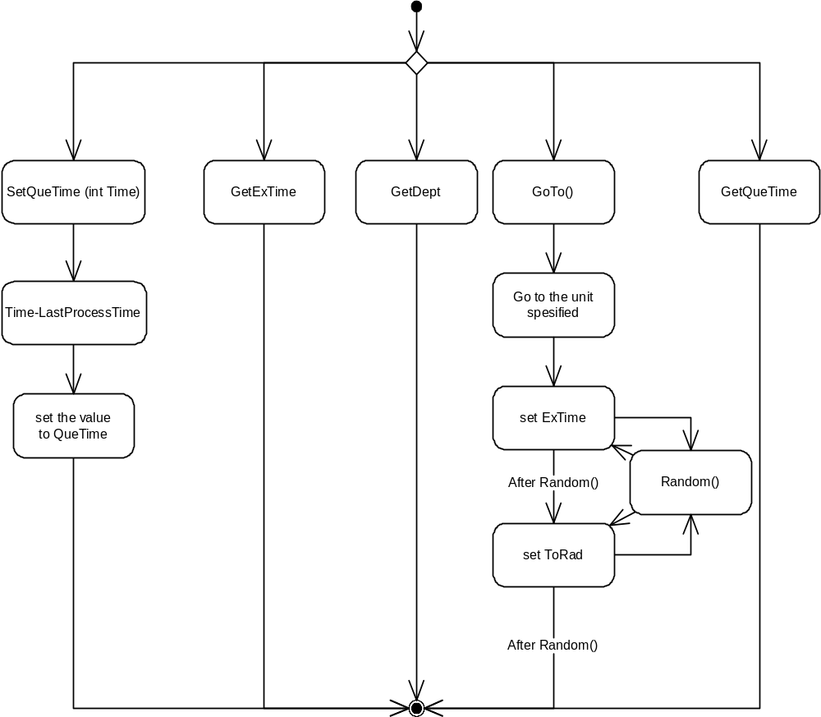

Class <QueType>

3.2.2 | QueType
 | 3.2.2.1 | Class decomposition
 |  |  | Inherited classes: -
 |  |  | Aggregated classes: -
 |  |  | Associated classes: Patient
Data members:
NodeType* front: Will point the front of the queue.
NodeType* rear: Will point the rear of the queue.
int Length: The length of the queue.
Member functions:
QueType(): Constructor
~QueType: Destructor
void MakeEmpty(): Will empty the queue.
void Enqueue (Patient): Enqueue the Patient to the queue.
void Dequeue (Patient&): Dequeue the Patient from the queue.
bool IsEmpty () const: Will check the queue for being empty.
bool IsFull () const: Will check the queue for being full.
int LengthIs (): Will return the length of the queue.
 | 3.2.2.2 | Function Decomposition
 |  |  | Function Name QueType()
 |  |  | Return Type: None
 |  |  | Input parameter: None
 |  |  | Output parameter: None
 |  |  | Files accessed: None
 |  |  | Files changed: None
 |  |  | Caller: Unit::Unit
 |  |  | Pre: None
 |  |  | Post: Class is constructed
 |  |  | Algorithm (Description in pseudo-code): front and rear is null, length is 0.
 |  |  | Function Name: ~QueType
 |  |  | Return Type: None
 |  |  | Input parameter: None
 |  |  | Output parameter: None
 |  |  | Files accessed: None
 |  |  | Files changed: None
 |  |  | Caller: -
 |  |  | Pre: -
 |  |  | Post: Class is destructed.
 |  |  | Algorithm (Description in pseudo-code): Empty the queue.
 |  |  | Function Name: MakeEmpty
 |  |  | Return Type: void
 |  |  | Input parameter: None
 |  |  | Output parameter: None
 |  |  | Files accessed: None
 |  |  | Files changed: None
 |  |  | Caller: QueType::~QueType, endofday(Unit &Unt, Unit &RAD, char* Uname, Statistics &ClinicStat)
 |  |  | Pre: Class must have been constructed
 |  |  | Post: Queue is empty.
 |  |  | Algorithm (Description in pseudo-code): Delete the members one by one until front points to NULL.
 |  |  | Function Name: IsEmpty
 |  |  | Return Type: bool
 |  |  | Input parameter: None
 |  |  | Output parameter: None
 |  |  | Files accessed: None
 |  |  | Files changed: None
 |  |  | Caller: Unit::GetPatient(), QueType::Dequeue
 |  |  | Pre: Class must have been constructed.
 |  |  | Post: Returns true if class is empty. Otherwise, returns false.
 |  |  | Algorithm (Description in pseudo-code): Return true if class is empty. Otherwise, return false.
 |  |  | Function Name: IsFull
 |  |  | Return Type: bool
 |  |  | Input parameter: None
 |  |  | Output parameter: None
 |  |  | Files accessed: None
 |  |  | Files changed: None
 |  |  | Caller: QueType::Enqueue
 |  |  | Pre: Class must have been constructed.
 |  |  | Post: Returns true if class is full. Otherwise, returns false.
 |  |  | Algorithm (Description in pseudo-code): Try to allocate one element. If new returns bad_alloc exception, return 1; otherwise delete the element and return 0.
 |  |  | Function Name: LengthIs
 |  |  | Return Type: int
 |  |  | Input parameter: None
 |  |  | Output parameter: None
 |  |  | Files accessed: None
 |  |  | Files changed: None
 |  |  | Caller: Statistics::SetNotBeingEx(Unit &Temp,char* Unitname), Statistics::SetQueLength(Unit &Temp,char* Unitname,long int Time)
 |  |  | Pre: Class must have been constructed.
 |  |  | Post: Returns the length of the queue.
 |  |  | Algorithm (Description in pseudo-code): Return Length.
 |  |  | Function Name: Enqueue
 |  |  | Return Type: void
 |  |  | Input parameter: Patient newPatient
 |  |  | Output parameter: None
 |  |  | Files accessed: None
 |  |  | Files changed: None
 |  |  | Caller: Patient::GoTo(Unit &Dept,char* UName, long int Time)
 |  |  | Pre: Class must have been constructed.
 |  |  | Post: A patient is added to the queue if the queue is not full. If it is full, a FullQueue exception is thrown.
 |  |  | Algorithm (Description in pseudo-code): Check if the queue is full or not. If it is full, throw a FullQueue exception. If not, create a new Patient and add it to the queue.
 |  |  | Function Name: Dequeue
 |  |  | Return Type: void
 |  |  | Input parameter: None
 |  |  | Output parameter: Patient&
 |  |  | Files accessed: None
 |  |  | Files changed: None
 |  |  | Caller: Unit::GetPatient()
 |  |  | Pre: Class must have been constructed.
 |  |  | Post: If queue is no empty, the front of the queue has been removed and a copy returned in item; otherwise, an EmptyQueue exception is thrown.
 |  |  | Algorithm (Description in pseudo-code): Check if the queue is empty or not. If it is empty, throw an EmptyQueue exception. Otherwise, remove front item from the queue and return it.
 | 3.2.2.3 | Statechart
 | 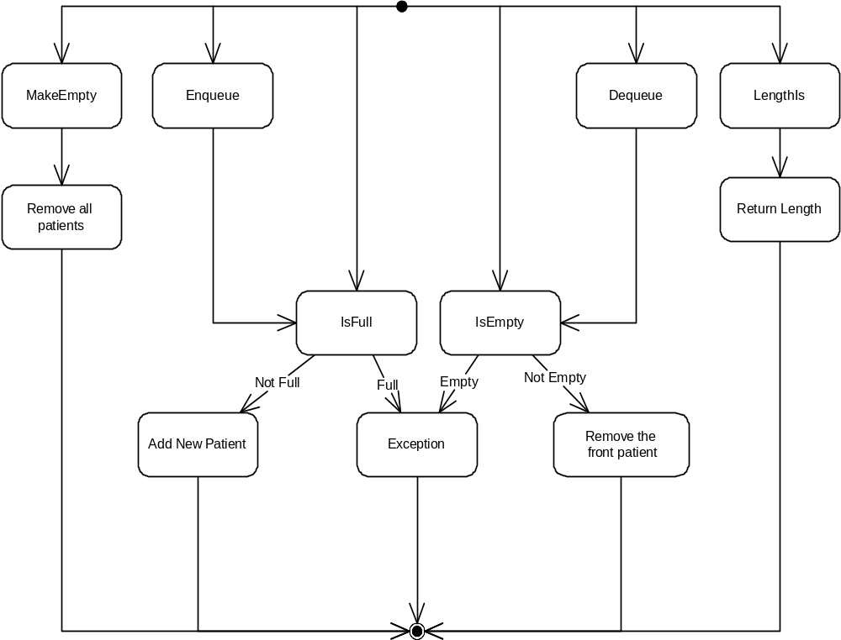

Class <Unit>

3.2.3 | Unit
 | 3.2.3.1 | Class decomposition
 |  |  | Inherited classes: -
 |  |  | Aggregated classes: -
 |  |  | Associated classes: Queue, Patient
Data members:
bool empty: 1 if unit is empty.
QueType NormQue: Normal queue of the patients.
QueType RadQue: Patients coming from radiology will wait in this queue.
Patient ExaminedPat: The patient, and its specifications, being examined in the unit.
Member functions:
Unit(): Constructor.
bool IsEmpty(): Checks if there is a patient in the unit.
void GetPatient(): Brings a patient to the unit from the queue.
void MakeEmpty():Empties the unit.
 | 3.2.3.2 | Function Decomposition
 |  |  | Function Name: IsEmpty
 |  |  | Return Type: bool
 |  |  | Input parameter: None
 |  |  | Output parameter: None
 |  |  | Files accessed: None
 |  |  | Files changed: None
 |  |  | Caller: endofday(Unit &Unt, Unit &RAD, char* Uname, Statistics &ClinicStat), checkUnit (Unit &Unt,Unit &RAD,Unit &ORT,Unit &INT,Unit &CAR,Unit &SUR,char* Uname,long int Time, Statistics &ClinicStat)
 |  |  | Pre: Class must have been constructed.
 |  |  | Post: Returns true if there is no patient in the unit.
 |  |  | Algorithm (Description in pseudo-code): If empty is 0, return False, otherwise return True.
 |  |  | Function Name: Unit
 |  |  | Return Type: None
 |  |  | Input parameter: None
 |  |  | Output parameter: None
 |  |  | Files accessed: None
 |  |  | Files changed: None
 |  |  | Caller: main()
 |  |  | Pre: None
 |  |  | Post: Class is constructed.
 |  |  | Algorithm (Description in pseudo-code): Set empty to 0.
 |  |  | Function Name: MakeEmpty
 |  |  | Return Type: None
 |  |  | Input parameter: None
 |  |  | Output parameter: None
 |  |  | Files accessed: None
 |  |  | Files changed: None
 |  |  | Caller: endofday(Unit &Unt, Unit &RAD, char* Uname, Statistics &ClinicStat), checkUnit (Unit &Unt,Unit &RAD,Unit &ORT,Unit &INT,Unit &CAR,Unit &SUR,char* Uname,long int Time, Statistics &ClinicStat)
 |  |  | Pre: None
 |  |  | Post: Unit is empty.
 |  |  | Algorithm (Description in pseudo-code): Set empty to 1.
 |  |  | Function Name: GetPatient
 |  |  | Return Type: void
 |  |  | Input parameter: None
 |  |  | Output parameter: None
 |  |  | Files accessed: None
 |  |  | Files changed: None
 |  |  | Caller: checkUnit (Unit &Unt,Unit &RAD,Unit &ORT,Unit &INT,Unit &CAR,Unit &SUR,char* Uname,long int Time, Statistics &ClinicStat)
 |  |  | Pre: Class must have been constructed.
 |  |  | Post: If any of the unit queues is not empty, gets the patient. If they are empty, nothing is done.
 |  |  | Algorithm (Description in pseudo-code): Check the RadQueue, if it is not empty, dequeue a patient and set it to ExaminedPat Change empty to 0. If it is empty, check NormQueue and do the same operation. If both of them are empty, do nothing.
 | 3.2.3.3 | Statechart
 | 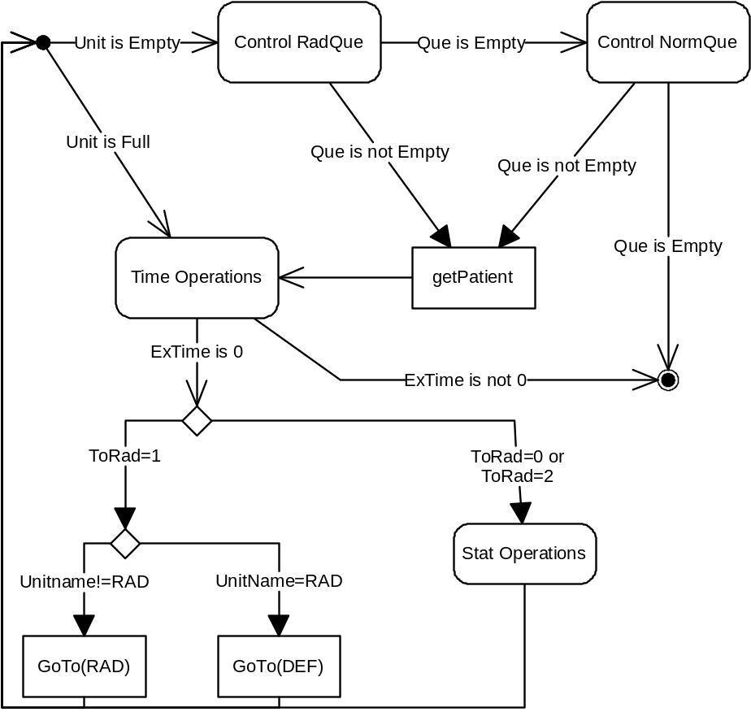

Class <Statistics>

3.2.4 | Statistics
 | 3.2.4.1 | Class decomposition
 |  |  | Inherited classes: -
 |  |  | Aggregated classes: -
 |  |  | Associated classes: Unit
Data members:
int ArrPar: Arrival parameter.
int SimTime: Simulation duration (day).
int UnitPat[8]: Patient numbers of each unit.
int ExaminedUnitPat[8]:Examined patient numbers of each unit.
int UnitTime[8]: Time spent in each unit.
double QueLength[8]: Sum of the queue lengths of each second.
int NotBeingEx: Sum of number of patients who can not be examined at the end of each day.
int QueTime[8]: Sum of the waiting time in each queue.
int TotalClinicTime: Sum of total time spent in the clinic of each patient.
int TotalPat: Total number of patients came to the clinic.
int MaxWaitingTime: Will store the maximum waiting time.
Member functions:
Statistics(): Constructor
void SetArrPar(int A): Sets ArrPar to A.
void SetSimTime(int ST): Sets SimTime to ST.
void SetPatientTime (char* UnitName, int ExTime, int QTime): ExTime and QueTime will be added to the UnitTime.
void SetQueLength(Unit &Temp,char* Unitname): Will take the given unit’s queue lengths and sum it to the QueLength.
void SetNotBeingEx(Unit &Temp,char* Unitname): Will take the given unit’s queue lengths at the end of the day and will sum it with NotBeingEx.
void DisplayStat(): Will write the statistics to the “medsim.out” file.
void SetQueTime (char* UnitName, int QTime): Will increment the given Unit’s QueTime by QTime.
void SetTotalClinicTime(int CT): Will increment TotalClinicTime by CT.
int FindDepthNumber(char* Unitname): Client will give the 3 letter code of unit, this will convert it to number that class uses.
void IncrementUnitPat(char* Unitname): Increments the given unit’s patients by 1.
void IncrementExaminedUnitPat(char* Unitname):Increments the given unit’s examined patients by 1.
 | 3.2.4.2 | Function Decomposition
 |  |  | Function Name: SetArrPar
 |  |  | Return Type: void
 |  |  | Input parameter: int A
 |  |  | Output parameter: None
 |  |  | Files accessed: None
 |  |  | Files changed: None
 |  |  | Caller: main()
 |  |  | Pre: Class must have been constructed.
 |  |  | Post: A is set to ArrPar.
 |  |  | Algorithm (Description in pseudo-code): Set A to ArrPar.
 |  |  | Function Name: Statistics
 |  |  | Return Type: None
 |  |  | Input parameter: None
 |  |  | Output parameter: None
 |  |  | Files accessed: None
 |  |  | Files changed: None
 |  |  | Caller: main()
 |  |  | Pre: None
 |  |  | Post: Class is constructed.
 |  |  | Algorithm (Description in pseudo-code): Set TotalPat, NotBeingEx, TotalClinicTime, MaxWaitingTime and all members of UnitPat, UnitTime, QueLength, RadPat, QueTime to 0.
 |  |  | Function Name: SetSimTime
 |  |  | Return Type: void
 |  |  | Input parameter: int ST
 |  |  | Output parameter: None
 |  |  | Files accessed: None
 |  |  | Files changed: None
 |  |  | Caller: main()
 |  |  | Pre: Class must have been constructed.
 |  |  | Post: ST is set to SimTime.
 |  |  | Algorithm (Description in pseudo-code): Set ST to SimTime.
 |  |  | Function Name: SetPatientTime
 |  |  | Return Type: void
 |  |  | Input parameter: char* UnitName, int ExTime, int QTime
 |  |  | Output parameter: None
 |  |  | Files accessed: None
 |  |  | Files changed: None
 |  |  | Caller: endofday(Unit &Unt, Unit &RAD, char* Uname, Statistics &ClinicStat), checkUnit (Unit &Unt,Unit &RAD,Unit &ORT,Unit &INT,Unit &CAR,Unit &SUR,char* Uname,long int Time, Statistics &ClinicStat)
 |  |  | Pre: Class must have been constructed.
 |  |  | Post: Patient number of the given unit is incremented by 1. Patient’s total time spent on the unit is recorded.
 |  |  | Algorithm (Description in pseudo-code): Increment UnitPat’s appropriate member by 1. Sum the ExTime and QTime and add them to appropriate member of UnitTime.
 |  |  | Function Name: SetQueLength
 |  |  | Return Type: void
 |  |  | Input parameter: Unit &Temp, char* Unitname
 |  |  | Output parameter: None
 |  |  | Files accessed: None
 |  |  | Files changed: None
 |  |  | Caller: main()
 |  |  | Pre: Class must have been constructed.
 |  |  | Post: The queue lengths of given unit is taken and saved.
 |  |  | Algorithm (Description in pseudo-code): Get the queue lengths of the unit. Sum them, if unit uses radiology unit, divide queue lengths to 2, and add to the appropriate member of QueLength.
 |  |  | Function Name: SetNotBeingEx
 |  |  | Return Type: void
 |  |  | Input parameter: Unit &Temp
 |  |  | Output parameter: None
 |  |  | Files accessed: None
 |  |  | Files changed: None
 |  |  | Caller: endofday(Unit &Unt, Unit &RAD, char* Uname, Statistics &ClinicStat)
 |  |  | Pre: Class must have been constructed.
 |  |  | Post: The queue lengths of given unit is taken and saved.
 |  |  | Algorithm (Description in pseudo-code): Get the queue lengths of the unit. Sum them and add to NotBeingEx.
 |  |  | Function Name: DisplayStat():
 |  |  | Return Type: void
 |  |  | Input parameter: None
 |  |  | Output parameter: None
 |  |  | Files accessed: medsim.out
 |  |  | Files changed: medsim.out
 |  |  | Caller: main()
 |  |  | Pre: Class must have been constructed.
 |  |  | Post: All of the required info is saved to the medsim.out. If medsim.out can not be created, give an error and terminate.
 |  |  | Algorithm (Description in pseudo-code): Open Medsim.out and save the stats there. If Medsim.out can not be created, give an error and terminate.
 |  |  | Function Name: SetQueTime
 |  |  | Return Type: void
 |  |  | Input parameter: char* UnitName, int QTime
 |  |  | Output parameter: None
 |  |  | Files accessed: None
 |  |  | Files changed: None
 |  |  | Caller: endofday(Unit &Unt, Unit &RAD, char* Uname, Statistics &ClinicStat), checkUnit (Unit &Unt,Unit &RAD,Unit &ORT,Unit &INT,Unit &CAR,Unit &SUR,char* Uname,long int Time, Statistics &ClinicStat)
 |  |  | Pre: Class must have been constructed.
 |  |  | Post: Patient’s waiting times in queue saved.
 |  |  | Algorithm (Description in pseudo-code): Add QTime to the appropriate member of the QueTime.
 |  |  | Function Name: IncrementUnitPat
 |  |  | Return Type: void
 |  |  | Input parameter: char* Unitname
 |  |  | Output parameter: None
 |  |  | Files accessed: None
 |  |  | Files changed: None
 |  |  | Caller: checkUnit (Unit &Unt,Unit &RAD,Unit &ORT,Unit &INT,Unit &CAR,Unit &SUR,char* Uname,long int Time, Statistics &ClinicStat), NewPatient (long int time,Unit &INT,Unit &CAR,Unit &SUR,Unit &PSY,Unit &ORT,Unit &DER,Unit &ENT,Unit &RAD,Statistics &ClinicStat)
 |  |  | Pre: Class must have been constructed.
 |  |  | Post: Given unit’s patient number is incremented by 1.
 |  |  | Algorithm (Description in pseudo-code): Increment the appropriate member of UnitPat[8] by 1.
 |  |  | Function Name: IncrementExaminedPat
 |  |  | Return Type: void
 |  |  | Input parameter: char* Unitname
 |  |  | Output parameter: None
 |  |  | Files accessed: None
 |  |  | Files changed: None
 |  |  | Caller: checkUnit (Unit &Unt,Unit &RAD,Unit &ORT,Unit &INT,Unit &CAR,Unit &SUR,char* Uname,long int Time, Statistics &ClinicStat)
 |  |  | Pre: Class must have been constructed.
 |  |  | Post: Given unit’s examined patient number is incremented by 1.
 |  |  | Algorithm (Description in pseudo-code): Increment the appropriate member of ExaminedUnitPat[8] by 1.
 |  |  | Function Name: FindDeptNumber
 |  |  | Return Type: int
 |  |  | Input parameter: char* Unitname
 |  |  | Output parameter: None
 |  |  | Files accessed: None
 |  |  | Files changed: None
 |  |  | Caller: Statistics::IncrementExaminedPat(char *Unitname), Statistics::SetQueTime(char* UnitName, int QTime), Statistics::SetNotBeingEx(Unit &Temp,char* Unitname), Statistics::IncrementUnitPat(char* Unitname), Statistics::SetPatientTime(char* Unitname,int ExTime,int QTime)
 |  |  | Pre: Class must have been constructed.
 |  |  | Post: The code of the unit is converted to a number.
 |  |  | Algorithm (Description in pseudo-code): INT is 0, CAR is 1, SUR is 2, so on. (As given in the project description)
 |  |  | Function Name: SetTotalClinicTime
 |  |  | Return Type: void
 |  |  | Input parameter: int CT
 |  |  | Output parameter: None
 |  |  | Files accessed: None
 |  |  | Files changed: None
 |  |  | Caller: checkUnit (Unit &Unt,Unit &RAD,Unit &ORT,Unit &INT,Unit &CAR,Unit &SUR,char* Uname,long int Time, Statistics &ClinicStat), NewPatient (long int time,Unit &INT,Unit &CAR,Unit &SUR,Unit &PSY,Unit &ORT,Unit &DER,Unit &ENT,Unit &RAD,Statistics &ClinicStat)
 |  |  | Pre: Class must have been constructed.
 |  |  | Post: CT is added to the TotalClinicTime.
 |  |  | Algorithm (Description in pseudo-code): Add CT to the TotalClinicTime.
 | 3.2.4.3 | Statechart
 | 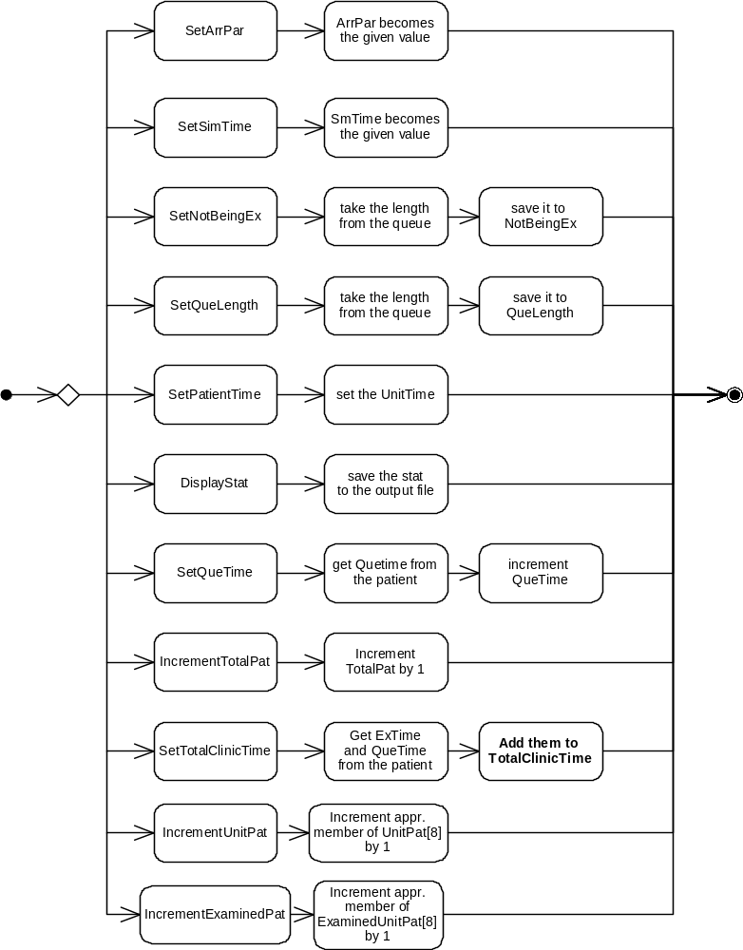

Flow Diagram
