<Sparse Matrices>
Design Document
Version <1.0>

INSTRUCTOR | LEVENT AKIN
STUDENT | EMİN ŞENAY
STUDENT ID | 2002103907
YEAR | 2004/2nd TERM

Revision History
Date | Version | Description | Author
<13/05/2004> | <1.0> | <Main SDD> | <Emin Şenay>

Table of Contents
1. Introduction 4
1.1 Purpose 4
1.2 Scope 4
1.3 Definitions, Acronyms, and Abbreviations 4
1.4 References 4
1.5 Overview 4
2. Software Interface Design 4
2.1 User Interface 4
2.2 Dynamic Models of System Interface 5
3. Internal Module Design 6
3.1 Class Diagram 6
3.2 Class Descriptions 6
3.2.1 Class <SparseMatrix> 6
3.2.2 Class <Mnode> 9
3.2.3 Global Functions 11
3.2.3.1 operator >> 11
3.2.3.2 operator << 11
4. Flow Diagram 13

Design Document

Introduction

Purpose
This software document is prepared to explain the CMPE 160 PROJECT #4 “Sparse Matrices”, so people who is interested in modifying or inspecting the program can easily get related data and can easily understand the detailed design of the program.
The purpose of this document is to provide all details of the Software Interface Design (SID), and Internal Module Design (IMD) for Sparse Matrices. The SID focuses on the user interfaces and the high-level module interfaces, and the IMD focuses on the low-level description of the implementation classes and all their attributes and methods.

Scope
This document is about the “Sparse Matrices” program. The program must take the matrix, do addition, subtraction and multiplication operations and display the whole matrix in a nice way. Given input will be in input1.txt and input2.txt, and first contain the dimensions and number of nonzero terms, and then will contain the row, column and value specifications of nonzero terms.
Because of these specifications, the program must contain operator overloading. >>, <<, +, -, * and = operators must be overloaded in the program.

Definitions, Acronyms, and Abbreviations

References
C How to Program, Deitel&Deitel, 3rd Edition
C++ Plus Data Structures, Nell Dale, 3rd Edition

Overview
The remaining parts of this document are designed as following: Second part of the design document will be about the software interface design. The program will be explained using user interface and sequence diagrams. Part 3 is about internal module design and will contain class diagrams and detailed information about classes. Part 4 contains the flow diagram of the software.

Software Interface Design

User Interface

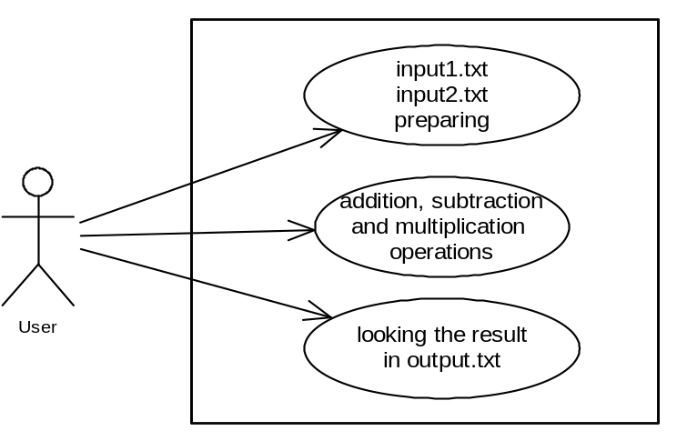

Dynamic Models of System Interface
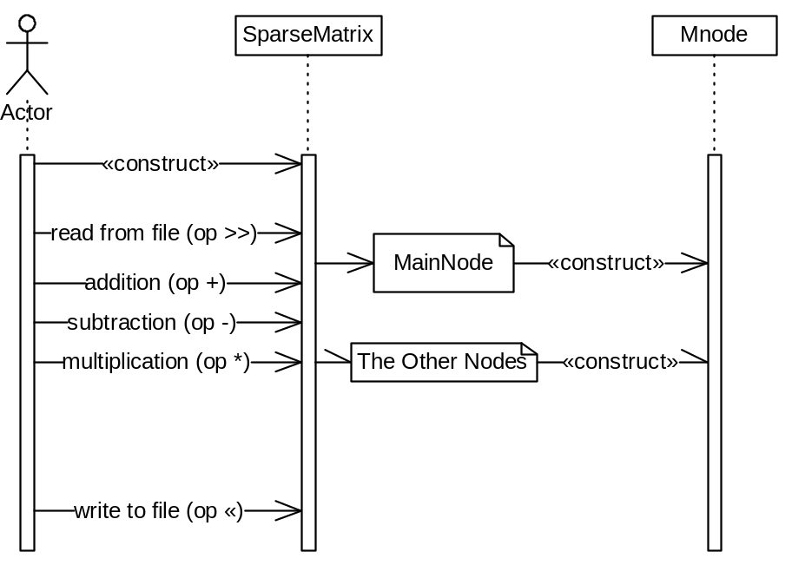

Internal Module Design

Class Diagram

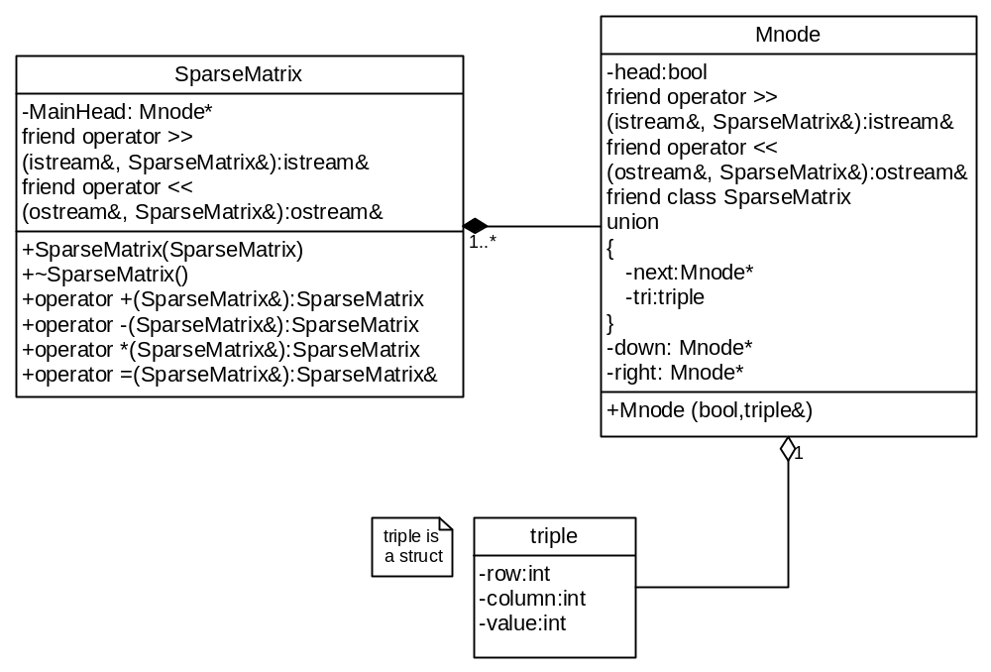

Class Descriptions

Class <SparseMatrix>

3.2.1 |  |  | SparseMatrix
 |  | 3.2.1.1 |  |  | Class decomposition
 |  |  |  |  |  | Inherited classes: None
 |  |  |  |  |  | Aggregated classes: Mnode
 |  |  |  |  |  | Associated classes: None
Data members:
Mnode* MainHead: Will point to the main head node
Member functions:
SparseMatrix(SparseMatrix& rhs): Copy constructor
~SparseMatrix(): Destructor
SparseMatrix operator + (SparseMatrix& rhs): + operator overload
SparseMatrix operator - (SparseMatrix& rhs): - operator overload
SparseMatrix operator * (SparseMatrix& rhs): * operator overload
SparseMatrix operator = (SparseMatrix& rhs): = operator overload
 |  | 3.2.1.2 |  |  | Function Decomposition
 |  |  |  |  |  | Function Name: SparseMatrix
 |  |  |  |  |  | Return Type: None
 |  |  |  |  |  | Input parameter: SparseMatrix& rhs
 |  |  |  |  |  | Output parameter: None
 |  |  |  |  |  | Files accessed: None
 |  |  |  |  |  | Files changed: None
 |  |  |  |  |  | Caller: -
 |  |  |  |  |  | Pre: -
 |  |  |  |  |  | Post: The class is deep copied.
 |  |  |  |  |  | Algorithm (Description in pseudo-code): Set this pointer to rhs.
 |  |  |  |  |  | Function Name: ~SparseMatrix
 |  |  |  |  |  | Return Type: None
 |  |  |  |  |  | Input parameter: None
 |  |  |  |  |  | Output parameter: None
 |  |  |  |  |  | Files accessed: None
 |  |  |  |  |  | Files changed: None
 |  |  |  |  |  | Caller: main()
 |  |  |  |  |  | Pre: -
 |  |  |  |  |  | Post: The class is destructed.
 |  |  |  |  |  | Algorithm (Description in pseudo-code): First, delete all the element nodes, then delete all the head nodes, and lastly delete the MainHead.
 |  |  |  |  |  | Function Name: operator +
 |  |  |  |  |  | Return Type: SparseMatrix
 |  |  |  |  |  | Input parameter: SparseMatrix& rhs
 |  |  |  |  |  | Output parameter: None
 |  |  |  |  |  | Files accessed: None
 |  |  |  |  |  | Files changed: None
 |  |  |  |  |  | Caller: main()
 |  |  |  |  |  | Pre: Matrices must be initialized.
 |  |  |  |  |  | Post: Matrices are added to another SparseMatrix class.
 |  |  |  |  |  | Algorithm (Description in pseudo-code): First, create a new SparseMatrix. Number of head nodes will be the same as the rhs (or this). Create head nodes and link them to each other and the MainHead. Do the summation row by row. Take the elements of both matrixes (this and rhs) until one of them becomes head node. If their column numbers are same, add the values of them, create a new node by this value and then link it to the row list. Linking to the row list is done by a last pointer, which points the last added node. (By this way, we do not need to search the place to add the new node.) Then do the column linking. First, find the place to link the element. Go to the element’s column in the head node list starting from the MainHead, then go down until nodes’ down is pointing to head node. Link the new element to there. (Although this solution needs more time to operate, I chose this way. Finding the element’s column may have been faster if we used array for head nodes, but this bigger space complexity. Linking to the column like linking to the row is a third solution, but this solution is worse than the other solutions.) If one of the element’s column is smaller, add this one to the sum matrix. If one of the matrixes has no element to add, i.e. pointing to the head node, add all of the elements of the other matrix in that row. Do this operation for all rows in both matrices. While doing all these operations, count the number of added elements and then use it to change the value of the sum SparseMatrix’ MainHead. (It must contain the number of non-zero elements)
 |  |  |  |  |  | Function Name operator -
 |  |  |  |  |  | Return Type: SparseMatrix
 |  |  |  |  |  | Input parameter: SparseMatrix& rhs
 |  |  |  |  |  | Output parameter: None
 |  |  |  |  |  | Files accessed: None
 |  |  |  |  |  | Files changed: None
 |  |  |  |  |  | Caller: main()
 |  |  |  |  |  | Pre: Matrices must be initialized.
 |  |  |  |  |  | Post: Matrices are subtracted.
 |  |  |  |  |  | Algorithm (Description in pseudo-code): Do the same operation as the operator +, but take the negatives of rhs’ elements.
 |  |  |  |  |  | Function Name: operator *
 |  |  |  |  |  | Return Type: SparseMatrix
 |  |  |  |  |  | Input parameter: SparseMatrix& rhs
 |  |  |  |  |  | Output parameter: None
 |  |  |  |  |  | Files accessed: None
 |  |  |  |  |  | Files changed: None
 |  |  |  |  |  | Caller: main()
 |  |  |  |  |  | Pre: Matrices must be initialized.
 |  |  |  |  |  | Post: Matrices are multiplied.
 |  |  |  |  |  | Algorithm (Description in pseudo-code): Again, create a new SparseMatrix (named product) like you did in the summation. If product’s element names were p_{xx}, start from p₁₁ and first find the this (pointer this) row’s elements (p₁₂, p₁₃,…, p_{1n}), then find the other row’s elements (p_{21,} p_{22…}), and so on. For an element p_{mn,} go to the m^{th} row of this and n^{th} column of rhs. Take the elements of both matrices (this and rhs) until one of them becomes head node. Look at the column number of the element taken by this and the row number of the element taken by rhs. If they are same, multiply them and add them to product (int prod). Else, pass to the smaller columned (or rowed) element’s next. (It may seem strange, but we do not need to multiply it and add to the product since the other element is 0. We understand the value of the other element inspecting the bigger row or column number. Since the SparseMatrix does not contain any element smaller than that row (or column), we understand that this element must be 0.) If one of the elements is head node, we understand that elements of the other node will be multiplied by 0, so again there is no need to spend time doing that operation. Lastly, create a new node with the product value and link it to the product SparseMatrix like you did in the addition operation. Do all of this operations for all members of the product matrix. While doing all these operations, count the number of added elements and then use it to change the value of the product SparseMatrix’ MainHead (It must contain the number of non-zero elements).
 |  |  |  |  |  | Function Name: operator =
 |  |  |  |  |  | Return Type: SparseMatrix
 |  |  |  |  |  | Input parameter: SparseMatrix& rhs
 |  |  |  |  |  | Output parameter: None
 |  |  |  |  |  | Files accessed: None
 |  |  |  |  |  | Files changed: None
 |  |  |  |  |  | Caller: main()
 |  |  |  |  |  | Pre: SparseMatrix in the lhs must be empty and SparseMatrices in rhs must be initialized.
 |  |  |  |  |  | Post: SparseMatrix in the lhs is set to the SparseMatrix in the rhs.
 |  |  |  |  |  | Algorithm (Description in pseudo-code): Starting with first head node, copy all elements until you reach the head node. Then pass the head node’s next. Do these operations until you reach the MainHead. Return this (pointer this).
 |  | 3.2.1.3 |  |  | Statechart  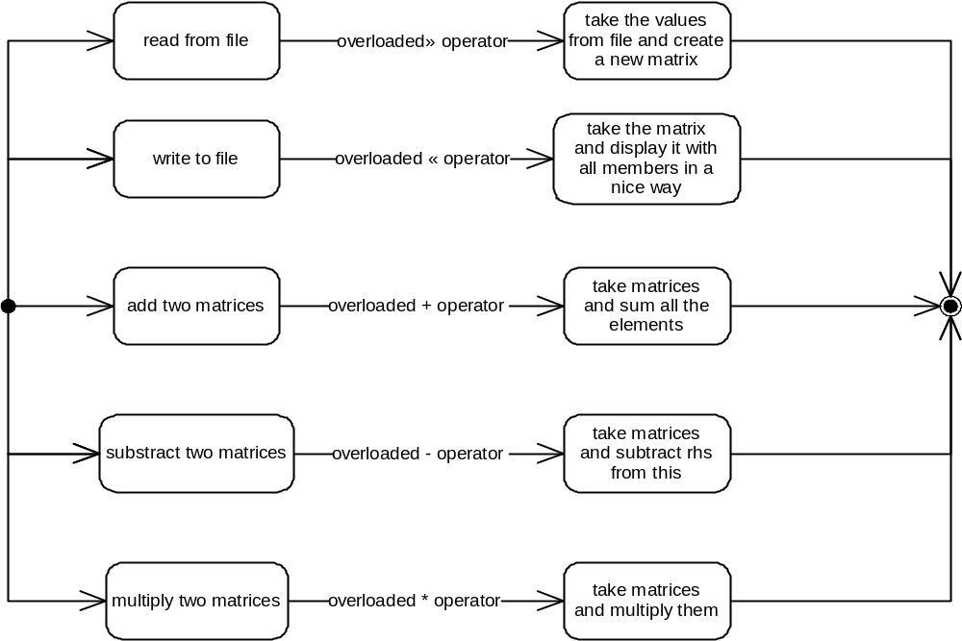

Class <Mnode>

4.2.X | Class Name
 | 4.2.X.1 | Class decomposition
 |  |  | Inherited classes: None
 |  |  | Aggregated classes: None
 |  |  | Associated classes: None
Data members:
bool head: Head node indicator.
Mnode *down: Points to the node in the next row.
Mnode *right: Points to the node in the next column.
union
{
Mnode *next: for head nodes, points to the next head node
triple tri: For MainHead and normal nodes, includes row, column and value specifications.
}
Member functions:
Mnode(bool h, triple& tr): constructor
 | 4.2.X.2 | Function Decomposition
 |  |  | Function Name: Mnode
 |  |  | Return Type: None
 |  |  | Input parameter: bool h, triple &tr
 |  |  | Output parameter: none
 |  |  | Files accessed: none
 |  |  | Files changed: none
 |  |  | Caller: SparseMatrix operator +, -, * and istream& operator >>
 |  |  | Pre: -
 |  |  | Post: Mnode class is constructed.
 |  |  | Algorithm (Description in pseudo-code): Set head to h. Point down and right to itself. If node is head, set next to itself; else set tri to tr.
 | 4.2.X.3 | Statechart  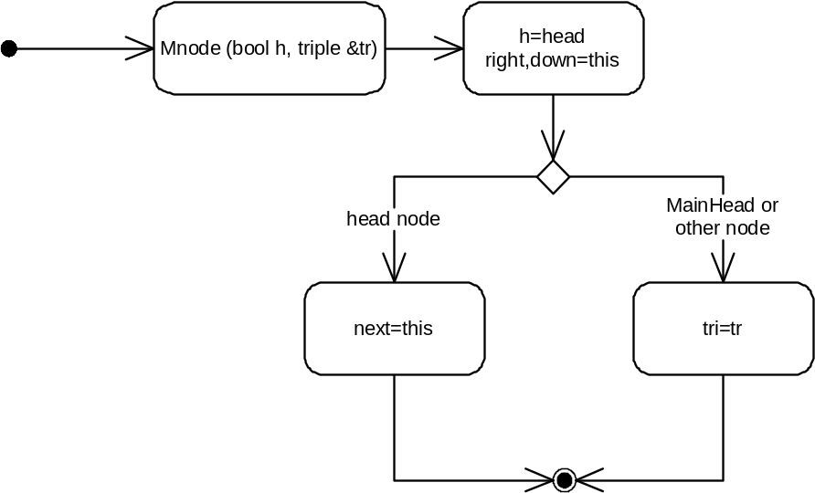

Global Functions

operator >>
Function Name: operator >>
Return Type: istream&
Input parameter: istream& file
Output parameter: SparseMatrix& Matrix
Files accessed: File pointed with istream&
Files changed: none
Caller: main()
Pre: -
Post: SparseMatrix is taken and non-zero elements are linked with each other.
Algorithm (Description in pseudo-code): First, take the matrix sizes and non-zero elements. After that, create head nodes as much as the row number of the matrix and link them (Since we are working with square matrices, row number or column number is not important when creating head nodes.). Then take a new element, i.e. triple value and create a new node with that value. First, find the column to add the new node, which is given as triple’s column value. Go to the head node of this column. Now, we must find the correct place to add and link the new node. While next element’s down link is not pointing to the head node or next element’s row number is smaller than new node’s row number, go down. After this operation, we will be in the place to add the new node. Link the new node to this place. Now, we did the column linking. Do the same operation for row linking. Do these operations until taking all of the non-zero elements, whose number is specified in the data of MainHead.
Statechart
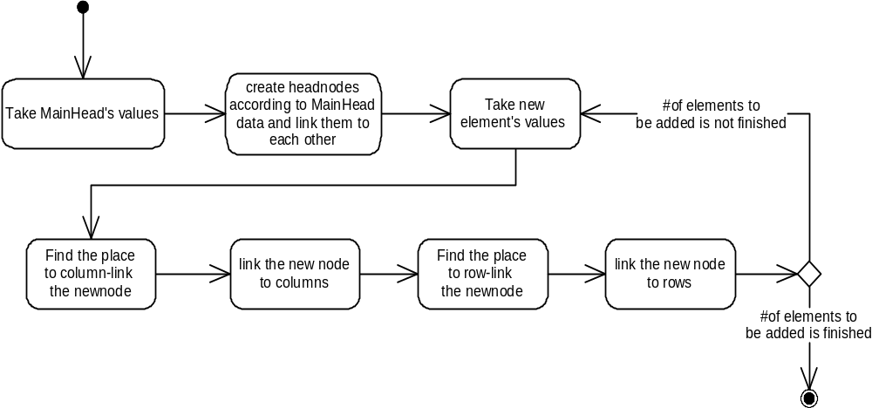

operator <<
Function Name: operator <<
Return Type: ostream&
Input parameter: ostream& file, SparseMatrix& Matrix
Output parameter: None
Files accessed: File pointed with ostream&
Files changed: File pointed with ostream&
Caller: main()
Pre: -
Post: SparseMatrix is written to the place specified with ostream& file.
Algorithm (Description in pseudo-code): Start from the first head node. Go to the first element, look at its column, print column-lastprintedcolumn (which is at first 0) times 0. Set lastprintedcolumn to column. Go to the right element. Do it until you reach the head node. Do these operations until you come to MainHead.
Statechart
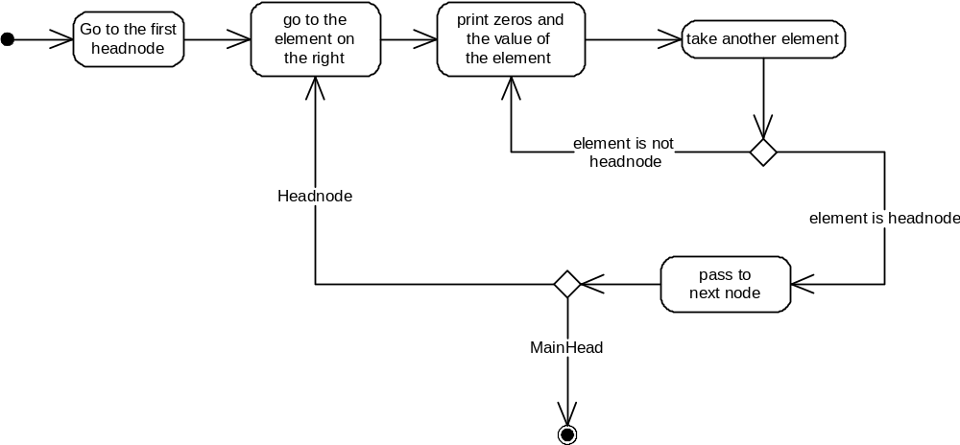

Flow Diagram
