<Sparse Matrices>
Design Document
Version <1.1>

INSTRUCTOR | LEVENT AKIN
STUDENT | EMİN ŞENAY
STUDENT ID | 2002103907
YEAR | 2004/2nd TERM

Revision History
Date | Version | Description | Author
<13/05/2004> | <1.0> | <Main SDD> | <Emin Şenay>
<23/05/2004> | <1.1> | <Some Corrections and patches> | <Emin Şenay>

Table of Contents
1. Introduction 4
2. Software Interface Design Error! Bookmark not defined.
3. Internal Module Design 4
3.1 Class Diagram 4
3.2 Class Descriptions 4
3.2.1 Class <SparseMatrix> 4
3.2.2 Class <Mnode> 5
3.2.3 Global Functions 5
3.2.3.1 operator >> 5
3.2.3.2 operator << 5
4. Flow Diagram 6

Design Document

Introduction

This SDD update is written because I added some functions to some of the classes. Moreover, because of the small misunderstanding about the output file, the operator >> algorithm has changed. Update only contains changed parts of the document.

Software Interface Design

Internal Module Design

Class Diagram

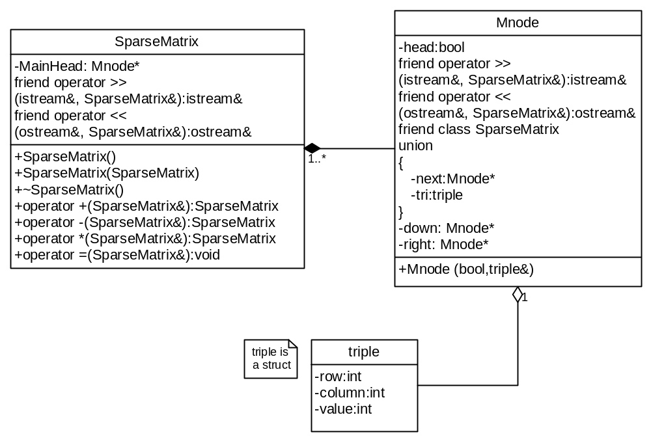

Class Descriptions

Class <SparseMatrix>

3.2.1 |  |  | SparseMatrix
 |  | 3.2.1.1 |  |  | Class decomposition
 |  |  |  |  |  | Inherited classes: None
 |  |  |  |  |  | Aggregated classes: Mnode
 |  |  |  |  |  | Associated classes: None
Data members:
Mnode* MainHead: Will point to the main head node
Member functions:
SparseMatrix():Default constructor
SparseMatrix(SparseMatrix& rhs): Copy constructor
~SparseMatrix(): Destructor
SparseMatrix operator + (SparseMatrix& rhs): + operator overload
SparseMatrix operator - (SparseMatrix& rhs): - operator overload
SparseMatrix operator * (SparseMatrix& rhs): * operator overload
void operator = (SparseMatrix& rhs): = operator overload
 |  | 3.2.1.2 |  |  | Function Decomposition
 |  |  |  |  |  | Function Name: SparseMatrix
 |  |  |  |  |  | Return Type: None
 |  |  |  |  |  | Input parameter: None
 |  |  |  |  |  | Output parameter: None
 |  |  |  |  |  | Files accessed: None
 |  |  |  |  |  | Files changed: None
 |  |  |  |  |  | Caller: -
 |  |  |  |  |  | Pre: -
 |  |  |  |  |  | Post: The class is constructed.
 |  |  |  |  |  | Algorithm (Description in pseudo-code): Set MainHead to NULL.
 |  |  |  |  |  | Function Name: operator =
 |  |  |  |  |  | Return Type: void
 |  |  |  |  |  | Input parameter: SparseMatrix& rhs
 |  |  |  |  |  | Output parameter: None
 |  |  |  |  |  | Files accessed: None
 |  |  |  |  |  | Files changed: None
 |  |  |  |  |  | Caller: main()
 |  |  |  |  |  | Pre: SparseMatrix in the lhs must be empty and SparseMatrices in rhs must be initialized.
 |  |  |  |  |  | Post: SparseMatrix in the lhs is set to the SparseMatrix in the rhs.
 |  |  |  |  |  | Algorithm (Description in pseudo-code): Starting with first head node, copy all elements until you reach the head node. Then pass the head node’s next. Do these operations until you reach the MainHead. Return this (pointer this).

Class <Mnode>

Global Functions

operator >>

operator <<
Function Name: operator <<
Return Type: ostream&
Input parameter: ostream& file, SparseMatrix& Matrix
Output parameter: None
Files accessed: File pointed with ostream&
Files changed: File pointed with ostream&
Caller: main()
Pre: -
Post: SparseMatrix is written to the place specified with ostream& file.
Algorithm (Description in pseudo-code): First, print the number of rows, columns and the number of non-zero elements. Then, print first row until you reach the head node, then second row, then third… until you reach the MainHead.
Statechart
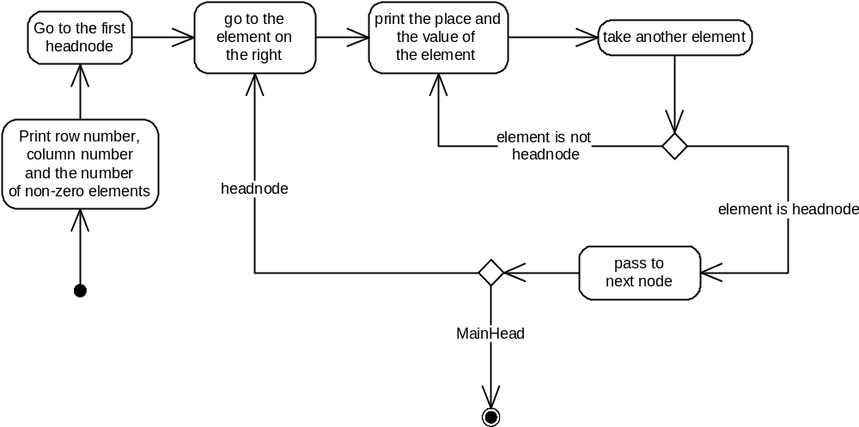

Flow diagram

