Celebration Ogranization Application
Kreirat ćemo aplikaciju koja će posjedovati :
- Login
- Register
- Dashboard – korisnici kada se loguju će imati prikazan svoj dashboard
- Logout
- Nivoe pristupa: različit dashboard u zavisnosti od prava
Imat ćemo nekoliko PRIVILEGIJA pristupa, a samim tim I nivoa pristupa:
- client
- managera
- administratora
Aplikacije će imati INTERNO RAZVIJEN User Management Access.

Poraditi na HTML/CSS

Tehnologije
- HTML/CSS, JavaScript
- Servlet, JSP
- Jakarta EE - EJB
  - Session Bean
    - stateless
    - stateful
  - MDB – out of scope
- Hibernate/EclipseLink + JPA
- MySQL

DB Design
MySQL relaciona baza sa tabelama:
- users
- privilege
- country
- town
- address
- celebration
- celebration_cost
- service_type
- quantity_unit
- discount_rule

Postavke konekcije: GlassFish + MySQL
Konfigurisati Connection Pool
Zaključak
- Nećemo praviti mi vlastiti connection pool
- Konfigurisat ćemo GlassFish da kreira pool: celebrationPool
- JNDI link na Connection Pool: jdbc/celebrations
- EntityManager -> persistence.xml -> JNDI name :
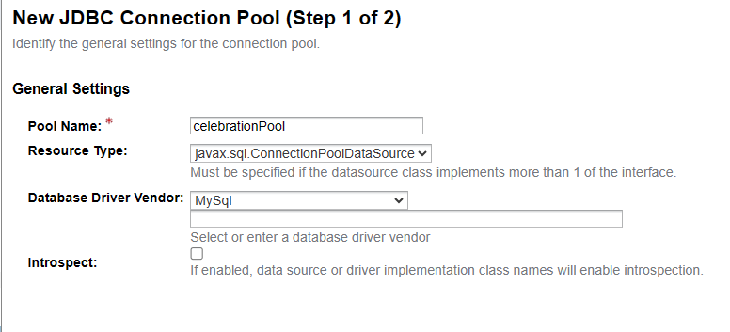

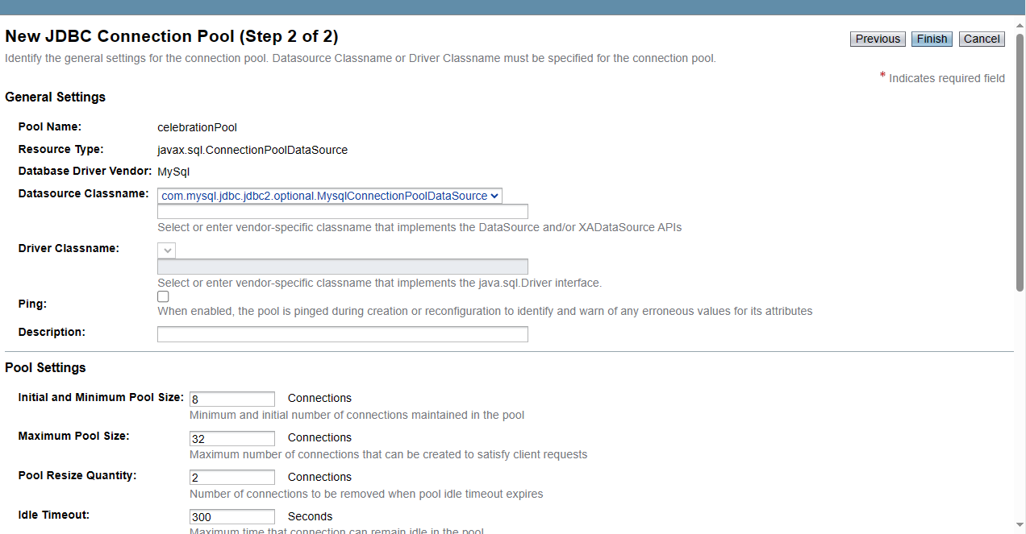
Gore iznad je pogrešan Datasource Classname. Ispravan je : com.mysql.cj.jdbc.MysqlDataSource
MySQL Bugs: #91068: Problems with Connector/J 8.0 in GlassFish

JNDI JDBC Resources -> Connection Pool : jdbc/celebrations
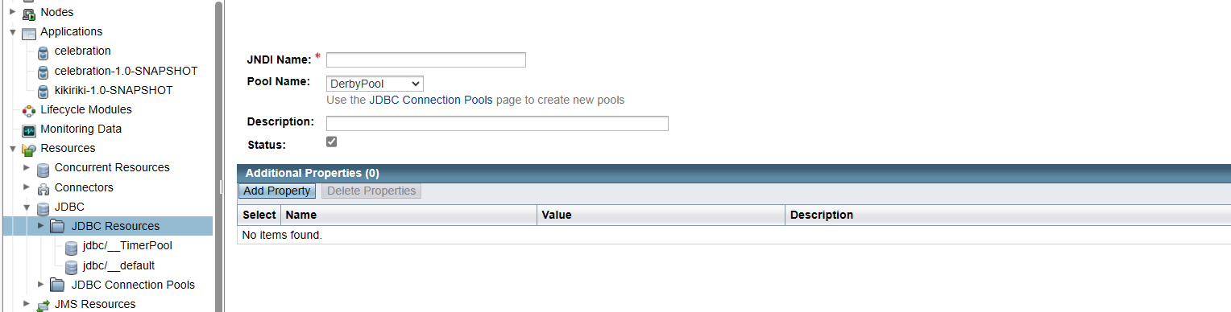

TEST: ping iz GlassFish GUI

Postavke Tehnologija Web Aplikacije
Tehnologije:
- html + css + JavaScript
- servlet
- CDI ili DI Jakarta EE : EJB
- ORM : JPA + Hibernate
- MySQL
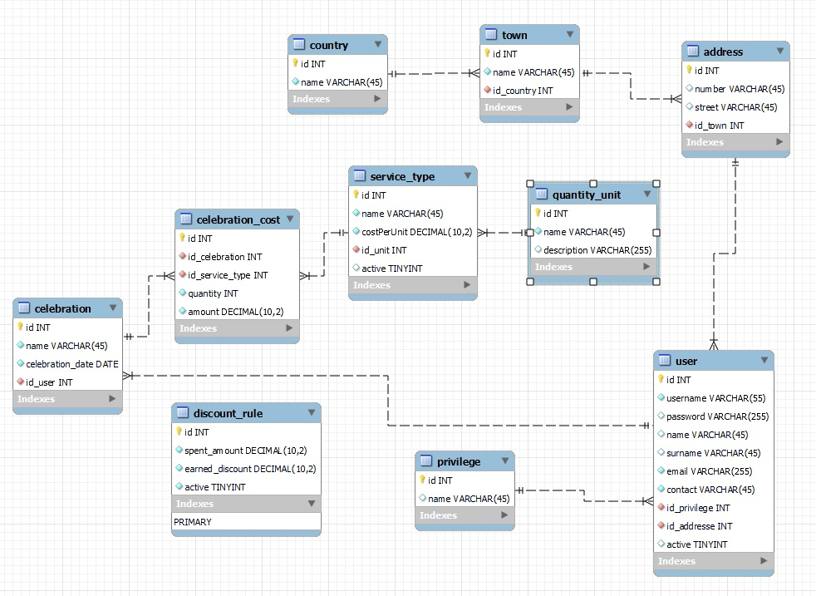

Jakarta EE ( kao zamjena je nastao Spring)
Enterprise Java Bean:
- SessionBean
  - Local
  - Remote(njih zamijenili REST, SOAP)
- MDB(Message Driven Bean)
Set dependecies koji funkcionišu sa Glassfissh 7.0.13
<dependencies>
<!-- Jakarta EE API -->
<dependency>
<groupId>jakarta.platform</groupId>
<artifactId>jakarta.jakartaee-api</artifactId>
<version>10.0.0</version>
<scope>provided</scope>
</dependency>
<!-- CDI API -->
<dependency>
<groupId>jakarta.enterprise</groupId>
<artifactId>jakarta.enterprise.cdi-api</artifactId>
<version>4.0.1</version>
<scope>provided</scope>
</dependency>
<!-- EJB API -->
<dependency>
<groupId>jakarta.ejb</groupId>
<artifactId>jakarta.ejb-api</artifactId>
<version>4.0.1</version>
<scope>provided</scope>
</dependency>
<!-- Servlet API -->
<dependency>
<groupId>jakarta.servlet</groupId>
<artifactId>jakarta.servlet-api</artifactId>
<version>6.0.0</version>
<scope>provided</scope>
</dependency>
<!-- JAX-WS API -->
<dependency>
<groupId>jakarta.xml.ws</groupId>
<artifactId>jakarta.xml.ws-api</artifactId>
<version>3.0.1</version>
<scope>provided</scope>
</dependency>
<!-- Hibernate -->
<dependency>
<groupId>org.hibernate</groupId>
<artifactId>hibernate-core-jakarta</artifactId>
<version>5.6.15.Final</version>
</dependency>

Problem koji smo imali:
@Inject
private ServiceTypeServiceLocal serviceTypeService;

EJB
Podjela:
- Stateless @Stateless
- Stateful
Podjela:
- local @Local
- remote(X)

