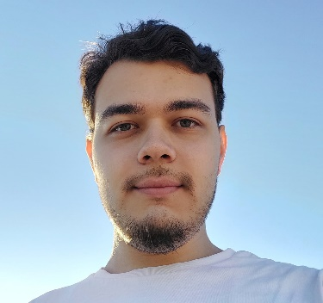**Şahin Özsoy**

Mobile: + 90 552 789 60 24

E-mail: sahinozsoy46@gmail.com

Date Of Birth: 11.10.2003

github.com/Sharcano

Ankara, Turkey

**EDUCATION**

**Cankaya University 2022(August) – Cont.**

Major: Department of Software Engineering

*Cumulative GPA: 3.06*

**Özel Ankara Çağlayan Anadolu Lisesi**

Mathematics & Science

*High School Diploma: 98.8 (The first position in the most successful students list according to High School Diploma)*

# PROJECTS

**Course Scheduling System for Cankaya University 02.10.2024 – Cont.**

I developed a system to efficiently schedule courses by optimizing classroom, instructor, and time slot allocation, ensuring conflict-free and streamlined course management.

# FOREIGN LANGUAGES

* English: C1
* German A2

# SOFTWARE DEVELOPMENT SKILLS

* JAVA Language is at advanced level.
* C and C++ Language are at medium level.
* Office Programs (Excel, Word, Power Point, Access), CoLab Google, LucidChart are at basic level.

**INTERESTS**

* Software, Economy, Cyber Security, playing Chess, playing Table Tennis, reading Books.