PROJE RAPORU

# Proje Numarası : 2

# Projeyi Yapan : Emir Baran Özkaptan

# Numarası : 1112706040

# Sonlu Durum Makinesi Çizimi

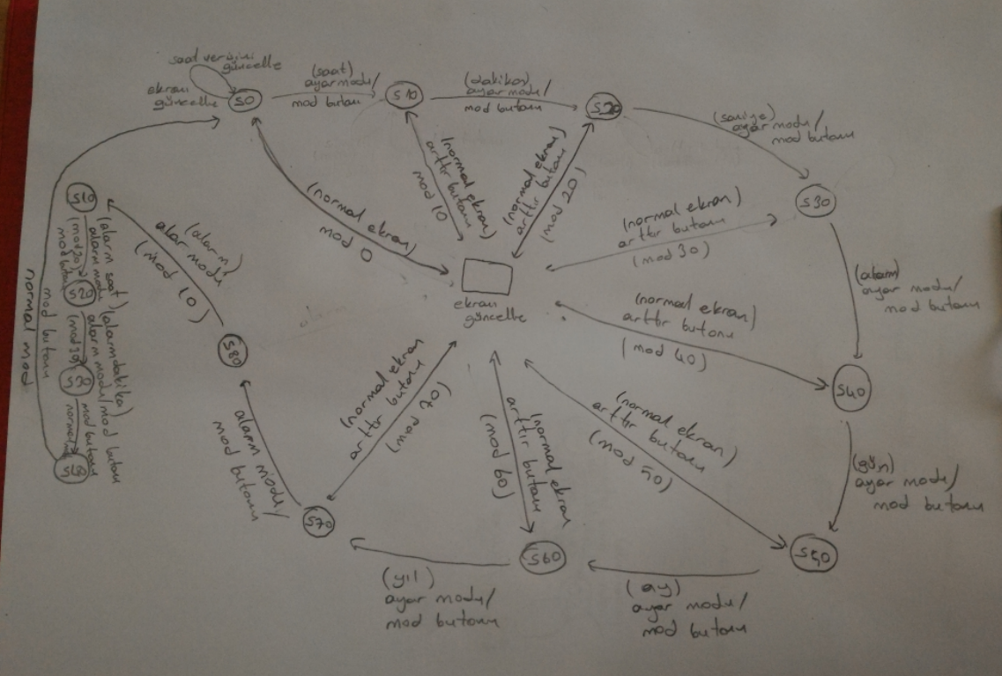

# Devre Şeması

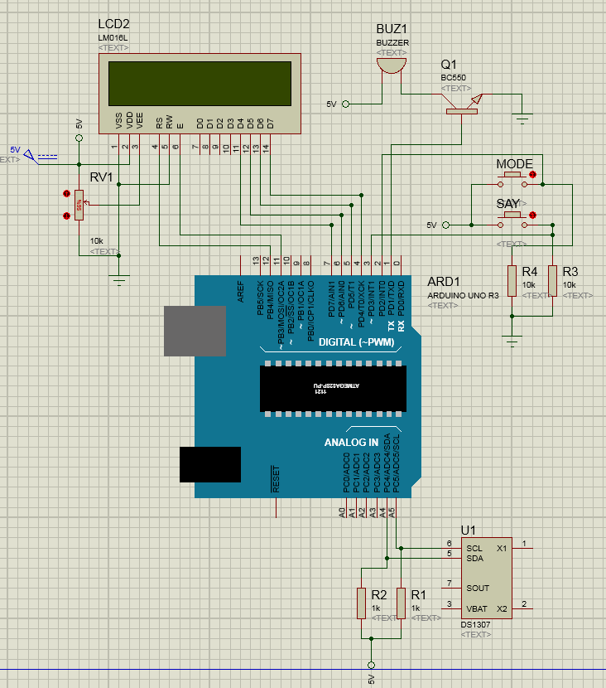

# Kodlar

#include <LiquidCrystal.h>

#include <Wire.h>

#include "RTClib.h"

DateTime simdi;

RTC_DS1307 rtc;

LiquidCrystal lcd(12, 11, 7, 6, 5, 4);

long simdikizaman=millis();

long eskizaman=millis();

long lcd_eskizaman=millis();

long cursor_eskizaman=millis();

long debounce_sure = 100;

volatile unsigned long onceki_micros;

byte st=0,dk=0,sn=0,gn=0,ay=0;int yil=0;

byte a_st=0,a_dk;

char alarm = 'K';

int mode=0;

int ekran=0;

void setup() {

pinMode(2,INPUT);

pinMode(3,INPUT);

pinMode(1,OUTPUT);

rtc.begin();

attachInterrupt(0, Mode_Buton, FALLING);

lcd.begin(16, 2);

lcd.noCursor();

}

void ekran_yaz(){

if(simdikizaman-lcd_eskizaman>100){

if(ekran==0){

//lcd.clear();

lcd.setCursor(4,0);

if(st<10) lcd.print("0");

lcd.print(st,DEC);

lcd.print(":");

if(dk<10) lcd.print("0");

lcd.print(dk,DEC);

lcd.print(":");

if(sn<10) lcd.print("0");

lcd.print(sn,DEC);

lcd.setCursor(13,0);

lcd.print("(");

lcd.print(alarm);

lcd.print(")");

lcd.setCursor(3,1);

if(gn<10) lcd.print("0");

lcd.print(gn,DEC);

lcd.print("/");

if(ay<10) lcd.print("0");

lcd.print(ay,DEC);

lcd.print("/");

lcd.print(yil,DEC);

lcd_eskizaman=simdikizaman;

}else{

lcd.clear();

lcd.setCursor(6,0);

lcd.print("(");

lcd.print(alarm);

lcd.print(")");

lcd.setCursor(5,1);

if(a_st<10) lcd.print("0");

lcd.print(a_st,DEC);

lcd.print(":");

if(a_dk<10)lcd.print("0");

lcd.print(a_dk,DEC);

lcd_eskizaman=simdikizaman;

}

}

}

void loop() {

simdikizaman=millis();

if(ekran==0){

switch(mode){

case 0:

simdi = rtc.now();

lcd.noCursor();

st= simdi.hour();

dk = simdi.minute();

sn = simdi.second();

gn = simdi.day();

ay = simdi.month();

yil= simdi.year();

ekran_yaz();

break;

case 10:

cursor_blink(5,0);//saat

rtc.adjust(DateTime(yil,ay,gn,st,dk,sn));

break;

case 20:

cursor_blink(8,0);

rtc.adjust(DateTime(yil,ay,gn,st,dk,sn));

break;

case 30:

cursor_blink(11,0);

rtc.adjust(DateTime(yil,ay,gn,st,dk,sn));

break;

case 40:

cursor_blink(14,0);

rtc.adjust(DateTime(yil,ay,gn,st,dk,sn));

break;

case 50:

cursor_blink(4,1);

rtc.adjust(DateTime(yil,ay,gn,st,dk,sn));

break;

case 60:

cursor_blink(7,1);

rtc.adjust(DateTime(yil,ay,gn,st,dk,sn));

break;

case 70:

cursor_blink(12,1);

rtc.adjust(DateTime(yil,ay,gn,st,dk,sn));

break;

case 80:

ekran=1;

mode=10;

ekran_yaz();

break;

}

}else{

switch(mode){

case 10:

cursor_blink(7,0);

break;

case 20:

cursor_blink(6,1);

break;

case 30:

cursor_blink(9,1);

break;

case 40:

ekran=0;

mode=0;

break;

}

}

if(digitalRead(3)==HIGH){

delay(50);

if((simdikizaman-eskizaman>200) & digitalRead(3)==HIGH){

Say_Buton();

eskizaman=simdikizaman;

}

}

if(alarm=='A'){

if(a_st == st & a_dk==dk){

digitalWrite(1,HIGH);

}else{

digitalWrite(1,LOW);

}

}else{

digitalWrite(1,LOW);

}

}

void cursor_blink(byte sutun,byte satir){

if(simdikizaman-cursor_eskizaman >=0 & simdikizaman-cursor_eskizaman <100){

lcd.cursor();

lcd.setCursor(sutun,satir);

}else if(simdikizaman-cursor_eskizaman >=100 & simdikizaman-cursor_eskizaman <=200){

lcd.noCursor();

}else{

cursor_eskizaman = simdikizaman;

}

}

void Mode_Buton(){

if((long)(micros() - onceki_micros) >= debounce_sure * 1000) {

mode+=10;

if(mode==90)mode=0;

onceki_micros = micros();

}

}

void Say_Buton(){

if(ekran==0){

switch(mode){

case 10:

st++;

if(st==24)st=0;

break;

case 20:

dk++;

if(dk==60)dk=0;

break;

case 30:

sn++;

if(sn==60)sn=0;

break;

case 40:

if(alarm=='K')alarm='A';

else alarm='K';

break;

case 50:

gn++;

if(gn==32)gn=1;

break;

case 60:

ay++;

if(ay==13)ay=1;

break;

case 70:

yil++;

if(yil==2100)yil=1970;

break;

}

}else{

switch(mode){

case 10:

if(alarm=='K')alarm='A';

else alarm='K';

break;

case 20:

a_st++;

if(a_st==24)a_st=0;

break;

case 30:

a_dk++;

if(a_dk==60)a_dk=0;

break;

}

}

ekran_yaz();

}