Komently AI Service — Project Summary
Author: Emircan Gezer Date: May 2026

1. What Is Komently?
Komently is an AI-powered comment moderation SaaS. Website owners embed a comment section on their site; Komently’s AI service evaluates every incoming comment in real time and decides whether to approve, flag, shadow-hide, or reject it. Section owners manage their community through a dashboard that lets them configure rules, chat with an AI copilot, and receive weekly analytics reports.
The AI service is a FastAPI application backed by three agentic frameworks — each with a distinct, non-overlapping responsibility.
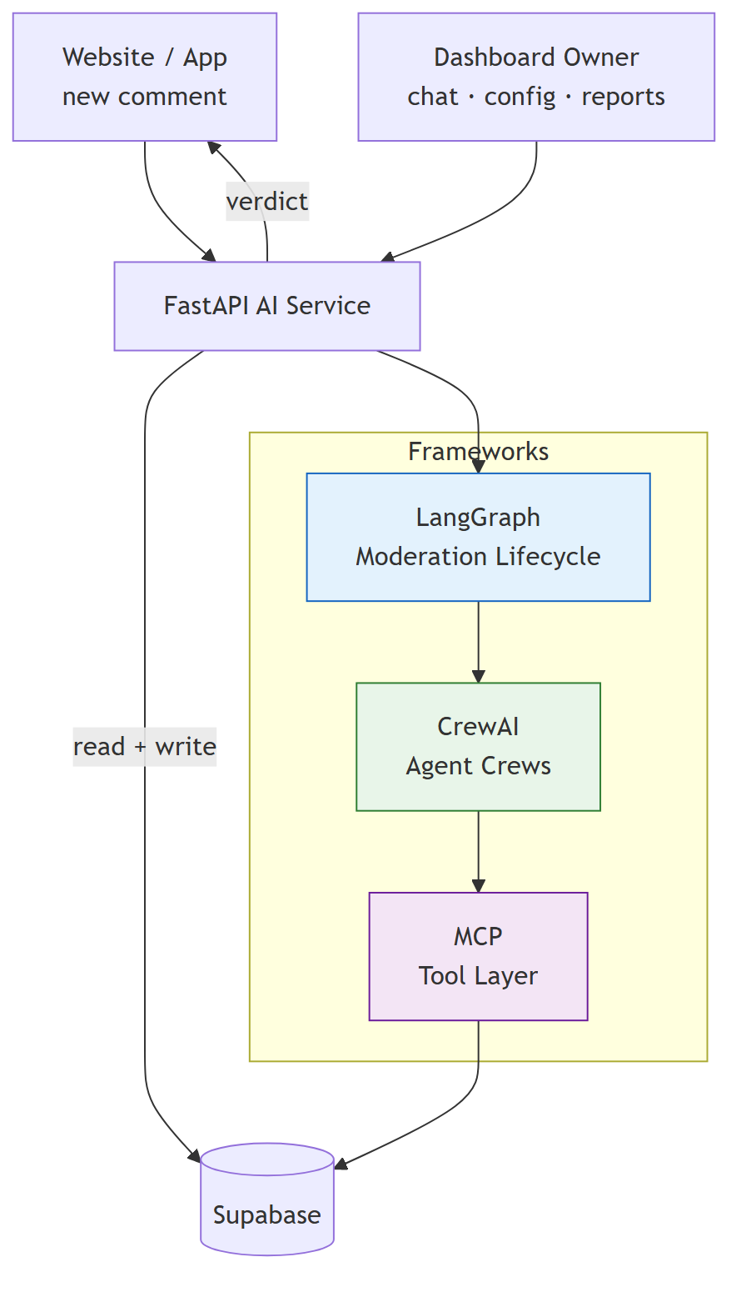

2. API Endpoints
Four endpoints. Each has a distinct owner in the framework stack.
Endpoint | Trigger | Returns
POST /moderate | Every new comment | Moderation verdict JSON
POST /chat | Dashboard owner message | Reply + list of actions taken
POST /generate-report | Internal trigger from trigger_intel_report | 202 Accepted — report saved async
PATCH /moderate/{thread_id}/resume | Moderator human decision | Final verdict after human review

3. Endpoint Deep-Dives

3.1 POST /moderate
Runs the full stateful moderation lifecycle via LangGraph. Every comment travels through confidence-based routing, optional retries, optional deep review, and optional human escalation before a final verdict is written.
Request:
{
"comment_id": "uuid",
"section_id": "uuid",
"body": "comment text",
"parent_id": "uuid | null"
}
Response (ModerationVerdict):
{
"status": "approved | flagged | rejected | shadow_hidden",
"action": "approved | flagged | rejected | shadow_hidden",
"toxicity_score": 0.0,
"is_spam": false,
"reason": "brief explanation",
"metadata": { "sentiment_score": 0.0, "confidence": 1.0 }
}
Flow:
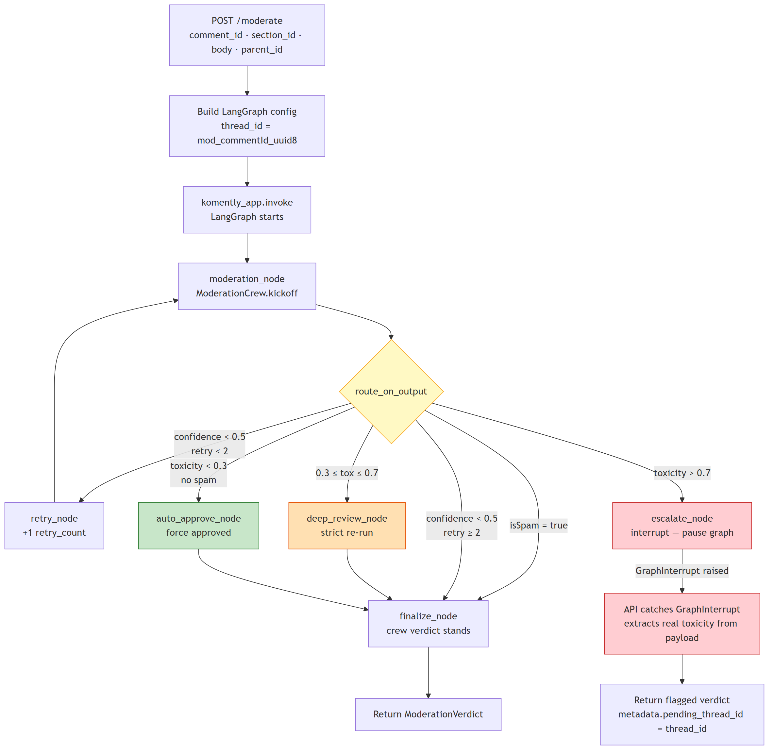
Error handling: - GraphInterrupt → returns flagged + pending_thread_id for human review - Any other exception → fail-safe approved response (never silently blocks users) - Empty/unparseable crew output → finalize_node falls back to crew_output, then to a safe flagged default

3.2 PATCH /moderate/{thread_id}/resume
Resumes a graph that was paused at escalate_node after a human moderator reviews the comment in the dashboard.
Request:
{ "status": "approved | rejected | flagged" }
Response: Same ModerationVerdict shape with metadata.resumed_by_human = true.
Flow:
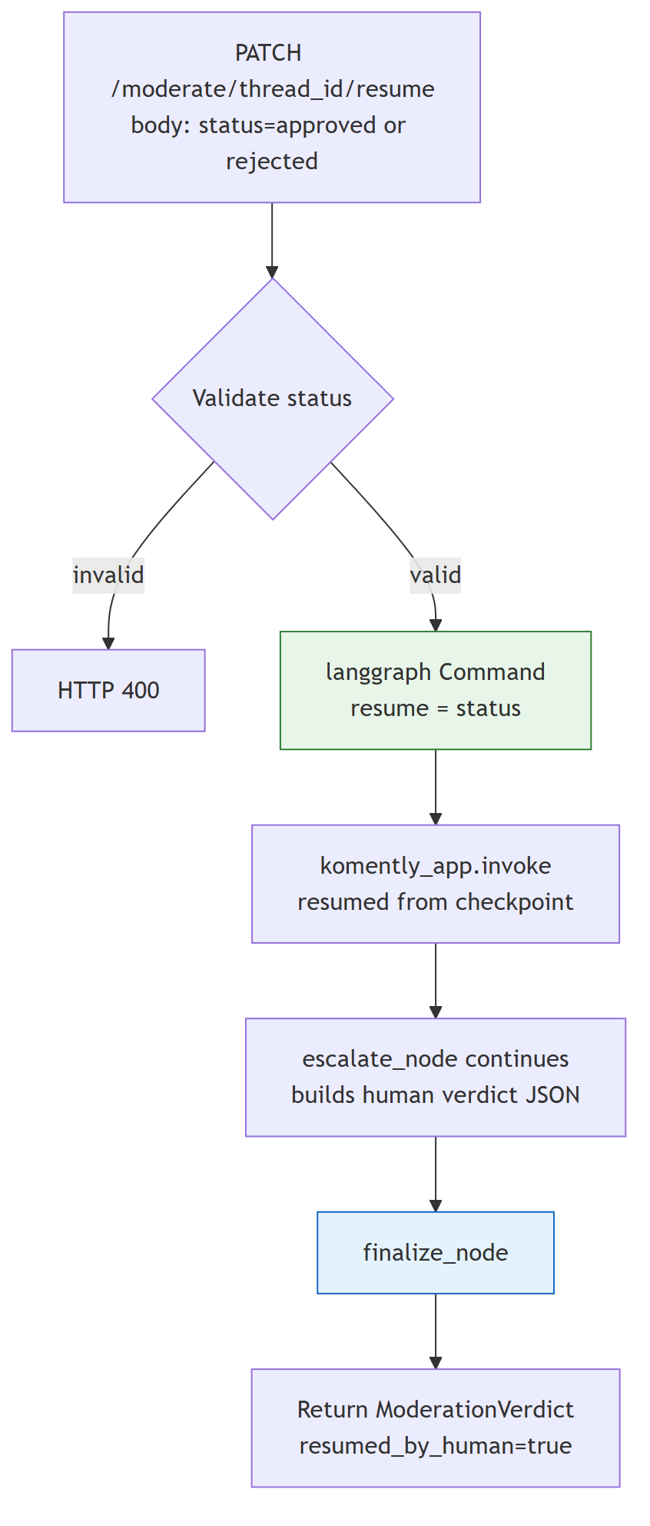

3.3 POST /chat
Dashboard chat. Calls ChatCrew directly — no LangGraph overhead needed for a single conversational pass. Before kicking off the crew, the API calls fetch_section_settings from mcp_server.py directly so the agent can answer configuration questions instantly without spending a tool call of its own.
Request:
{
"section_id": "uuid",
"message": "user message",
"history": [{ "role": "user", "content": "..." }]
}
Response:
{
"reply": "agent reply text",
"actions_taken": ["Updated toxicity threshold to 0.7", "..."]
}
Flow:
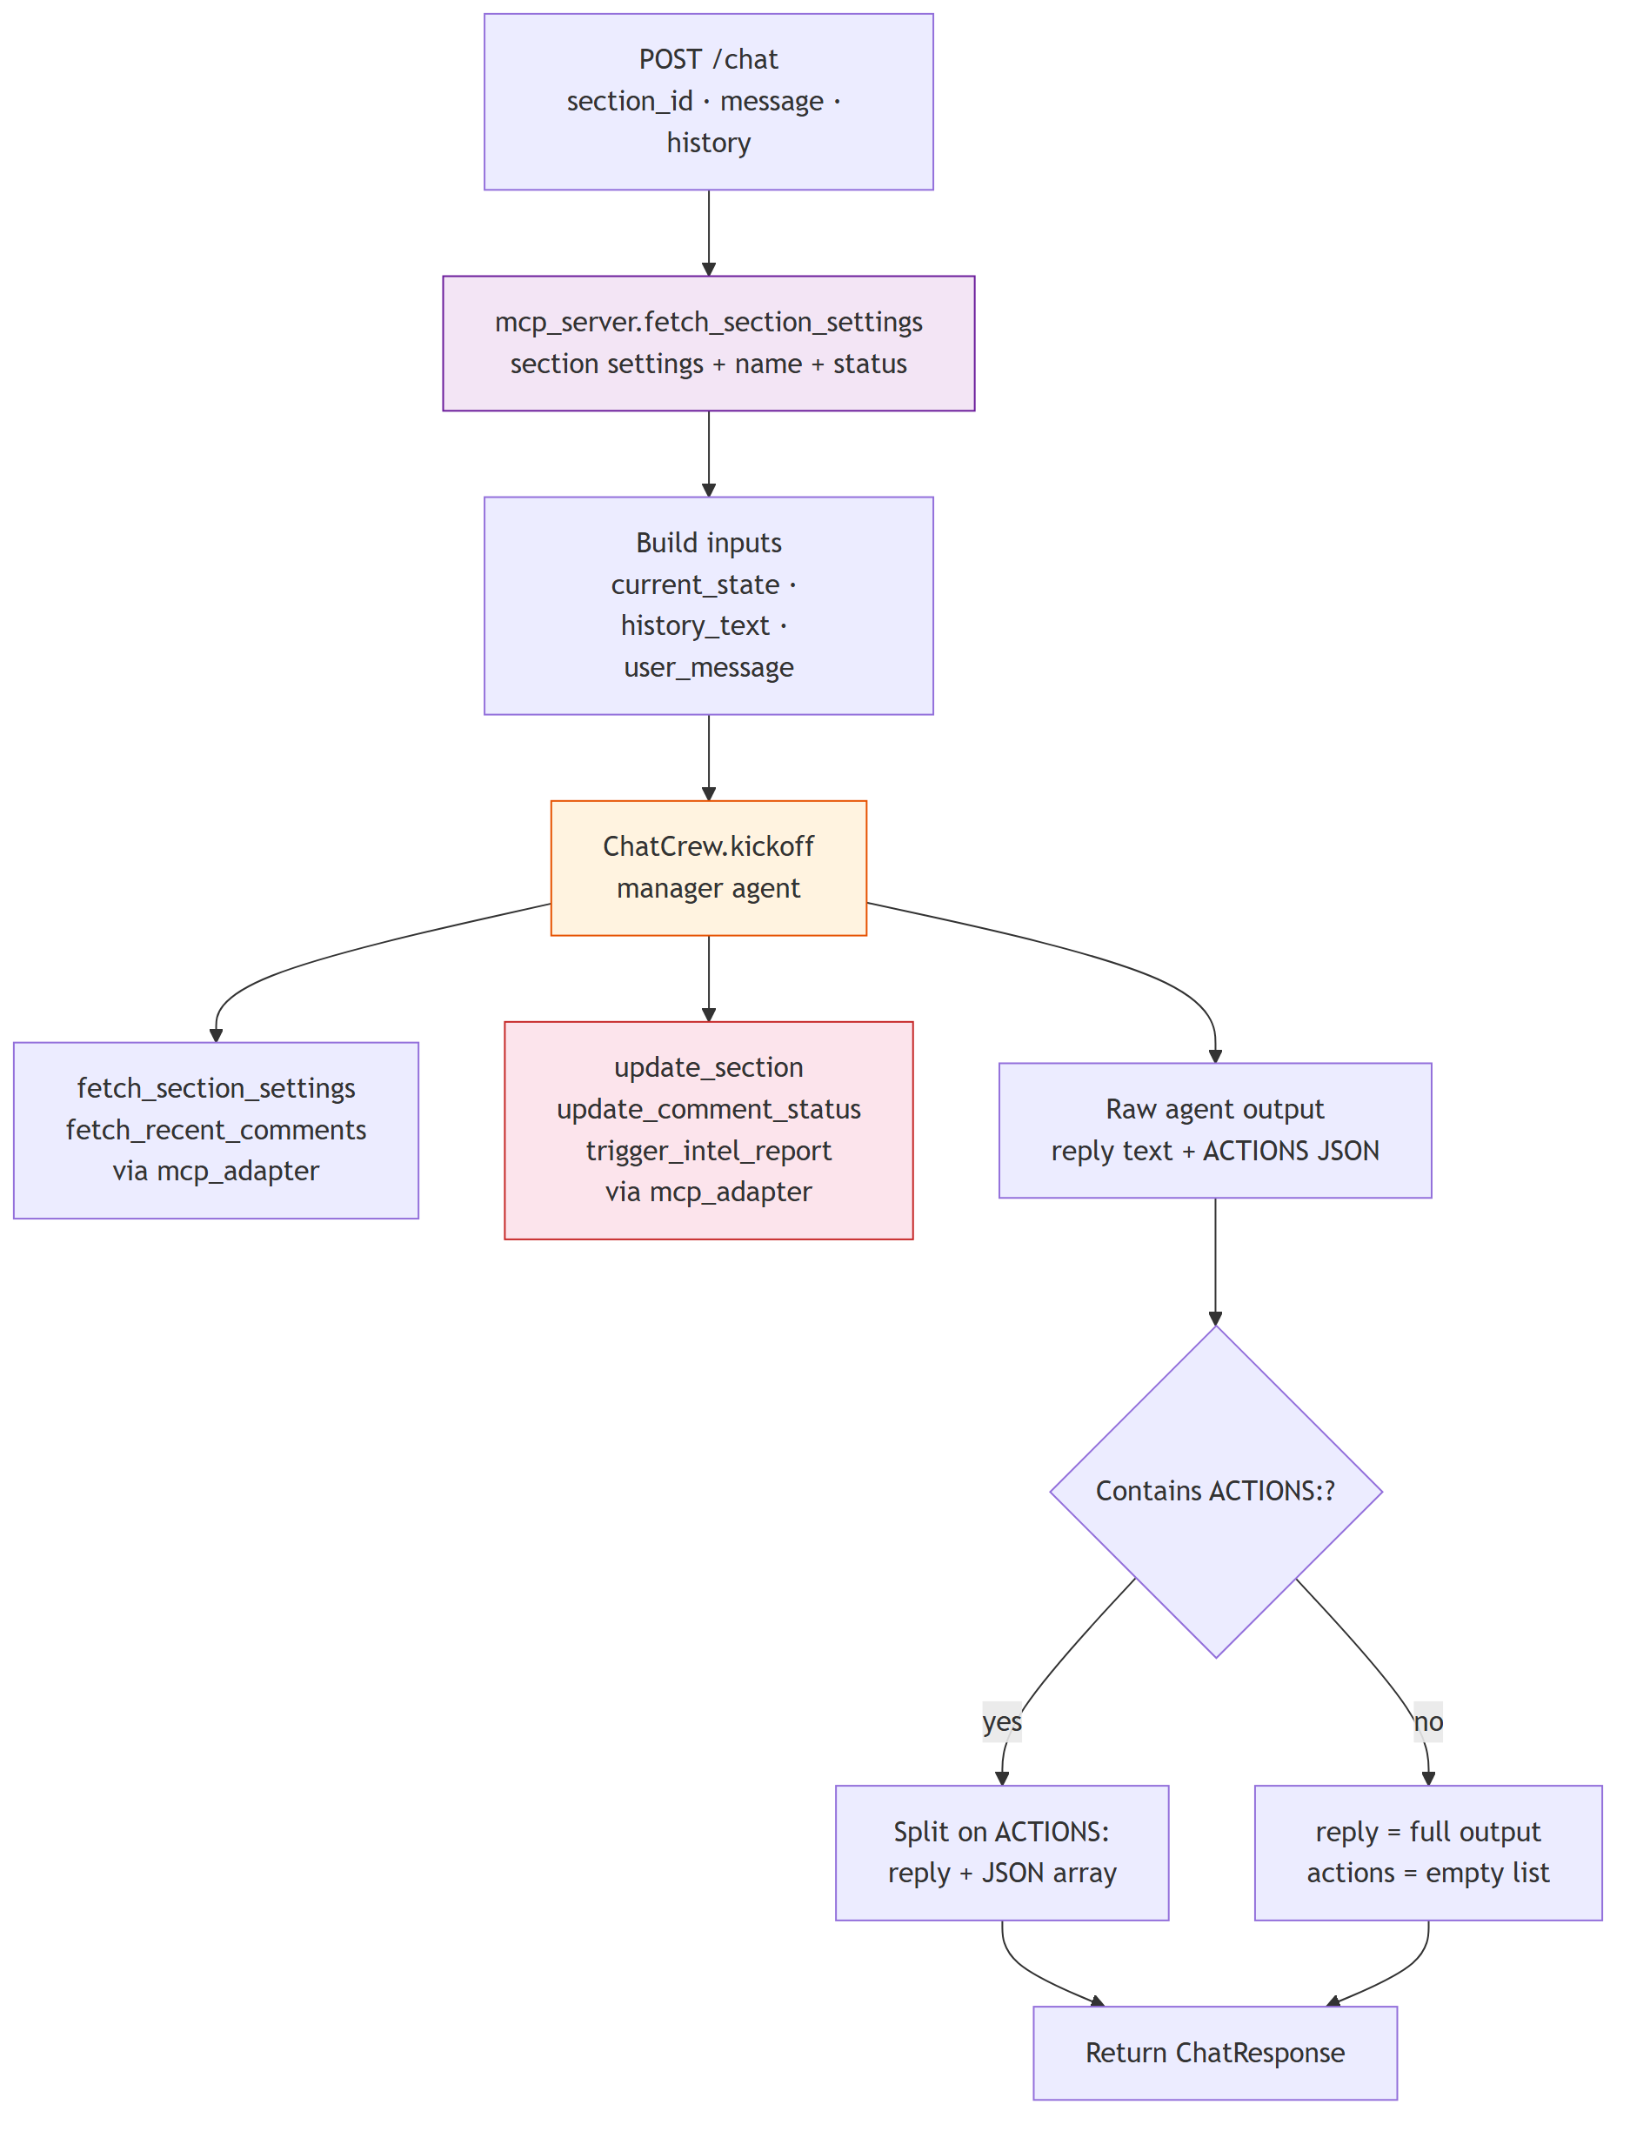

3.4 POST /generate-report
Internal endpoint called by trigger_intel_report (MCP tool). Runs AnalystCrew as a FastAPI BackgroundTask and returns 202 immediately. The crew fetches 7 days of analytics, reads top comments, writes a Markdown report to the database, and marks the row completed.
Request:
{ "section_id": "uuid", "report_id": "uuid" }
Response: { "status": "processing", "report_id": "uuid" } (202)
Flow:
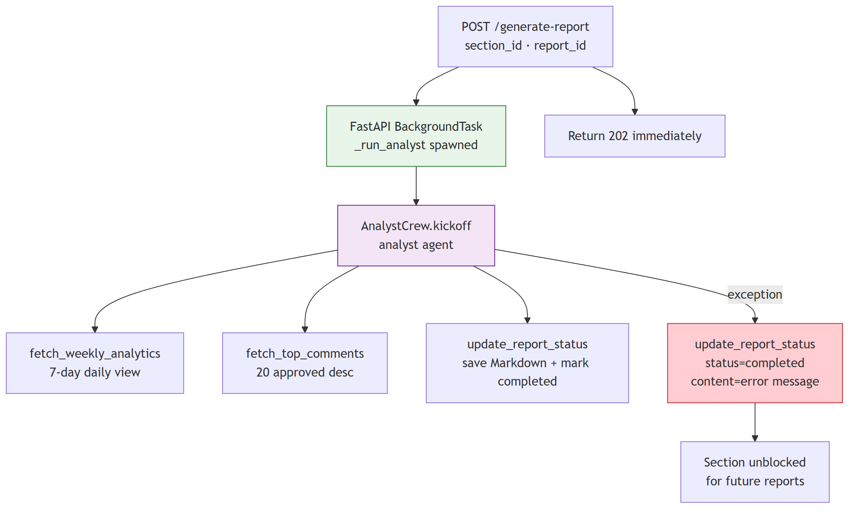
Why no LangGraph here? Report generation is a linear single-pass job: fetch → analyse → write. There’s no branching, no retry logic, no human escalation. A direct BackgroundTask call is simpler and faster.

4. MCP — The Tool Layer
MCP (tools/mcp_server.py) is the single source of truth for every database operation in the service. Every tool is defined here as a @mcp.tool() decorated plain Python function. Nothing bypasses it — not the agents, not the API itself.
Three consumers, one tool layer:
- CrewAI agents — call MCP functions in-process through mcp_adapter.py
- main.py directly — calls fetch_section_settings and update_report_status as regular imports for pre-flight data fetching and error recovery
- External clients — the same FastMCP instance runs as an SSE server on port 8001, letting Claude Desktop, Cursor, or any MCP-compatible client discover and call all 9 tools
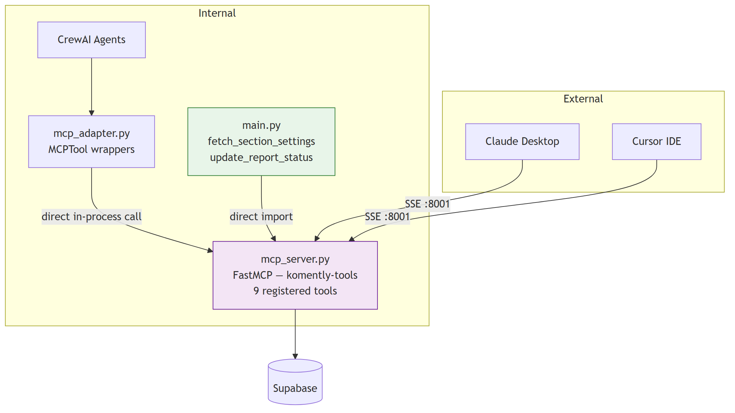

The 9 Tools
Tool | Operation | Table
fetch_section_settings | Read | comment_sections
fetch_recent_comments | Read | comments
update_comment_status | Write | comments
update_section | Write | comment_sections
fetch_parent_thread | Read | comments
trigger_intel_report | Insert + HTTP ping | section_reports
fetch_weekly_analytics | Read | section_analytics_daily
fetch_top_comments | Read | comments
update_report_status | Write | section_reports

The Adapter
mcp_adapter.py wraps each MCP tool as a CrewAI BaseTool instance. The MCPTool class looks up the function by name from a registry and calls it directly — no HTTP, no protocol overhead for internal calls.
class MCPTool(BaseTool):
mcp_tool_name: str
def _run(self, **kwargs) -> str:
return _TOOL_REGISTRY[self.mcp_tool_name](**kwargs)

5. CrewAI — The Agent Layer
Three crews are defined in crew.py. All tool access goes through mcp_adapter.py.

5.1 ModerationCrew
Hierarchical process. Three specialist agents each evaluate the comment independently; a Manager LLM synthesises their findings into a single JSON verdict. The task description embeds the comment text multiple times to ensure the Manager always includes it in every delegation — preventing agents from searching for the comment instead of evaluating the one given to them.
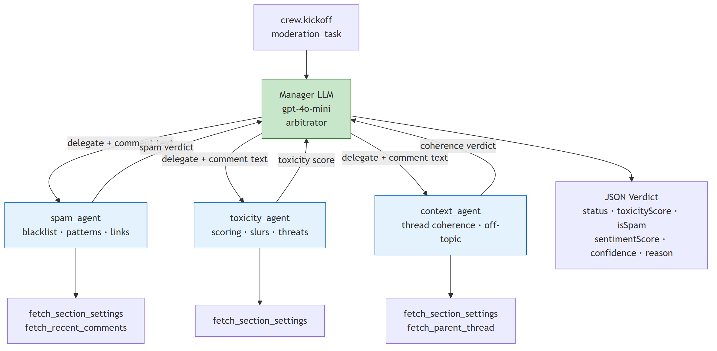
Output schema:
{
"status": "approved | flagged | rejected | shadow_hidden",
"action": "approved | flagged | rejected | shadow_hidden",
"toxicityScore": 0.0,
"isSpam": false,
"sentimentScore": 0.0,
"confidence": 1.0,
"reason": "brief explanation"
}

5.2 ChatCrew
A single manager agent with full read/write tool access. Called directly from main.py.
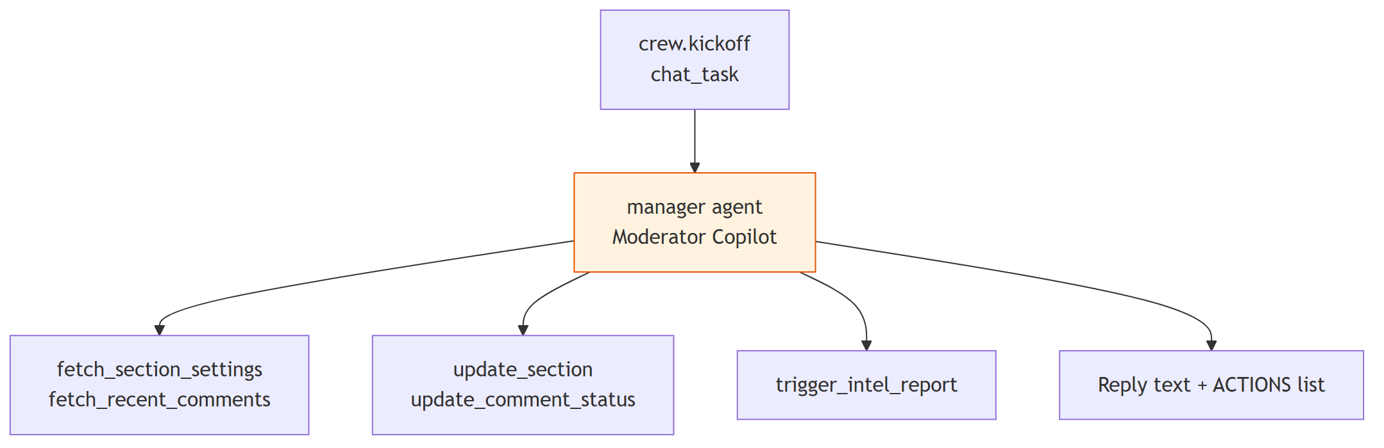

5.3 AnalystCrew
A single analyst agent that runs as a FastAPI BackgroundTask.
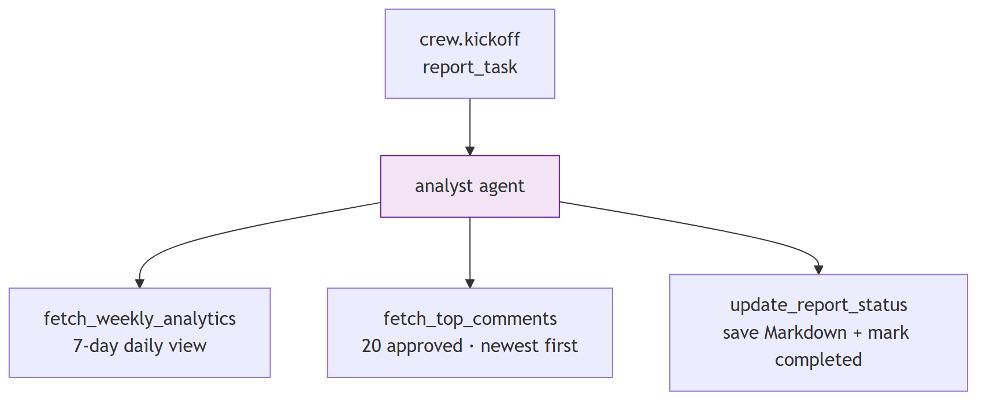

6. LangGraph — The Moderation Lifecycle
LangGraph manages the stateful lifecycle of a single comment. It is used exclusively for POST /moderate.

6.1 State
GraphState
├── input — comment body (from API)
├── section_id — section UUID (from API)
├── history — reserved for future multi-turn use
├── toxicity_score — written by moderation/deep_review nodes
├── confidence — written by moderation/deep_review nodes
├── retry_count — written by retry_node
├── escalation_reason— written by moderation_node
├── crew_output — final parsed JSON verdict
├── final_response — raw string output from crew
└── metadata — comment_id · parent_id · origin

6.2 Graph Topology
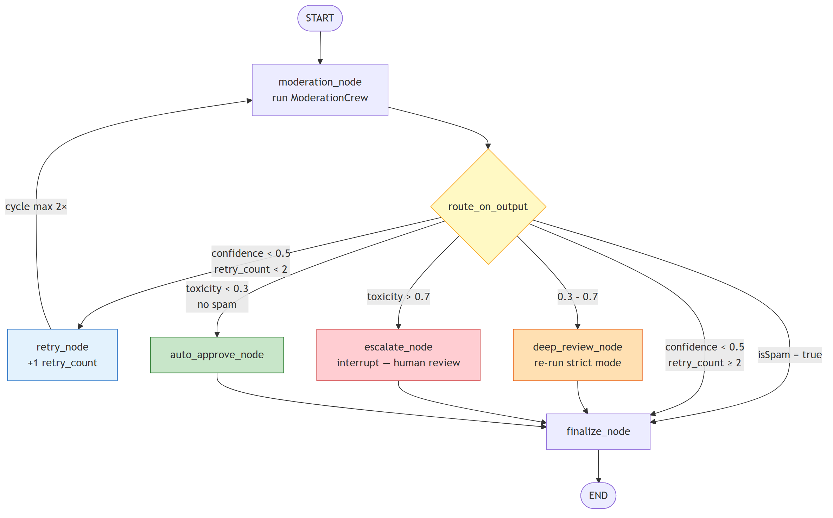

6.3 Routing Logic
Condition | Route | What happens
isSpam = true | → finalize | Crew already decided — verdict passes through unchanged
confidence < 0.5 and retry_count < 2 | → retry_node | Increment counter, re-run crew
confidence < 0.5 and retry_count ≥ 2 | → finalize | Give up, pass last verdict through
toxicity > 0.7 | → escalate_node | Pause graph, notify moderator
0.3 ≤ toxicity ≤ 0.7 | → deep_review_node | Re-run with stricter prompt
toxicity < 0.3 and no spam | → auto_approve_node | Fast-approve

6.4 finalize_node Fallback Chain
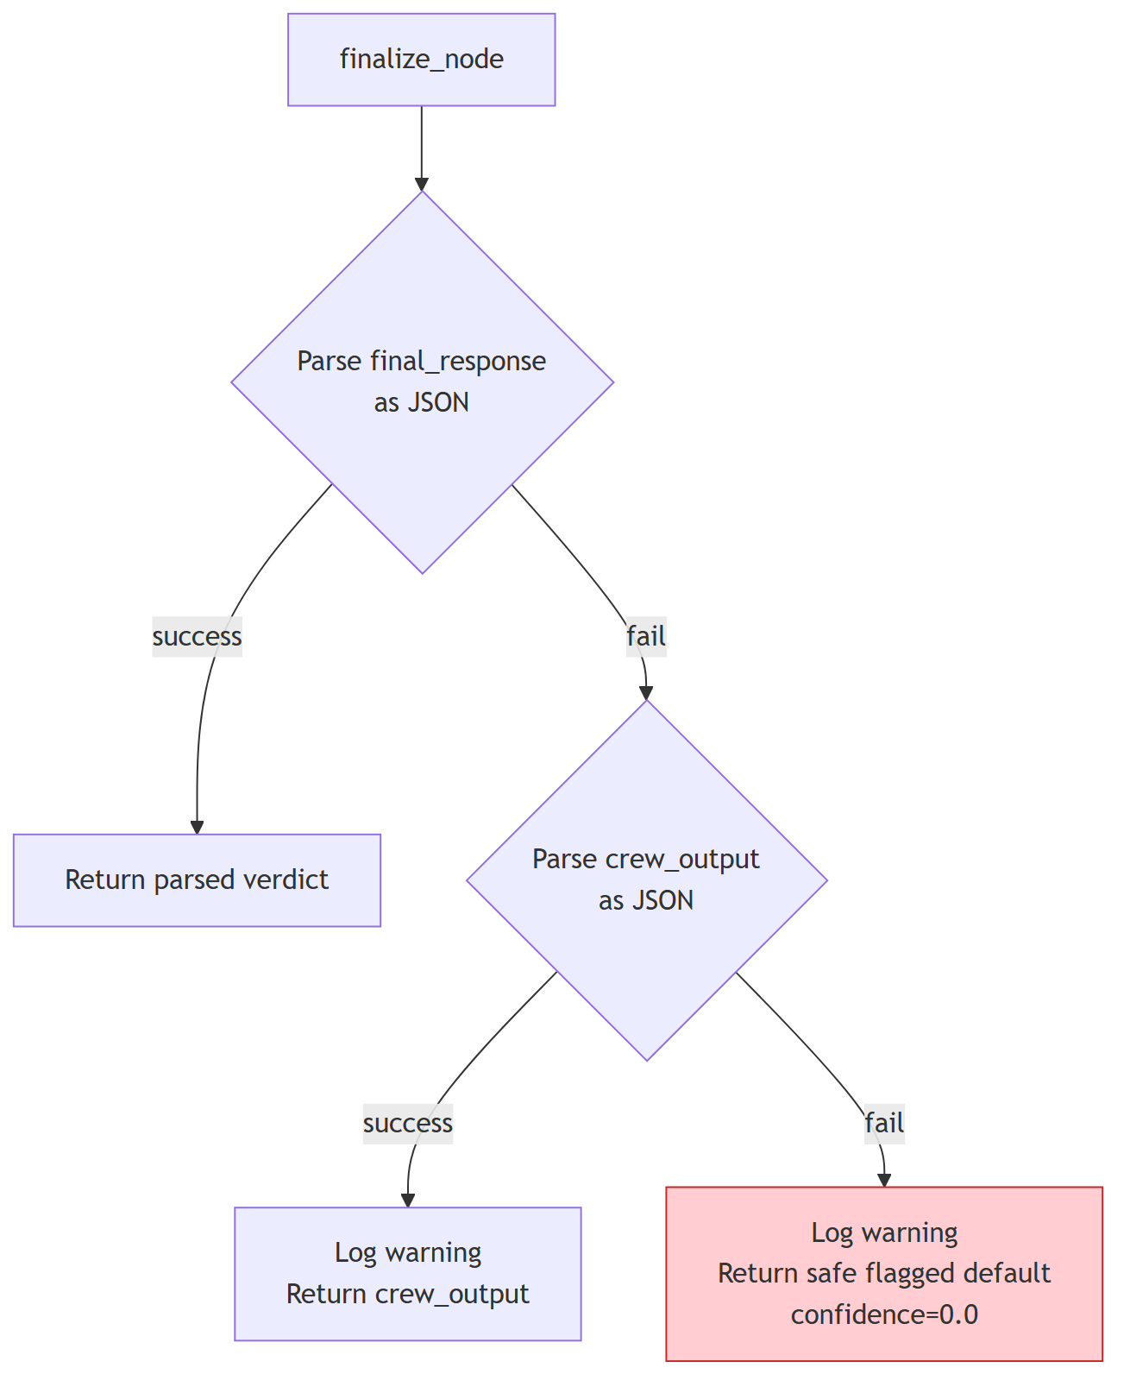

6.5 Human Escalation Flow
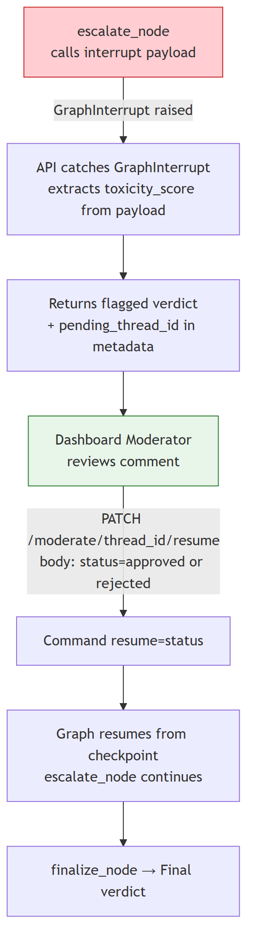

7. Deployment
Both the FastAPI app and the MCP server run inside the same Railway container. start.sh launches the MCP server as a background process on port 8001, waits for the port to open, then starts FastAPI on the Railway-assigned $PORT.
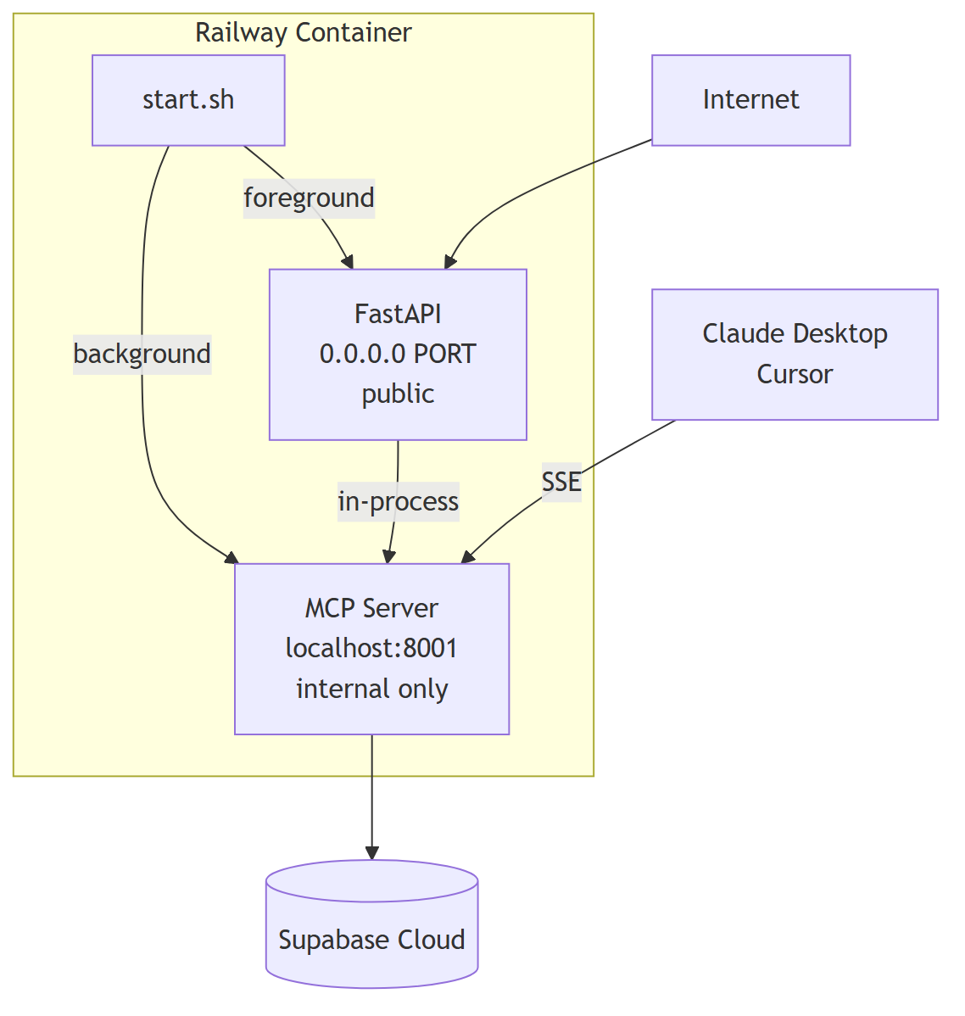

8. File Map
File | Role
main.py | FastAPI app — 4 endpoints, lifespan, error handling; imports MCP tools directly
graph.py | LangGraph moderation workflow — state, nodes, routing, fallback chain
crew.py | CrewAI crew definitions — ModerationCrew, ChatCrew, AnalystCrew
tools/mcp_server.py | Single source of truth — all 9 tool implementations + SSE transport
tools/mcp_adapter.py | MCPTool wrappers — bridges CrewAI BaseTool → MCP functions in-process
config/agents.yaml | Agent roles, goals, and backstories
config/tasks.yaml | Task descriptions and expected output formats
railway.toml | Railway build and deploy configuration
nixpacks.toml | Nixpacks build phases — Python 3.12, pip install
start.sh | Process launcher — MCP server then FastAPI
claude_desktop_config.json | MCP connection config for Claude Desktop / Cursor

9. Full System Diagram
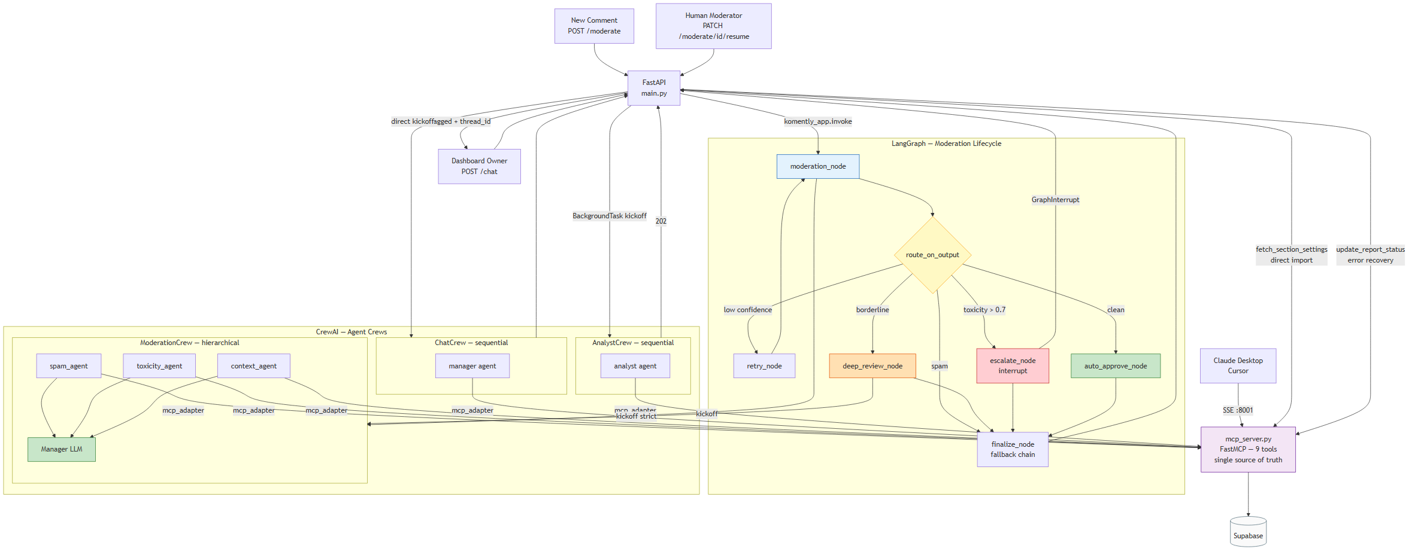

May 2026

