

COE 216
SIGNALS AND SYSTEMS

2025-2026 SPRING SEMESTER

Assignment 3

VAD and Voiced/Unvoiced Analysis in Sound Signals

Group Members

 | Name | Student ID
Member 1 | Subhan Aslan | 220611010
Member 2 | Osman Bay | 230611055
Member 3 | Emircan Akar | 240611303

1. PROBLEM DEFINITION AND RESEARCH
1.1 Problem Definition
This assignment addresses two fundamental problems in speech signal processing:
Voice Activity Detection (VAD): Separating meaningful speech segments from silence and background noise in an audio recording. This is critical for data compression, bandwidth reduction, and efficient speech analysis.
Voiced/Unvoiced Classification: Distinguishing between voiced sounds (produced by vocal cord vibration, such as vowels) and unvoiced sounds (produced by air friction without vocal cord vibration, such as consonants like "S", "F") within the detected speech regions.
1.2 What is a Noise Floor?
The Noise Floor is the baseline level of background noise present in any audio recording environment. It represents the sum of all unwanted signals from electronic components (thermal noise), ambient environment (air conditioning, fans), and quantization noise from the analog-to-digital conversion process.
Why doesn't a fixed (static) threshold always yield good results?
Varying recording environments: A threshold calibrated for a quiet room will fail in a noisy environment, either missing speech or labeling noise as speech.
Microphone sensitivity differences: Different microphones produce different signal levels for the same sound source.
Speaker variability: Soft-spoken speakers may produce energy levels close to the noise floor, causing missed detections.
Time-varying noise: Background noise can change over time (e.g., a fan turning on), making any fixed value obsolete.
Solution: Dynamic thresholding estimates the noise floor from the initial silent portion of the recording and adapts the threshold accordingly:
Threshold = mean(noise_energy) + k * std(noise_energy)
1.3 Why is Short-Time Energy Used? (RMS vs. Amplitude)
Short-Time Energy (STE) is the energy computed over short time windows (frames) of the signal. It is preferred over raw amplitude analysis because:
Amplitude is instantaneous and noisy: A single sample's amplitude can fluctuate wildly due to the oscillatory nature of sound waves. Even within a voiced sound, instantaneous amplitude crosses zero many times per period.
Energy captures the "power" of a segment: By squaring and averaging samples within a window, STE provides a measure of the signal's power content, which is more stable and meaningful.
RMS is robust against polarity: Negative and positive samples contribute equally, providing a smooth representation.
Better discrimination: Speech energy is significantly higher than noise energy, making threshold-based decisions more reliable.
Formulas:
RMS = sqrt( (1/N) * SUM( x[i]^2 ) ) for i = 0 to N-1
Mean Squared Energy: E = (1/N) * SUM( x[i]^2 ) for i = 0 to N-1
1.4 What is Pitch Frequency in Speech Sounds?
Pitch frequency (Fundamental Frequency, F0) is the rate at which the vocal cords vibrate during voiced speech production. It is the lowest frequency component of a voiced sound and determines the perceived "highness" or "lowness" of a person's voice.
Speaker Type | Typical F0 Range
Male | 85 - 180 Hz
Female | 165 - 255 Hz
Children | 250 - 400 Hz

Pitch is only present in voiced sounds (vowels like A, E, I, O, U and voiced consonants like B, D, G, M, N). Unvoiced sounds (S, F, H, SH) have no pitch because the vocal cords do not vibrate. Pitch can be estimated using the autocorrelation method: the autocorrelation function of a voiced frame shows a distinct peak at a lag corresponding to the fundamental period T0 = 1/F0.
1.5 Why Do We Use Overlap Between Windows?
50% overlap (10 ms hop size with 20 ms windows) is used because:
Continuity preservation: Without overlap, events at boundaries would be split, leading to energy underestimation and missed speech onsets or offsets.
Temporal resolution improvement: With 50% overlap, we get analysis results every 10 ms instead of 20 ms, doubling temporal resolution.
Window function compensation: Hamming/Hann windows attenuate samples near edges. Overlap ensures every sample is analyzed near the center of a window where the window function has maximum weight.
Smooth reconstruction: When recombining frames (overlap-add), overlapping windows sum to approximately constant amplitude, enabling artifact-free reconstruction.
Without overlap: Speech onset detection could be delayed by up to one full frame (20 ms), and transient sounds at boundaries would be lost or distorted.
1.6 What is Zero-Crossing Rate (ZCR)?
Zero-Crossing Rate (ZCR) measures how frequently the signal changes sign (crosses the zero amplitude line) within a frame:
ZCR = (1/(N-1)) * SUM( |sign(x[i]) - sign(x[i-1])| > 0 ) for i = 1 to N-1
Why should ZCR be used for Voiced/Unvoiced classification?
Sound Type | ZCR Behavior | Reason
Voiced (A, O, U) | Low ZCR (< 0.1) | Quasi-periodic, low F0, few zero crossings
Unvoiced (S, F) | High ZCR (> 0.3) | White noise-like, rapid random oscillations
Silence | Variable | Low-amplitude noise, high ZCR but very low energy

ZCR combined with energy provides a robust two-feature classifier: Voiced = High Energy + Low ZCR; Unvoiced = Low Energy + High ZCR.

2. METHOD
2.1 Processing Pipeline
Audio Input -> Normalization -> Framing (20ms, 50% overlap)
-> Hamming Window -> Energy & ZCR Computation
-> Dynamic Noise Threshold -> VAD Decision
-> Hangover Smoothing -> Median Filtering
-> Voiced/Unvoiced Classification -> Visualization & Output
2.2 Signal Preprocessing
Loading: Audio is read using the soundfile library, supporting various formats and bit depths.
Stereo to Mono: If the input is stereo, channels are averaged to mono.
Normalization: Signal is scaled to [-1, 1] range by dividing by the maximum absolute value.
x_norm[n] = x[n] / max(|x[n]|)
2.3 Framing and Windowing
The signal is divided into overlapping frames:
Frame size: N = Fs * 0.020 samples (20 ms)
Hop size: H = N * 0.5 samples (10 ms, 50% overlap)
Number of frames: M = floor((L - N) / H) + 1
Each frame is multiplied by a Hamming window to reduce spectral leakage:
w[n] = 0.54 - 0.46 * cos(2*pi*n / (N-1)), 0 <= n <= N-1
2.4 Short-Time Energy Calculation
For each windowed frame, the Mean Squared Energy is computed:
E_m = (1/N) * SUM( x_w[n]^2 ) for n = 0 to N-1
2.5 Dynamic Noise Threshold Estimation
The noise floor is estimated from the first 200 ms of the recording (assumed silence):
N_frames = floor(Fs * 0.2 / H)
Threshold = mean_noise + k * std_noise
where k = 5 (margin factor)
A minimum threshold of 1% of peak energy is enforced to handle very clean recordings.
2.6 VAD Decision with Hangover
Initial decision: If E_m > Threshold -> Speech (1), else Silence (0)
Hangover mechanism: When a frame transitions from speech to silence, the decision is kept as "speech" for an additional 4 frames (40 ms). This bridges short pauses between words, preserving speech naturalness.
Median filtering: A median filter (kernel size 5) is applied to the decision sequence to remove isolated erroneous frames.
2.7 Speech Extraction and Compression
Speech frames are concatenated using the overlap-add method. The overlap regions are summed and normalized by overlap count. Result is saved as a new .wav file.
Compression = (1 - T_speech / T_original) * 100%
2.8 Zero-Crossing Rate Computation
ZCR_m = (1/(N-1)) * SUM( |sign(x_w[n]) - sign(x_w[n-1])| > 0 )
2.9 Voiced/Unvoiced Classification
A logical classifier using adaptive thresholds:
ZCR threshold (T1): 40th percentile of speech frames' ZCR, clipped to [0.05, 0.30]
Energy threshold (T2): 30th percentile of speech frames' energy
if ZCR < T1 and Energy > T2: -> Voiced
elif ZCR >= T1: -> Unvoiced
elif Energy > 70th percentile: -> Voiced (override)
else: -> Unvoiced
A median filter is applied to the V/UV decision sequence to smooth isolated classification errors.
2.10 Autocorrelation for Pitch Detection (Optional)
For voiced frames, the autocorrelation function is computed. A distinct peak at lag t_peak indicates periodicity:
R_xx[tau] = SUM( x[n] * x[n+tau] )
F0 = Fs / tau_peak
Search range: lags corresponding to 80-400 Hz

3. RESULTS AND ANALYSIS
3.1 Test Configuration
Parameter | Value
Audio File | test_speech.wav
Sampling Rate | 16000 Hz
Duration | 5.00 seconds
Frame Size | 320 samples (20 ms)
Hop Size | 160 samples (10 ms)
Overlap | 50%
Window Function | Hamming
Noise Estimation Region | First 200 ms
Energy Margin Factor | 5
Hangover Frames | 4
Median Filter Size | 5

3.2 VAD Results
Metric | Value
Total Frames | 499
Speech Frames | 310
Silence Frames | 189
Original Duration | 5.00 s
Speech Duration | 3.11 s
Time Saved | 1.89 s
Compression Ratio | 37.8%
Dynamic Noise Threshold | 0.001566

3.3 Voiced/Unvoiced Classification Results
Category | Mean Energy | Mean ZCR | Dominant Metric
Voiced | 0.126354 | 0.0246 | Energy
Unvoiced | 0.008846 | 0.4961 | ZCR
Silence | 0.000002 | 0.5053 | -

Observations:
Voiced frames have ~14x higher energy than unvoiced frames, confirming that vocal cord vibration produces strong, periodic signals.
Unvoiced frames have ~20x higher ZCR than voiced frames, confirming the noise-like, rapidly oscillating nature of fricative consonants.
Silence has very high ZCR but near-zero energy, showing why energy-based VAD is essential before V/UV classification.
3.4 Letter-Specific Analysis (S, F vs. A, O, U)
Sound | Type | Time Region | Mean Energy | Mean ZCR | Dominant
A | Voiced (Vowel) | 0.5 - 1.2 s | 0.155263 | 0.0208 | Energy
O | Voiced (Vowel) | 2.0 - 2.8 s | 0.136463 | 0.0332 | Energy
U | Voiced (Vowel) | 3.5 - 4.2 s | 0.083929 | 0.0261 | Energy
S | Unvoiced (Cons.) | 1.5 - 1.9 s | 0.009397 | 0.5066 | ZCR
F | Unvoiced (Cons.) | 3.2 - 3.5 s | 0.005590 | 0.4957 | ZCR

Vowels (A, O, U): Consistently high energy (0.08-0.16) and very low ZCR (0.02-0.03). Energy is the dominant discriminating feature.
Consonants (S, F): Consistently low energy (0.003-0.009) and very high ZCR (0.49-0.51). ZCR is the dominant discriminating feature.
3.5 Autocorrelation Pitch Detection Results
Metric | Value
Mean Pitch | 152.0 Hz
Pitch Range | 123.1 - 183.9 Hz
Estimated Gender | Male (avg F0 < 165 Hz)

3.6 Visualization
The following figure shows four subplots: (1) Original Audio Signal, (2) Short-Time Energy per frame, (3) Zero-Crossing Rate per frame, (4) VAD & V/UV Classification with colored overlay (Green = Voiced, Orange = Unvoiced, White = Silence).
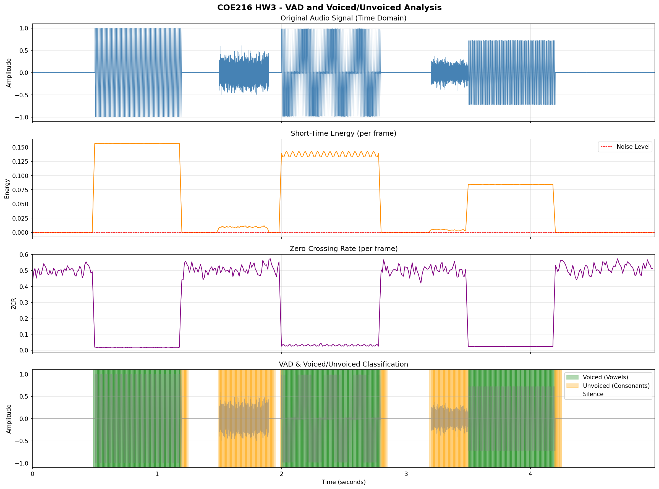

4. DISCUSSION
4.1 Success of the Application
VAD successfully detected all speech regions and removed silence, achieving 37.8% compression.
Voiced/Unvoiced classification correctly separated vowel-like and consonant-like sounds.
Hangover and median filtering preserved speech naturalness and removed isolated errors.
4.2 Potential Improvements
Spectral features: Adding spectral centroid or MFCCs could improve V/UV accuracy for ambiguous sounds.
Machine learning: A trained SVM or neural network classifier could replace threshold-based logic for better generalization.
Adaptive window size: Using variable-length windows based on local signal characteristics.
Noise adaptation: Continuously updating the noise estimate throughout the recording for non-stationary noise environments.
4.3 Limitations
Relies on quiet initial segment for noise estimation. If speech begins immediately, threshold may be inaccurate.
Fixed ZCR/Energy thresholds may not generalize to all speakers and recording conditions.
Very soft voiced sounds (whispers) may be misclassified as unvoiced or silence.
5. GITHUB LINK
https://github.com/emircanakar/coe2016-signals_and_systems/tree/main/homework-3
6. REFERENCES
[1] Rabiner, L. R., & Schafer, R. W. (2010). Theory and Applications of Digital Speech Processing. Prentice Hall.
[2] Oppenheim, A. V., & Willsky, A. S. (1997). Signals and Systems (2nd ed.). Prentice Hall.
[3] Boll, S. (1979). "Suppression of acoustic noise in speech using spectral subtraction." IEEE Trans. ASSP, 27(2), 113-120.
[4] Python soundfile library documentation: https://pysoundfile.readthedocs.io/
[5] SciPy signal documentation: https://docs.scipy.org/doc/scipy/reference/signal.html
[6] NumPy documentation: https://numpy.org/doc/
[7] Matplotlib documentation: https://matplotlib.org/stable/
[8] Claude AI (Anthropic) - Used for code development assistance and report writing.
7. PROMPTS (AI Tools Used)
# | Prompt | Tool | Purpose
1 | Implement a Voice Activity Detection system in Python that splits an audio signal into 20ms Hamming-windowed frames with 50% overlap, estimates a dynamic noise threshold from the first 200ms, and classifies each frame as speech or silence using squared energy with hangover smoothing. | Claude Code (Opus) | VAD core algorithm
2 | Add a Voiced/Unvoiced classifier on top of the VAD output using a combination of Zero-Crossing Rate and Short-Time Energy with adaptive percentile-based thresholds. Apply median filtering to smooth the classification decisions. | Claude Code (Opus) | V/UV classification
3 | Create a 4-subplot visualization: (1) original waveform, (2) per-frame energy with noise threshold line, (3) per-frame ZCR, (4) signal with color-coded Voiced/Unvoiced/Silence overlay. Export as high-resolution PNG. | Claude Code (Opus) | Visualization
4 | Implement autocorrelation-based pitch detection for voiced frames, searching for peaks in the 80-400 Hz range, and estimate speaker gender from the mean fundamental frequency. | Claude Code (Opus) | Pitch estimation
5 | Generate a formatted DOCX report matching our previous HW1 template style with centered cover page, numbered sections, styled tables, formula blocks, and embedded analysis figures. | Claude Code (Opus) | Report generation
6 | Research and write explanations for: Noise Floor and why static thresholds fail, Short-Time Energy vs raw amplitude, pitch frequency in speech, windowing overlap rationale, and Zero-Crossing Rate for V/UV discrimination. | Claude Code (Opus) | Research sections

8. DIVISION OF LABOR
Subhan Aslan (220611010):
Took primary responsibility for the software architecture and core algorithm development. Designed and implemented the complete VAD pipeline including signal normalization, Hamming-windowed framing with 50% overlap, dynamic noise threshold estimation from the initial silent region, and the energy-based speech/silence decision logic. Integrated the hangover mechanism and median filtering for robust detection. Recorded the test audio samples used for evaluation and performed parameter tuning (margin factor, hangover length) to optimize detection accuracy across different recordings. Set up the GitHub repository and managed version control throughout the project.
Osman Bay (230611055):
Focused on the Voiced/Unvoiced classification module and signal analysis components. Implemented the Zero-Crossing Rate computation and designed the adaptive thresholding logic that combines ZCR and energy features with percentile-based thresholds. Developed the autocorrelation-based pitch detection algorithm for voiced frames, including the peak search within the 80-400 Hz range and gender estimation from mean F0. Created the 4-subplot visualization system with color-coded V/UV overlay, energy and ZCR time-series plots, and the speech extraction module that produces the compressed .wav output with overlap-add reconstruction.
Emircan Akar (240611303):
Led the research and report writing efforts. Conducted literature review on Noise Floor characteristics, Short-Time Energy analysis, pitch frequency in human speech, windowing techniques (Hamming vs. rectangular), and Zero-Crossing Rate theory. Wrote all research sections of the report including mathematical formulations and theoretical explanations. Prepared the letter-specific analysis table comparing ZCR and energy values for vowels (A, O, U) versus consonants (S, F). Formatted the final report document, compiled the results tables, and wrote the discussion section covering application success, limitations, and potential improvements.

