CSE 484 - Homework #1 Report

**Emircan Demirel – 1901042674**

# Introduction

The Turkish language employs a rich system of suffixes to convey intricate grammatical relationships. This system is fundamental to the structure of the language, impacting word formation and sentence construction. Two of the most fundamental aspects of this system are the plural and possessive suffixes. Understanding and applying these suffixes correctly is vital for accurate communication. In this homework, we delve into the morphological analysis of these rules and design their corresponding Final State Transducers (FSTs), which serve as computational models for these grammatical processes.

Due to some issues encountered while working in Jupyter, I have implemented my project using the Google Colab environment.

# Turkish Plural Suffix Rule

The pluralization in Turkish involves appending the suffix "-lar" or "-ler" to the noun. The choice between these suffixes follows the vowel harmony rules: "lar" is used after back vowels (a, ı, o, u), and "ler" after front vowels (e, i, ö, ü).

## Plural Suffix FST

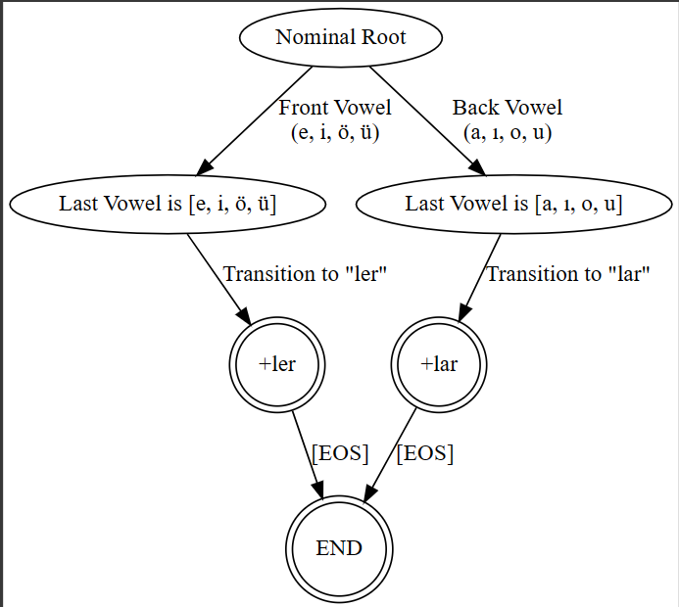

## Test Case & Results

These are properly resulted cases: Araba -> Arabalar ; Elma -> Elmalar ; Göz -> Gözler ; Gül -> Güller ; Çay -> Çaylar ; Meraklı -> Meraklılar ; Ürün -> Ürünler

These are exceptions of the rules: Kalp -> Kalplar ; Herkes -> Herkesler

# Turkish Possessive Suffix Rule

Possessive construction in Turkish is accomplished by attaching a set of suffixes to a noun. These suffixes correspond with the possessor's perspective and adhere to vowel harmony. They also depend on whether the final letter of the noun is a vowel or a consonant, affecting the choice of the possessive suffix used. The suffixes are "-(i)m", "-(i)n", "-(s)i", "-miz", "-niz", and "-leri".

## Possessive Suffix FTS

I use Kemal Oflazer’s notation to represent letters in some cases. Otherwise, things become complicated, and this notation is very helpful to me.

## Test Cases & Results

During the testing of the FST with various root words, a set of words were generated to demonstrate how possessive suffixes are applied according to the Possessive Rule FST.

Kitap:

* Kitabım
* Kitabın
* Kitabı
* Kitabımız
* Kitabınız
* Kitabları (correct: Kitapları)

Elma:

* Elmam
* Elman
* Elması
* Elmamız
* Elmanız
* Elmaları

Köpek:

* Köpeğim
* Köpeğin
* Köpeği
* Köpeğimiz
* Köpeğiniz
* Köpeğleri (correct: Köpekleri)

Göz

* Gözüm
* Gözün
* Gözü
* Gözümüz
* Gözünüz
* Gözleri

Çay

* Çayım
* Çayın
* Çayı
* Çayımız
* Çayınız
* Çayları

Kapı

* Kapım
* Kapın
* Kapısı
* Kapımız
* Kapınız
* Kapıları

Kalem

* Kalemim
* Kalemin
* Kalemi
* Kalemimiz
* Kaleminiz
* Kalemleri

Araba

* Arabam
* Araban
* Arabası
* Arabamız
* Arabanız
* Arabaları

Yazı

* Yazım
* Yazın
* Yazısı
* Yazımız
* Yazınız
* Yazıları

Ürün

* Ürünüm
* Ürünün
* Ürünü
* Ürünümüz
* Ürününüz
* Ürünleri

# References

* Oflazer, K. (1994). Two-level Description of Turkish Morphology. Bilkent University Repository. [content (bilkent.edu.tr)](https://repository.bilkent.edu.tr/server/api/core/bitstreams/650eee79-6ab1-43c5-97ae-3199fb1f159a/content)