Istanbul Technical University · UUM 523E Advanced Flight Dynamics · Fall 2026–2027
Homework 1: F-16 Plant Model and Aerodynamic Coefficients
Group 2: Dilan Gelturan, Emirhan Oskay, Emircan Sürücü, Berat Alku
October 2026 · Code and models: github.com/emircansurucu/UUM523E-F16-Flight-Dynamics (hw1 branch)

Abstract
This report presents the Simulink implementation and verification of a nonlinear six-degree-of-freedom (6-DOF) F-16 plant model. The aerodynamic and engine models are based on NASA TP-1538 [1]; the atmosphere model and equations of motion on Stevens, Lewis and Johnson [2]. The aerodynamic and propulsion subsystems matched independent reference calculations in all ten and five verification cases, respectively. In Problem 2, the lift, drag and pitching moment coefficients are examined versus angle of attack; at the reference center of gravity ($0.35 \overset{‾}{c}$) the aircraft is longitudinally statically unstable at small angles of attack, with a static margin of about −4% $\overset{‾}{c}$.

1. Introduction
The model consists of six subsystems: Atmosphere, Aerodynamics, Propulsion, Mass and Inertia, Actuators, and Equations of Motion. The aerodynamic and engine models are based on NASA TP-1538 [1], and the atmosphere model on Appendix A.6 of Stevens, Lewis and Johnson [2]. The course-provided aerodynamic and engine tables, derived from TP-1538 [1], were used with their own breakpoints.
The Aerospace Blockset was not used; all subsystems were built from basic Simulink blocks (n-D Lookup Table, Gain, Sum, Product, Integrator, Saturation, Switch, Trigonometric Function, Transfer Fcn). The only library block used is Radians to Degrees from simulink_extras. Model files and scripts are in the project repository [3].

2. Overall Model Structure
The root level (Figure 1) has five inputs: stabilator, aileron, rudder and speed brake commands (deg) and throttle position (%). Subsystems are connected with Goto/From tags, so each signal (alpha, q_dyn, F_aero, etc.) has a single name throughout the model.
Control commands enter the Actuators subsystem, whose actual surface deflections feed the Aerodynamics subsystem. Forces from Aerodynamics, Propulsion and Mass & Inertia are summed at the root level and passed, with the aerodynamic moment, to Equations of Motion. Its outputs (body velocities, angular rates, Euler angles, altitude) are fed back, and the Atmosphere subsystem computes $α$, $β$, $V_{T}$, $\overset{‾}{q}$, Mach number and static pressure from them. The leading-edge flap (LEF) schedule is also at the root level (Section 3.7).
All data and constants are loaded into the workspace by init_F16.m [3], and the lookup table and breakpoint fields are linked to these variables (AeroData, AeroBP, EngData, etc.). All calculations are in SI units; tables in English units are converted only at the input and output of the relevant block (1 ft = 0.3048 m, 1 lbf = 4.448222 N). A variable-step automatic solver (relative tolerance ${10}^{-3}$) was used.
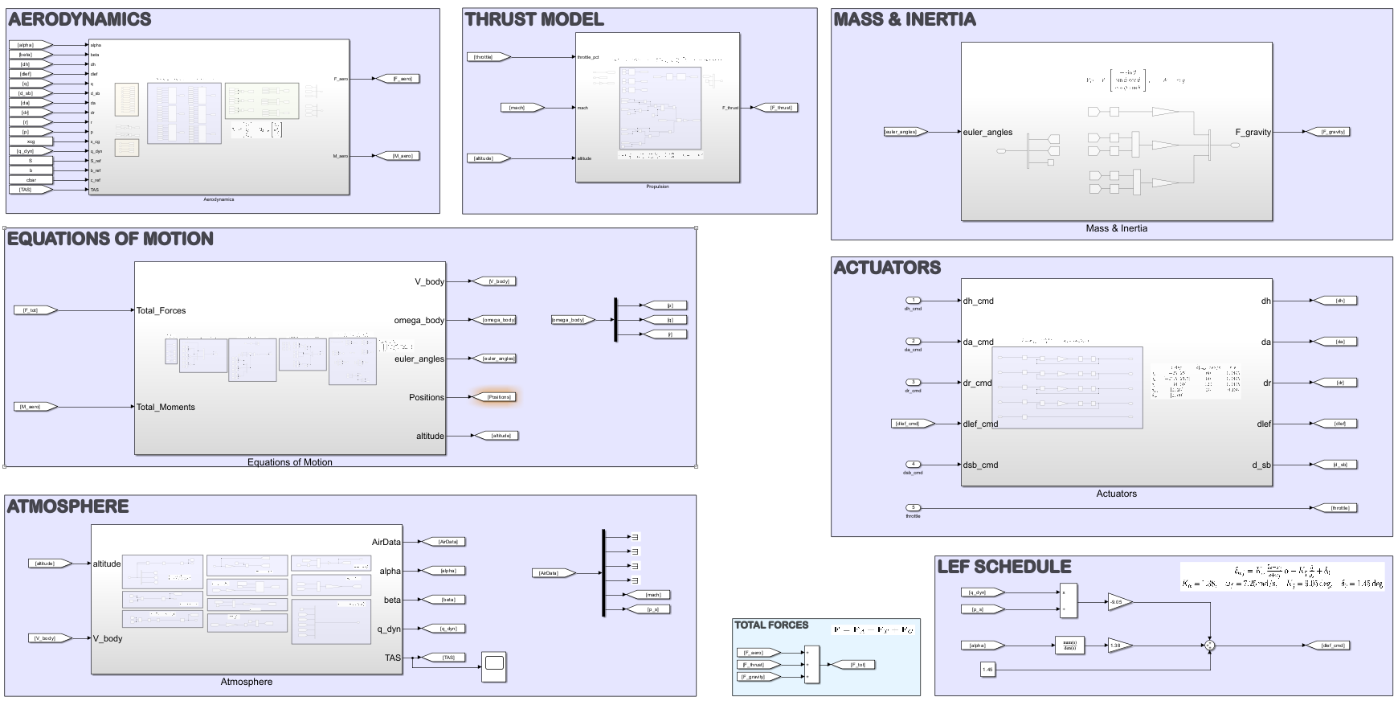
Figure 1. Root level of the F16_6DOF.slx model.

3. Subsystems

3.1 Atmosphere
The Atmosphere subsystem computes air data from altitude and body velocities using the Stevens–Lewis–Johnson model [2] with constants converted to SI. Total velocity is computed with Dot Product and Sqrt blocks, followed by a Saturation with a 0.1 m/s lower limit to avoid division by zero. $α$ is obtained with atan2 and $β$ with asin, whose argument is limited to ±1 by a separate Saturation. The temperature ratio $T^{*}=1-kh$ uses Constant and Gain blocks, and the tropopause is handled by a Switch with threshold $h_{tr}$. Density is computed with a Math Function (pow) block [2]:
$T=\left\{\begin{matrix}T_{0} T^{*} & h≤h_{tr} \\ T_{tr} & h>h_{tr}\end{matrix}\right., ρ=ρ_{0} {\left(T^{*}\right)}^{4.14}, M=\frac{V_{T}}{\sqrt{γR_{a}T}}, \overset{‾}{q}=\frac{1}{2}ρV_{T}^{2}, p_{s}=R_{p} ρ T$ (1)
The source model uses two different gas constants for the speed of sound and static pressure ($R_{a}=287.009$, $R_{p}=286.792$ J/(kg·K)) [2]; both were kept. Other constants: $ρ_{0}=1.22506$ kg/m³, $k=2.30643⋅{10}^{-5}$ 1/m, $T_{0}=288.333$ K, $T_{tr}=216.667$ K, $h_{tr}=10 668$ m. At the verification condition (Mach 0.4, 3048 m) the block outputs are $V_{T}=131.2776$ m/s and $\overset{‾}{q}=7806.32$ Pa.

3.2 Aerodynamics
The Aerodynamics subsystem computes the body-axis aerodynamic forces and moments about $x_{cg}=0.35 \overset{‾}{c}$. The terms $\overset{‾}{c}/\left(2V_{T}\right)$ and $b/\left(2V_{T}\right)$ are computed first (Divide and Gain). Each coefficient (CX, CY, CZ, Cl, Cm, Cn) has its own subsystem and is converted to forces and moments with three/four-input Product blocks: $\left[X,Y,Z\right]=\overset{‾}{q}S \left[C_{X},C_{Y},C_{Z}\right]$, $\left[L,M,N\right]=\overset{‾}{q}S \left[b C_{l}, \overset{‾}{c} C_{m}, b C_{n}\right]$. The coefficient subsystems follow the TP-1538 build-up structure [1]; e.g., the pitching moment coefficient is:
$\begin{matrix}C_{m,t} & =C_{m}\left(α,β,δ_{h}\right) η_{δ_{h}}\left(δ_{h}\right)+\frac{q\overset{‾}{c}}{2V_{T}}\left[C_{m_{q}}\left(α\right)+ΔC_{m_{q},lef}\left(α\right) Λ\right]+C_{Z,t} \left(x_{cg,ref}-x_{cg}\right) \\ & +ΔC_{m,lef} Λ+ΔC_{m,sb}\left(α\right) \frac{δ_{sb}}{60}+ΔC_{m}\left(α\right)+ΔC_{m,ds}\left(α,δ_{h}\right), Λ=1-\frac{δ_{lef}}{25}\end{matrix}$ (2)
Block-level implementation:
- Tables. Each table is an n-D Lookup Table block with its table and breakpoint fields linked directly to AeroData.<coefficient>.<table> and AeroBP.<coefficient>.<table>. The six subsystems contain 68 lookup blocks in total (Table 1), all with linear interpolation and clipping at the table limits.
- $δ_{h}=0$ slice. Difference terms (e.g. $ΔC_{lef}=C_{lef}\left(α,β\right)-C\left(α,β,0\right)$) need the $δ_{h}=0$ value of the base table [1], obtained from a second copy of the base table whose $δ_{h}$ input passes through a Gain of 0.
- Scaling terms. $Λ$ is formed by subtracting a Gain of 1/25 from a constant 1. The $δ_{sb}/60$, $δ_{a}/20$ and $δ_{r}/30$ scalings [1] also use Gain blocks; scaled terms are multiplied with Product blocks and summed in a multi-input Sum block.
- Center-of-gravity terms. In $C_{m}$, the term $C_{Z,t}\left(x_{cg,ref}-x_{cg}\right)$ requires $C_{Z,t}$ is taken from the CZ subsystem as an input; likewise, in $C_{n}$, the term $-C_{Y,t}\left(x_{cg,ref}-x_{cg}\right) \overset{‾}{c}/b$ [2] is fed from the CY subsystem. Since $x_{cg}$ is a root-level input, the center of gravity can be changed from outside the model.
Table domains differ: the main tables cover $α=-20…{90}^{∘}$ and $β=-30…{30}^{∘}$, while the LEF tables cover only $α=-20…{45}^{∘}$; the $δ_{h}$ dimension also differs between $C_{l}$ and $C_{n}$ on the one hand and $C_{X}$, $C_{Z}$ and $C_{m}$ on the other [1]. Hence each block is linked to its own breakpoint variable rather than a common vector.
Table 1. Lookup tables in the coefficient subsystems (1D/2D/3D: table dimension).
Subsystem | Number of blocks | 1D / 2D / 3D | $δ_{h}$ breakpoints [deg] | Additional tables
CX, CZ | 6 + 6 | 3 / 1 / 2 | −25, −10, 0, 10, 25 | $C_{q}$, $ΔC_{q,lef}$, $ΔC_{sb}$
CY | 15 | 4 / 11 / – | – | $δ_{a}=20$, $δ_{r}=30$, $p$, $r$ tables
Cl, Cn | 16 + 16 | 5 / 6 / 5 | −25, 0, 25 | $δ_{a}$, $δ_{r}$, $p$, $r$, $ΔC_{β}$
Cm | 9 | 5 / 2 / 2 | −25, −10, 0, 10, 25 | $η_{δ_{h}}$, $ΔC_{m}$, $ΔC_{m,ds}$, $ΔC_{m,sb}$
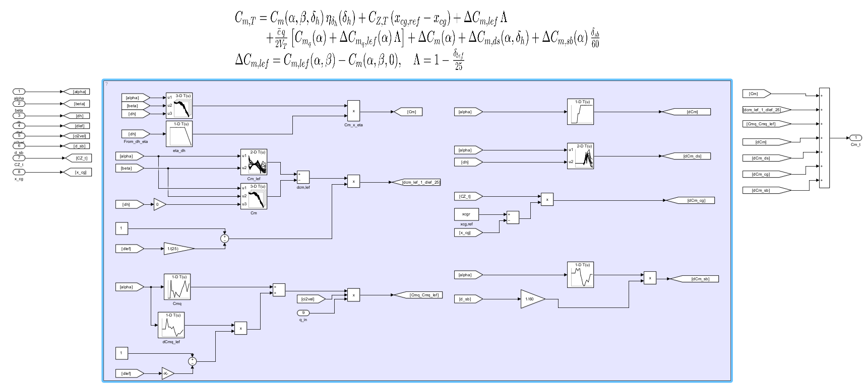
(a) Cm coefficient subsystem
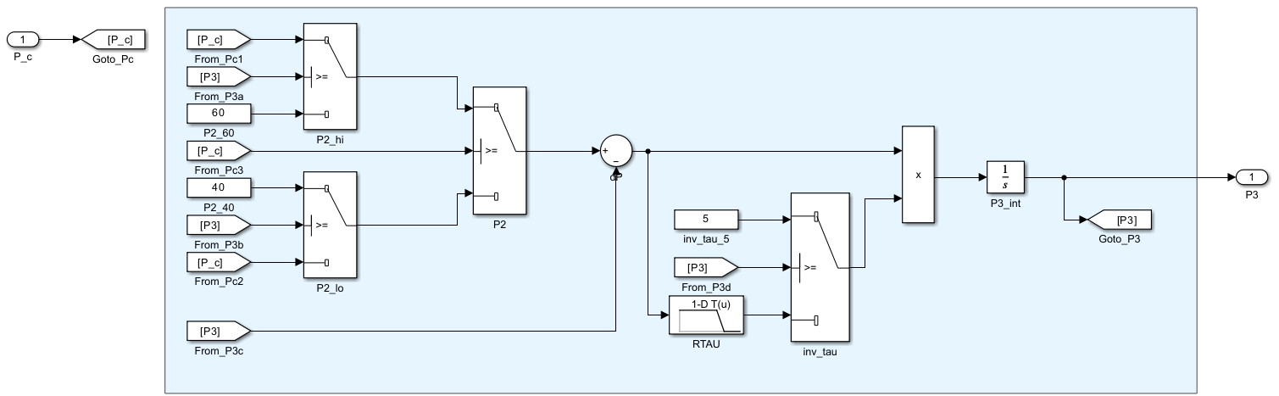
(b) Engine Dynamics subsystem
Figure 2. Examples of the internal structure of the aerodynamic and propulsion subsystems.

3.3 Propulsion
The Propulsion subsystem computes engine thrust from throttle position, including the engine lag (TP-1538 engine model [1]). It has four parts:
- Throttle gearing. A 1-D lookup table with breakpoints [0, 77, 100] % and values [0, 50, 100] maps throttle position to the power command ($P_{c}$); 77% corresponds to military power ($P_{c}=50$) [2].
- Engine dynamics (Figure 2b). The power level $P_{3}$ evolves through an Integrator (initial value P3_0) as ${\dot{P}}_{3}=\left(P_{2}-P_{3}\right)/τ$ [1]. The target power $P_{2}$ and $1/τ$ are selected by four Switches (threshold 50) according to Table 2. $R_{τ}\left(ΔP\right)$ is a lookup table with breakpoints [−100, 25, 50, 100] and values [1, 1, 0.1, 0.1].
- Thrust tables. Idle, military and maximum thrust are read from three 2-D lookup tables of Mach number and altitude [1]; altitude is converted to ft by a Gain of 1/0.3048. A Switch (threshold 50) selects the interpolation branch based on $P_{3}$: $T=T_{idle}+\left(T_{mil}-T_{idle}\right) P_{3}/50$ or $T=T_{mil}+\left(T_{max}-T_{mil}\right)\left(P_{3}-50\right)/50$.
- Output. Thrust is converted from lbf to N with a Gain and formed into $F_{T}={\left[T, 0, 0\right]}^{T}$ with a Mux.
Table 2. Selection of $P_{2}$ and $1/τ$ in the engine dynamics [1].
Condition | $$P_{2}$$ | $1/τ$ [1/s]
$P_{c}≥50$, $P_{3}≥50$ | $$P_{c}$$ | 5
$P_{c}≥50$, $P_{3}<50$ | 60 | $$R_{τ}\left(P_{2}-P_{3}\right)$$
$P_{c}<50$, $P_{3}≥50$ | 40 | 5
$P_{c}<50$, $P_{3}<50$ | $$P_{c}$$ | $$R_{τ}\left(P_{2}-P_{3}\right)$$
The gearing equation in Stevens–Lewis–Johnson uses rounded coefficients ($P_{c}=64.94 δ_{th}$ and $217.38 δ_{th}-117.38$) [2]. Defining the gearing by breakpoints gives exactly $P_{c}=50$ at 77%; the thrust differs from the rounded-coefficient result by at most 2 N (0.008%).

3.4 Mass and Inertia
This subsystem transforms gravity into body axes. The Euler angles are split with a Demux, and the three components of $F_{G}=W {\left[-sinθ, sinϕcosθ, cosϕcosθ\right]}^{T}$ [2] are computed with Trigonometric Function and Product blocks and multiplied by the Weight gain. The unused $ψ$ input goes to a Terminator. Mass, inertia and geometry values are taken from TP-1538 Table I [1] and converted to SI (Table 3).
Table 3. Mass, inertia and geometry (TP-1538 Table I [1], SI). $g=9.80665$ m/s².
Quantity | Value | Quantity | Value | Quantity | Value
$$W$$ | 91 188.6 N | $$S$$ | 27.8709 m² | $$I_{xx}$$ | 12 874.8 kg·m²
$$m$$ | 9 298.64 kg | $$b$$ | 9.144 m | $$I_{yy}$$ | 75 673.6 kg·m²
$x_{cg}$, $x_{cg,ref}$ | 0.35 $\overset{‾}{c}$ | $$\overset{‾}{c}$$ | 3.45034 m | $$I_{zz}$$ | 85 552.1 kg·m²
$H_{e}$ (engine) | 216.931 kg·m²/s |  |  | $$I_{xz}$$ | 1 331.41 kg·m²

3.5 Actuators
The actuators track their commands with a lag and within physical limits [1]. The stabilator, aileron, rudder and LEF channels share the structure: position Saturation → error (Sum) → $1/τ$ Gain → rate Saturation → Integrator, i.e. $\dot{δ}={sat}_{\dot{δ}}\left[\left({sat}_{δ}\left(δ_{c}\right)-δ\right)/τ\right]$. The speed brake has no dynamics, only a position limit. Parameters are given in Table 4.
Table 4. Actuator parameters [1].
Channel | Position limit | Rate limit | $$τ$$
Stabilator $δ_{h}$ | ±25° | 60 °/s | 0.0495 s
Aileron $δ_{a}$ | ±21.5° | 80 °/s | 0.0495 s
Rudder $δ_{r}$ | ±30° | 120 °/s | 0.0495 s
Leading-edge flap $δ_{lef}$ | 0 … 25° | 25 °/s | 0.136 s
Speed brake $δ_{sb}$ | 0 … 60° | – | –

3.6 Equations of Motion
This subsystem computes the aircraft motion from the total force ($F=F_{A}+F_{T}+F_{G}$) and aerodynamic moment, assuming a rigid body, constant mass and a flat, non-rotating Earth [2]. It has five parts: Inputs, Translational Dynamics, Rotational Dynamics, Rotational Kinematics and Translational Kinematics. Four vector Integrators give body velocities, angular rates, Euler angles and position, initialized from V_body_0, omega_0, Euler_0 and Pos_0 in init_F16.m. The equations are [2]:
${\dot{V}}_{B}=\frac{F}{m}-ω×V_{B}, \dot{ω}=I^{-1}\left[M_{A}-ω×\left(Iω+h_{e}\right)\right], I=\left[\begin{matrix}I_{xx} & 0 & -I_{xz} \\ 0 & I_{yy} & 0 \\ -I_{xz} & 0 & I_{zz}\end{matrix}\right]$ (3)
$\dot{ϕ}=p+\left(qsinϕ+rcosϕ\right)tanθ, \dot{θ}=qcosϕ-rsinϕ, \dot{ψ}=\frac{qsinϕ+rcosϕ}{cosθ}$ (4)
$Iω$ and $I^{-1}$ products use Gain blocks in matrix-multiplication mode (I_mat, inv_I). Cross products are built component-wise with Product and Sum blocks. The engine angular momentum $h_{e}={\left[H_{e}, 0, 0\right]}^{T}$ [1] is added through two Gains of $±H_{e}$. Ground velocity is obtained by rotating the body velocity through $ϕ$, $θ$, $ψ$; its integral gives the NED position, and $h=-z_{E}$ the altitude. The product of inertia $I_{xz}$ couples roll and yaw, so the inverse inertia matrix $I^{-1}$ is used directly. The Euler-angle kinematics are singular at $θ=±{90}^{∘}$ [2], which the homework flight conditions do not reach.

3.7 LEF Schedule and Total Force
At the root level, the LEF command is generated with Transfer Fcn, Gain and Constant blocks as $δ_{lef}=1.38 \frac{2s+7.25}{s+7.25} α-9.05 \overset{‾}{q}/p_{s}+1.45$ [2] and sent to the flap channel of the Actuators. As the homework specifies, this schedule was not used in verification; $δ_{lef}$ was taken directly from the table.

4. Aerodynamic and Propulsion Verification

4.1 Method
Verification was performed with run_HW1.m [3], which places an exact copy of the model's Aerodynamics block into a temporary test model fed by From Workspace blocks. The test model runs with a fixed step of 1, so each time step is one verification case; the ten cases or an $α$ sweep are thus computed in a single run through the model's own subsystem. The flight condition (Mach 0.4, 10 000 ft) was computed from the atmosphere equations [2], $p$, $q$, $r$ were converted to rad/s, and $δ_{lef}$ was taken directly from the table. For thrust, the Propulsion block was run alone in the same way, with the engine initialized at the steady-state power of the throttle setting ($P_{3}\left(0\right)=P_{c}$) so that the engine lag does not affect the result. Results were saved to HW1_Group2.mat in the required format.

4.2 Results
Coefficients for the ten cases of homework Table 1 are given in Table 5 and forces and moments in Table 6; steady-state thrust for the five cases of Table 2 is given in Table 7.
Table 5. Aerodynamic coefficients (cases of Table 1 of the homework, Mach 0.4, 10 000 ft, $x_{cg}=0.35 \overset{‾}{c}$).
Case | $$C_{X}$$ | $$C_{Y}$$ | $$C_{Z}$$ | $$C_{l}$$ | $$C_{m}$$ | $$C_{n}$$
1 | −0.020 200 | 0 | −0.100 000 | 0 | −0.007 700 | 0
2 | −0.030 300 | 0 | −0.485 800 | 0 | −0.011 100 | 0
3 | 0.022 100 | 0 | −1.355 000 | 0 | 0.023 900 | 0
4 | −0.015 200 | −0.267 700 | −0.106 500 | −0.018 200 | −0.006 600 | 0.051 200
5 | −0.050 167 | 0 | 0.019 333 | 0 | 0.127 733 | 0
6 | −0.048 900 | 0 | −0.025 000 | 0 | −0.040 800 | 0
7 | −0.020 200 | 0.010 450 | −0.100 000 | −0.025 600 | −0.007 700 | −0.004 950
8 | −0.020 200 | −0.041 050 | −0.100 000 | −0.007 250 | −0.007 700 | 0.022 550
9 | −0.003 960 | 0 | −0.417 217 | 0 | 0.000 061 | 0
10 | 0.000 621 | 0.000 193 | −0.478 558 | 0.000 287 | 0.000 054 | 0.000 033

Table 6. Aerodynamic forces [N] and moments [N·m] (body axes, about $x_{cg}=0.35 \overset{‾}{c}$).
Case | $$X$$ | $$Y$$ | $$Z$$ | $$L$$ | $$M$$ | $$N$$
1 | −4 394.90 | 0 | −21 756.93 | 0 | −5 780.29 | 0
2 | −6 592.35 | 0 | −105 695.17 | 0 | −8 332.63 | 0
3 | 4 808.28 | 0 | −294 806.41 | 0 | 17 941.42 | 0
4 | −3 307.05 | −58 243.30 | −23 171.13 | −36 208.06 | −4 954.54 | 101 860.03
5 | −10 914.73 | 0 | 4 206.34 | 0 | 95 887.78 | 0
6 | −10 639.14 | 0 | −5 439.23 | 0 | −30 628.04 | 0
7 | −4 394.90 | 2 273.60 | −21 756.93 | −50 930.02 | −5 780.29 | −9 847.80
8 | −4 394.90 | −8 931.22 | −21 756.93 | −14 423.54 | −5 780.29 | 44 862.18
9 | −861.66 | 0 | −90 773.72 | 0 | 45.84 | 0
10 | 135.14 | 42.05 | −104 119.59 | 571.22 | 40.39 | 65.40

Table 7. Steady-state thrust (cases of Table 2 of the homework).
Case | Mach | Altitude [ft] | Throttle [%] | $P_{c}$ [%] | Thrust [N] | Thrust [lbf]
1 | 0.25 | 5 000 | 10.00 | 6.49 | 7 891.80 | 1 774.15
2 | 0.65 | 25 000 | 77.00 | 50.00 | 26 867.26 | 6 040.00
3 | 0.90 | 45 000 | 95.00 | 89.13 | 24 059.66 | 5 408.83
4 | 0.40 | 10 000 | 16.66 | 10.82 | 9 049.33 | 2 034.37
5 | 0.40 | 10 000 | 19.77 | 12.84 | 10 717.85 | 2 409.47
Although case 3 is in the afterburner region, it gives less thrust than case 2: per the atmosphere model [2], air density at 45 000 ft (0.254 kg/m³) is only 46% of that at 25 000 ft (0.550 kg/m³).

4.3 Checking the Results
The results were checked as follows:
- Symmetry. With zero lateral-directional inputs (cases 1, 2, 3, 5, 6, 9), $C_{Y}$, $C_{l}$ and $C_{n}$ are exactly zero.
- LEF weighting. In case 6, $δ_{lef}={25}^{∘}$, hence $Λ=0$, so the LEF difference terms vanish and the result comes directly from the base tables.
- Signs. In case 4 ($β=12.5^{∘}$), $C_{n}>0$ and $C_{l}<0$: the aircraft is directionally stable and the dihedral effect has the correct sign. Negative stabilator (case 5) gives a nose-up moment ($C_{m}=0.128$), positive aileron (case 7) a left-rolling moment, and negative rudder (case 8) a positive yawing moment, all consistent with TP-1538 sign conventions [1].
- Near-trim cases. The $δ_{lef}$ values in cases 9 and 10 agree with the LEF schedule [2], and the pitching moment is nearly zero ($C_{m}≈6⋅{10}^{-5}$).
- Independent calculation. test_aero_table1.m and test_thrust_table2.m [3] compare the same calculation with model-independent reference values (maximum difference $3.3⋅{10}^{-12}$ in the coefficients and $4.8⋅{10}^{-7}$ N in thrust). All equations were also re-implemented from the raw data in Python (verify_hw1.py), giving differences of order ${10}^{-16}$ in the coefficients and identical thrust values.

5. Running the Complete Model
The complete model was run as a 6 s free response with zero control inputs ($δ_{h}=δ_{a}=δ_{r}=δ_{sb}=0$) and 0% throttle (idle). The initial condition from init_F16.m is $V_{T}=131.28$ m/s, $α=θ=0$, $h=3048$ m, with zero angular rates. Since the model is not trimmed, the aim is not to verify a flight condition but to show that the six subsystems run together without numerical problems and respond in the physically expected direction.
With zero stabilator the pitching moment is nose-down, so the aircraft pitches nose-down (Figure 3). Being longitudinally statically unstable at small angles of attack (Section 7), the motion grows rather than damps: at t = 3 s, $θ$ ≈ −11°, and at t = 6 s, $θ$ ≈ −64° and $α$ ≈ −24°. Pitch rate peaks at about −30 °/s at t ≈ 5.5 s. Speed rises to 134.5 m/s at t ≈ 4.8 s due to the dive, then falls as drag grows at large negative angles of attack. Altitude drops by about 175 m in 6 s. The run ends before t ≈ 7 s, where $θ$ reaches −90° and the Euler representation becomes singular. No numerical problems occurred, and the response is consistent with the aircraft's static instability.
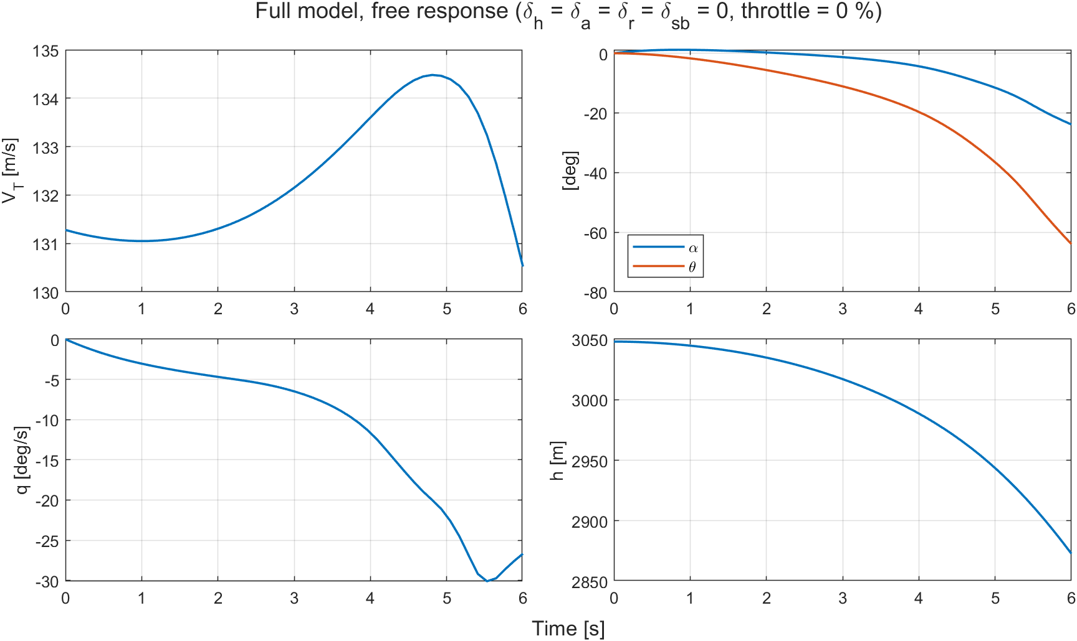
Figure 3. Free response of the complete model (controls at zero, throttle at 0%).

6. Problem 2a: Lift and Drag Coefficients
For five conditions, $α=-20…{90}^{∘}$ was swept in 0.5° steps (zero angular rates, same flight condition as in verification), and the body-axis coefficients were converted to wind axes [2]:
$C_{L}=C_{X}sinα-C_{Z}cosα, C_{D}=-C_{X}cosαcosβ-C_{Y}sinβ-C_{Z}sinαcosβ$ (5)
Results are shown in Figure 4; the dashed line at $α={45}^{∘}$ marks the LEF table limit [1].
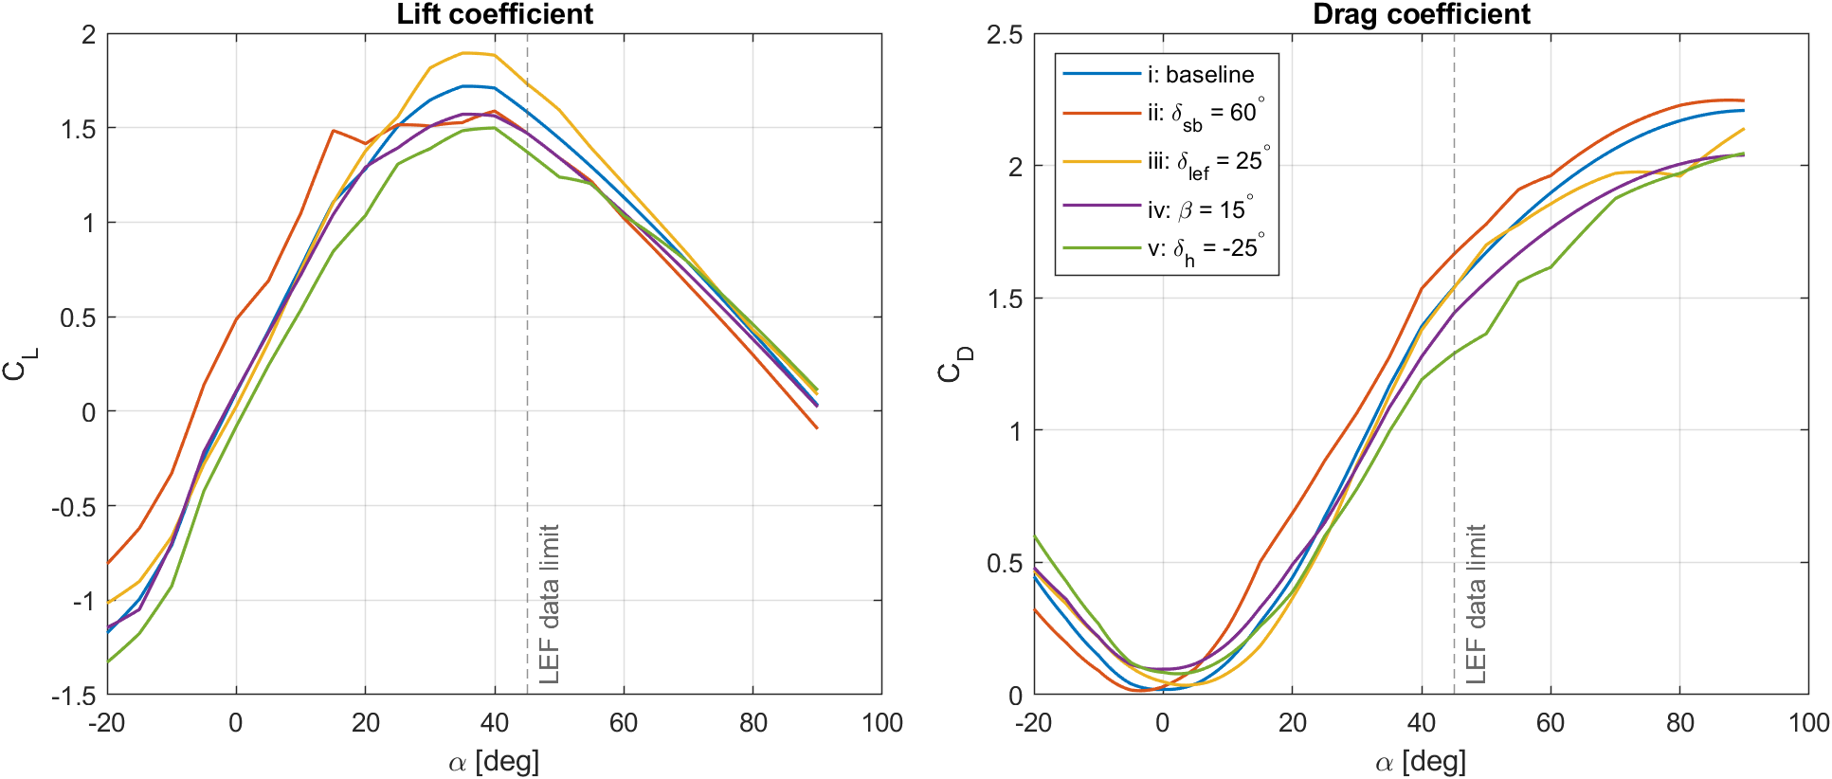
Figure 4. Variation of $C_{L}$ and $C_{D}$ with angle of attack for the five conditions.
- Baseline case (i). $C_{L}$ rises almost linearly at small angles ($C_{L_{α}}≈0.066$ 1/deg) and peaks at $α≈{35}^{∘}$ ($C_{L,max}≈1.72$), then decreases. $C_{D}$ is minimum near $α≈0^{∘}$ ($≈0.020$) and rises to 2.2 at $α={90}^{∘}$.
- Speed brake (ii, $δ_{sb}={60}^{∘}$). At $α={20}^{∘}$, $C_{D}$ increases by about 0.24. Lift also rises at low angles (at $α=0^{∘}$, $C_{L}$ rises from 0.10 to 0.49), but $C_{L,max}$ drops to 1.59.
- Leading-edge flap (iii, $δ_{lef}={25}^{∘}$). $C_{L,max}$ increases to about 1.89. At $α={20}^{∘}$, drag decreases, while it increases slightly at low angles.
- Sideslip (iv, $β={15}^{∘}$). $C_{L,max}$ drops to about 1.57. $C_{D}$ is higher than baseline at low angles (+0.076 at $α=0^{∘}$; partly from the $C_{Y}sinβ$ term) and smaller at high angles.
- Stabilator (v, $δ_{h}=-{25}^{∘}$). For $α<{45}^{∘}$, $C_{L}$ is below baseline (−0.18 at $α=0^{∘}$) and $C_{L,max}$ drops to 1.50.

7. Problem 2b: Pitching Moment and Longitudinal Static Stability
$C_{m,t}$ was computed for nine $β$ values with $x_{cg}=x_{cg,ref}=0.35 \overset{‾}{c}$, $δ_{h}=δ_{lef}=δ_{sb}=0$ and $q=0$, so the center-of-gravity term is zero. The derivative $C_{m,t_{α}}=∂C_{m,t}/∂α$ was computed by central differences over $α=-20…{60}^{∘}$ in 0.5° steps; since the tables are linearly interpolated between points 5° apart, it is piecewise constant. Results are shown in Figure 5, and the unstable ranges ($C_{m,t_{α}}>0$) are listed in Table 8.
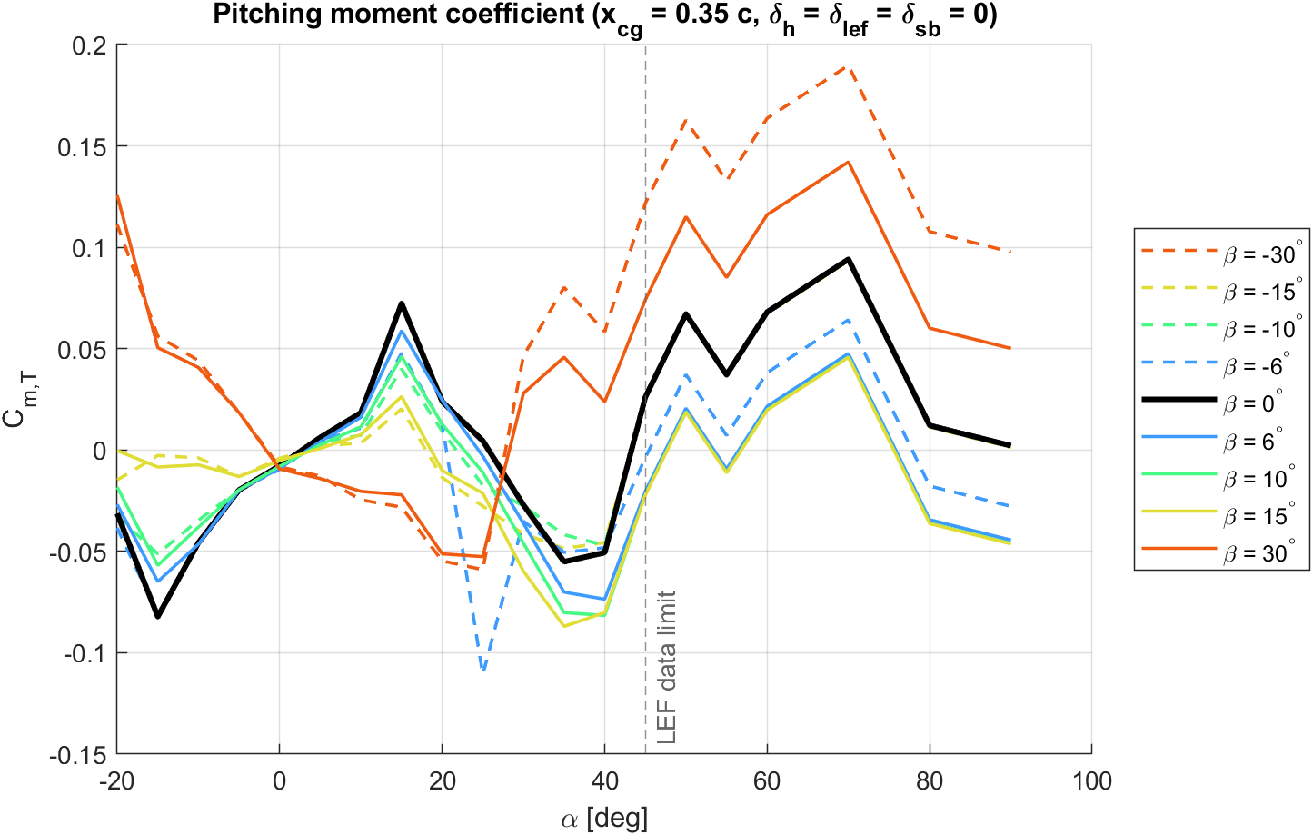
(a) $C_{m,t}\left(α\right)$
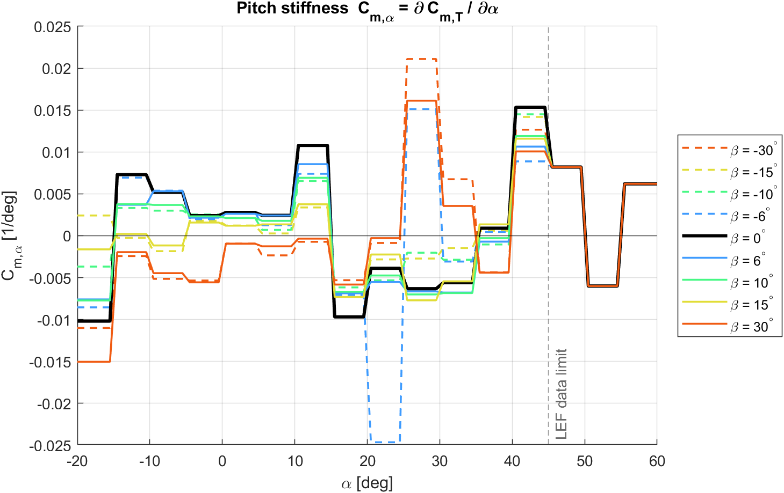
(b) $C_{m,t_{α}}\left(α\right)$ [1/deg]
Figure 5. Pitching moment coefficient and its derivative at nine sideslip angles.
Table 8. Regions with $C_{m,t_{α}}>0$ (statically unstable): $α$ ranges [deg].
$β$ [deg] | Unstable $α$ ranges | $β$ [deg] | Unstable $α$ ranges
−30 | 25…35, 40…50, 55…60 | 6 | −14.5…15, 40…50, 55…60
−15 | −20…−15, −4.5…14.5, 35.5…50, 55…60 | 10 | −14.5…15, 40…50, 55…60
−10 | −14.5…15, 40…50, 55…60 | 15 | −14.5…−10.5, −5…14.5, 35.5…50, 55…60
−6 | −14.5…15, 25.5…30, 35.5…50, 55…60 | 30 | 25…34.5, 40…50, 55…60
0 | −14.5…15, 35.5…50, 55…60
- $β=0$. The aircraft is longitudinally statically unstable for about $-{15}^{∘}<α<{15}^{∘}$. Near $α=0^{∘}$, $C_{m,t_{α}}≈+0.0026$ 1/deg and $C_{L_{α}}≈0.067$ 1/deg, placing the neutral point near $0.31 \overset{‾}{c}$ and the static margin at about −4% $\overset{‾}{c}$. With the center of gravity aft of the neutral point, this is the relaxed longitudinal static stability condition studied in TP-1538, where stability is provided by the flight control system [1]. The aircraft is stable for $α=15$–${35}^{∘}$, unstable again for 35–50°, stable for 50–55° and unstable for 55–60°.
- $β$ effect. For $\left|β\right|≤{10}^{∘}$, the curves are close. At $\left|β\right|={15}^{∘}$, the low-angle unstable region splits in two. At $\left|β\right|={30}^{∘}$, the low-angle instability vanishes, but high-angle instability begins earlier, at $α≈{25}^{∘}$.
- $β=-6^{∘}$ curve. The dip between $α=20$–${30}^{∘}$ comes from a single table data point (Section 8) and is absent from the symmetric $β=+6^{∘}$ curve.

8. Data Notes and Assumptions
- $C_{l_{p}}$, $α={55}^{∘}$. The course data gives −1200, whereas TP-1538 gives −0.12 (neighbors −0.10 and −0.14) [1]. It was corrected to −0.12 in memory in init_F16.m without modifying the data file. Verification cases do not use $α={55}^{∘}$.
- $C_{m,lef}$, $α={25}^{∘}$, $β=-6^{∘}$. The value is −0.1607, versus neighbors −0.0648 and −0.0558 and symmetric counterpart −0.0530; TP-1538 contains the same value [1]. Since the homework requires the given data, it was kept; it affects only the $β=-6^{∘}$ curve in Problem 2b.
- Assumptions. Table inputs and control deflections are in degrees, angular rates in rad/s, and $g=9.80665$ m/s². Since the last value is held beyond table limits, the LEF contribution for $α>{45}^{∘}$ stays at its 45° value. The engine angular momentum $H_{e}$ is constant and the initial actuator deflections are zero.

9. Conclusion
The six-subsystem F-16 plant model was built with basic Simulink blocks only, without the Aerospace Blockset. The aerodynamic and propulsion subsystems matched independent reference calculations in all ten and five homework cases, respectively, and the symmetry and sign checks agree with TP-1538 sign conventions [1]. Problem 2 shows that at the reference center of gravity the aircraft is longitudinally statically unstable at small angles of attack, with a static margin of about −4% $\overset{‾}{c}$, and becomes unstable again for $α=35$–${50}^{∘}$.

References
[1] Nguyen, L. T., Ogburn, M. E., Gilbert, W. P., Kibler, K. S., Brown, P. W., Deal, P. L., (1979) Simulator Study of Stall/Post-Stall Characteristics of a Fighter Airplane With Relaxed Longitudinal Static Stability, NASA Technical Paper 1538.
[2] Stevens, B. L., Lewis, F. L., Johnson, E. N., (2016) Aircraft Control and Simulation: Dynamics, Controls Design, and Autonomous Systems, 3rd Edition, John Wiley & Sons.
[3] Group 2, (2026) UUM523E-F16-Flight-Dynamics project repository, hw1 branch, https://github.com/emircansurucu/UUM523E-F16-Flight-Dynamics.

