FINAL PROJECT REPORT
BeePlan & KidTask
AI-Supported Software Development Project

1. Project Details & Access (Repository Access)
Project Information
- Project Name:
  - BeePlan
  - KidTask
- Developers:
  - Student A: Emir Cerrahoğlu - BeePlan – Weekly Course Scheduling System
  - Student B: Çağatay Temel - KidTask – Gamified Task & Wish Management System
- AI Tools Used:
  - Gemini
  - ChatGPT
  - Claude
GitHub Repository
- Repository Link:
  - 👉 https://github.com/emircerrahoglu/SENG383/tree/main
- Repository Structure (Checklist)
  - /src
    - beeplan.py
    - kidtask.java
  - [x] /docs
    - Final_Report.pdf
    - Class_Diagrams.pdf
    - Activity_Diagrams.pdf
  - [x] /video
    - Final_Presentation.mp4
  - [x] README.md
- README.md File:
  - Contains information regarding:
    - Project setup (Python environment, JDK installation)
    - Execution instructions
    - Required libraries (PyQt5 for BeePlan, standard Java libraries for KidTask)

2. Final Design Artifacts
2.1 Class Diagram
BeePlan (Python):
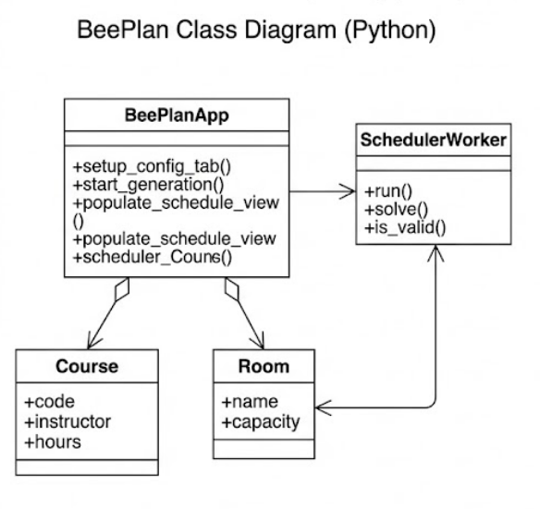
KidTask (Java):
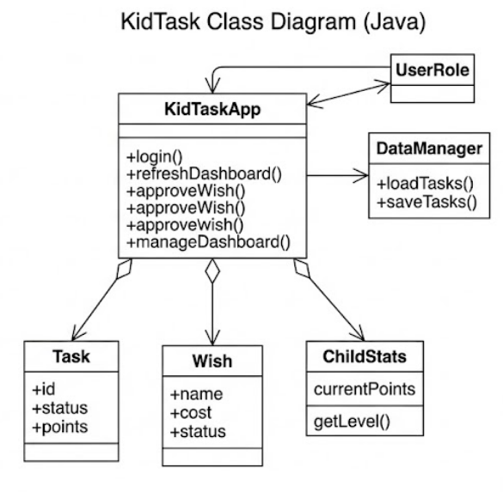
2.2 Activity Diagram
BeePlan (Scheduling Logic):
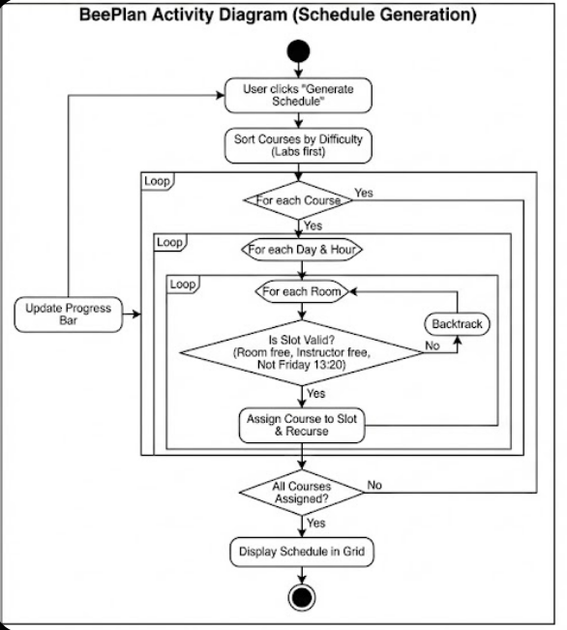
KidTask (Approval Flow):
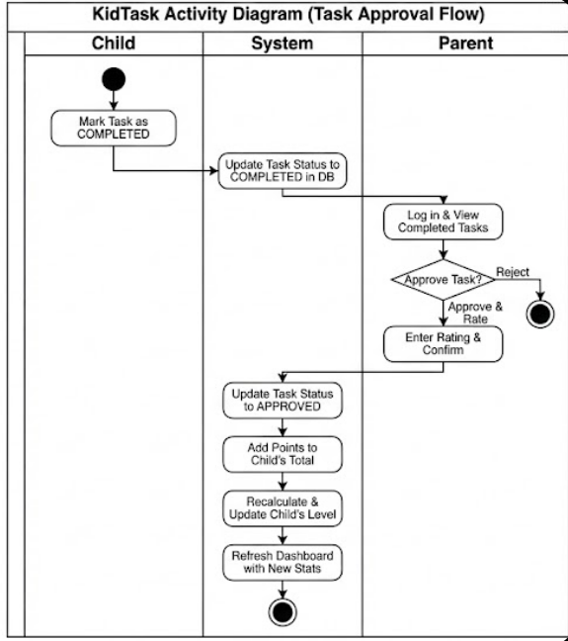

2.3 GUI Screenshots
- BeePlan:
- 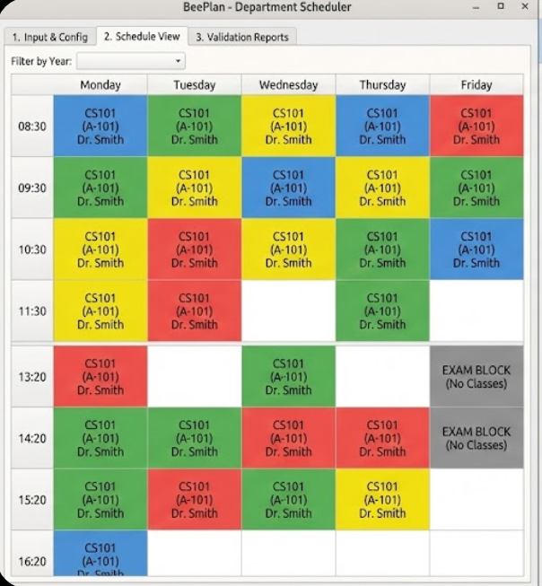
- KidTask:
- 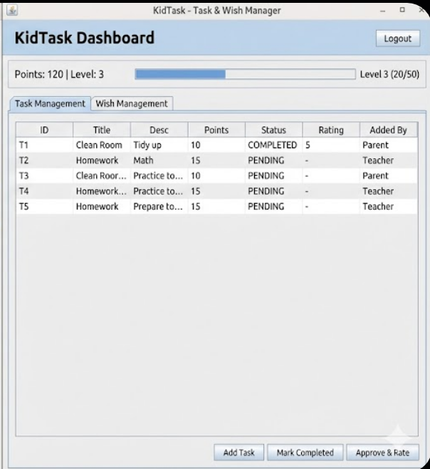

3. AI Usage & Prompts
The AI-supported development processes used in the project are detailed below.
3.1 AI Usage Table
Process | Tool Used | Prompt | AI Output Analysis | Human Intervention
GUI Design | Gemini | "Create a Python PyQt5 dashboard with 3 tabs: Config, Schedule Grid, and Reports. Use a table for the weekly schedule." | The layout was good, but the table columns didn't stretch to fit the window and cells were editable. | I added code to auto-stretch columns and disabled cell editing so users can't type over the schedule.
Coding | ChatGPT | "Write a Python backtracking algorithm for a course scheduler. Constraints: Friday afternoon is blocked, and rooms have capacity limits." | The algorithm worked but didn't check if an instructor was already teaching in another room at the same time. | I added a specific "is instructor busy?" check inside the main loop to prevent double-booking.
Coding | Claude | "Write a Java function for a parent to approve a task. It should change status to APPROVED and add points." | The code allowed parents to approve tasks that the child hadn't even finished yet. | I added an if statement to ensure tasks are marked "COMPLETED" by the child before a parent can approve them.
Testing | ChatGPT | "Look for bugs in this Python scheduling function where it might get stuck or not clear old data." | AI found that when the algorithm backtracked (tried a new path), it forgot to delete the old "ghost" schedule data. | I added a line to explicitly remove the failed schedule assignment before trying the next option.
Reporting | Gemini | “Summarize AI usage ” | Too academic | Simplified
3.2 Prompt → Output → Revision Example
Prompt: “Write a Java method for the 'Redeem' button that subtracts points when a child selects a wish.”
AI Output: The generated code successfully checked if the child had enough points and deducted them. However, it failed to check if the parent had actually approved the wish first.
Revision: I added a validation condition. This ensures a child cannot redeem a reward until the parent has explicitly changed its status from REQUESTED to APPROVED.

4. V&V Test Reports (Verification & Validation)
4.1 Test Case Table
Test Case | Scenario | Expected Result | Actual Result
TC-01 | Assigning a "Lab" course to a "Classroom" | Room type mismatch error | Successful
TC-02 | Instructor assigned >4 hours in one day | 5th hour is blocked | Successful
TC-03 | Child attempts to click "Approve Task" | "Permission Denied" popup | Successful
TC-04 | Redeeming wish with insufficient points | Transaction blocked | Successful

4.2 Bug Resolution with AI Tutor
- Bug 1:
  - Issue: Schedule generation was too slow/timed out.
  - Solution: AI suggested sorting "Lab" courses first to speed up the solver.
- Bug 2:
  - Issue: Child users could click the "Approve Task" button.
  - Solution: Role validation was added to the button listener to block unauthorized actions.

4.3 Peer Review Findings
- Student A → Student B:
  - Observation: Entering a comma in a Task description broke the CSV save file structure.
  - Solution: Added input sanitization to replace commas with dashes before saving to file.
- Student B → Student A:
  - Observation: The application crashed if "Generate Schedule" was clicked before loading data.
  - Outcome: Added an error message popup to prevent the algorithm from running on empty lists.

