GDV Report
Attack patterns from FIFA World Cup 2022 data
A practical exploratory visualization project for amateur coaches

Name | Emir Can
Module | Fundamentals of Data Visualization
Semester | FS26
Dataset | StatsBomb Open Data, FIFA World Cup 2022
Notebook | EDA_GDV_final_abgabe.ipynb
Submission | Final version
Method | Penalty shootouts excluded. Set pieces in regular play are marked as context.

Main text covers sections 1 to 6. Figures, evaluation notes and references follow after the main text.

Short summary
This project looks at simple attacking patterns from the FIFA World Cup 2022 and asks what amateur coaches can learn from them. I do not treat professional match data as a direct training recipe. The aim is more realistic: the data can make repeated patterns visible and help coaches discuss useful training situations. The main research question is: Which simple attacking patterns from the FIFA World Cup 2022 can amateur coaches use as ideas for training? To answer this, I analysed shots, goals, successful passes before shots, entries into the attacking third, entry methods and expected goals. The results suggest that dangerous attacks do not only come from long possession phases. Many shots and goals happen after few or medium length passing sequences. The important point is not only the number of passes, but whether the ball reaches dangerous spaces and whether the team creates a shot soon after entering the attacking third.

1. Research question and use case
The target users are amateur coaches and football interested readers with basic football knowledge. In amateur football, training time is limited. For that reason, the analysis focuses on questions that are easy to explain and possible to translate into exercises. Do shots and goals happen more often after few passes or after longer passing sequences? Which pass categories are common, and which ones have a higher goal conversion rate? Which teams create shots after entering the attacking third? How does the ball enter this area, by long passes, short passes, carries or attacks that already start high up the pitch? Finally, one Spain example is used to connect the general patterns with a concrete coaching idea.
The analysis is descriptive. It does not prove that one attacking method is always better than another. It also does not claim that World Cup tactics can be copied directly into amateur football. The value is that the visualizations make patterns visible and support simple coaching discussions, for example about the first forward pass after winning the ball, support runs after an entry and quick occupation of shooting areas.

2. Data and preparation
The project uses StatsBomb Open Data from the FIFA World Cup 2022. The data is event data. This means that it contains recorded actions such as passes, carries and shots, together with locations on the pitch and extra information such as expected goals. Expected goals, or xG, estimates the chance that a shot becomes a goal based on similar shots. A higher xG value means a better chance quality, but it is still only an estimate.
From the raw data, I created three working tables. The first table contains shots and goals. For every shot, I counted how many successful passes happened earlier in the same possession. The second table contains entries into the attacking third. An entry is counted when the ball is moved from outside the attacking third into the area close to the opponent goal. After each entry, I checked whether the same possession later produced a shot or a goal. The third table contains team level summaries, for example average passes before goals and rates after entries.
Penalty shootouts were excluded because they are not normal attacking possessions. Penalties, free kicks and corners during regular play remain in the data because they are part of the match context, but they are treated carefully in the interpretation. The main limitation is that event data does not show complete off ball movement, pressing structure or tactical instructions.

3. Design approach and theory
The report follows a simple visual story. First, it gives an overview of pass categories before shots and goals. Then it separates frequency from efficiency. After that, it moves to entries into the attacking third, entry methods, start zones and team style. The last figure is a Spain use case. This order follows the idea of starting with the purpose, then choosing the relevant data and then selecting suitable visual encodings.
For category comparisons, I used bar charts because values on a common baseline are easy to compare. This fits the perception research by Cleveland and McGill, where position and length are more accurate than area or angle. For team comparisons, I used a lollipop style plot. It keeps the ranking readable and looks lighter than many full bars. For the Spain use case, I used a pitch plot because the position on the field is part of the message. I avoided more decorative graphics when they did not help answer the research question. Earlier heatmap ideas looked interesting, but they made the coaching message less direct.

4. Results
Figure 1 shows that almost half of all shots and goals happen after zero to three successful passes. This does not mean that very direct attacks are always the best option, but it shows that short attacking sequences are common in this World Cup data. For amateur coaches, this supports training situations such as winning the ball, playing the first forward pass and reaching a shooting option quickly.
Figure 2 separates frequency from conversion. In the data, the category with four to six passes has the highest goal conversion rate. This is useful because it shows that the most common pattern is not automatically the most efficient one. A practical training idea is to work on attacks that are still quick, but controlled enough to create a better shooting position.
Figures 3 and 4 look at entries into the attacking third. Some teams were better at turning entries into shots, and long passes had a high shot rate after entry in this dataset. This should not be read as proof that long passes are always better. It is better to read it as one possible training scenario: a forward pass into space, immediate support around the ball and a fast shot option.
Figure 5 simplifies the start zones of goal attacks. The simplified zones are less precise than a detailed heatmap, but they are easier to understand for the target audience. Figure 6 compares team directness. It is a style comparison, not a quality ranking. A team with fewer passes before goals is not automatically better than a team with longer build up play. Figure 7 uses Spain as an example and shows where entries into the attacking third created xG. This connects the data story to a concrete coaching discussion about entries, support and chance quality.

5. Evaluation and iteration
I conducted a short formative evaluation with three football interested participants. They looked at the final figures and answered tasks about pass categories, conversion rate, entries into the attacking third, entry methods, start zones, team directness and the Spain plot. The goal was not to run a statistical study. The goal was to check whether the figures could be understood and whether the captions or labels needed improvement.
The simple comparison charts were understood fastest. Participants could explain that many shots and goals happened after few passes, and they understood the team directness ranking as a style comparison. The more complex figures needed more explanation. One participant first read the entry method chart too strongly as tactical advice. Another participant needed the xG areas in the Spain plot explained more directly. Because of this feedback, I strengthened the captions, added clearer percentage labels, explained xG in the figure and added more explicit wording that the analysis is descriptive and not causal. This made the final report more honest and easier to read.

6. Limitations and conclusion for training
The results should be interpreted carefully. Event data shows actions on the ball, but not all runs away from the ball. It also cannot show the coach instructions behind an attack. Opponent strength, game state, match phase and player quality can influence every result. Set pieces during regular play remain part of the data, so they can affect direct attacks and high xG values. Penalty shootouts were excluded because they do not represent normal attacking patterns.
For amateur coaches, the most useful conclusion is not a fixed rule, but a set of training ideas. The data supports exercises around the first forward pass after winning possession, fast support after entering the attacking third and quick occupation of shooting areas. From a GDV perspective, the project also showed that simple and well explained visualizations are often more useful than complex graphics that look impressive but are harder to read.
End of main text. Figures, evaluation notes and references follow in the appendix.

Appendix A. Final visualizations
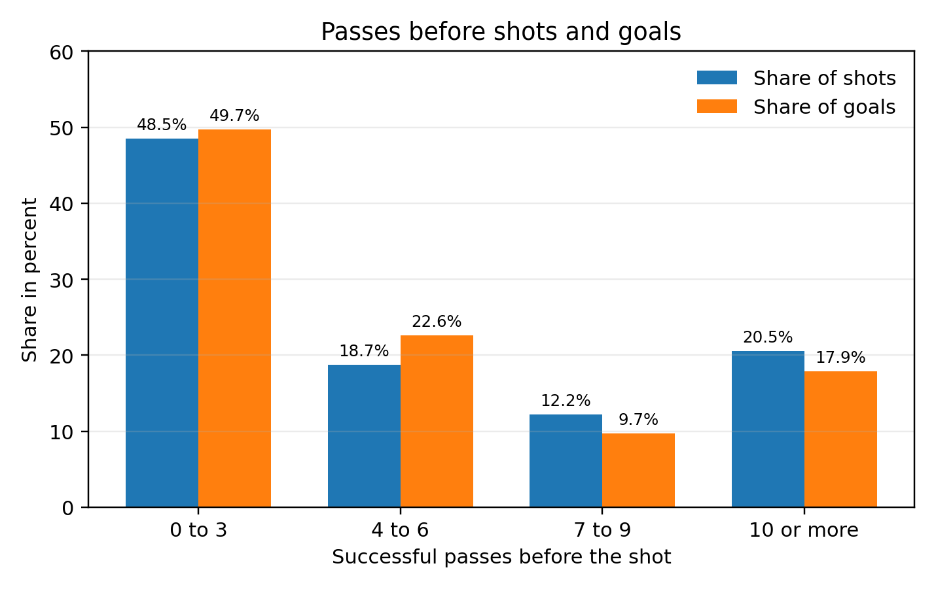
Figure 1. Share of shots and goals by pass category. The figure shows whether shots and goals happen more often after few or many successful passes.
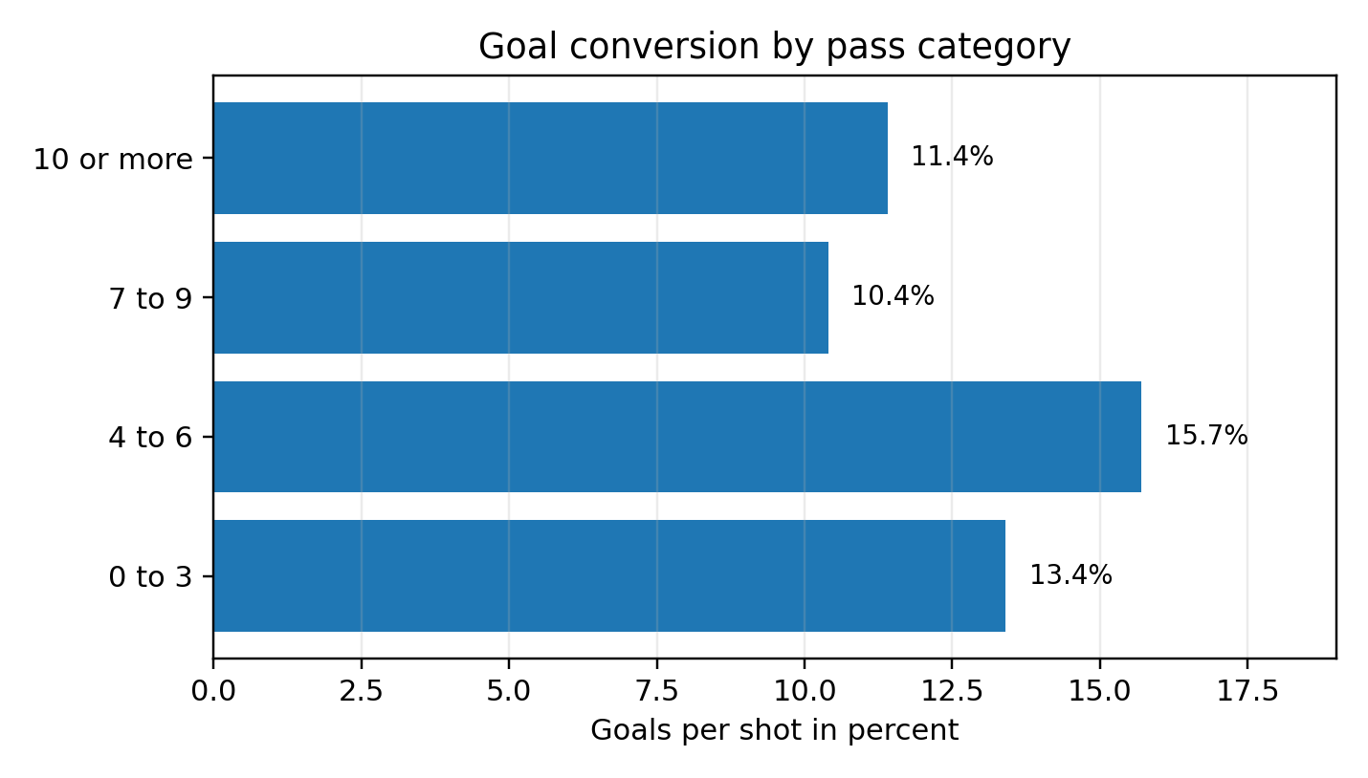
Figure 2. Goal conversion rate by pass category. The figure separates frequency from efficiency and should be read as descriptive, not causal.

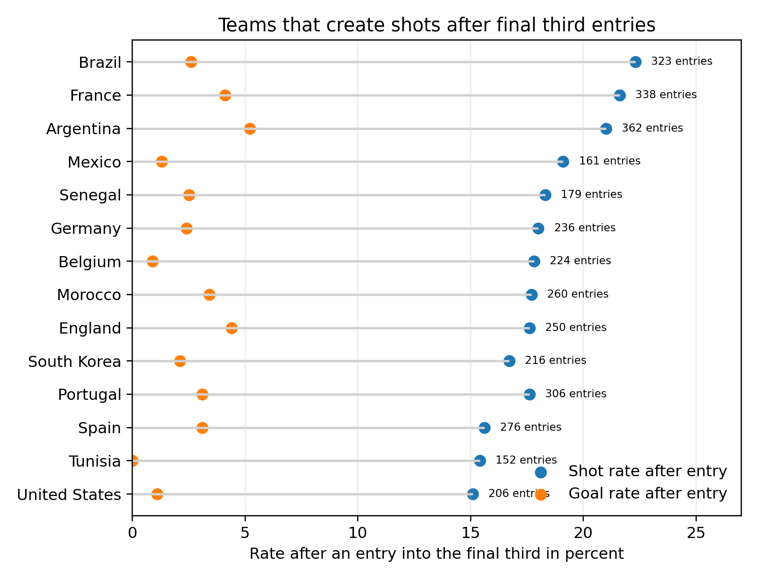
Figure 3. Teams with high shot rates after entries into the attacking third. The plot connects progression into dangerous areas with the outcome after the entry.
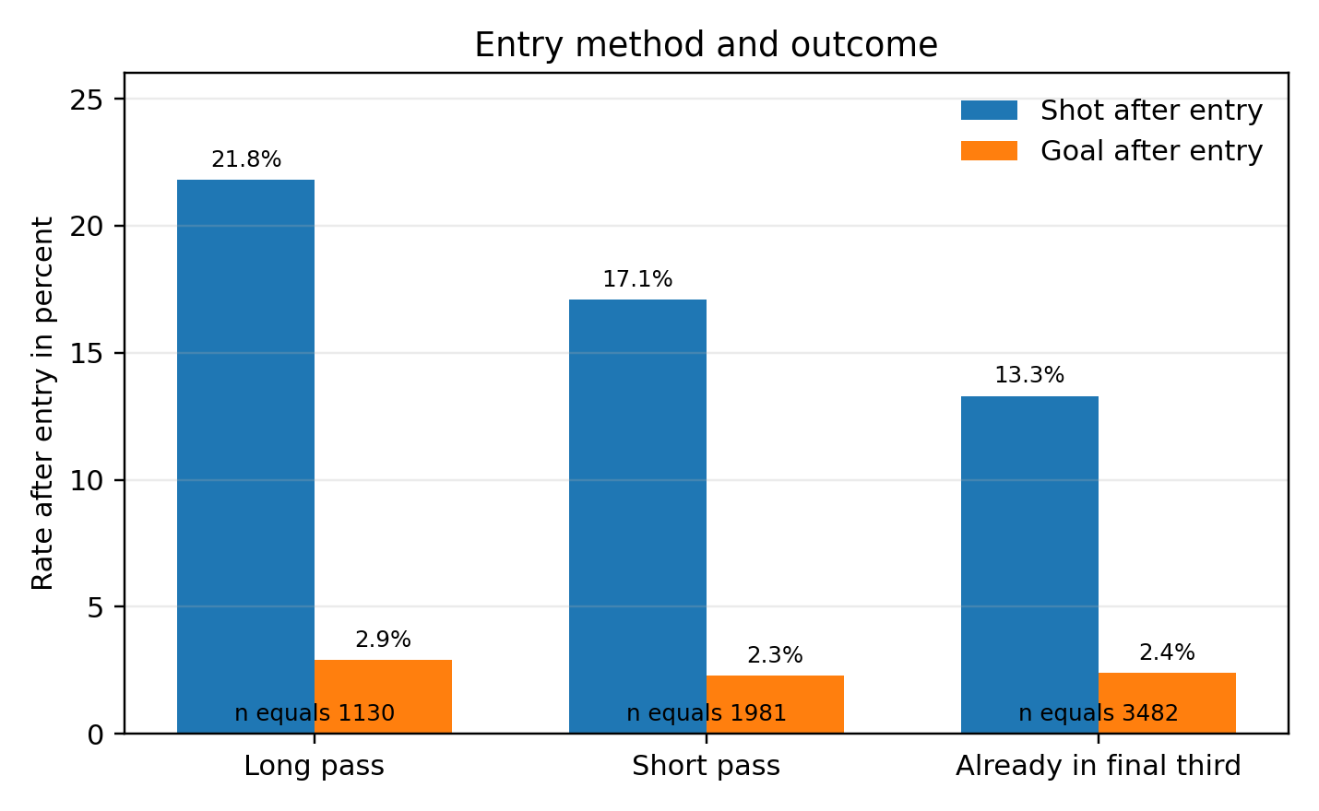
Figure 4. Entry method and outcome. The figure compares long passes, short passes and high starts by shot rate and goal rate after the entry.

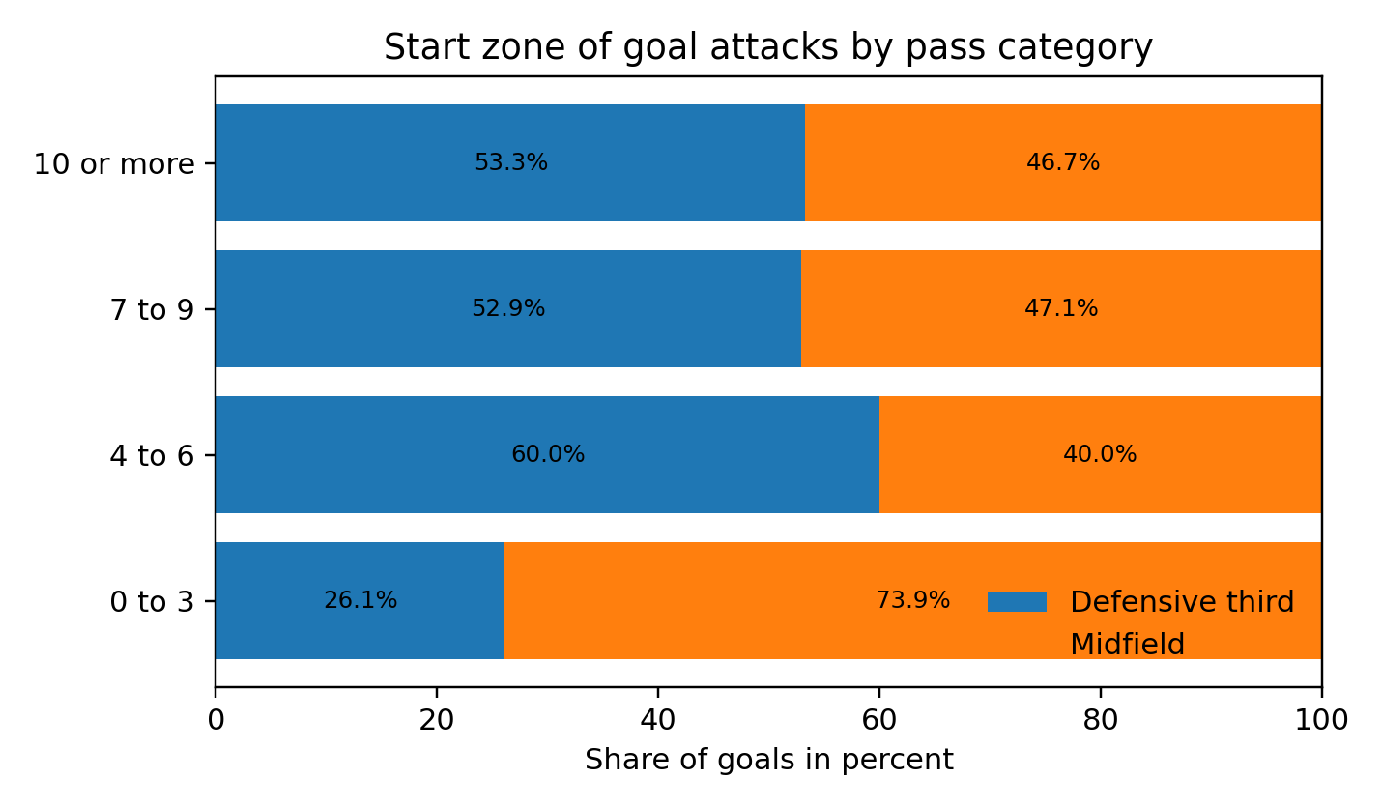
Figure 5. Start zone of goal attacks by pass category. The simplified zones make the origin of goal attacks easier to explain.
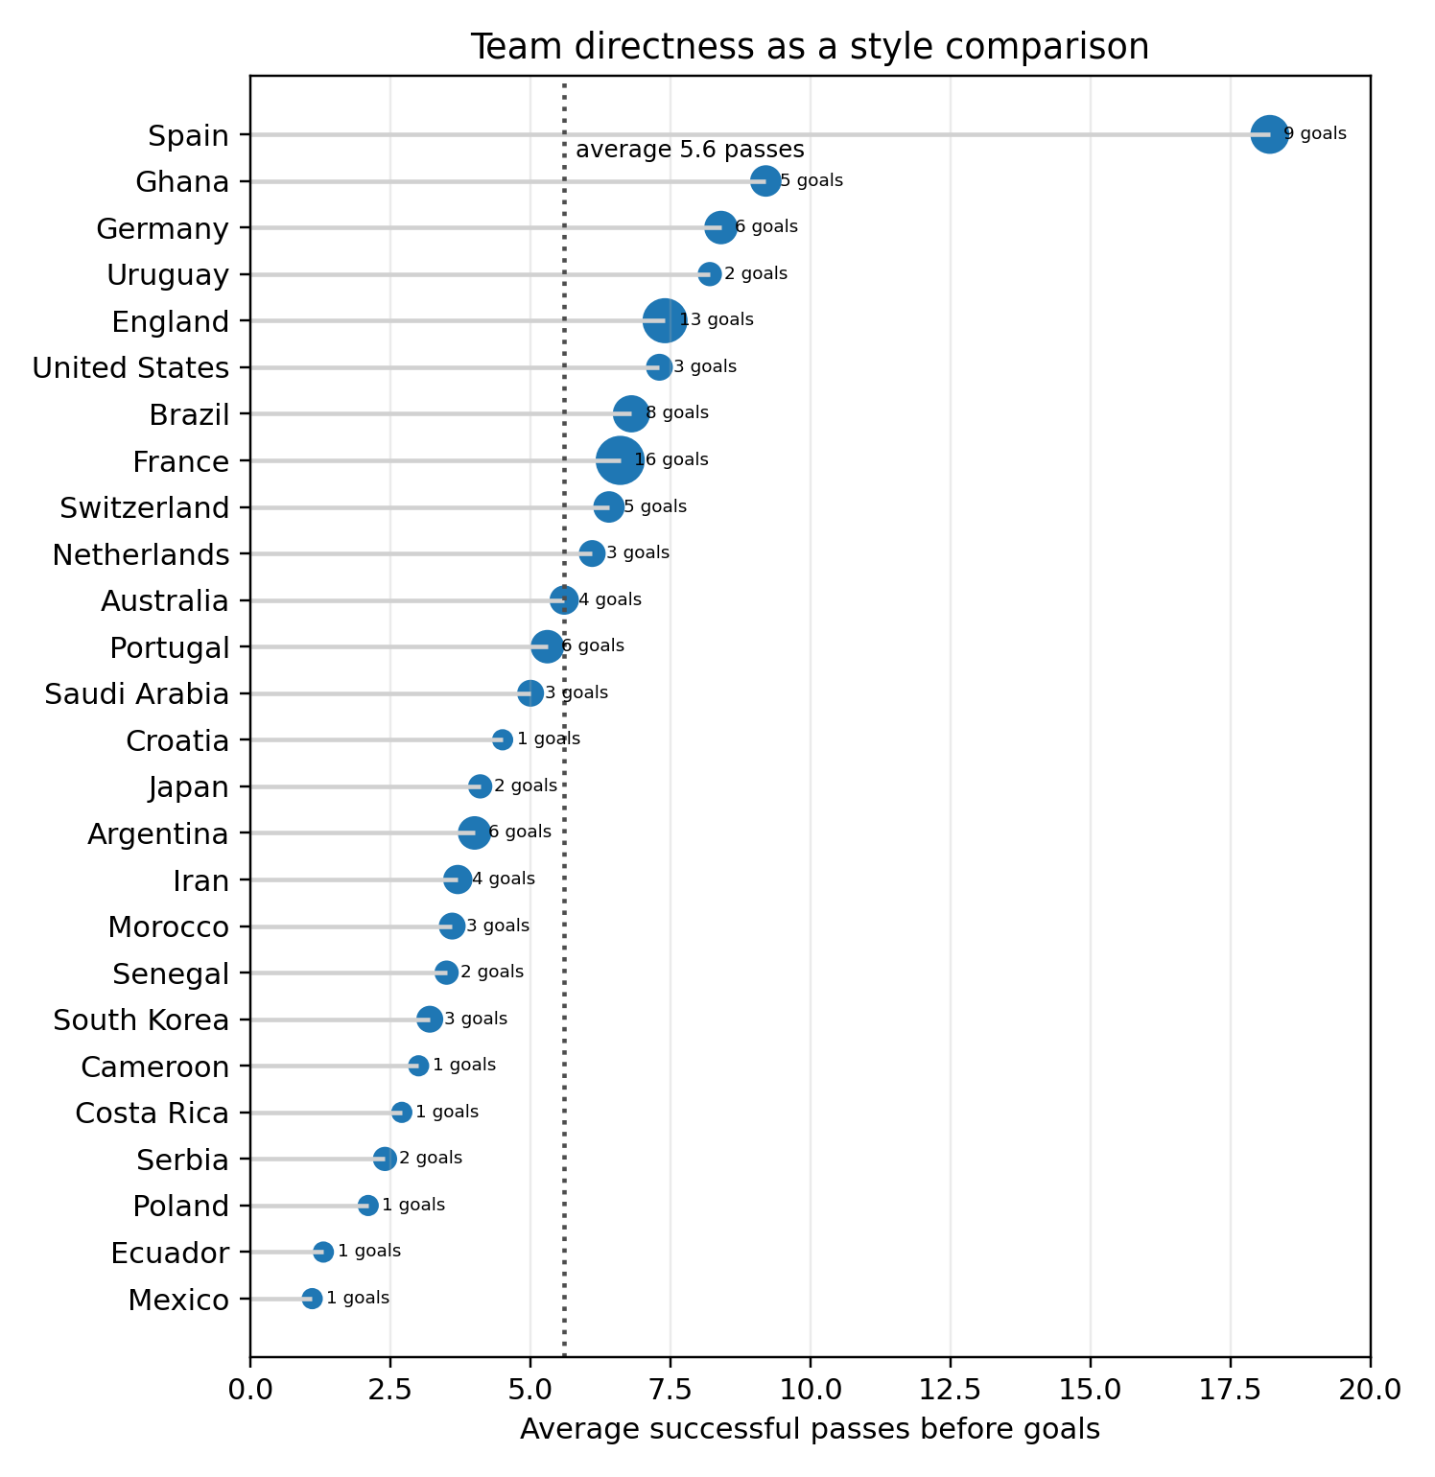
Figure 6. Team directness as a style comparison. The lollipop plot shows the average number of successful passes before goals.

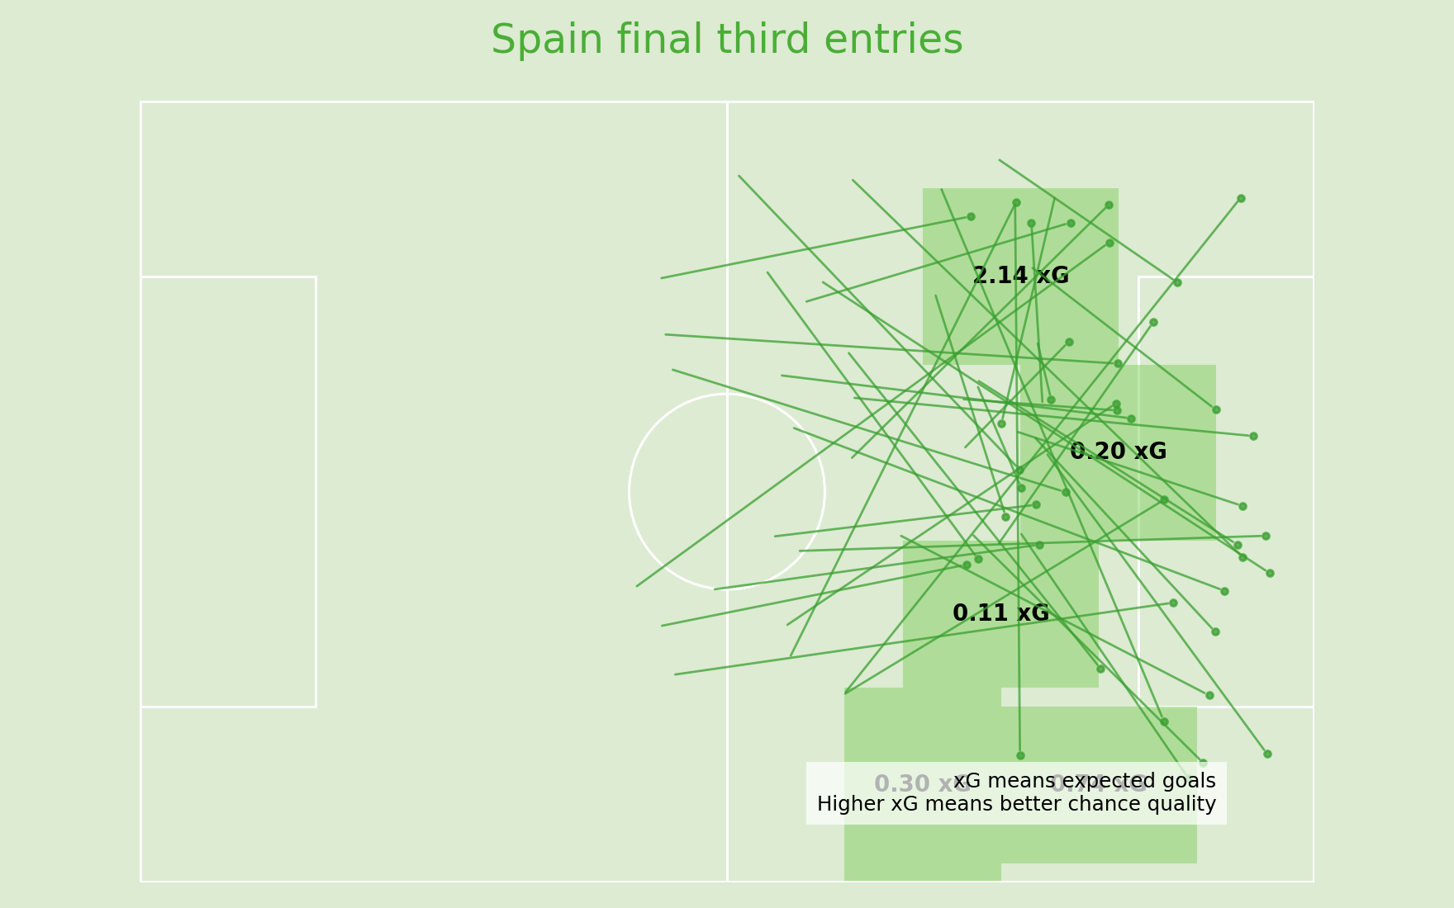
Figure 7. Spain entries into the attacking third. Green areas show summed xG by entry zone, and lines continue from entries to shots.

Appendix B. Evaluation material and iteration
Method: short formative evaluation with three football interested participants.
Tasks: participants read the final figures and answered questions about pass categories, conversion rate, entries, entry methods, start zones and the Spain plot.
Main observation: simple bar charts and ranking plots were understood fastest. Figures with several layers needed clearer legends and captions.
Applied improvements: clearer titles, direct percentage labels, xG explanation in the Spain figure, stronger captions and a clear note that the analysis is descriptive and does not prove causality.

References
StatsBomb. (n.d.). StatsBomb Open Data. GitHub repository.
Cleveland, W. S., and McGill, R. (1984). Graphical perception: Theory, experimentation, and application to the development of graphical methods. Journal of the American Statistical Association, 79(387), 531 to 554.
Munzner, T. (2014). Visualization Analysis and Design. CRC Press.
Franconeri, S. L., Padilla, L. M., Shah, P., Zacks, J. M., and Hullman, J. (2021). The science of visual data communication: What works. Psychological Science in the Public Interest, 22(3), 110 to 161.
Wilke, C. O. (2019). Fundamentals of Data Visualization. O Reilly Media.

