GDV Report
Attack Patterns from FIFA World Cup 2022 Data
A practical exploratory visualization project for amateur coaches

Emircan Bagcivan
Fundamentals of Data Visualization
FS26

Inhalt
List of Figures 2
Abstract 3
1. Research question and use case 3
1.1 Research question 3
1.2 Target audience 3
1.3 Scope and boundaries 3
2. Data and preparation 3
2.1 Dataset 3
2.2 Working tables 4
2.3 Filtering decisions 4
2.4 Data limitations 4
3. Design approach and visualization choices 4
3.1 Visual story 4
3.2 Chart choices 4
3.3 Colour use 4
4. Tournament level results 5
4.1 Shot and goal volume by pass category 5
4.2 Efficiency by pass category 5
4.3 Shot rates after final third entries 6
4.4 Entry methods and outcome 7
4.5 Start zones of goal attacks 8
4.6 Team directness as a style comparison 9
5. Spain case study after feedback 10
5.1 Original Spain plot before redesign 10
5.2 Numbered pass sequences before Spain goals 10
5.3 Final third entry lane quality 11
5.4 Spain shots by pass combination 12
6. Formative evaluation 13
6.1 Method 13
6.2 Main feedback 13
6.3 Changes after evaluation 13
7. Limitations and training conclusions 14
7.1 Analytical limitations 14
7.2 Training conclusions 14
8. GDV reflection 14
References 14

List of Figures
Figure 1. Regular shots and goals by build up category. Each bar shows the number of regular shot sequences and goals after the respective number of completed passes.
Figure 2. Build up efficiency by pass category. Bars show goal conversion rate and the line shows average xG per regular shot. The two axes use different scales.
Figure 3. Shot and goal rates after final third entries. Teams are ranked by shot rate after entering the final third.
Figure 4. Entry method and outcome. The bars compare shot and goal rates for carries, long passes, short passes and possessions already starting in the final third.
Figure 5. Start zone of goal attacks by pass category. The zones are simplified into defensive third, middle third and final third.
Figure 6. Team directness as a style comparison. The plot shows the average number of completed passes before goals for teams with at least two analysed goals.
Figure 7. Original Spain final third plot before redesign. The plot was visually interesting, but it combined zones, lines, points and labels in one view.
Figure 8. Numbered Spain pass sequences leading to goals. Each panel shows one Spain goal build up and the numbers show the order of completed passes.
Figure 9. Spain chance quality by final third entry lane. The plot shows total xG, chances, entries and chance rate by lane.
Figure 10. Spain shots after pass combinations. The plot compares how many Spain shots after short, medium and long pass sequences became goals.

Abstract
This project analyses simple attacking patterns from the FIFA World Cup 2022 and asks what amateur coaches can realistically take from them. The analysis uses StatsBomb event data and focuses on regular shot sequences, final third entries, entry methods, expected goals and a Spain case study.
The main result is that dangerous attacking situations do not always need long passing sequences. Many regular shots in the tournament came after short possessions with few completed passes. At the same time, the efficiency values show that frequency alone is not enough. A pattern can create many shots, but the quality of those shots also matters.
For coaching, the practical message is to combine ball progression with control. Teams should practise how to move the ball into dangerous zones, how to support the player on the ball and how to prepare a shot option after entering the final third. The analysis remains descriptive and should be used as training inspiration, not as fixed tactical rules.

1. Research question and use case

1.1 Research question
Which simple attacking patterns from the FIFA World Cup 2022 can amateur coaches use as ideas for training?
The analysis focuses on regular football situations. Penalty shootouts, penalties and direct free kick shots are excluded because these situations do not describe normal attacking build up.

1.2 Target audience
The main audience is amateur coaches and football interested players with basic football knowledge. Amateur teams often have limited training time and cannot prepare in detail for every opponent. World Cup data can therefore be a useful reference point, because national teams also have limited preparation time during a tournament.
The project does not claim that amateur teams should copy professional football directly. That would often be unrealistic because player quality, training time and tactical structure are different. The goal is more practical: to find simple attacking principles that can be discussed and adapted in training.

1.3 Scope and boundaries
The results are descriptive patterns from one tournament. They show what happened in the data, but they do not prove that one attacking style is always better. Opponent strength, match state, individual player quality and game phase can all influence the observed patterns.

2. Data and preparation

2.1 Dataset
The project uses StatsBomb Open Data from the FIFA World Cup 2022. The data is event data. This means that every action on the ball, for example a pass, carry or shot, is stored as a separate row with coordinates and context information.
Expected goals, called xG in this report, estimate how likely a shot is to become a goal. The value is based on factors such as shot position, angle and similar historical situations. A higher xG value means a better chance, but it is still only a statistical estimate.
A final third entry means the first action in a possession that moves the ball from outside the final third into the final third. In this report, entries are used to study how teams arrive in dangerous areas before a shot is created.

2.2 Working tables
Three working tables were created from the raw event data.
Table | Content | Size
Shot sequences | One row per regular shot. Contains completed passes in the possession, start zone, xG and outcome. | 1,145 shots and 123 goals
Final third entries | One row per possession that moved the ball into the final third. Contains entry method and following outcome. | 7,456 entries
Team summary | One row per team. Contains shot rates after entries and average passes before goals. | 32 teams

2.3 Filtering decisions
Penalty shootouts, penalties and direct free kick shots are excluded from the main analysis. These situations create shots without normal attacking build up and would distort the shortest pass category. Corners and throw ins remain in the data because they can continue as normal attacking sequences.

2.4 Data limitations
The data only records actions on the ball. Off ball movement, pressing structure and exact coach instructions are not included. Because of that, the results should be interpreted as descriptive patterns, not as causal proof.

3. Design approach and visualization choices

3.1 Visual story
The report starts with a general question: how many completed passes happen before regular shots and goals? After that, frequency and efficiency are separated. The analysis then looks at final third entries, entry methods, start zones and team directness. The last part uses Spain as a more detailed case study.

3.2 Chart choices
Bar charts are used for category comparisons because values on a common baseline are easy to compare. This makes them suitable for an audience that knows football but does not necessarily have a data science background.
Ranking plots are used for team comparisons because they keep many team names readable. Pitch based plots are used only when the spatial position on the field is important. The original Spain pitch plot was later redesigned because it contained too many visual elements at once.

3.3 Colour use
The colour design is kept simple. Colours are used to highlight one main idea at a time. In the final Spain plots, the most important category or lane is emphasised while less important values are shown more quietly. This creates a clearer visual hierarchy and reduces visual noise.

4. Tournament level results

4.1 Shot and goal volume by pass category
The first figure shows the number of regular shots and goals by pass category. The category with the fewest completed passes creates the largest number of regular shots. This suggests that quick ball progression was a common way to reach shooting situations in the tournament.
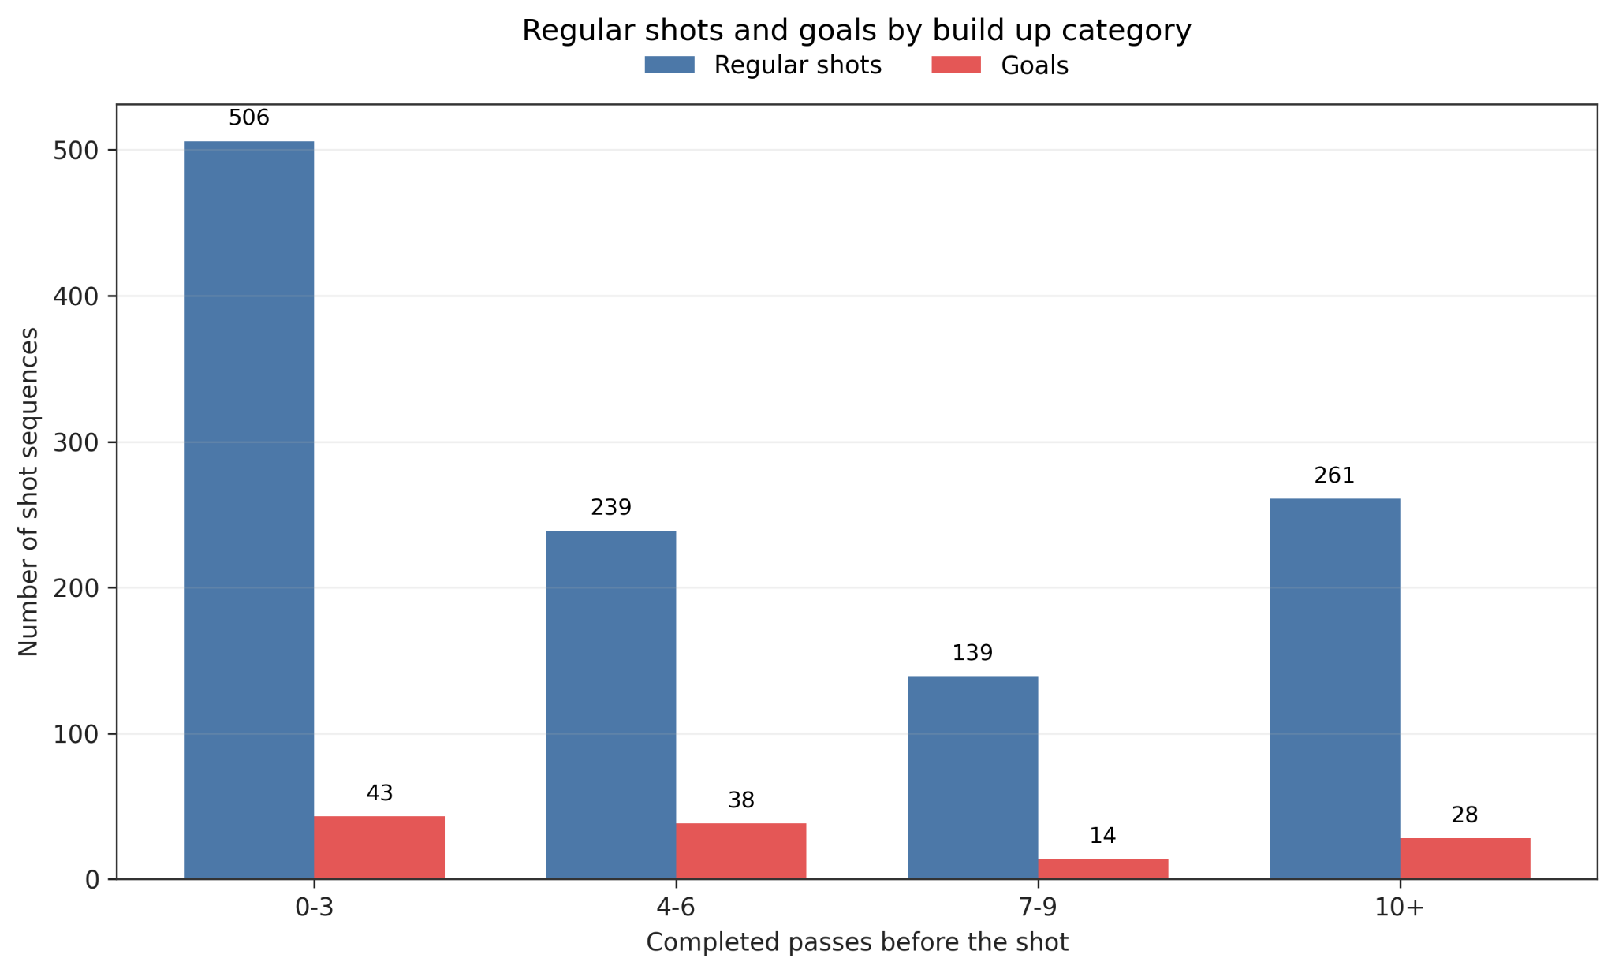
Figure 1. Regular shots and goals by build up category. Each bar shows the number of regular shot sequences and goals after the respective number of completed passes.

4.2 Efficiency by pass category
The second figure separates frequency from efficiency. A pass category can create many shots without being the most efficient one. For coaching, this means that the number of shots and the quality of the shot position should be considered together.
The bars show goal conversion rate, while the line shows average xG per regular shot. The two axes have different scales and should not be compared directly.
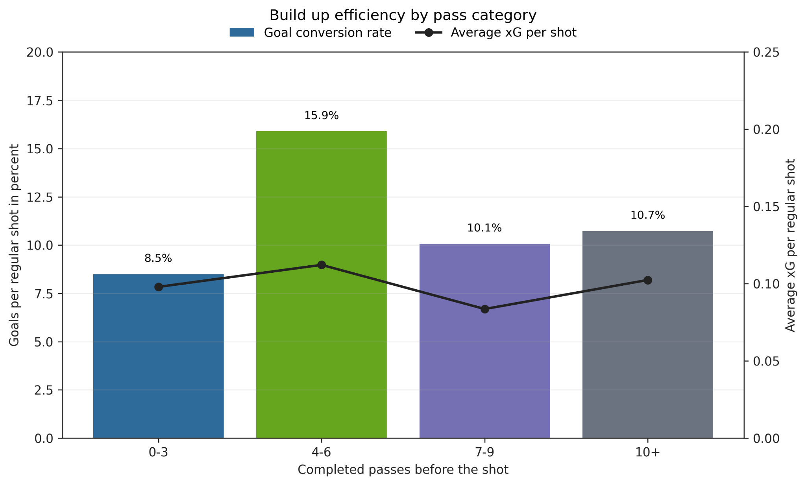
Figure 2. Build up efficiency by pass category. Bars show goal conversion rate and the line shows average xG per regular shot. The two axes use different scales.

4.3 Shot rates after final third entries
The third figure shows which teams converted final third entries into shots most often. This is not a quality ranking. It only shows how often a team produced a shot after moving the ball into the final third.
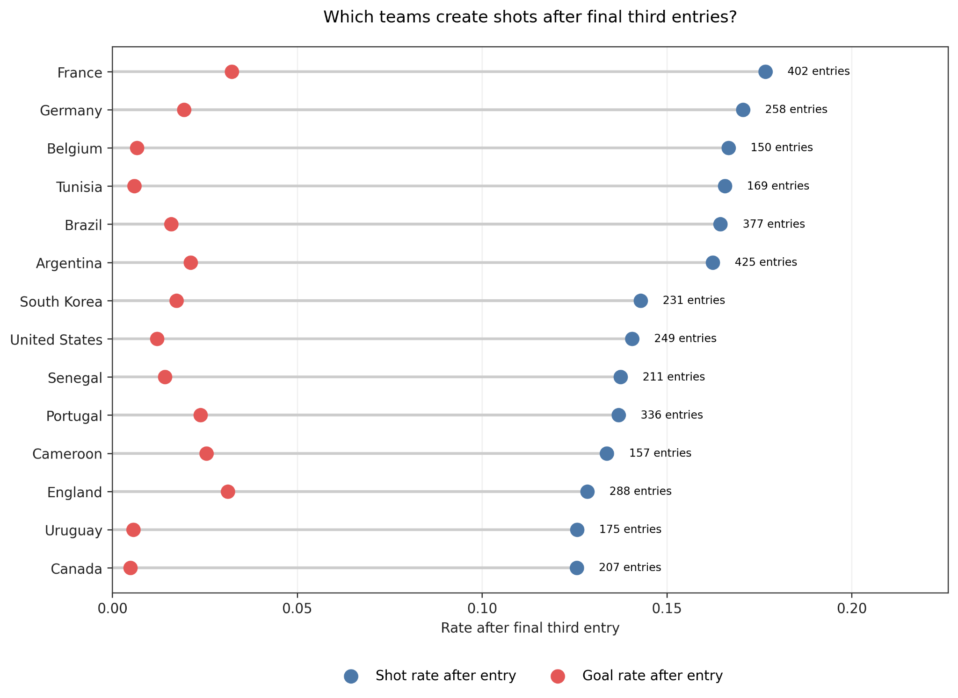
Figure 3. Shot and goal rates after final third entries. Teams are ranked by shot rate after entering the final third.

4.4 Entry methods and outcome
The fourth figure compares different ways of entering the final third. Carries, long passes, short passes and possessions that already start in the final third are compared by shot rate and goal rate.
The practical training idea is not to always play long balls or always dribble. The useful point is to move the ball forward dynamically, support the ball carrier quickly and prepare shot options before or immediately after the entry.
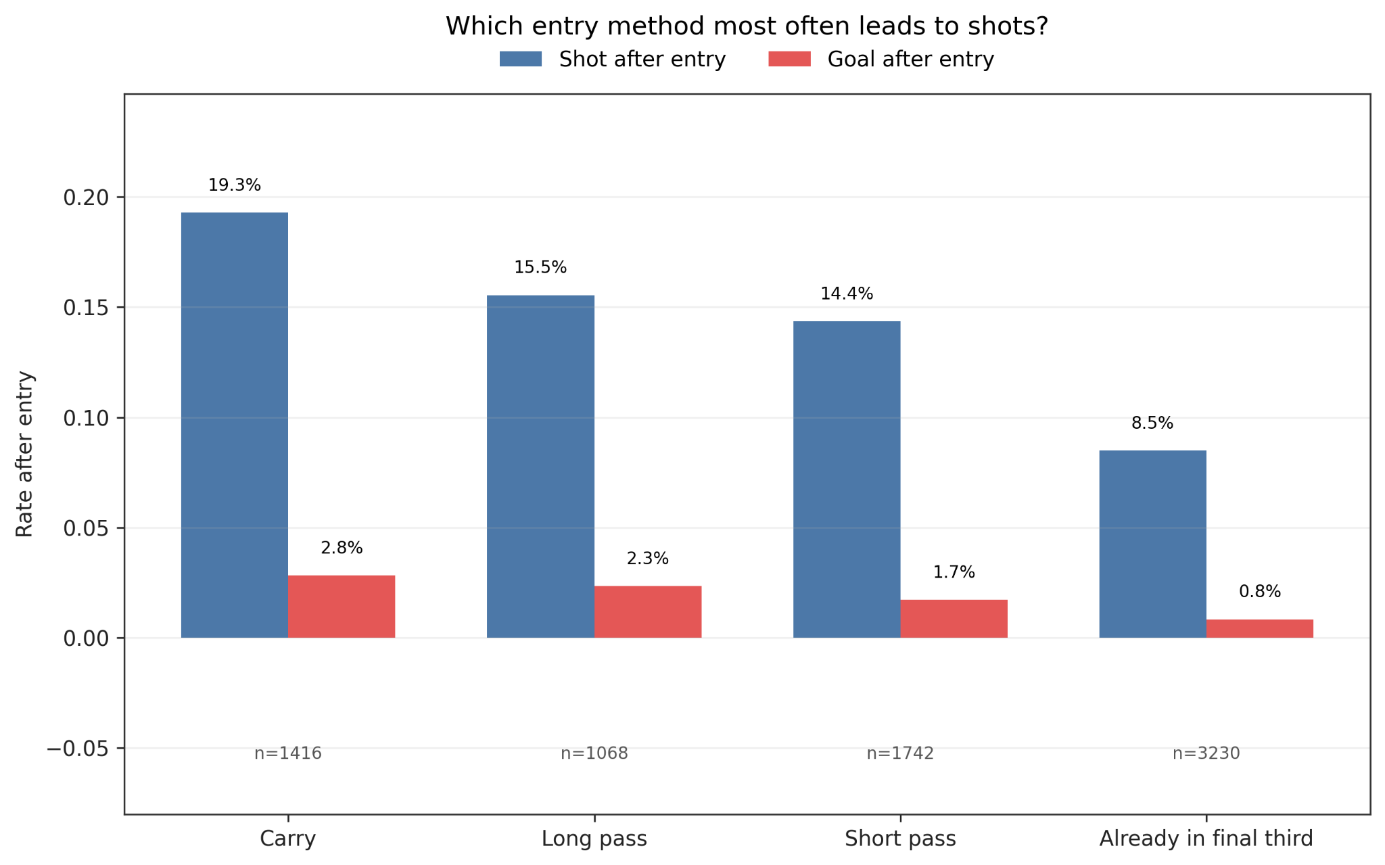
Figure 4. Entry method and outcome. The bars compare shot and goal rates for carries, long passes, short passes and possessions already starting in the final third.

4.5 Start zones of goal attacks
The fifth figure shows from which field zones goal attacks started. The zones are simplified into defensive third, middle third and final third. Because only goal attacks are shown, some values are based on small counts and should be interpreted carefully.
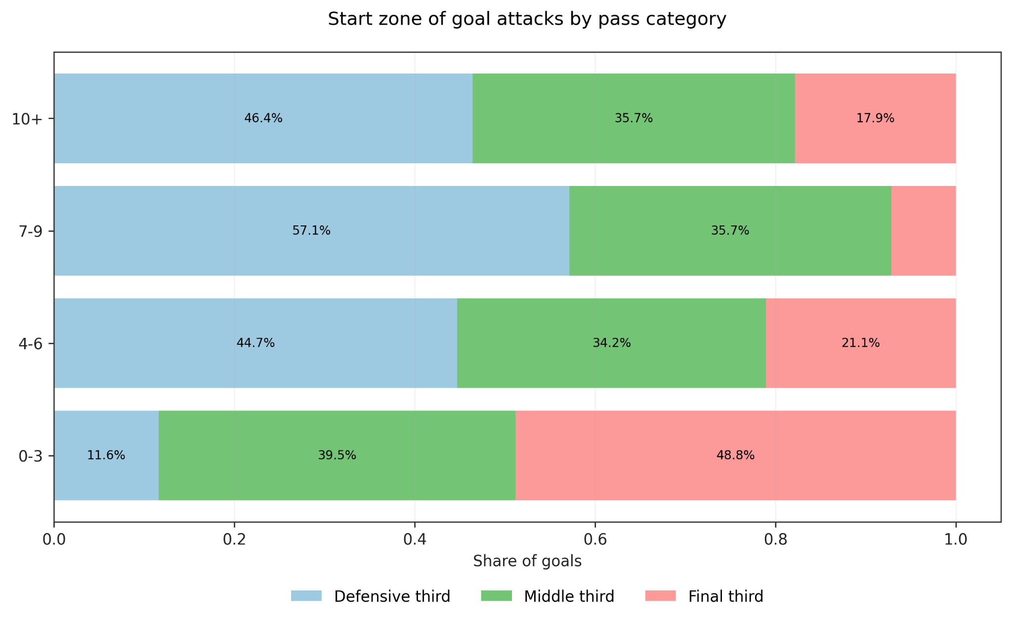
Figure 5. Start zone of goal attacks by pass category. The zones are simplified into defensive third, middle third and final third.

4.6 Team directness as a style comparison
The sixth figure shows the average number of completed passes before goals for teams with at least two analysed goals. Spain stands out with a much higher average, which fits their possession based playing style.
This plot should be read as a style comparison, not as a quality ranking. Fewer passes before goals do not automatically mean better football, and more passes do not automatically mean worse football.
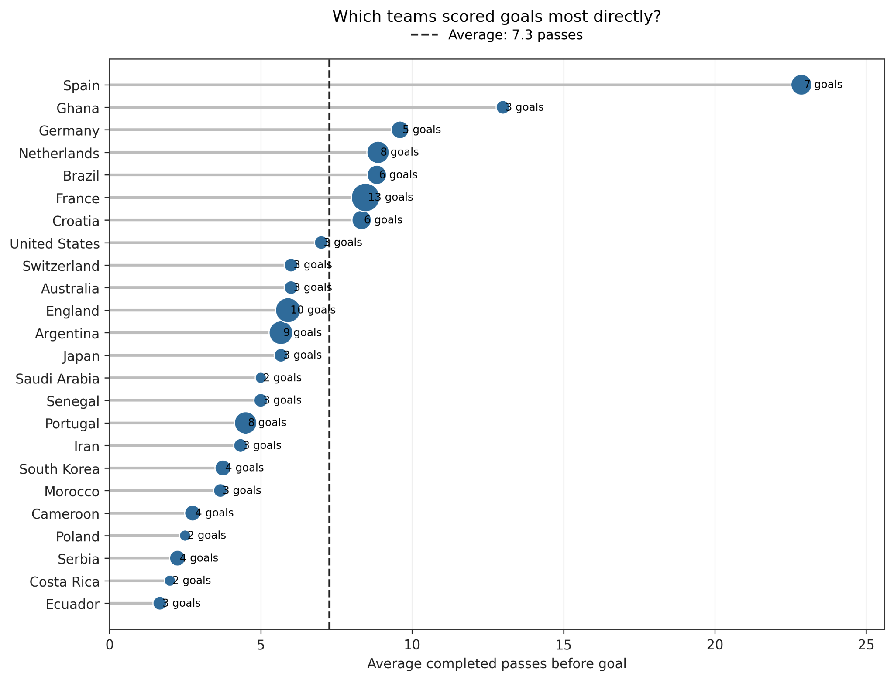
Figure 6. Team directness as a style comparison. The plot shows the average number of completed passes before goals for teams with at least two analysed goals.

5. Spain case study after feedback
Spain was used as a case study because their playing style is strongly connected to possession and passing. The first Spain figure was a green pitch plot with zones, lines, points and labels in one view. During the pitch feedback and the formative evaluation, this plot created confusion. Viewers found it interesting, but the main message was not clear enough.
For that reason, the Spain analysis was split into three simpler views. The final version separates build up structure, final third entry quality and finishing outcome. This makes the analysis easier to read and fits the Spain case better.

5.1 Original Spain plot before redesign
The original plot is included here to document the design change. It showed many pieces of information at once and created too much visual noise. The figure was therefore not used as the final main result.
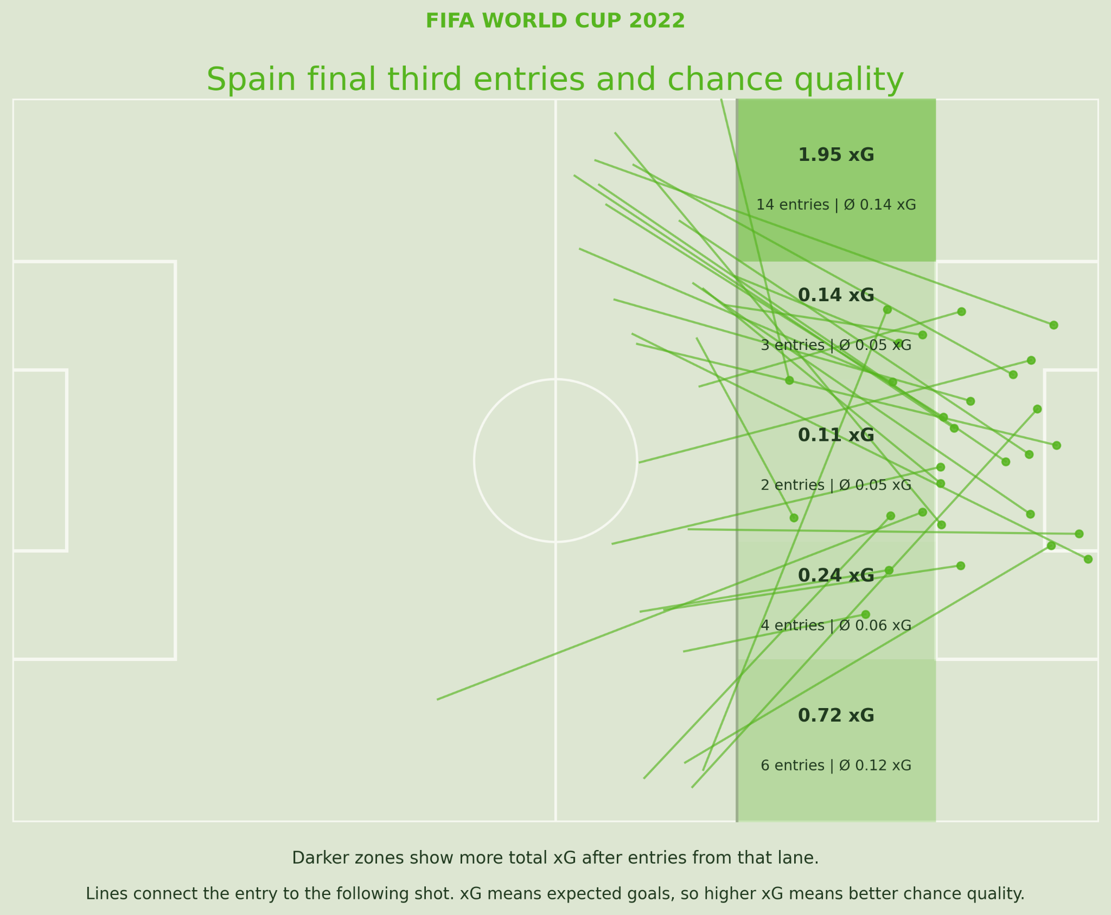
Figure 7. Original Spain final third plot before redesign. The plot was visually interesting, but it combined zones, lines, points and labels in one view.

5.2 Numbered pass sequences before Spain goals
The first redesigned Spain plot shows the completed pass sequences before Spain goals. Each panel shows one goal build up. The numbers show the order of completed passes, and the green marker shows the final action and the goal location.
The arrows do not always connect perfectly because only passes are shown. A receiving player may carry the ball before playing the next pass. This is important because the plot does not contain tracking data or every movement between passes.
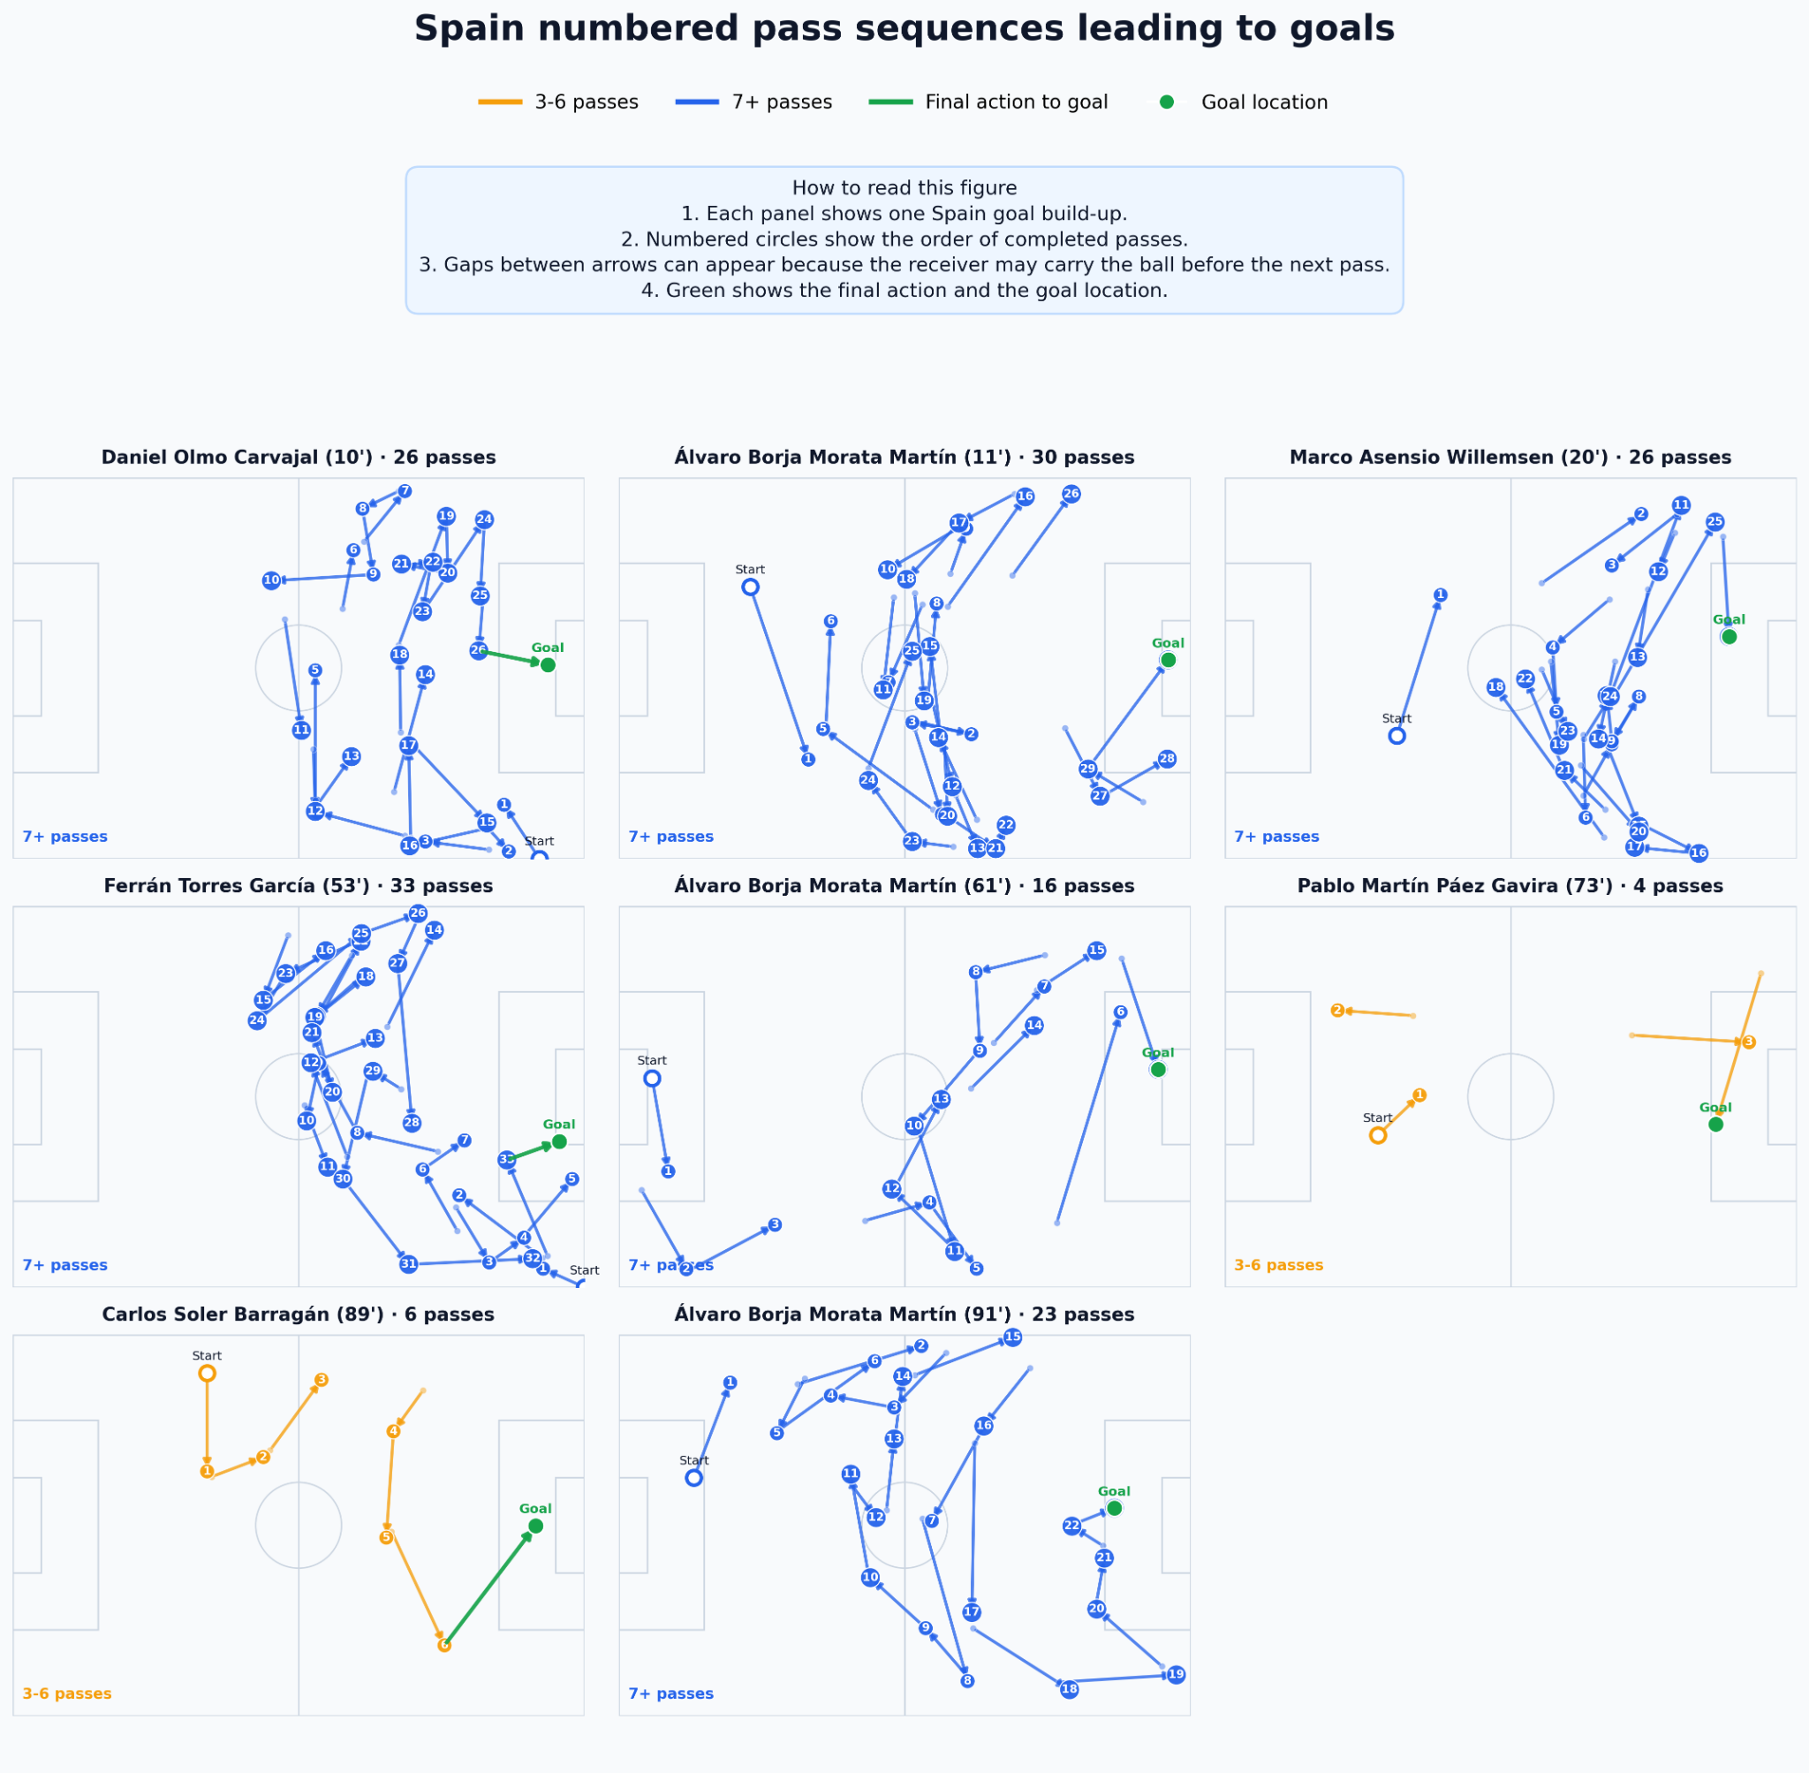
Figure 8. Numbered Spain pass sequences leading to goals. Each panel shows one Spain goal build up and the numbers show the order of completed passes.

5.3 Final third entry lane quality
The second redesigned Spain plot focuses on the spatial question. It shows which final third entry lane created the highest total xG for Spain. The left wing produced the highest total xG in this dataset, together with the highest number of chance creating entries.
This version is clearer than the original green pitch plot because it removes the noisy connection lines and shows the ranking directly.
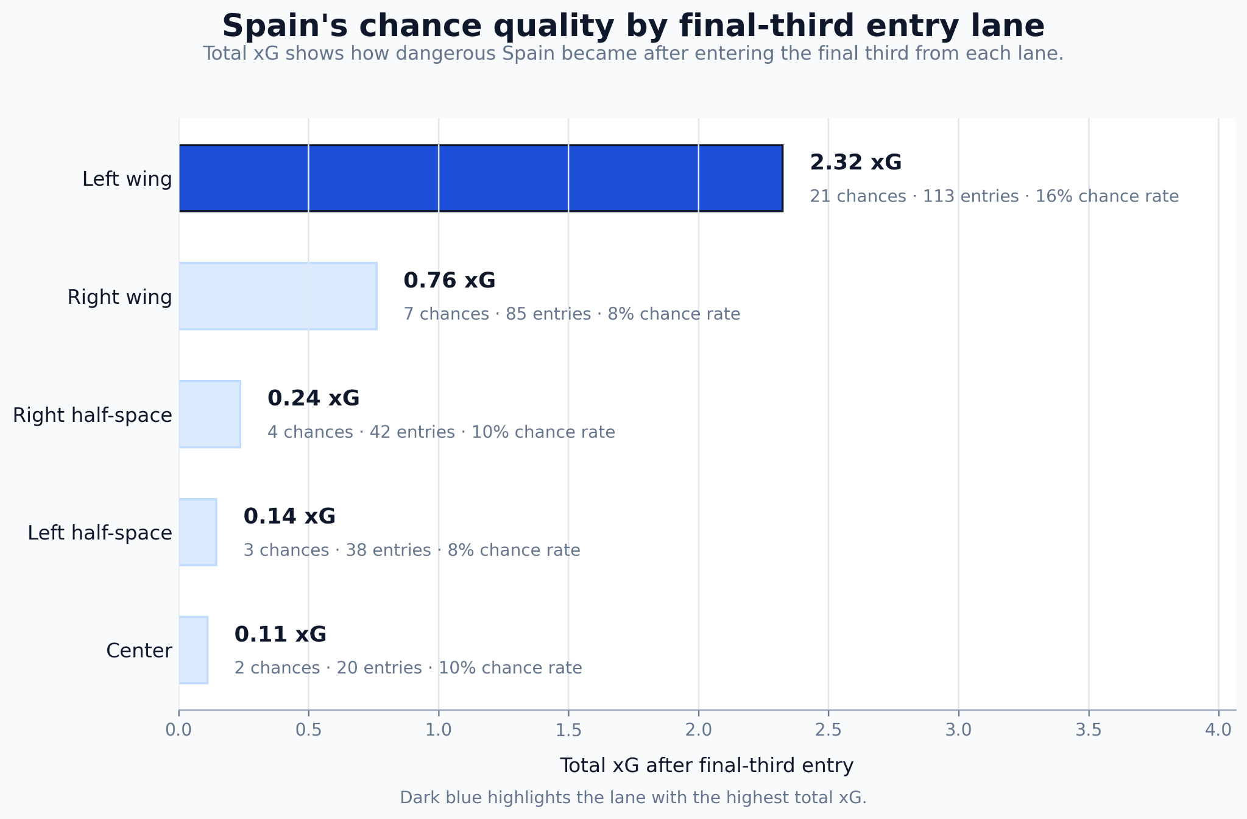
Figure 9. Spain chance quality by final third entry lane. The plot shows total xG, chances, entries and chance rate by lane.

5.4 Spain shots by pass combination
The third redesigned Spain plot looks at whether Spain shots after short, medium or long pass sequences became goals. It shows that many Spain shots came after longer pass combinations. This supports the idea that Spain often created chances through patient passing sequences.
This does not mean that long build up is always better. It shows that Spain had the technical quality to create shots through longer possessions, while other teams may use more direct attacks.
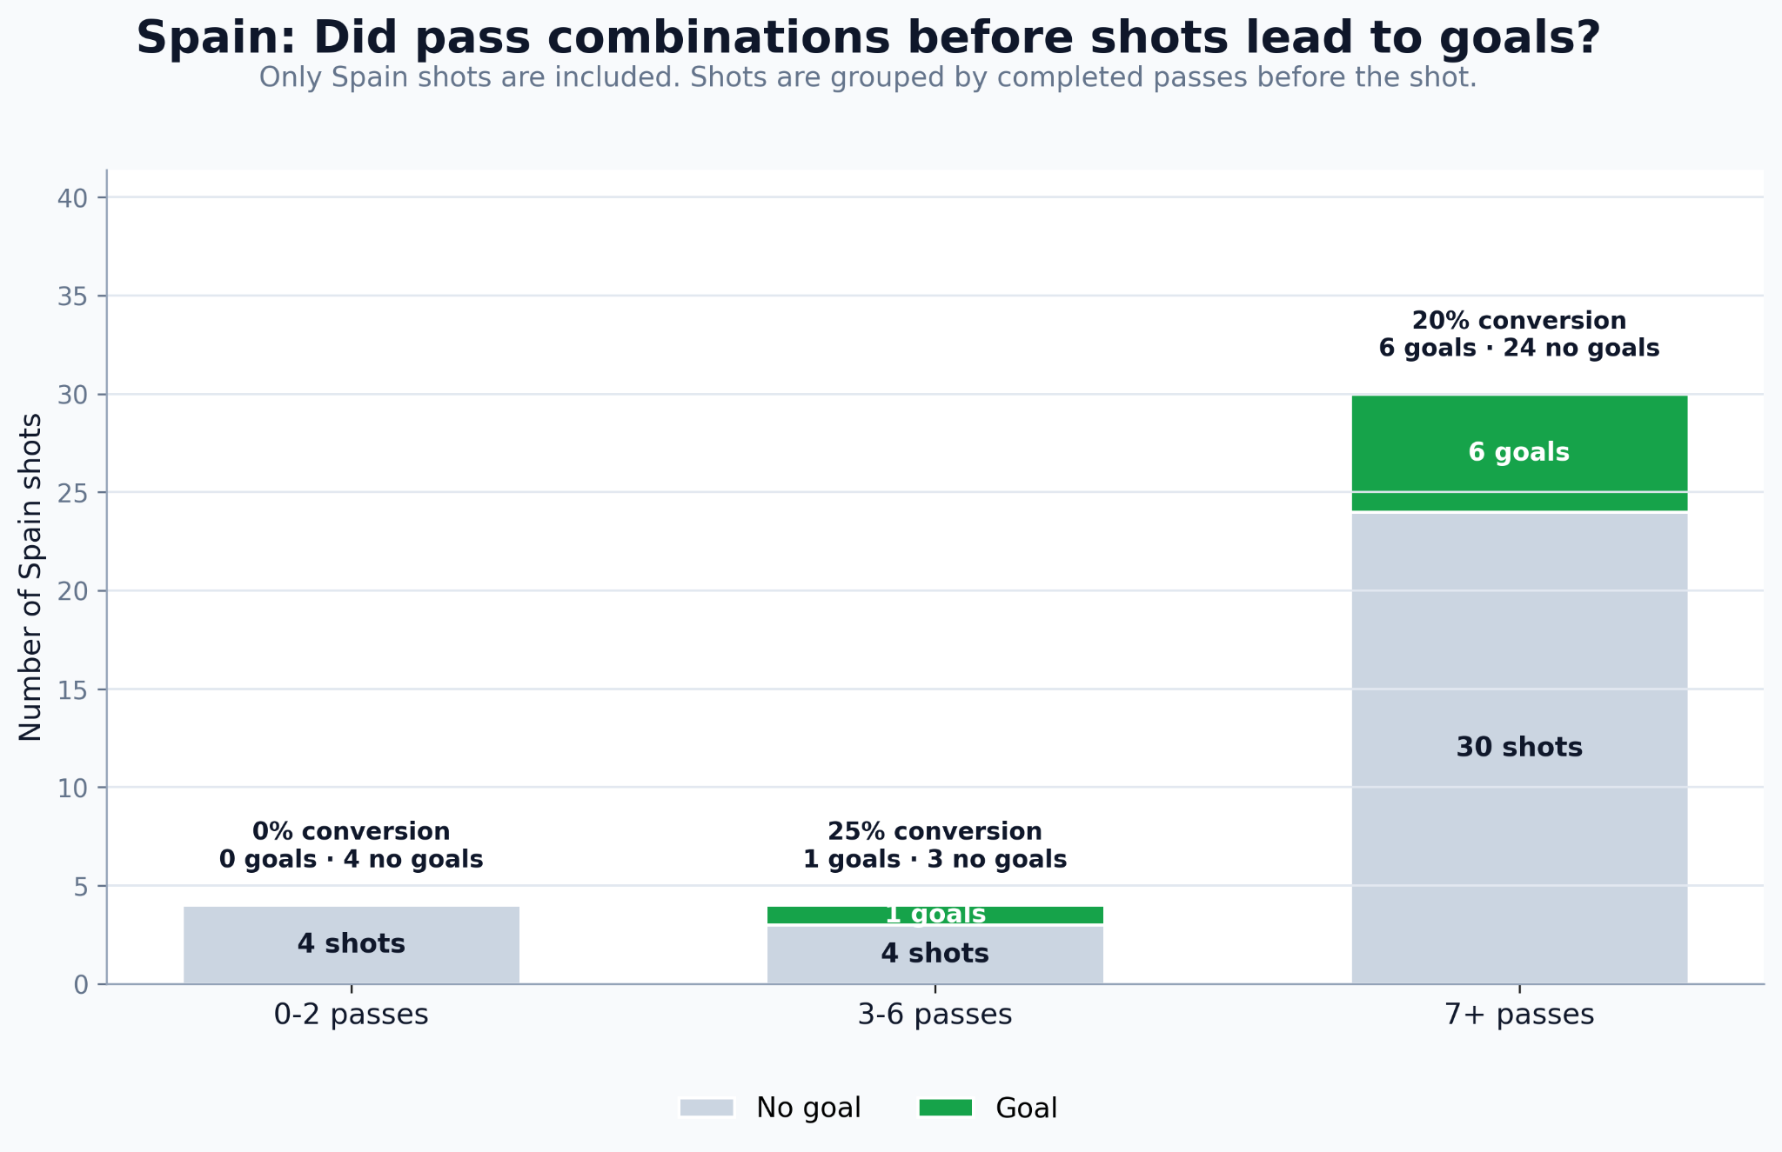
Figure 10. Spain shots after pass combinations. The plot compares how many Spain shots after short, medium and long pass sequences became goals.

6. Formative evaluation

6.1 Method
A short formative evaluation was conducted with two participants who play football. The goal was to check whether the visualizations were understandable for the target audience and to identify terms or plots that needed more explanation.
Participant | Role | Football knowledge | Date
Ivan Batista | Striker | High | 13 May 2026
Yannick Geiger | Midfielder | Medium | 13 May 2026
Both participants answered interpretation questions from a player perspective. This was suitable because the visualizations are intended for coaches and players, not data experts.

6.2 Main feedback
The simple comparison charts were understood quickly. The participants could identify the main message of the pass category charts and the team directness plot without much explanation.
The terms entry and xG required short explanations. This feedback led to clearer wording in captions and text. The old Spain pitch plot caused the most questions because it combined too many visual layers. This was the reason for splitting the Spain case study into three clearer plots.

6.3 Changes after evaluation
Change | Reason
Entry explained at first use | The term was not clear without context.
xG explained next to the analysis | Both participants needed a short explanation.
Original Spain pitch plot replaced | It contained too many visual elements.
Spain analysis split into three plots | Build up, finishing outcome and entry lane quality are easier to read separately.
Team directness described as style | This avoids the wrong idea that fewer passes are always better.
Conversion rate explained carefully | This avoids turning one value into a tactical rule.

7. Limitations and training conclusions

7.1 Analytical limitations
Event data only records actions on the ball. Off ball runs, pressing triggers, positional structure and exact coach instructions are not visible. The patterns describe what happened, but they do not prove why it happened or whether one method is generally superior.
The dataset also covers only one tournament. The World Cup has tight schedules, high pressure and limited opponent specific preparation. Direct transfer to amateur league football should therefore be made carefully.

7.2 Training conclusions
The main conclusion is not that teams should always play direct. A more useful conclusion is that teams need clear and trained ideas for moving the ball into dangerous zones and preparing shot options. Quick attacks, medium combinations and longer build up can all create value in different situations.
Training theme | Connection to data analysis
First forward pass after winning the ball | Many shot sequences happen after few passes, so early progression is important.
Support after entering the final third | Carries and decisive passes showed high shot rates, so support after the entry is central.
Fast occupation of shooting areas | The Spain case study shows repeated entries followed by shot preparation.
Controlled shot preparation | Efficiency depends on the balance between speed and control.

8. GDV reflection
From a data visualization perspective, the project shows that simple and well labelled charts are often more useful for a non specialist audience than visually complex graphics. The formative evaluation confirmed that the simpler comparison charts were understood faster.
The Spain visualization was the most interesting part, but it also needed the most explanation. The redesign reduced visual noise by separating one complex plot into three clearer plots. This made the main messages easier to understand.
As a football player, my main takeaway is that chance creation depends on both speed and control. Fast transitions can create dangerous moments, but uncontrolled long balls can also lead to turnovers and counter attacks. For amateur training, the useful idea is not to copy Spain completely or to always play direct. The useful idea is to train how to move the ball into the final third with enough support to create a real shot chance.

References
Cleveland, W. S., & McGill, R. (1984). Graphical perception: Theory, experimentation, and application to the development of graphical methods. Journal of the American Statistical Association, 79(387), 531 to 554.
Franconeri, S. L., Padilla, L. M., Shah, P., Zacks, J., & Hullman, J. (2021). The science of visual data communication: What works. Psychological Science in the Public Interest, 22(3), 110 to 161.
Munzner, T. (2014). Visualization Analysis and Design. CRC Press.
StatsBomb. (n.d.). StatsBomb Open Data. GitHub repository. https://github.com/statsbomb/open-data
Wilke, C. O. (2019). Fundamentals of Data Visualization. O'Reilly Media.

