IVI Report
Coach Attack Explorer
Goal build up replay and tournament style comparison

Name | Emircan Bagcivan
Module | Interactive Visualisation
Semester | FS26
Dataset | StatsBomb Open Data

Inhalt
1. Summary 3
2. Research question and use case 3
3. Data and preparation 3
4. Dashboard design and interaction choices 4
5. Evaluation method 4
6. Evaluation results and changes 5
7. Limitations 5
8. Conclusion 6
References 6
Final visualizations 7

1. Summary
The Coach Attack Explorer is an interactive dashboard for looking at how football teams create goals in major tournaments. The project does not try to predict match results and it does not try to prove that one style is always better. The idea is more practical. A user can choose a tournament, select a team, replay one goal attack and then compare the team with the rest of the tournament.
My main question is: How do teams create goals in major tournaments, and how does their attacking style compare with other teams in the same tournament? I used goal build ups, completed passes before goals, attack duration, build up categories and team comparison values to answer this question in an interactive way.
The evaluation with Yannick, Kenan and Ivan showed a clear pattern. The replay was the strongest part because it connects the data to a familiar football pitch. The comparison area was useful, but it needed clearer wording. Directness Rank, quick, medium and long build up and the team style map were the parts where users needed the most explanation.

2. Research question and use case
The target users are football coaches, football players, fans and beginner analysts. I wanted the dashboard to be understandable without advanced data science knowledge. This was important for me because the project is not only about showing charts. It should be a small tool that a football person can actually use.
The practical use case is simple. A user selects a tournament, chooses a team and opens one goal example. The attack can then be replayed step by step on the pitch. After that, the user can inspect whether the team scored more directly or through longer build ups compared with other teams in the same tournament.
This matters because goals are often discussed only from the final pass or shot. The dashboard moves one step earlier. It helps users talk about questions such as: Was the attack direct? Did the team need many passes? How long did the attack take? Does this team look different from the rest of the tournament?

3. Data and preparation
The project uses StatsBomb Open Data. The raw event data contains on ball actions such as passes, carries and shots. For the dashboard, I transformed this data into local goal build up tables. This means that the dashboard does not download full tournament data during normal use. It reads prepared CSV files instead.
This local setup was necessary because loading full event data during dashboard interaction was too slow and unstable. The final app therefore uses processed files for analysed goal build ups, events inside each build up and team level comparison values.
The build up style is intentionally simple. It is based mainly on completed passes before the goal and attack duration. The categories are quick attack, medium build up and long build up. This is not a perfect tactical model, but it makes the dashboard easier to understand for the intended users.
The most important limitation is that event data only shows actions on the ball. It does not show all off ball runs, defensive pressure or exact coaching instructions. For that reason, the dashboard should be read as an exploratory tool and not as a full tactical explanation.

4. Dashboard design and interaction choices
The dashboard is designed around a simple workflow. First, the user chooses a tournament. Then the user selects a team and one goal example. After that, the user can replay the attack and compare the team style with other teams. This order is now explained directly in the header because the evaluation showed that users need a clear starting point.
The central view is the attack replay. It shows one selected goal attack on a football pitch. The user can move through the sequence with Previous, Play, Pause, Next, Show full and Jump to event controls. This supports details on demand because the user can either inspect one event at a time or show the full sequence.
The tournament pattern section gives the overview. It contains KPI cards, a build up type chart and a scatterplot for passes against duration. The selected goal is highlighted in the scatterplot. This links the detailed replay to the tournament level pattern.
The team comparison section shows how teams differ in attacking style. The map places teams by average completed passes before goals and number of analysed goals. The ranking table gives a simpler ordered view. In the final version, the wording explains that Directness is a style comparison and not a quality ranking.
The most important ideas in the project are filtering, linked views, overview first and details on demand. The tournament and team selections control the whole dashboard. The user can start with a broad view and then move into one concrete goal sequence. This is why interaction adds value compared with a static visualization. A static chart could show average passes or number of goals, but it could not let the user choose one goal and replay the sequence step by step.
I also considered performance. Instead of loading raw event data during every interaction, the app uses local processed CSV files. This makes the dashboard faster and more stable. The larger data preparation is done before the user starts exploring the dashboard.

5. Evaluation method
I evaluated the dashboard with three participants: Yannick Geiger, Kenan and Ivan Batista. All three understand football, but they have different dashboard experience. This was useful because the dashboard should work for football people, not only for users who already know data tools.
The evaluation was a small formative usability test. The goal was not statistical proof. The goal was to check whether the main workflow is understandable and where the interface still needs clearer explanations before submission.
The participants completed five tasks. They loaded a tournament, selected a team and goal example, replayed one attack, read the tournament goal patterns and compared a team in the team style map and directness ranking. After the tasks, they answered a SUS questionnaire.
Participant | Role | Football knowledge | Dashboard experience | SUS score
Yannick Geiger | Player and fan | Medium | Medium | 75.0
Kenan | Coach and fan | High | Medium | 75.0
Ivan Batista | Player and fan | High | High | 62.5

6. Evaluation results and changes
The first four tasks caused almost no problems. All three participants could load a tournament, select a team, select a goal example, follow the replay and read the basic tournament charts. The replay was clearly the strongest view. Participants said that seeing the attack directly on the pitch made the goal build up easier to understand.
The weaker part was the team comparison. All three participants reached the view, but two of them needed an explanation for Directness Rank or the team style map. The main problem was not the interaction itself, but the interpretation. Some users first read Directness Rank as a quality ranking. In the dashboard, it only describes style. Fewer completed passes before goals means a more direct style.
The SUS scores were 75.0 for Yannick, 75.0 for Kenan and 62.5 for Ivan. The average score was 70.8. I interpret this as acceptable usability for a student prototype, but not as a perfect result. This fits the written feedback. The main workflow works, while the comparison view and some terms still need guidance.
The most useful feedback was practical. Yannick found the replay easy to follow with the Next buttons. Kenan said the scatterplot needed a short moment because it was not immediately clear what the points mean. Ivan said the replay was more helpful than only seeing numbers, but Directness Rank and the build up categories needed short explanations.
After the final pitch and the evaluation, I did not rebuild the whole app. I kept the core workflow and improved the parts that caused confusion. I made the colors more consistent because too many different colors can distract users. I also improved the explanations around the plots and added a clearer header. The header now explains that the dashboard only analyses goal attacks, that arrows show event data and not tracking paths, and that gaps can appear because the receiver may move before playing the next pass.
These changes are small, but they directly address the feedback. They help users understand what they are seeing before they start interpreting the dashboard.

7. Limitations
The dashboard only analyses goal build ups, not every attack in a match. This means it focuses on successful attacking examples. It cannot describe all offensive behaviour of a team.
The data is also limited to recorded event actions. Off ball runs, defensive positioning and coaching instructions are not fully visible. A replay can show how the ball moved, but it cannot explain every reason why space opened.
The build up classification is simplified. Completed passes and duration are useful for a clear dashboard, but they do not capture every tactical detail. A direct attack is not automatically better than a patient attack. The dashboard helps users explore examples, but it cannot explain every tactical reason behind a goal.
The evaluation was also small. Three participants were enough for my formative test, but of course this is not enough to make general claims about all possible users. The results are useful for improving this prototype.

8. Conclusion

The Coach Attack Explorer is a focused interactive dashboard for exploring goal build ups in football tournaments. The strongest part of the project is the replay view, because it lets users inspect one real goal attack step by step instead of only looking at summary numbers. This made the dashboard useful in the evaluation, especially for users who understand football but are not necessarily used to data dashboards.
From the perspective of the module, the project includes the main elements that were relevant for my use case filtering, linked views, overview and detail, details on demand, visual comparison and a small formative evaluation. Interaction adds value here because the user can choose a tournament, filter teams, select one goal, replay the sequence and then compare the team style with the rest of the tournament. A static chart could show some of these numbers, but it could not support this exploration in the same way.
The final result is not a tool for predicting matches and it is not a complete tactical model. It is an interactive prototype that helps users look at selected goal attacks more closely and compare attacking styles inside a tournament. For me, the most important result is that the dashboard makes goal build ups easier to discuss, while still showing the limits of event data clearly.

References
Brooke, J. (1996). SUS: A quick and dirty usability scale. In P. W. Jordan, B. Thomas, B. A. Weerdmeester, and A. L. McClelland (Eds.), Usability Evaluation in Industry.
Munzner, T. (2014). Visualization Analysis and Design. CRC Press.
Shneiderman, B. (1996). The eyes have it: A task by data type taxonomy for information visualizations. Proceedings of the IEEE Symposium on Visual Languages.
StatsBomb. (n.d.). StatsBomb Open Data. GitHub repository.

Final visualizations
The figures below show the final interface views that are discussed in the report. They are placed after the main text so the main report stays within the required page range.
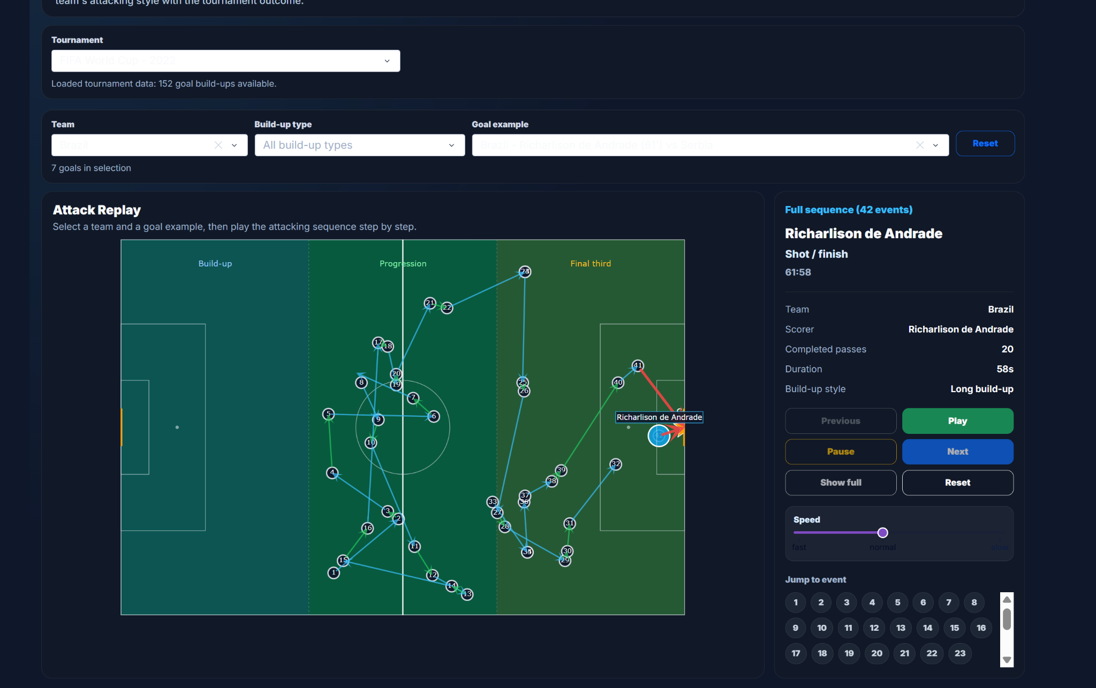
Figure 1. Attack replay view. The selected goal is shown as a sequence on the pitch with replay controls and event details on the right.
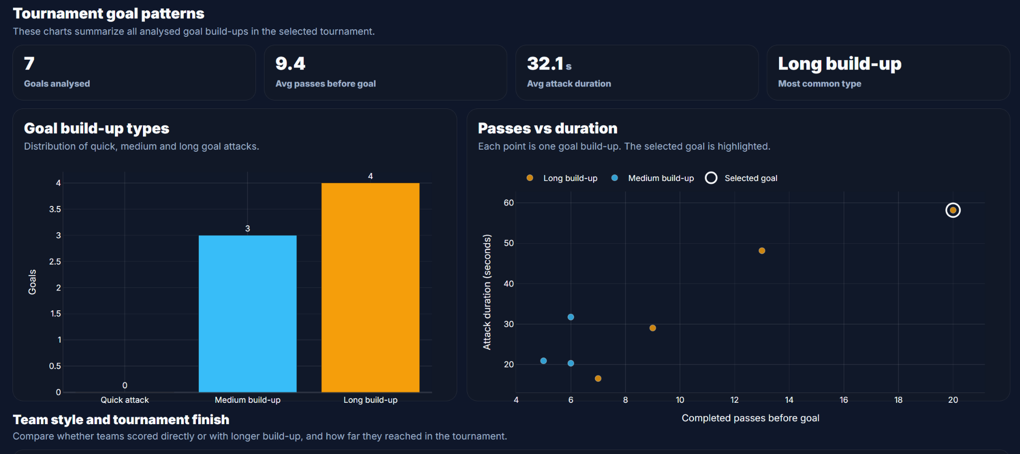
Figure 2. Tournament goal patterns. KPI cards, build up type distribution and passes against duration summarize the selected tournament data.
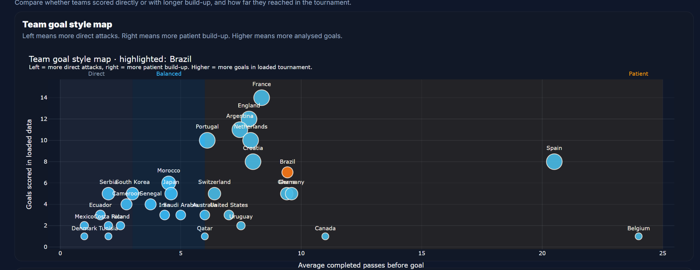
Figure 3. Team style map. The selected team is highlighted and compared with other teams by average completed passes before goals and analysed goals.

