IVI Report
Coach Attack Explorer
Goal build-up replay and tournament style comparison

Name Emircan Bagcivan

Module: Interactive Visualisation

Semester: FS26

Dataset: StatsBomb Open Data

Short summary
The Coach Attack Explorer is an interactive dashboard for inspecting how football teams create goals in major tournaments. The project does not try to predict match results or prove that one playing style is better. The goal is more practical: a user can choose a tournament, select a team, replay one goal attack and then compare the team with the rest of the tournament.
The main question is: How do teams create goals in major tournaments, and how does their attacking style compare with other teams in the same tournament? To answer this, I built a dashboard around goal build-ups, event replay, build-up types, directness and tournament comparison.
The final evaluation with three football-interested participants showed a clear pattern. The replay was the strongest part because it connects the data to a familiar football pitch. The comparison area was useful, but it needed clearer wording. Directness Rank, quick/medium/long build-up and the team style map were the parts where users needed the most explanation.

1. Research question and use case
The target users are football coaches, football fans and beginner analysts. I wanted the dashboard to be understandable without advanced data-science knowledge. This was important because the project is not only about creating charts, but about making an interactive tool that a football person can actually use.
The practical use case is simple. A coach or player selects a tournament, chooses a team and opens one goal example. The attack can then be replayed step by step on the pitch. After that, the user can inspect whether the team scored more directly or through longer build-ups compared with other teams in the same tournament.
This matters because coaches often discuss goals only from the final pass or shot. The dashboard moves one step earlier. It shows the build-up before the goal and makes it easier to talk about questions such as: Was the attack direct? Did the team need many passes? How long did the attack take? Is this team different from the rest of the tournament?

2. Data and preparation
The project uses StatsBomb Open Data. The raw event data contains on-ball actions such as passes, carries and shots. For the dashboard, I transformed this event data into local goal build-up tables. This means the dashboard does not download full tournament data during normal use. It reads prepared CSV files instead.
This local setup was necessary because loading full tournament data directly from StatsBomb during dashboard interaction was too slow and unstable. The final app therefore uses three processed files: one table for analysed goal build-ups, one table for the events inside each build-up and one table for team-level comparison values.
The build-up style is intentionally simple. It is based mainly on completed passes before the goal and attack duration. The categories are quick attack, medium build-up and long build-up. This is not a perfect tactical model, but it makes the dashboard understandable for the intended users.
The main limitation of the data is that event data only shows actions on the ball. It does not show all off-ball runs, defensive pressure or the exact coaching instructions. For that reason, the dashboard should be read as an exploratory tool and not as a complete tactical explanation.

3. Dashboard design and IVI choices
The dashboard is structured around three main parts. The first part is the attack replay. It is the central view because it gives the user a concrete example instead of only aggregated numbers. The selected goal is shown on a football pitch and the user can move through the sequence with Previous, Play, Pause, Next, Show full and Jump to event controls. Figure 1 shows this replay view with a selected Brazil goal build-up.
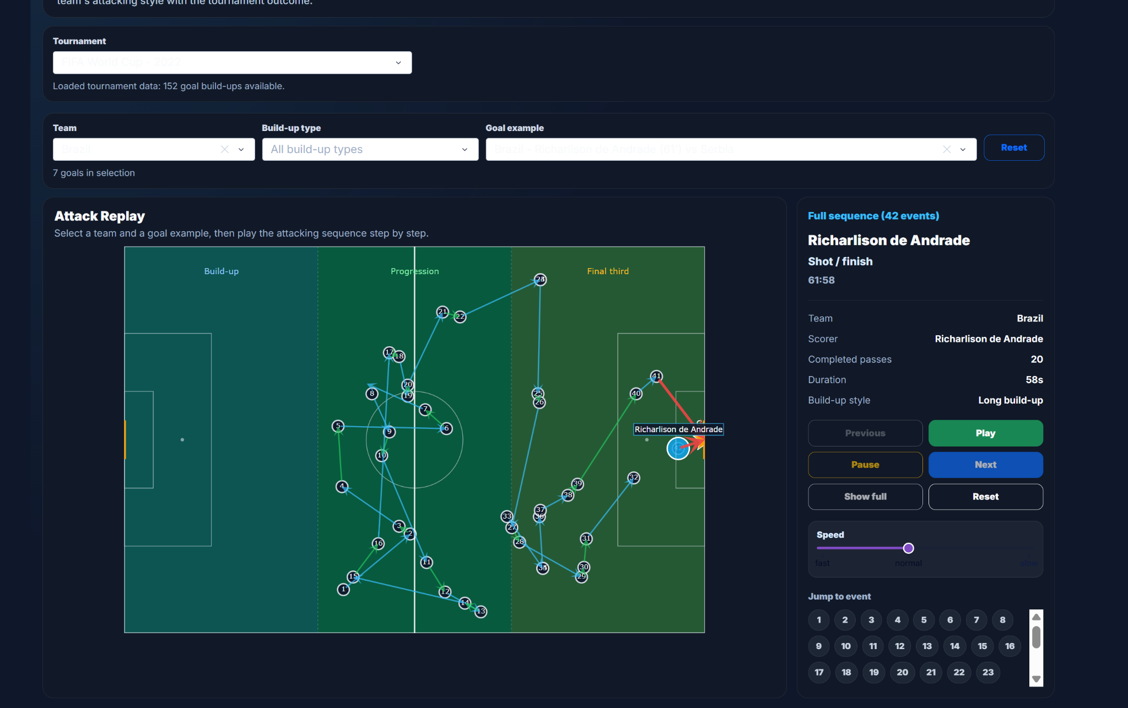
Figure 1. Attack replay view. The selected Brazil goal is shown as a step-by-step sequence on the pitch with replay controls and event details on the right.
The second part is the tournament overview. KPI cards and charts show how many goal build-ups are available, the average number of passes before goals, the average duration and the most common build-up type. The bar chart gives a simple category overview, while the scatterplot connects passes and duration for individual goal build-ups. Figure 2 shows this overview for the selected team and tournament.
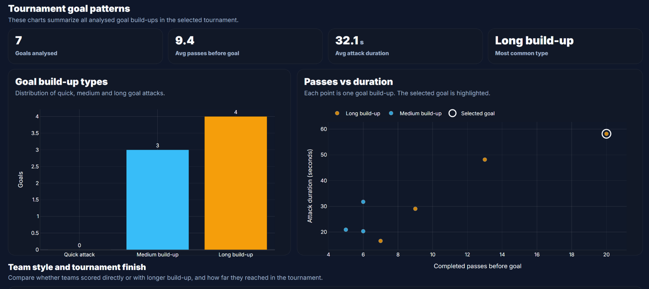
Figure 2. Tournament goal patterns. The KPI cards summarize the current selection, the bar chart shows build-up type distribution, and the scatterplot shows passes before goal against attack duration.
The third part is the team comparison. The team style map compares teams in the selected tournament. Teams further left scored with fewer completed passes before goals, while teams further right used longer build-up. The vertical axis shows how many analysed goals are available in the loaded tournament data. This view is useful, but also the part that needed the clearest explanation in the evaluation. Figure 3 shows the team style map with Brazil highlighted.
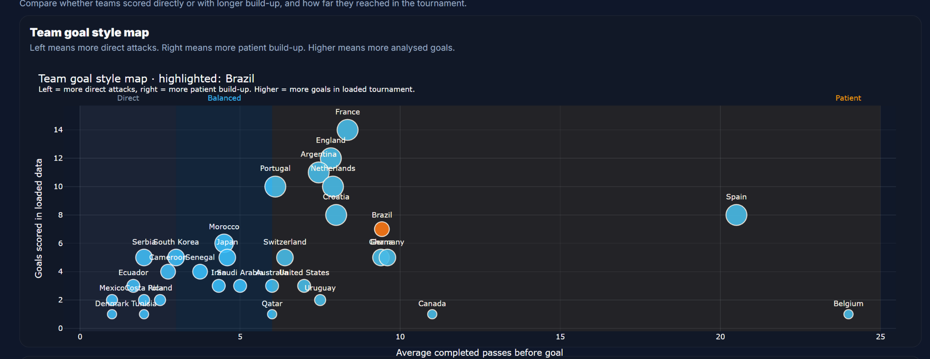
Figure 3. Team style map and directness comparison. Brazil is highlighted. Left means more direct attacks, right means more patient build-up, and higher means more analysed goals in the loaded tournament data.
The interaction design follows typical IVI principles. The user starts with an overview by selecting a tournament, filters by team and build-up type, then moves to details on demand by selecting a goal and stepping through the replay. The views are linked because the tournament, team and goal selections update the replay, charts and comparison area. This link between overview, filtering and detailed inspection is the main IVI idea of the project.

4. Evaluation method
I evaluated the dashboard with three participants: Yannick Geiger, Kenan and Ivan Batista. All three understand football, but they had different levels of dashboard experience. This was useful because the dashboard should work for football people, not only for users who already know data tools.
The evaluation was a small formative usability test. The goal was not statistical proof. The goal was to check whether the main workflow is understandable and where the interface still needs clearer explanations before submission.
The participants completed five tasks. They loaded a tournament, selected a team and goal example, replayed one attack, read the tournament goal patterns and compared a team in the team style map and directness ranking. After the tasks, they answered a short SUS questionnaire.

5. Evaluation results and interpretation
The first four tasks worked well. All three participants could load a tournament, select a team, select a goal example, follow the replay and read the basic tournament charts. The replay was clearly the strongest view. Participants said that seeing the attack directly on the pitch made the goal build-up easier to understand.
The weaker part was the team comparison. Task 5 was only fully completed by one participant, while two participants completed it partly. The main reason was not the interaction itself, but the interpretation. Directness Rank was not immediately clear for everyone, and the team style map required more time when many teams were visible.
The SUS scores were 75.0 for Yannick, 75.0 for Kenan and 62.5 for Ivan. The average score was 70.8. I interpret this as acceptable usability for a student prototype. The result is not perfect, but it fits the qualitative feedback: the main workflow works, while the comparison view needs more guidance.
The most useful feedback was practical. Yannick found the replay easy to follow with the Next buttons. Kenan said the scatterplot needed a short moment because it was not immediately clear what the points mean. Ivan said the replay was more helpful than only seeing numbers, but Directness Rank and the build-up categories needed short explanations.

6. Design iteration
The final improvements should not change the whole dashboard. The core workflow works. The important changes are smaller explanation and visibility improvements.
First, the dashboard should keep a short start instruction near the top. The user should immediately know the order: choose tournament, choose team, choose goal and replay the attack. Second, the build-up categories should be explained close to the chart, because quick, medium and long build-up are simple but still need a clear definition.
Third, the directness ranking needs a short explanation directly above the table. Lower rank means fewer completed passes before goals. It should also be clear that this is a style comparison and not a quality ranking. Fourth, the selected team should stay visually strong in both the team style map and the ranking table.
These changes are realistic for the final prototype because they do not require a new dashboard concept. They improve the parts where participants hesitated while keeping the replay and tournament workflow stable.

7. Limitations
The dashboard only analyses goal build-ups, not every attack in a match. This means it focuses on successful attacking examples. It cannot describe all offensive behaviour of a team.
The data is also limited to recorded event actions. Off-ball runs, defensive positioning and coaching instructions are not fully visible. A replay can show how the ball moved, but it cannot explain every reason why space opened.
The build-up classification is simplified. Completed passes and duration are useful for a clear dashboard, but they do not capture every tactical detail. A direct attack is not automatically better than a patient attack. The dashboard supports interpretation, not causal proof.

8. Conclusion
The Coach Attack Explorer provides a focused interactive visualisation for football goal build-up analysis. Its strongest part is the connection between one concrete attack replay and tournament-level comparison. This makes the project useful for coaching discussion because users can move from one real goal example to broader tournament patterns.
From an IVI perspective, the project includes linked views, filtering, overview and detail, details on demand, visual comparison and a formative evaluation. The screenshots in Section 3 document the final interface and show how the main interactions are arranged in the submitted dashboard.
The final result is not a prediction system and not a full tactical model. It is an exploratory dashboard that helps users understand how teams create goals and how different attacking styles appear within a tournament.

References
StatsBomb. (n.d.). StatsBomb Open Data. GitHub repository.
Munzner, T. (2014). Visualization Analysis and Design. CRC Press.
Brooke, J. (1996). SUS: A quick and dirty usability scale. In P. W. Jordan, B. Thomas, B. A. Weerdmeester, and A. L. McClelland (Eds.), Usability Evaluation in Industry.

