Comparing Stylistic And Linguistic Features On Fake News Detection

Emir Gençler
Adana Alparslan Türkeş Science and Technology University
Adana, Turkey
230601001@atu.edu.tr

Abstract— Fake news detection has become an important research topic because of the misleading information usage on online platforms. This experiment aims to compare the impact of stylistic and linguistic features in fake news detection. For this purpose, TF-IDF based linguistic features, along with the stylistic features such as punctuation and sentence structure, were used together with the Logistic Regression model. According to the obtained results, the model with linguistic features achieved the highest performance among the other models. These findings highlight that the usage of words and the structure of language may have more impact on fake news detection than the writing style. (Abstract)
Keywords— fake news detection, linguistic features, stylistic features

Introduction
In today’s modern world, fake news is all over social media platforms, and they have an inevitable impact on politics, society, and media. That is why detecting them plays an important role in our lives.
Natural Language Processing and Machine Learning are widely used to distinguish fake and real news. Especially, with the help of text classification techniques, it is possible to analyze language structure and word usage in news articles.
Linguistic approaches such as TF-IDF and n-grams are commonly used in the fake news detection task. Besides this, stylistic features like punctuation, sentence length, and capitalization have also been examined. However, studies comparing both of the feature types are still important.
The aim of this study is to compare the effects of linguistic and stylistic features in a fake detection task. For this purpose, three different experiments were conducted using the Logistic Regression model: using linguistic features only, using stylistic features only, and the combination of both feature types. The study analyzed which feature type was more effective.

Related Work

Linguistic feature based learning model for fake news detection and classification
This study focuses on detecting fake news using linguistic features. They used the Buzzfeed Political News and Random Political News as a dataset, which contains both real and fake news. They proposed a linguistic feature based neural network model and compared it with the machine learning algorithms, such as SVM and Naïve Bayes. Their model achieved 86% accuracy in fake news detection, which proved that their model performed better than the machine learning algorithms. However, the study only relied on textual features and did not consider additional information such as social network data. For future work, they suggested using more linguistic features and exploring more advanced neural network models.

Linguistic features based framwork for automatic fake news detection
This study examines fake news detection using linguistic features. The aim is to identify the most useful linguistic features, the most effective feature extraction technique, and the best classifier for this task. They selected 26 linguistic features and used multiple datasets, including the Random Political News Dataset, BuzzFeed Political News Dataset, and the Reuters Dataset. TF-IDF, Count Vectorizer, and Hash Vectorizer were used for text data. Several machine learning algorithms were compared, including Support Vector Machine, Naive Bayes, Logistic Regression, and Random Forest. The results indicated that Logistic Regression and Random Forest achieved the best performance, although the results depended on the dataset. Furthermore, readability, stylometric, and psycholinguistic features were the most useful linguistic features for fake news detection. However, they focused only on textual information and did not consider additional contextual data such as social network information. For future work, they suggested using additional features and exploring more advanced models for fake news detection.

Fake News Detection: It’s All In The Data!
This paper investigates the quality of datasets in fake news detection. They used several datasets such as LIAR, FakeNewsNet, Pheme, and M4. Some of them are text-only, and some of them are multimodal datasets. They used machine learning methods (Naive Bayes, SVM, Logistic Regression, Random Forest, Gradient Boosting) and deep learning methods (BERT, XLNet, ALBERT).
As a result, multimodal datasets achieved better performance then single modal datasets. However, they also highlighted several limitations, including ethical concerns, cultural bias, and class imbalance within the datasets. For future work, they suggested developing more datasets and focusing on the detection of AI-generated fake content.

Bad Actor, Good Advisor:Exploring the role of Large Language Models in Fake News Detection
This paper focuses on the performance of the LLMs on fake news detection. They used the Weibo21 dataset (includes the Chinese news) and the GossipCop dataset (includes the English news). They used GPT-3.5 as an LLM and BERT as SLM. They also suggest a method called ARG, which contains the advantages of both models. The method was compared with several approaches, including the LLM method (GPT-3.5), SLM methods (BERT, EANNT, ENDEF), and simple combinations of the two models. The results showed that the ARG model achieved better performance than the other models, especially in macro-F1 score and accuracy. However, the study has some limitations. For example, only GPT-3.5 was tested as the large language model, and the perspectives were limited. For future work, they suggest testing different large language models, developing better prompting strategies, and applying the model to other natural language tasks.

Content-Based Fake News Detection with Machine and Deep Learning: A Systematic Review
This work is a literature review of the most commonly used methods in fake news detection. As a dataset, they used Scopus, ScienceDirect, IEEE, and ACM papers. Then, they compared machine learning algorithms (SVM, Logistic Regression, K-NN, Random Forest, etc.) and deep learning algorithms (LSTM, BERT, ELMo, etc.). According to the results, models such as Gradient Boosting and Naive Bayes showed strong results, while models like XLNet and ALBERT showed promising results for fake news detection. However, the review also has some limitations because the performance comparison mainly focused on accuracy. For future research, they suggest developing multilingual models and creating systems that are more resistant to advanced techniques used by people who spread fake news.

WELFake: Word Embedding Over Linguistic Features for Fake News Detection
This paper is about a fake news detection model called WELFake, which combines linguistic features with word embedding methods. They created a new dataset by combining datasets such as Kaggle, Reuters, and Buzzfeed. The dataset contains more than seventy thousand real and fake news. Several machine learning algorithms, such as Support Vector Machine, Decision Tree, Naive Bayes, and K-Nearest Neighbor, were tested. The results show that they achieved strong performance and showed better results than deep learning models, such as CNN and BERT. However, the model focuses on textual features and does not include more information, such as user credibility or social network data. For future work, they suggest enlarging the model by including knowledge graphs and user features.
Table-1 shows a brief table about the literature review.

Study | Dataset | Method / Model | Compared With | Advantage | Limitation
Choudhary & Arora (2021) | Horne2017_FakeNewsData | linguistic feature based neural network model | NB, SVM, bagged trees, boosted trees, LSTM model | Strong model | No social network data
Garg & Sharma (2022) | Random Political; BuzzFeed Political; McIntire; Reuters | 26 linguistic features + TF-IDF/CV/HV + LR/RF/GNB/SVC/KNN | ML classifiers | Broad comparison across datasets | Text-only approach
Kuntur et al. (2026) | Multiple public datasets | Dataset analysis | Unimodal vs multimodal dataset | Shows why dataset design matters | ethical concerns, cultural bias, and class imbalance within the datasets
Hu et al. (2024) | Weibo21, GossipCop | ARG | LLM-SLM methods | Best macro-F1 with ARG | Only one main LLM tested
Capuano et al. (2023) | 40 reviewed studies | Systematic review | ML-DL Methods | Some methods show promising results. | Direct comparison across papers is difficult
Verma et al. (2021) | Merged | WELFake | Several ML methods | High accuracy | No user/network information
Table-1: Brief information about the literature review.

Material And Methods

Dataset
Firstly, the chosen dataset is the Fake and Real News Dataset from Kaggle because it’s easy to use and accessible. It comes with True.csv, around 21.000 articles, and Fake.csv, around 23.000 articles, files, which means approximately 44.000 articles are labeled in total. This class distribution reduces the risk of bias toward a single class during training.

In these files, each news item has a title, text, subject, and date. With these files, one single dataset was created. Fake ones are labeled as 1, real ones are labeled as 0 for classifying articles.

Preprocessing
Some preprocessing steps were applied depending on the feature type.
For linguistic features, the articles were converted to lowercase, punctuation and special characters were removed. Common stopwords (the, is, and, etc.) were removed. They don’t really carry any meaning, so keeping them would just add more noise.
However, for stylistic features, punctuation was not handled because elements like exclamation marks are directly used as features. Removing them would lead to the loss of important information.
Finally, spaces were cleaned, and the text was standardized for consistency.

Feature Extraction
Different kinds of features used: linguistic and stylistic.

Linguistic features aim to capture the content and meaning of the text. For this reason, TF-IDF was used. It helps to represent the data in numerical vectors based on the importance of the word.
With the help of unigram representations, Words that appeared rarely in the dataset were ignored to reduce noise and improve the model performance.

Furthermore, several stylistic features were extracted to capture the patterns in articles. They were calculated from the raw data before removing punctuation. The following stylistic features were used: number of exclamation marks, number of question marks, ratio of uppercase words to total words, average sentence length, and total word count.
These features are important because fake news articles often use emotionally charged writing styles.

After extracting both linguistic and stylistic features, they were combined into a single vector. This representation allows the model to learn all the features at the same time.

Methods
Logistic regression was used as the classification model because it’s a common method for binary classification problems.

The main spotlight was not on the model performance. It was on comparing different feature types. That is why the model was trained in three different ways. First, linguistic features were used. The second one was for the stylistic features. And the third one combines both of them. This approach helps us understand which feature type is more useful for fake news detection.

Evaluation Metrics
True positive (TP), true negative (TN), false positive (FP), and false negative (FN) values were used to measure how good the model's performance is.
Thanks to these values, four evaluation metrics (accuracy, precision, recall, and F1-score) were calculated.
Accuracy measures the overall correctness of the model and is defined as:
Accuracy = (TP + TN) / (TP + TN + FP + FN)
Precision shows how many of the predicted fake news articles are actually fake:
Precision = TP / (TP + FP)
Missing news can be a serious problem. So, recall helps to find out how many real fake news articles are correctly detected by the model:
Recall = TP / (TP + FN)
F1-score is a combination of precision and recall, and is calculated as:
F1-score = 2 × (Precision × Recall) / (Precision + Recall)
These metrics were calculated separately for each feature set (linguistic, stylistic, and combined). This allows us to compare their performance and understand which feature type is more effective for fake news detection.

Experimental Setup
%75 of the dataset was used for training, and %25 of the dataset was used for testing. During the division of the dataset, stratified sampling was used to make sure that the fake and real news articles remain the same in the training set and the test set.
Before training the model, preprocessing and feature extraction steps were applied according to the feature type. Python was used throughout the experiments. Pandas and NumPy for data processing, Scikit-learn for feature extraction and model training. For a fair comparison between feature types, the same tools were used for all feature types.

Results and Discussıons
In this section, the results of the stylistic model, the linguistic model, and the combined model are compared. The aim was to understand which feature type is more effective for fake news detection.

For this reason, three different experiments were conducted:
-The model used only stylistic features.
-The model used only linguistic features.
-The combined model used both stylistic and linguistic features.

Table-2 displays the obtained results from these experiments.

Model | Accuracy | Precision | Recall | F1-score
Linguistic features | 98.75% | 99.11% | 98.75% | 98.93%
Stylistic features | 81.70% | 87.83% | 75.47% | 81.18%
Combined features | 97.78% | 98.41% | 97.33% | 97.86%
Table-2: The performance results of all models.

According to the results, the best performance was achieved by the model with linguistic features. This model had higher accuracy and F1-score, unlike the others. The main reason for the success of this performance is that TF-IDF can capture the difference in word usage between fake and real news articles.

An analysis of the keywords learned by the linguistic model revealed that on the fake news side, more attention-grabbing phrases like “just” and “read” stood out. On the real news side, words associated with more formal news language, such as “Reuters,” “Washington,” and the names of days, were important. This demonstrates that linguistic features can successfully capture the content differences between fake and real news.

Figure-1 shows which words were more influential on the linguistic model.

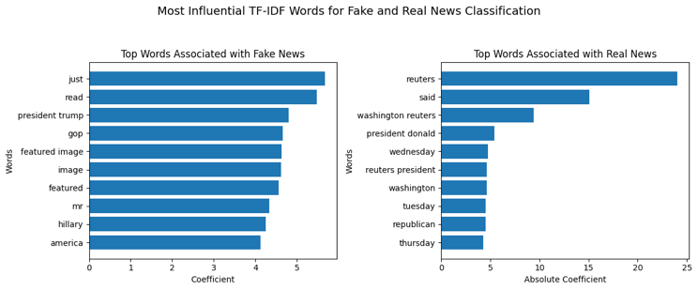
Figure-1: Most influential words on the linguistic model.

Furthermore, a large portion of the real news consists of news from Reuters sources, which means that some patterns specific to the dataset may have influenced the model.

Besides the linguistic model, the stylistic model has less promising results. Features like word count, question count, and exclamation count had more influence on the model. This enlightens that fake news may have a more emotional writing style.

However, using only stylistic features prevents the model from fully learning the news content, as real and fake news can sometimes share similar writing styles.

Figure-2 shows which features had more impact on our model.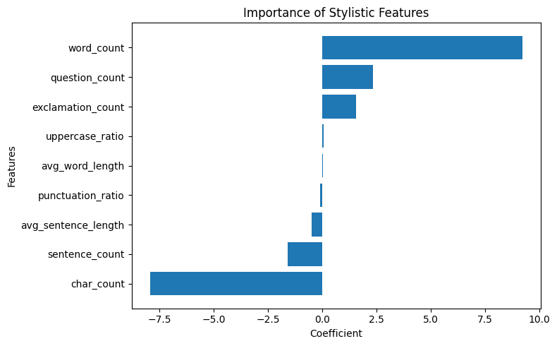
Figure-2: Importance of the stylistic features

Finally, the combined model has great results, although it is not as great as the linguistic model. The main reason for this might be that linguistic features already carry quite powerful information. Adding stylistic features did not significantly add new information to the model. In other words, TF-IDF features provided a strong representation to understand the news content.

These observations have some similarities between the
articles that have been showed on literature review part.
Especially, WELFake: Word Embedding Over Linguistic
Features for Fake News Detection[6] article observed that
the model with linguistic features has achieved strong
performance.

Overall, the results show that linguistic features are more effective than stylistic features in detecting fake news. Specifically, word usage and content structure provided stronger distinguishing information than writing style.

Conclusion

In this experiment, the impact of linguistic and stylistic features on fake news detection is examined. The findings show that the most successful performance was achieved in the model using linguistic features, which means that TF-IDF based linguistic features successfully captured differences in word usage between fake and real news articles.

However, the stylistic model showed lower performance compared to the linguistic model. This indicates that writing style features alone are not sufficient to distinguish fake news. Although the combined model produced strong results, it did not outperform the linguistic model. This shows that linguistic features already carry quite powerful information.
Overall, the experiments show that linguistic patterns play a more important role than stylistic writing patterns in fake news detection task.

Future Work
Future studies may explore more advanced deep learning and transformer-based language models like BERT for the fake news detection mission. Different datasets, which include social media data, can be used to determine if stylistic features have more impact or not. This kind of data may be more emotional, shorter, and have an informal writing style.
Furthermore, combining text and images in the dataset may improve the performance. More balanced datasets and different preprocessing techniques can also be explored in future research.

References
- Choudhary, Anshika, and Anuja Arora. "Linguistic feature based learning model for fake news detection and classification." Expert Systems with Applications 169 (2021): 114171.
- Garg, Sonal, and Dilip Kumar Sharma. "Linguistic features based framework for automatic fake news detection." Computers & Industrial Engineering 172 (2022): 108432.
- Kuntur, Soveatin, et al. "Fake News Detection: It’s All in the Data!." Applied Sciences 16.3 (2026): 1585.
- Hu, Beizhe, et al. "Bad actor, good advisor: Exploring the role of large language models in fake news detection." Proceedings of the AAAI conference on artificial intelligence. Vol. 38. No. 20. 2024.
- Capuano, Nicola, et al. "Content-based fake news detection with machine and deep learning: a systematic review." Neurocomputing 530 (2023): 91-103.
- Verma, Pawan Kumar, et al. "WELFake: Word embedding over linguistic features for fake news detection." IEEE Transactions on Computational Social Systems 8.4 (2021): 881-893.

