CENG 428 – Character Animation:
Modeling, Simulation and Human
Motion Control
220201016 – Emirhan Yıldız
This work presents a kinematic motion control plugin for the N8RO simulation environment. The character’s motion is driven entirely by direct joint-angle manipulation — no forces, torques, or rigid-body dynamics are involved. Ten major human joints (ankles, knees, hips, shoulders, elbows) are controlled through Euler rotation overrides, with additional trunk and head joints for posture. A simplified Center of Mass (CoM) estimation provides balance-aware corrections during the walk cycle. Three distinct motions — walking, pushing, and climbing — are registered as runtime animation evaluators on the Nathan human model. The result was verified visually through the N8RO GLB viewer.

Joint Angle Manipulation in the N8RO GLB Environment
The plugin integrates with N8RO through the IAnimationModel interface. When the simulation runs, the host calls the registered animation evaluator each tick. The evaluator computes joint angles from the current simulation time and returns sparse Euler-angle overrides for each driven joint. The GLB viewer reflects these overrides in real time on the character mesh.
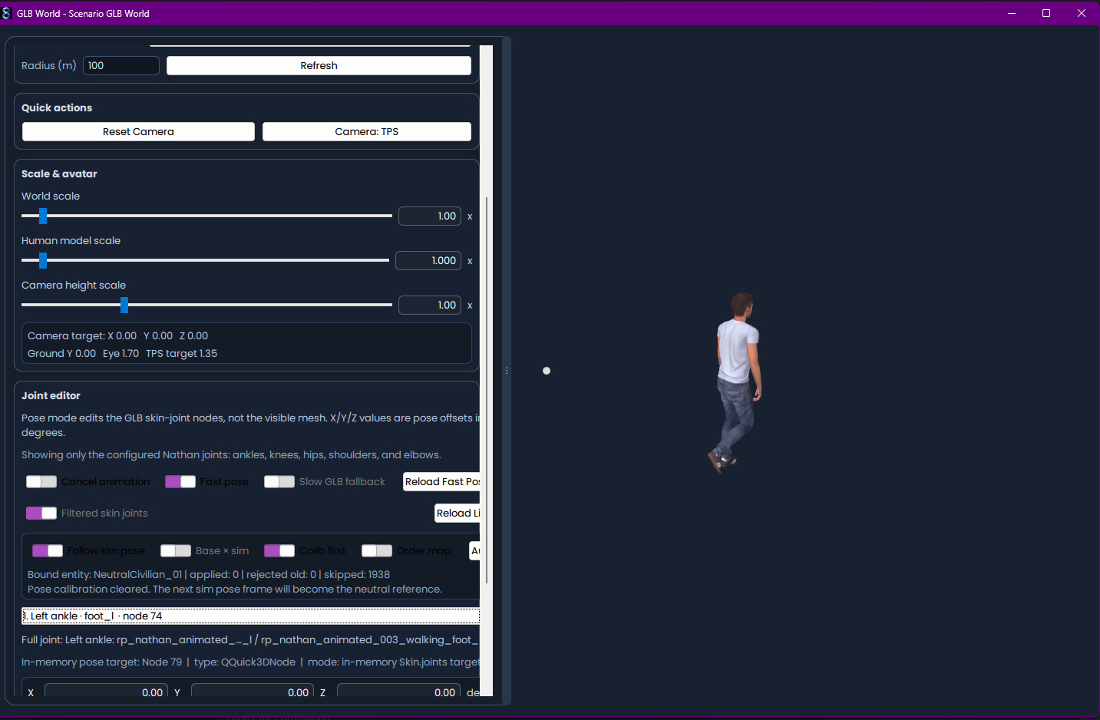
Figure 1. The human character model visualized in the N8RO GLB environment. Joint-angle overrides from the plugin produce a walking pose with natural arm swing.

Selected Human Joints for Kinematic Motion Control
Ten primary joints were selected from the GLB skeleton for kinematic control. These joints correspond to the five bilateral pairs that define the major articulations of human locomotion. The Joint Editor panel in the GLB viewer lists the configured Nathan joints along with their skeleton node indices.
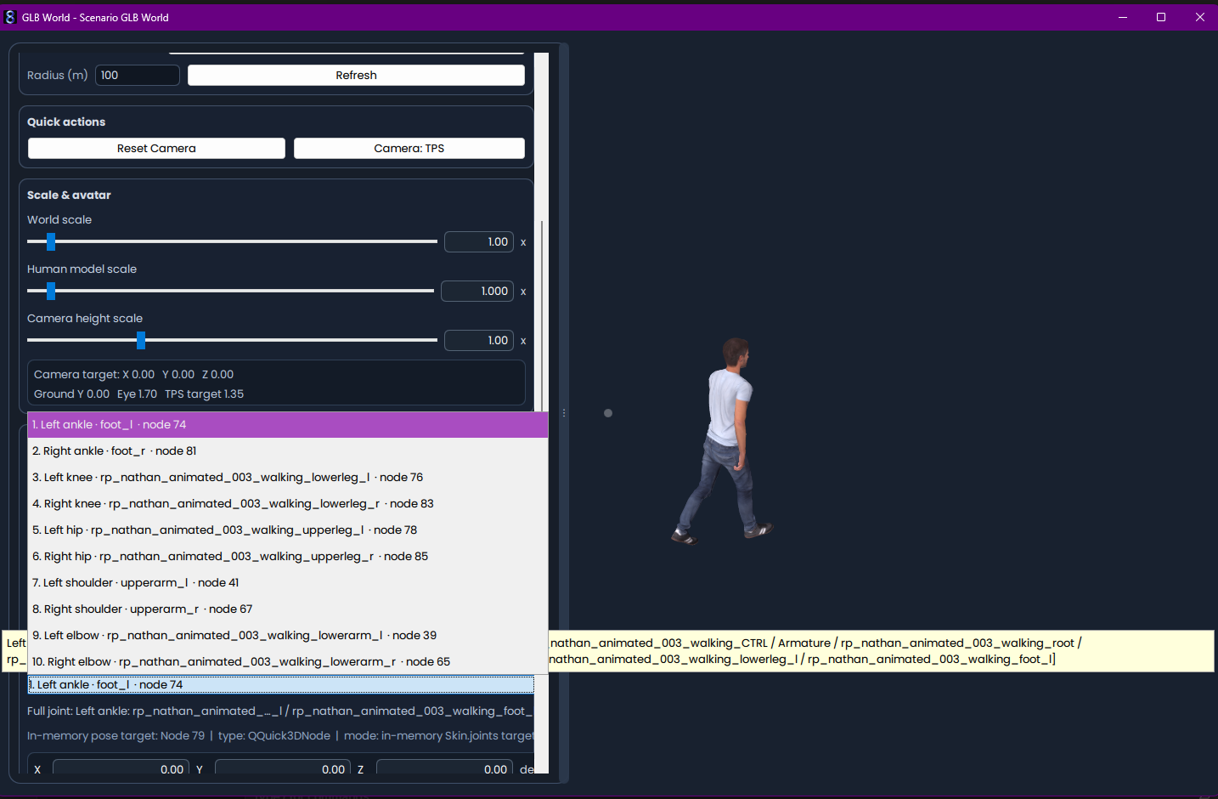
Figure 2. Ten predefined human joints were selected for kinematic pose manipulation in the N8RO GLB environment.

Runtime Joint Control and Pose Update Status
During simulation, the host updates 10 loaded skin-joint eulerRotation values directly in memory. The status panel confirms that in-memory gITF pose targets are active, and joint overrides are applied without requiring per-update GLB file read/write operations.
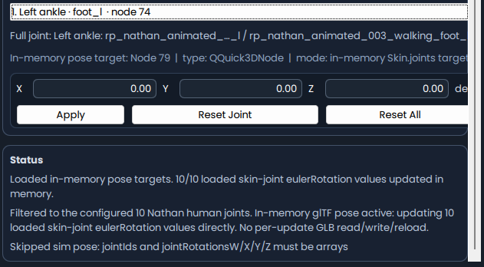
Figure 3. Runtime output showing direct Euler rotation updates applied to the loaded GLB skin-joint structure during pose manipulation.

Center of Mass Estimation and Balance Correction
A simplified anthropometric model estimates the Center of Mass (CoM) from the current joint configuration. Segment mass fractions are assigned to the trunk (46%), pelvis (14%), head (8%), thighs (10% each), and shins (6% each). The CoM position is compared against the support polygon center — derived from smooth foot-contact weights — and the resulting lateral and fore-aft errors drive small corrections to trunk roll, trunk pitch, and pelvis lateral shift.
Foot contact transitions use Hermite smoothStep interpolation rather than hard boolean thresholds, ensuring that the balance corrections vary continuously across the gait cycle without introducing visible trembling.

Registered Animation Motions
The plugin registers three animation evaluators on the animationModelNathanHuman model type:
Animation Code | Motion Type | Key Characteristics
Student CoM Walk | Bipedal walk | Sinusoidal hip/knee cycles, CoM balance, counter-swing arms
Student CoM Push | Two-hand push | Forward trunk lean, extended shoulder reach, rhythmic knee bend
Student CoM Climb | Step/climb | High alternating knee lifts, compensatory arm reach

Walk Animation Pipeline
The walk evaluator follows a fixed pipeline each tick:
- Compute gait phase from simulation time (stepFrequency = 1.25 Hz)
- Generate nominal joint angles from sinusoidal functions of the phase
- Infer foot-contact weights using smoothStep transitions
- Estimate Center of Mass from the current pose
- Compute lateral and fore-aft balance error against support polygon
- Apply conservative trunk and pelvis corrections
- Output sparse joint-angle overrides (Euler radians) to the host

Build and Deployment
The project builds with MSVC v143+ and CMake 3.20+ using the provided build script. The resulting DLL links against the N8RO SDK headers and the arkheon-astlib, arkheon-astsim libraries. No external physics libraries are required — all joint computations are self-contained.
Build command: .\scripts\build.ps1
Deploy path: C:\N8RO\userPlugins\sim\student-com-kinematic-plugin.dll

Appendix — Source Code
The complete plugin source code is listed below. The header file defines the plugin class, and the implementation file contains all three animation evaluators along with the CoM estimation and balance correction logic.

StudentComKinematicPlugin.h
#pragma once
#include <plugin/IPlugin.h>
#include <string>
#include <vector>
namespace arkheon::astsim {
class ModelFactoryRegistry;
}
namespace student::comkinematic {
class StudentComKinematicPlugin final : public arkheon::astlib::IPlugin {
public:
StudentComKinematicPlugin() = default;
~StudentComKinematicPlugin() override = default;
[[nodiscard]] int getInterfaceVersion() const override;
[[nodiscard]] arkheon::astlib::PluginMetadata getMetadata() const override;
void initialize(arkheon::astlib::PluginContext& context) override;
void tick(double dt) override;
void shutdown() override;
private:
bool initialized_ = false;
bool shutdown_ = false;
std::string modelType_ = "animationModelNathanHuman";
std::vector<std::string> registeredAnimationCodes_;
arkheon::astsim::ModelFactoryRegistry* modelFactoryRegistry_ = nullptr;
};
} // namespace student::comkinematic
extern "C" {
ARKHEON_ASTLIB_API arkheon::astlib::IPlugin* create_plugin();
ARKHEON_ASTLIB_API void destroy_plugin(arkheon::astlib::IPlugin* plugin);
ARKHEON_ASTLIB_API const char* get_plugin_signature();
}

StudentComKinematicPlugin.cpp
#include "StudentComKinematicPlugin.h"
#include <model/AnimationModel.h>
#include <model/ModelFactoryRegistry.h>
#include <plugin/IModelPluginService.h>
#include <plugin/IPluginServices.h>
#include <plugin/PluginContext.h>
#include <algorithm>
#include <cmath>
#include <string>
#include <unordered_set>
namespace student::comkinematic {
namespace {
constexpr double kPi = 3.14159265358979323846;
constexpr double kStepFrequencyHz = 1.25;
constexpr double kStepWidthM = 0.24;
constexpr double kStrideM = 0.62;
constexpr double kThighM = 0.45;
constexpr double kShinM = 0.45;
struct ContactState {
double leftFootWeight = 1.0;
double rightFootWeight = 1.0;
double supportX = 0.0;
double supportZ = 0.0;
};
struct KinematicPose {
double phase = 0.0;
double leftHipPitch = 0.0;
double rightHipPitch = 0.0;
double leftKnee = 0.0;
double rightKnee = 0.0;
double leftAnkle = 0.0;
double rightAnkle = 0.0;
double pelvisX = 0.0;
double pelvisZ = 0.0;
double trunkPitch = 0.0;
double trunkRoll = 0.0;
double armSwing = 0.0;
};
struct CenterOfMass {
double x = 0.0;
double z = 0.0;
};
[[nodiscard]] double clamp(double value, double lo, double hi)
{
return std::max(lo, std::min(value, hi));
}
[[nodiscard]] bool hasJoint(const std::unordered_set<std::string>& availableJointIds, const char* jointId)
{
if (!jointId || *jointId == '\0') {
return false;
}
if (availableJointIds.empty()) {
return true;
}
return availableJointIds.find(jointId) != availableJointIds.end();
}
[[nodiscard]] double smoothStep(double edge0, double edge1, double x)
{
const double t = clamp((x - edge0) / (edge1 - edge0), 0.0, 1.0);
return t * t * (3.0 - 2.0 * t);
}
[[nodiscard]] ContactState inferContactState(double phase)
{
ContactState contact;
contact.leftFootWeight = 1.0 - smoothStep(0.55, 0.70, phase);
if (phase >= 0.85) {
contact.leftFootWeight = smoothStep(0.85, 1.0, phase);
}
double rightBase = 0.0;
if (phase < 0.15) {
rightBase = 1.0 - smoothStep(0.05, 0.15, phase);
} else if (phase >= 0.42) {
rightBase = smoothStep(0.42, 0.55, phase);
}
contact.rightFootWeight = rightBase;
const double denom = std::max(0.01, contact.leftFootWeight + contact.rightFootWeight);
contact.supportX = ((-kStepWidthM * 0.5) * contact.leftFootWeight
+ ( kStepWidthM * 0.5) * contact.rightFootWeight) / denom;
contact.supportZ = 0.0;
return contact;
}
[[nodiscard]] KinematicPose buildNominalWalk(double simulationTimeSeconds)
{
KinematicPose pose;
pose.phase = std::fmod(simulationTimeSeconds * kStepFrequencyHz, 1.0);
if (pose.phase < 0.0) {
pose.phase += 1.0;
}
const double cycle = pose.phase * 2.0 * kPi;
const double stride = std::sin(cycle);
const double liftLeft = std::max(0.0, std::sin(cycle));
const double liftRight = std::max(0.0, -std::sin(cycle));
pose.leftHipPitch = 0.34 * stride;
pose.rightHipPitch = -0.34 * stride;
pose.leftKnee = 0.18 + 0.58 * liftLeft;
pose.rightKnee = 0.18 + 0.58 * liftRight;
pose.leftAnkle = -0.12 - 0.25 * liftLeft;
pose.rightAnkle = -0.12 - 0.25 * liftRight;
pose.pelvisX = 0.035 * std::sin(cycle + kPi * 0.5);
pose.pelvisZ = 0.035 * std::sin(cycle);
pose.trunkPitch = -0.08 + 0.04 * std::sin(cycle + kPi * 0.5);
pose.trunkRoll = -0.08 * std::sin(cycle + kPi * 0.5);
pose.armSwing = -0.36 * stride;
return pose;
}
[[nodiscard]] CenterOfMass estimateCenterOfMass(const KinematicPose& pose)
{
double weightedX = 0.0;
double weightedZ = 0.0;
double mass = 0.0;
const auto addMass = [&](double segmentMass, double x, double z) {
weightedX += segmentMass * x;
weightedZ += segmentMass * z;
mass += segmentMass;
};
const double leftHipX = pose.pelvisX - kStepWidthM * 0.32;
const double rightHipX = pose.pelvisX + kStepWidthM * 0.32;
const double trunkX = pose.pelvisX + 0.08 * std::sin(pose.trunkRoll);
const double trunkZ = pose.pelvisZ + 0.12 * std::sin(-pose.trunkPitch);
addMass(0.46, trunkX, trunkZ + 0.03);
addMass(0.14, pose.pelvisX, pose.pelvisZ);
addMass(0.08, trunkX, trunkZ + 0.05);
const double leftThighZ = pose.pelvisZ + std::sin(pose.leftHipPitch) * kThighM * 0.5;
const double rightThighZ = pose.pelvisZ + std::sin(pose.rightHipPitch) * kThighM * 0.5;
const double leftShinZ = pose.pelvisZ + std::sin(pose.leftHipPitch - pose.leftKnee) * kShinM * 0.5;
const double rightShinZ = pose.pelvisZ + std::sin(pose.rightHipPitch - pose.rightKnee) * kShinM * 0.5;
addMass(0.10, leftHipX, leftThighZ);
addMass(0.10, rightHipX, rightThighZ);
addMass(0.06, leftHipX, leftShinZ);
addMass(0.06, rightHipX, rightShinZ);
return {weightedX / mass, weightedZ / mass};
}
void applyBalanceCorrection(KinematicPose& pose, const ContactState& contact)
{
const CenterOfMass com = estimateCenterOfMass(pose);
const double lateralError = contact.supportX - com.x;
const double foreAftError = contact.supportZ - com.z;
const double trunkRollCorrection = clamp(lateralError * 0.35, -0.06, 0.06);
const double trunkPitchCorrection = clamp(foreAftError * 0.35, -0.06, 0.06);
pose.trunkRoll += trunkRollCorrection;
pose.trunkPitch += trunkPitchCorrection;
pose.leftHipPitch += trunkPitchCorrection * 0.20;
pose.rightHipPitch += trunkPitchCorrection * 0.20;
const double singleSupportBias = contact.leftFootWeight - contact.rightFootWeight;
pose.pelvisX -= singleSupportBias * 0.015;
}
void addOverrideIfAvailable(arkheon::astsim::AnimationModelOutput& output,
const std::unordered_set<std::string>& availableJointIds,
const char* jointId,
double xRad,
double yRad,
double zRad)
{
if (hasJoint(availableJointIds, jointId)) {
output.jointOverrides.push_back({jointId, xRad, yRad, zRad});
}
}
[[nodiscard]] bool evaluateStudentComWalk(const arkheon::astsim::AnimationModelInput& input,
arkheon::astsim::AnimationModelOutput& output)
{
std::unordered_set<std::string> availableJointIds;
availableJointIds.reserve(input.entity.joints.size());
for (const auto& joint : input.entity.joints) {
availableJointIds.insert(joint.jointId);
}
KinematicPose pose = buildNominalWalk(input.simulationTimeSeconds);
const ContactState contact = inferContactState(pose.phase);
applyBalanceCorrection(pose, contact);
const double cycle = pose.phase * 2.0 * kPi;
const double armSwingSmooth = pose.armSwing;
const double elbowBendDynamic = 0.5 * (1.0 - std::cos(2.0 * cycle)) * 0.10;
const double shoulderBob = 0.015 * std::sin(2.0 * cycle);
output.clearExistingJointOverrides = false;
output.jointOverrides.clear();
addOverrideIfAvailable(output, availableJointIds, "spineLower", pose.trunkPitch * 0.55, pose.trunkRoll * 0.25, -pose.trunkRoll * 0.35);
addOverrideIfAvailable(output, availableJointIds, "spineUpper", pose.trunkPitch * 0.45, pose.trunkRoll * 0.35, -pose.trunkRoll * 0.25);
addOverrideIfAvailable(output, availableJointIds, "head", -pose.trunkPitch * 0.45, 0.0, pose.trunkRoll * 0.35);
addOverrideIfAvailable(output, availableJointIds, "leftHip", pose.leftHipPitch, pose.trunkRoll * 0.15, -0.04);
addOverrideIfAvailable(output, availableJointIds, "rightHip", pose.rightHipPitch, pose.trunkRoll * 0.15, 0.04);
addOverrideIfAvailable(output, availableJointIds, "leftKnee", pose.leftKnee, 0.0, 0.0);
addOverrideIfAvailable(output, availableJointIds, "rightKnee", pose.rightKnee, 0.0, 0.0);
addOverrideIfAvailable(output, availableJointIds, "leftAnkle", pose.leftAnkle, 0.0, 0.0);
addOverrideIfAvailable(output, availableJointIds, "rightAnkle", pose.rightAnkle, 0.0, 0.0);
addOverrideIfAvailable(output, availableJointIds, "leftShoulder", 0.22 + shoulderBob, 0.0, -armSwingSmooth);
addOverrideIfAvailable(output, availableJointIds, "rightShoulder", 0.22 - shoulderBob, 0.0, armSwingSmooth);
addOverrideIfAvailable(output, availableJointIds, "leftElbow", 0.48 + elbowBendDynamic, 0.0, -0.06);
addOverrideIfAvailable(output, availableJointIds, "rightElbow", 0.48 + elbowBendDynamic, 0.0, 0.06);
return !output.jointOverrides.empty();
}
[[nodiscard]] bool evaluateStudentComPush(const arkheon::astsim::AnimationModelInput& input,
arkheon::astsim::AnimationModelOutput& output)
{
std::unordered_set<std::string> availableJointIds;
availableJointIds.reserve(input.entity.joints.size());
for (const auto& joint : input.entity.joints) {
availableJointIds.insert(joint.jointId);
}
const double t = input.simulationTimeSeconds;
const double pulse = 0.5 + 0.5 * std::sin(t * 2.8);
const double counter = std::sin(t * 2.8 + kPi * 0.5);
const double trunkPitch = -0.34 - 0.08 * pulse;
const double reach = 0.92 + 0.16 * pulse;
const double kneeBend = 0.42 + 0.12 * counter;
const double ankleCounter = -0.22 - 0.08 * counter;
output.clearExistingJointOverrides = false;
output.jointOverrides.clear();
addOverrideIfAvailable(output, availableJointIds, "spineLower", trunkPitch * 0.65, 0.0, 0.0);
addOverrideIfAvailable(output, availableJointIds, "spineUpper", trunkPitch * 0.45, 0.0, 0.0);
addOverrideIfAvailable(output, availableJointIds, "head", -trunkPitch * 0.35, 0.0, 0.0);
addOverrideIfAvailable(output, availableJointIds, "leftHip", -0.22, 0.06, -0.04);
addOverrideIfAvailable(output, availableJointIds, "rightHip", -0.22, -0.06, 0.04);
addOverrideIfAvailable(output, availableJointIds, "leftKnee", kneeBend, 0.0, 0.0);
addOverrideIfAvailable(output, availableJointIds, "rightKnee", kneeBend, 0.0, 0.0);
addOverrideIfAvailable(output, availableJointIds, "leftAnkle", ankleCounter, 0.0, 0.0);
addOverrideIfAvailable(output, availableJointIds, "rightAnkle", ankleCounter, 0.0, 0.0);
addOverrideIfAvailable(output, availableJointIds, "leftShoulder", reach, 0.18, -0.22);
addOverrideIfAvailable(output, availableJointIds, "rightShoulder", reach, -0.18, 0.22);
addOverrideIfAvailable(output, availableJointIds, "leftElbow", 0.36 + 0.16 * (1.0 - pulse), 0.0, -0.10);
addOverrideIfAvailable(output, availableJointIds, "rightElbow", 0.36 + 0.16 * (1.0 - pulse), 0.0, 0.10);
return !output.jointOverrides.empty();
}
[[nodiscard]] bool evaluateStudentComClimb(const arkheon::astsim::AnimationModelInput& input,
arkheon::astsim::AnimationModelOutput& output)
{
std::unordered_set<std::string> availableJointIds;
availableJointIds.reserve(input.entity.joints.size());
for (const auto& joint : input.entity.joints) {
availableJointIds.insert(joint.jointId);
}
const double t = input.simulationTimeSeconds;
const double cycle = std::sin(t * 2.1);
const double liftLeft = std::max(0.0, cycle);
const double liftRight = std::max(0.0, -cycle);
const double trunkPitch = -0.28 + 0.06 * std::sin(t * 4.2);
output.clearExistingJointOverrides = false;
output.jointOverrides.clear();
addOverrideIfAvailable(output, availableJointIds, "spineLower", trunkPitch * 0.55, 0.05 * cycle, -0.08 * cycle);
addOverrideIfAvailable(output, availableJointIds, "spineUpper", trunkPitch * 0.45, -0.06 * cycle, -0.05 * cycle);
addOverrideIfAvailable(output, availableJointIds, "head", -trunkPitch * 0.35, 0.0, 0.04 * cycle);
addOverrideIfAvailable(output, availableJointIds, "leftHip", 0.42 + 0.66 * liftLeft, 0.08, -0.03);
addOverrideIfAvailable(output, availableJointIds, "rightHip", 0.42 + 0.66 * liftRight, -0.08, 0.03);
addOverrideIfAvailable(output, availableJointIds, "leftKnee", 0.62 + 0.72 * liftLeft, 0.0, 0.0);
addOverrideIfAvailable(output, availableJointIds, "rightKnee", 0.62 + 0.72 * liftRight, 0.0, 0.0);
addOverrideIfAvailable(output, availableJointIds, "leftAnkle", -0.32 - 0.18 * liftLeft, 0.0, 0.0);
addOverrideIfAvailable(output, availableJointIds, "rightAnkle", -0.32 - 0.18 * liftRight, 0.0, 0.0);
addOverrideIfAvailable(output, availableJointIds, "leftShoulder", 0.62 + 0.24 * liftRight, 0.12, -0.42);
addOverrideIfAvailable(output, availableJointIds, "rightShoulder", 0.62 + 0.24 * liftLeft, -0.12, 0.42);
addOverrideIfAvailable(output, availableJointIds, "leftElbow", 0.86, 0.0, -0.22);
addOverrideIfAvailable(output, availableJointIds, "rightElbow", 0.86, 0.0, 0.22);
return !output.jointOverrides.empty();
}
} // namespace
int StudentComKinematicPlugin::getInterfaceVersion() const
{
return 1;
}
arkheon::astlib::PluginMetadata StudentComKinematicPlugin::getMetadata() const
{
arkheon::astlib::PluginMetadata metadata;
metadata.setPluginId("student-com-kinematic-plugin");
metadata.setVersion("0.1.0");
metadata.setAuthor("Student");
metadata.addCapability("animation:nathan-human:student-com-walk");
metadata.addCapability("animation:nathan-human:student-com-push");
metadata.addCapability("animation:nathan-human:student-com-climb");
return metadata;
}
void StudentComKinematicPlugin::initialize(arkheon::astlib::PluginContext& context)
{
initialized_ = true;
shutdown_ = false;
registeredAnimationCodes_.clear();
modelFactoryRegistry_ = nullptr;
if (context.services) {
auto* rawService = context.services->getService(arkheon::astsim::IModelPluginService::kPluginServiceId);
auto* service = static_cast<arkheon::astsim::IModelPluginService*>(rawService);
modelFactoryRegistry_ = service ? &service->modelFactoryRegistry() : nullptr;
}
if (!modelFactoryRegistry_) {
return;
}
auto* prototypeBase = modelFactoryRegistry_->getRegisteredPrototype(modelType_);
auto* prototypeAnimationModel = dynamic_cast<arkheon::astsim::IAnimationModel*>(prototypeBase);
if (!prototypeAnimationModel) {
return;
}
const auto registerAnimation = [&](const std::string& code,
arkheon::astsim::IAnimationModel::AnimationEvaluationFunction evaluator) {
if (prototypeAnimationModel->registerAnimation(code, std::move(evaluator))) {
registeredAnimationCodes_.push_back(code);
}
};
registerAnimation("Student CoM Walk", evaluateStudentComWalk);
registerAnimation("Student CoM Push", evaluateStudentComPush);
registerAnimation("Student CoM Climb", evaluateStudentComClimb);
}
void StudentComKinematicPlugin::tick(double dt)
{
static_cast<void>(dt);
}
void StudentComKinematicPlugin::shutdown()
{
if (modelFactoryRegistry_ && !registeredAnimationCodes_.empty()) {
auto* prototypeBase = modelFactoryRegistry_->getRegisteredPrototype(modelType_);
auto* prototypeAnimationModel = dynamic_cast<arkheon::astsim::IAnimationModel*>(prototypeBase);
if (prototypeAnimationModel) {
for (const auto& code : registeredAnimationCodes_) {
static_cast<void>(prototypeAnimationModel->registerAnimation(
code,
arkheon::astsim::IAnimationModel::AnimationEvaluationFunction {}));
}
}
}
registeredAnimationCodes_.clear();
shutdown_ = true;
modelFactoryRegistry_ = nullptr;
}
} // namespace student::comkinematic
extern "C" {
ARKHEON_ASTLIB_API arkheon::astlib::IPlugin* create_plugin()
{
return new student::comkinematic::StudentComKinematicPlugin();
}
ARKHEON_ASTLIB_API void destroy_plugin(arkheon::astlib::IPlugin* plugin)
{
delete plugin;
}
ARKHEON_ASTLIB_API const char* get_plugin_signature()
{
return "ARKHEON_PLUGIN_V1";
}
} // extern "C"

