CENG310-Human Computer Interaction

Spring 2025

PROJECT STAGE 3

CookEase

Nurten Çiftçioğlu 21050111027

Muhammed Enes Uğraş 23050151030

Emirhan Akbaş 23050151001

13/04/2025

## Introduction

The daily question of "what's for dinner?" presents a common challenge in many households. Our project, CookEase, aims to simplify this decision-making process through an AI-Powered Meal Recommender system. This report details the interface design phase of the CookEase application, building upon initial user requirements analysis. We are developing a system designed to offer personalized recipe suggestions tailored to user-provided ingredients, specific dietary needs (like vegetarian, gluten-free, etc.), cuisine preferences, and historical meal data. Key features include the ability to generate weekly meal plans, save favorite recipes, and rate meals based on taste, healthiness, and preparation difficulty. This stage focuses specifically on designing the graphical user interfaces for the core tasks identified through user research, aiming to create an intuitive and engaging experience that makes meal planning and cooking easier and more enjoyable for everyone.

## Part 1 – Interface Design Sketches

* Create a Weekly Meal Plan
* Discover and Filter Recipes
* Rate and Review a Recipe

#### Muhammed Enes Uğraş

Create a Weekly Meal Plan

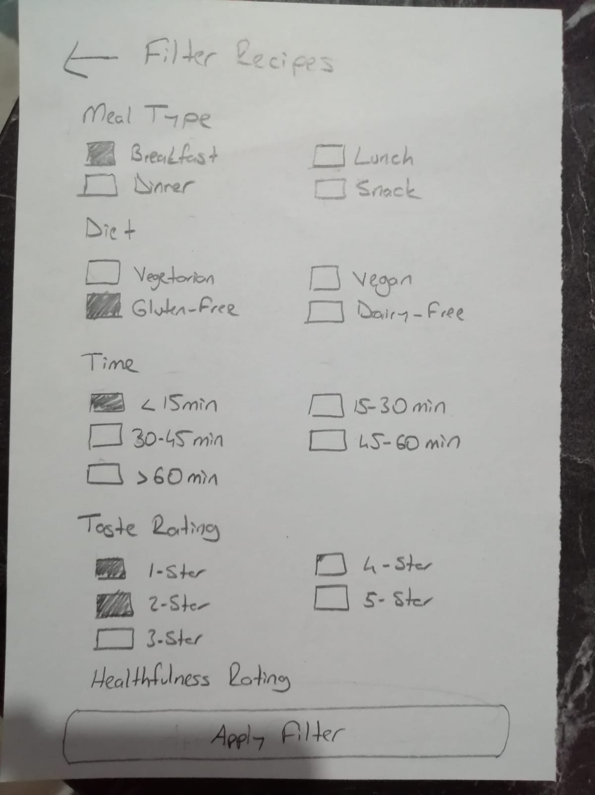

Discover and Filter Recipes

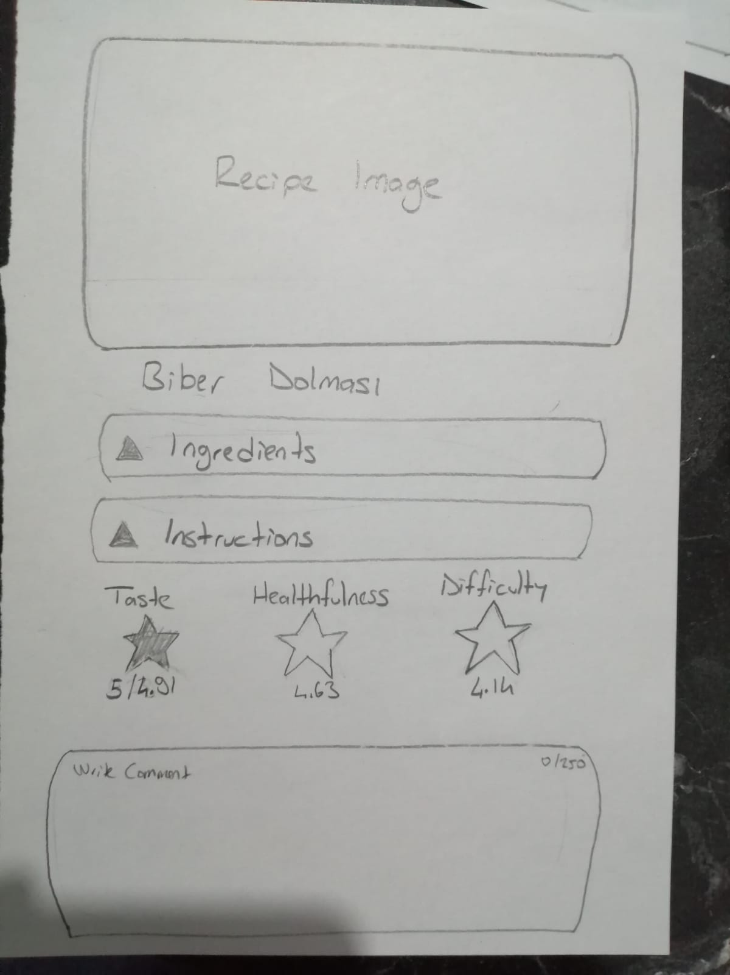

Rate and Review a Recipe

#### Emirhan Akbaş

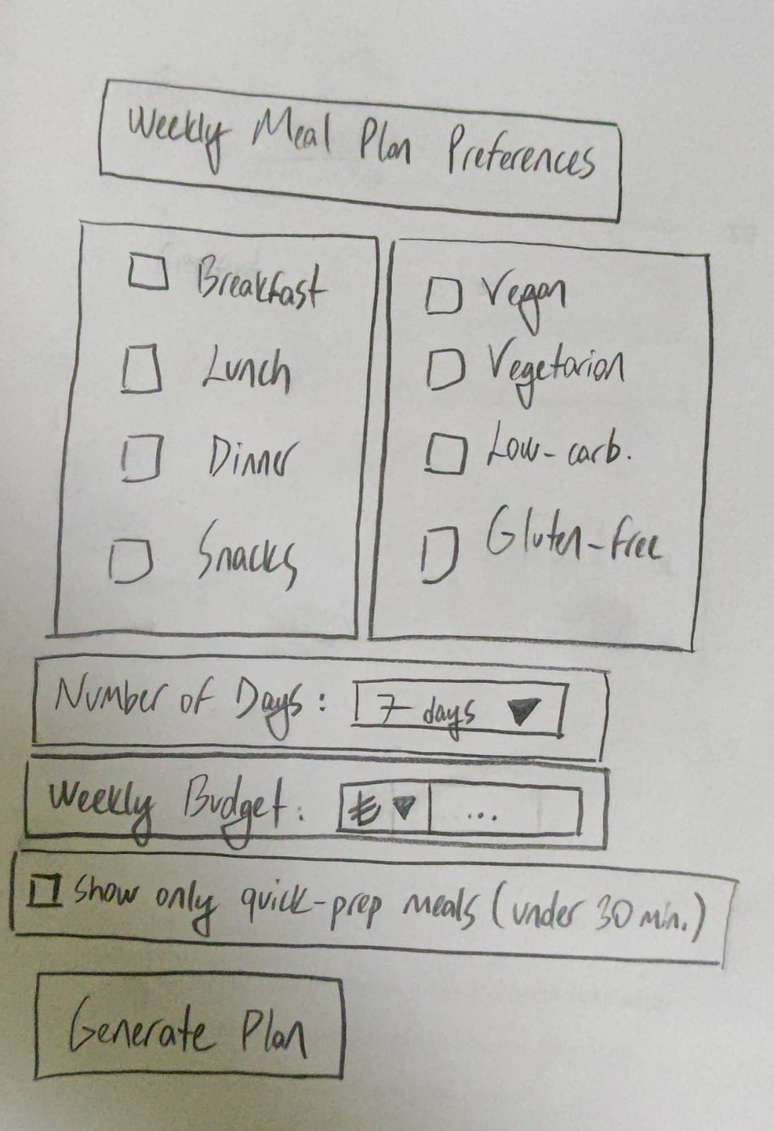

Create a Weekly Meal Plan

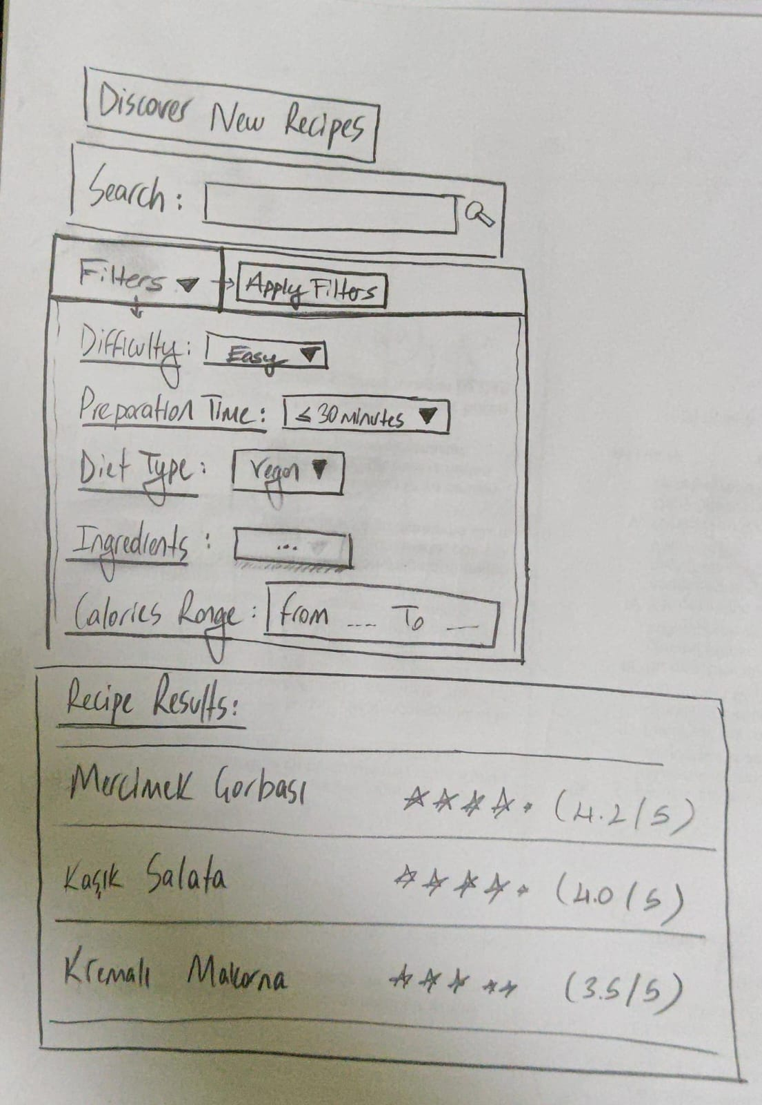

Discover and Filter Recipes

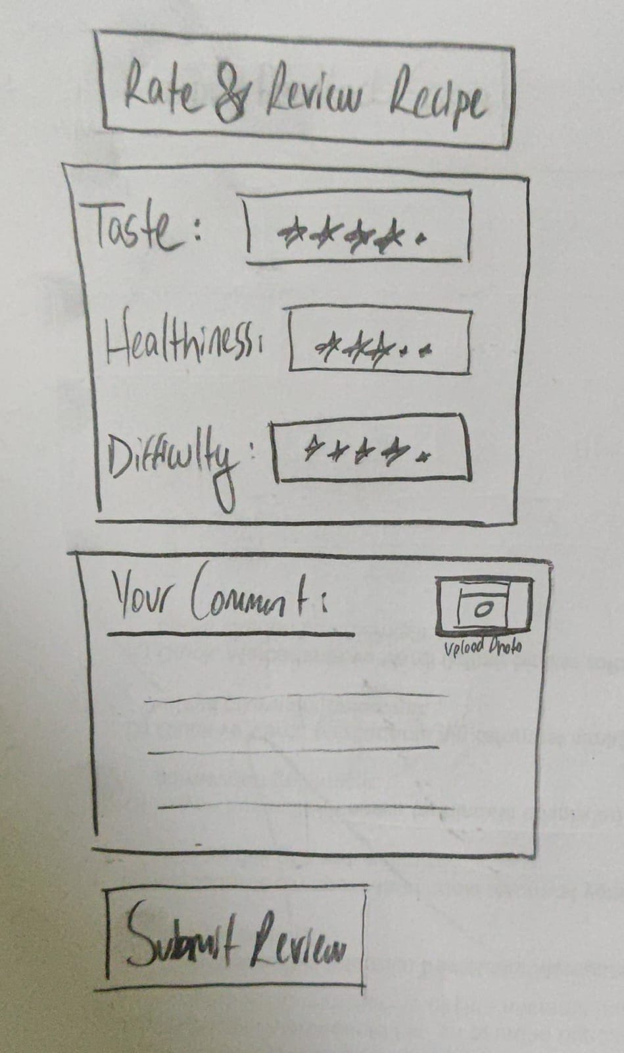

Rate and Review a Recipe

#### Nurten Çiftçioğlu

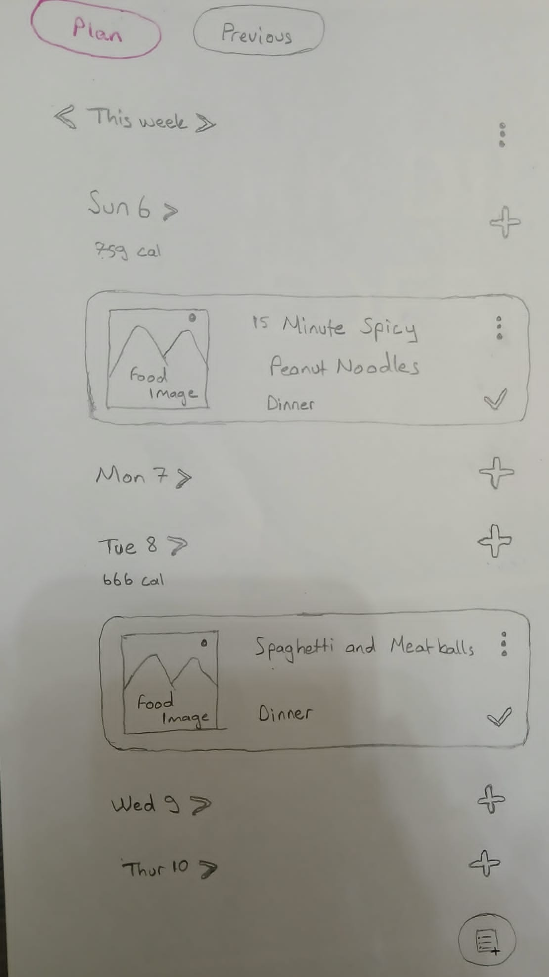

Create a Weekly Meal Plan

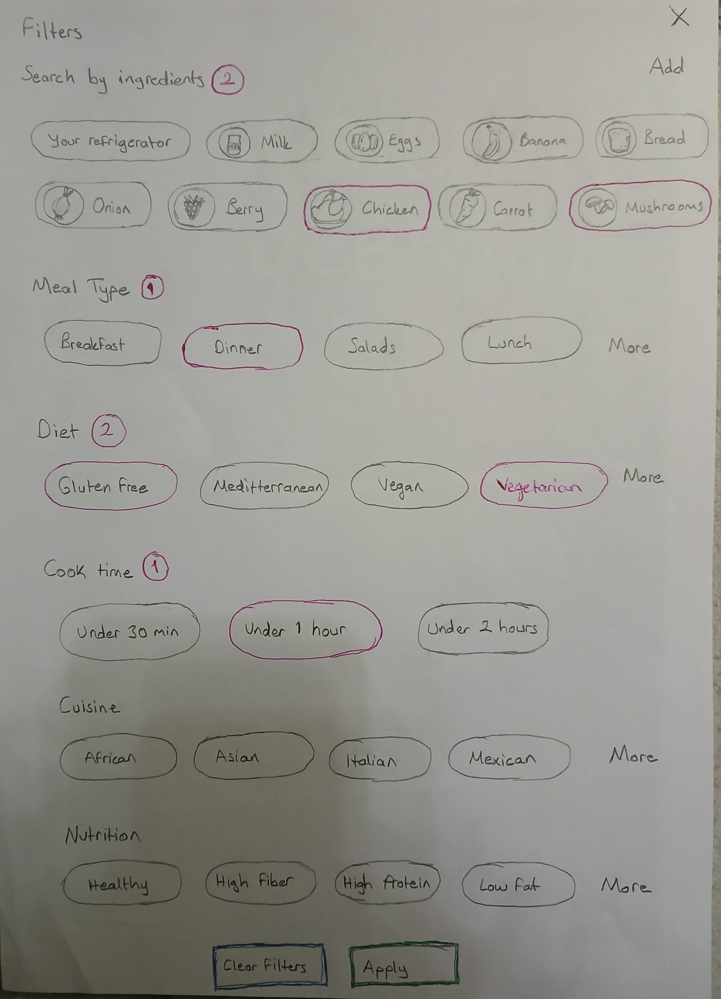

Discover and Filter Recipes

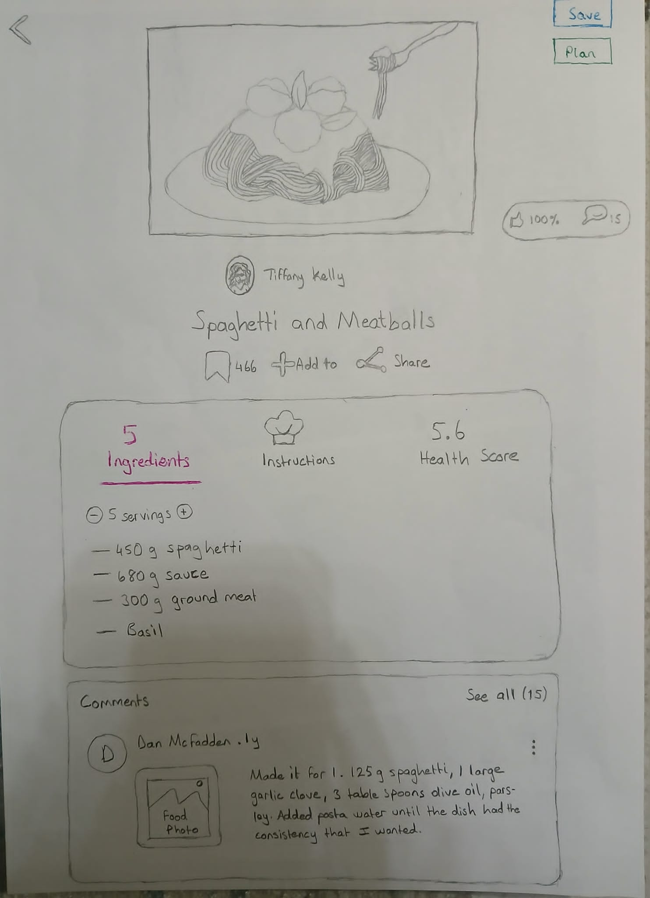

Rate and Review a Recipe

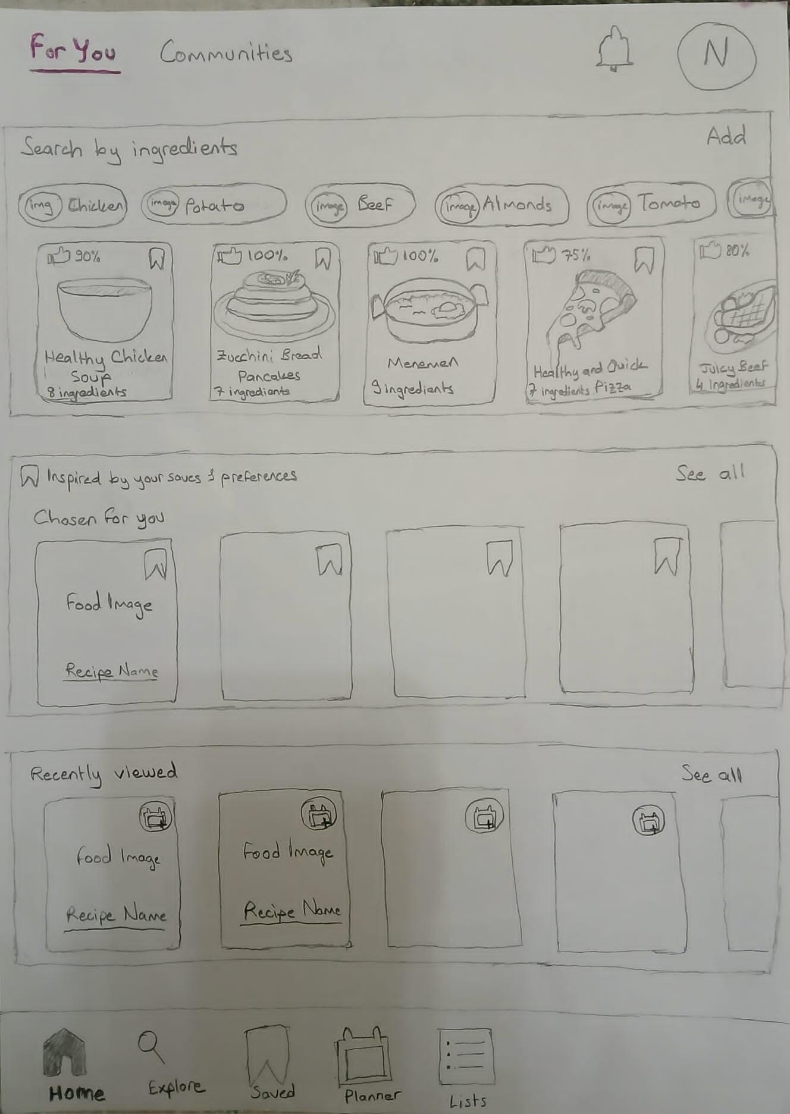

Main Page

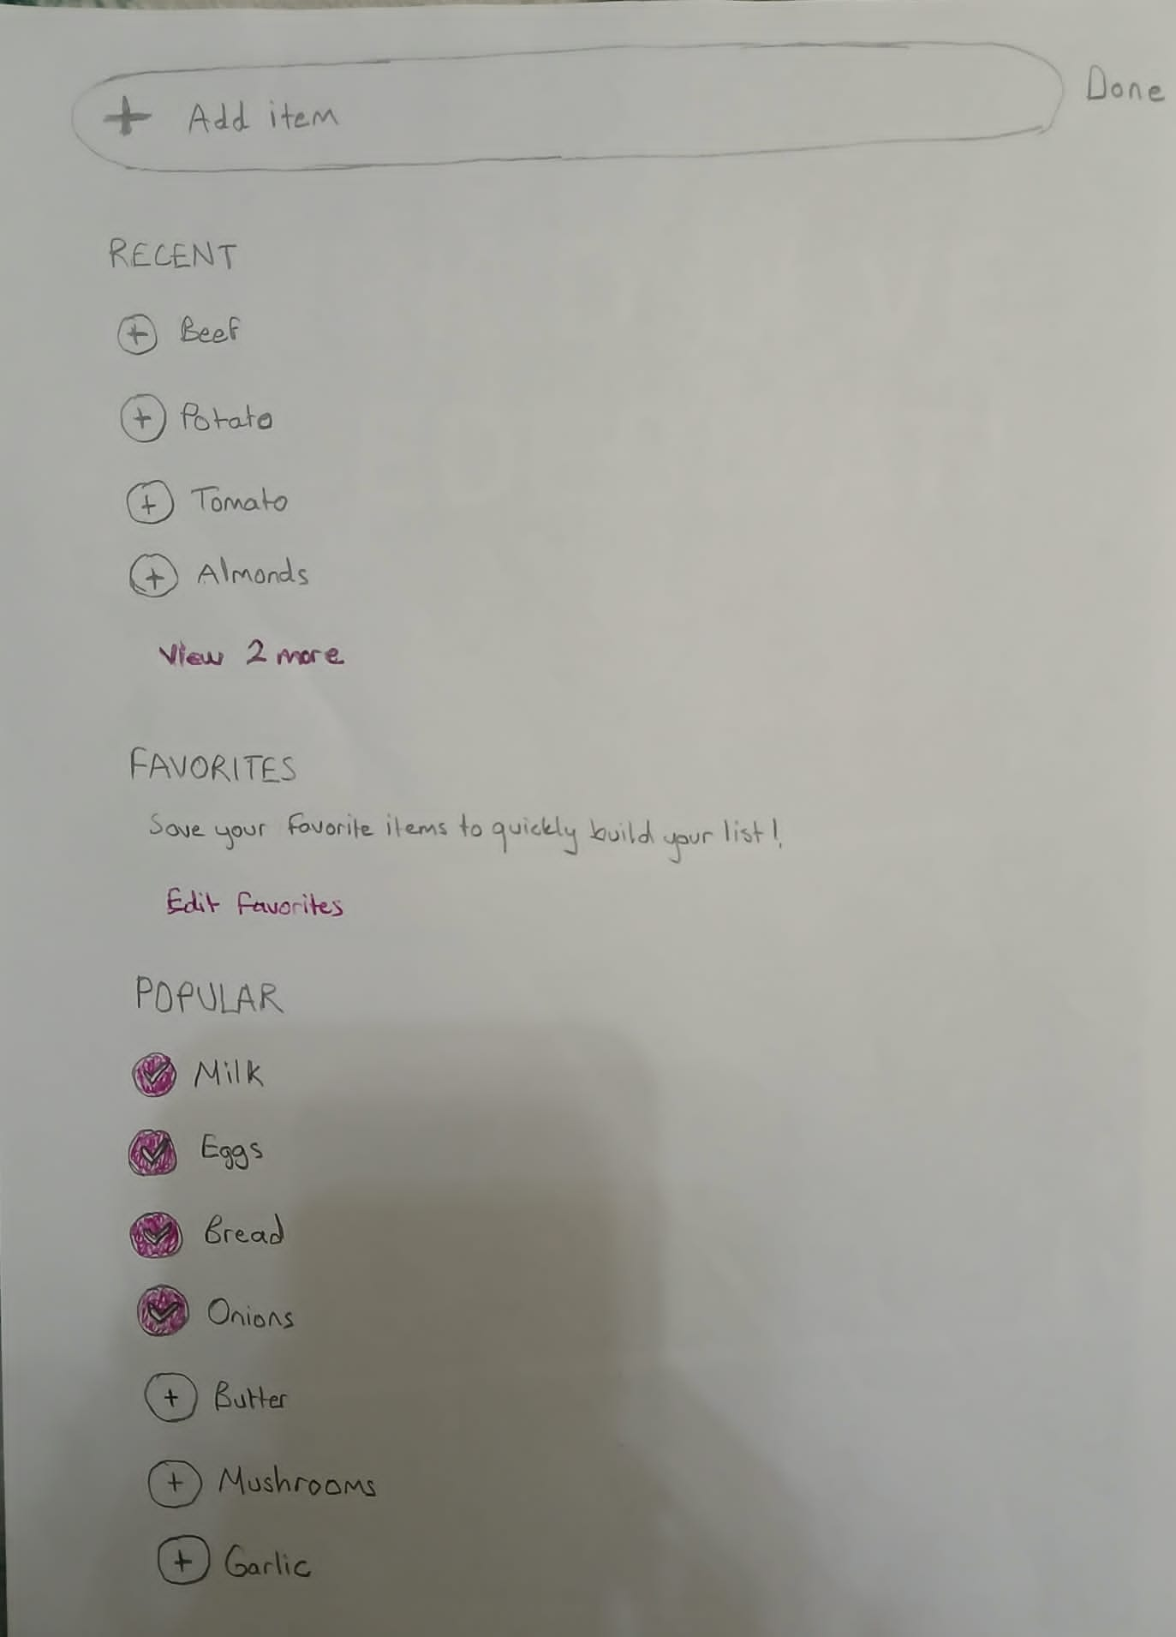

Add Ingredient

## Part 2

### Final Sketches



Create a Weekly Meal Plan

Nurten's weekly meal plan design excels through superior simplicity and thoughtful use of white space, creating a clean yet informative layout. The calendar metaphor provides immediate familiarity while strong contrast between headers and content establishes clear visual hierarchy. The consistent alignment of elements creates a sense of order, while the balanced distribution of content prevents a cluttered appearance. The intelligent use of white space elegantly separates functional areas without requiring explicit borders, resulting in a cleaner, more scannable interface.

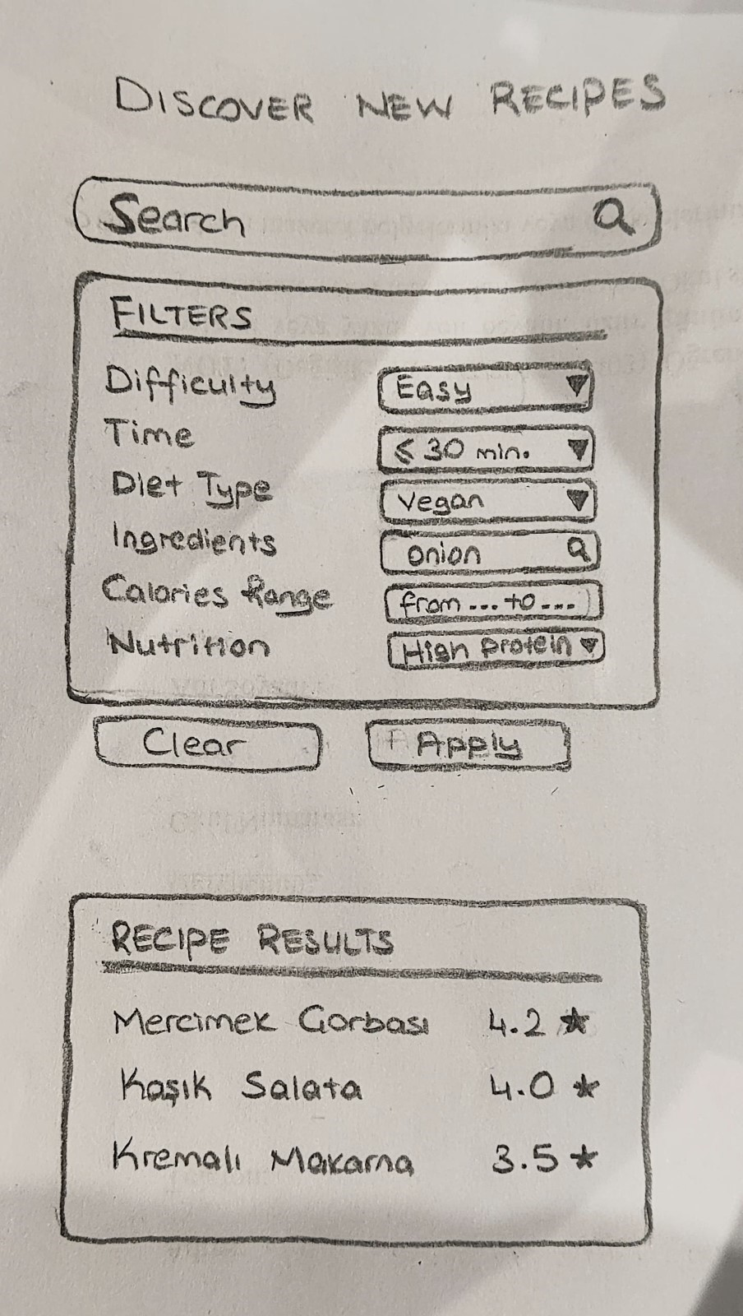

Discover and Filter Recipes

The task is based on Emirhan’s original sketch, with improvements made to enhance clarity, layout, and usability. The structured dropdown filter menus from the original design were kept, allowing users to filter recipes by difficulty, preparation time, dietary preferences, and nutrition in an intuitive way. The layout was refined with better spacing and alignment, and recipe results are presented in a compact card format with star ratings for easy browsing. Familiar metaphors like the magnifying glass for search and filter icons were retained to ensure intuitive interaction. Some visual polish was inspired by Nurten’s clean design style, helping to modernize the overall appearance while keeping the core structure and flow of Emirhan’s original concept.



Rate and Review a Recipe

Nurten's rating interface demonstrates excellence through a straightforward flow that guides users intuitively through the review process. Strong contrast between interactive elements and surrounding content makes input methods immediately obvious. The generous white space between rating categories prevents accidental selections, while careful alignment of form elements creates a professional appearance and helps users quickly scan different rating options. This consistent alignment extends to how rating controls, labels, and input fields are perfectly lined up, creating visual harmony and reducing cognitive load. The thoughtful visual hierarchy emphasizes primary elements like rating, helping users process information logically from reviewing the recipe to submitting their feedback.

### Scenarios and Storyboards

### Create a Weekly Meal Plan

### Ahmet (Student)

Ahmet opens his refrigerator on Monday evening after returning from a long day of classes, finding only a handful of random ingredients. Realizing he's been eating takeout too often and straining his tight student budget, he decides it's time to plan his meals for the week. He opens the CookEase app on his phone and taps on the planner tab at the bottom of the screen. The app transitions to the weekly meal plan page where he can see days laid out vertically, but most slots are empty except for a couple of previously planned meals. Noticing the plus icon next to Sunday's date, Ahmet taps it to add a new meal for today. A series of budget-friendly recipe cards appears, and Ahmet swipes through the recommendations until he finds that he likes. With a simple tap on the checkmark, he applies the recipe to his Sunday dinner slot, feeling satisfied that he's taking a step toward better meal organization and budget management.

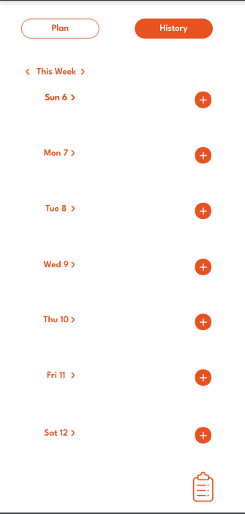 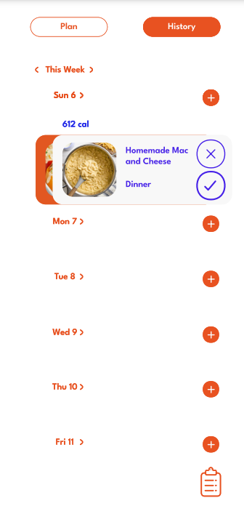

Scene 1 - 2

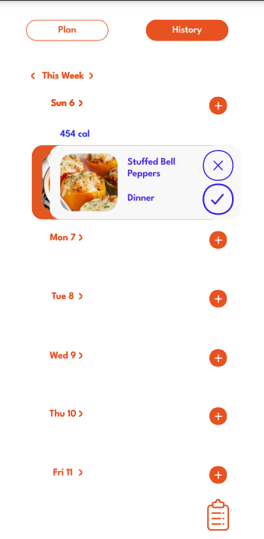 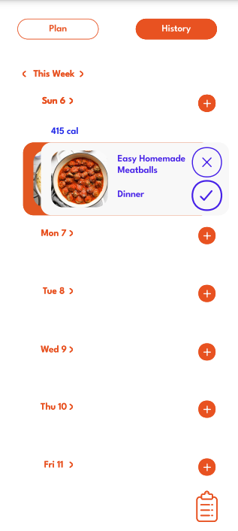

Scene 3 - 4

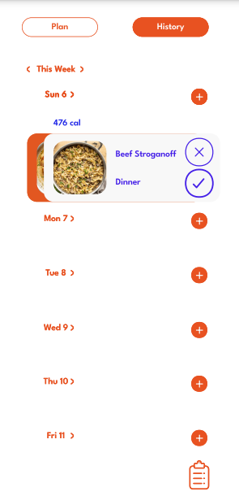 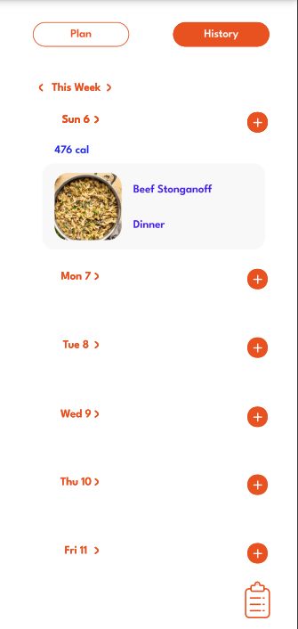

Scene 5 – 6

### Discover and Filter Recipes

### Meryem & Olcay (Family)

It’s a cozy Saturday afternoon, and Meryem and Olcay are sitting at the kitchen table with their kids, excited to try out a new dessert recipe together. They open the CookEase app and land on the “Discover New Recipes” page. At the top, Olcay types “Desserts” into the search bar.

They then open the Difficulty filter and select “Easy”, followed by setting the Time filter to “< 30 Min.” to ensure the recipe will be quick and fun for their kids to help with.

After tapping the Apply button, a list of dessert recipes appears, including options like “Muzlu Yulaf Topları”, “Çilekli Yoğurt Dondurması”, “Havuçlu Kek”, and “Köstebek Pasta.” Each recipe is displayed with its name and star rating making it easy for the family to browse.

After a bit of scrolling and discussion, they agree on Köstebek Pasta, which looks fun and delicious. Olcay taps the recipe to view the full details, ready to get started with the kids.

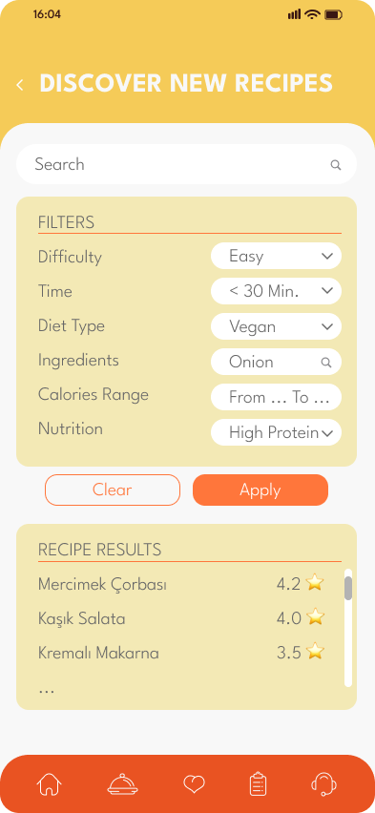 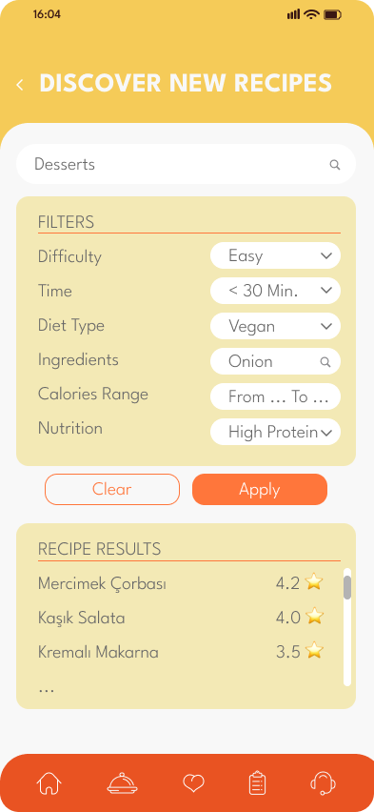

Scene 1 - 2

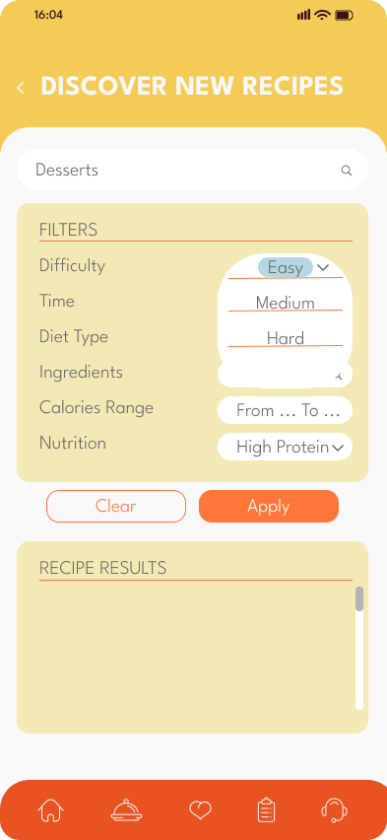 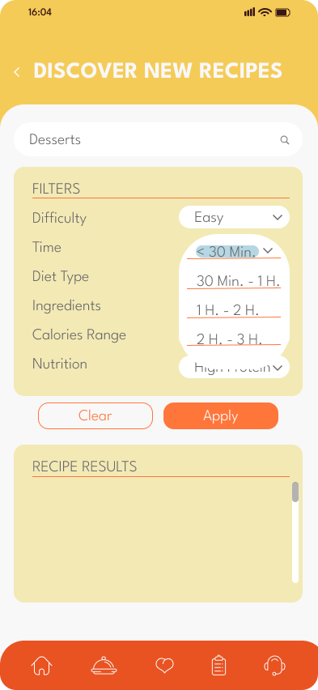

Scene 3 – 4

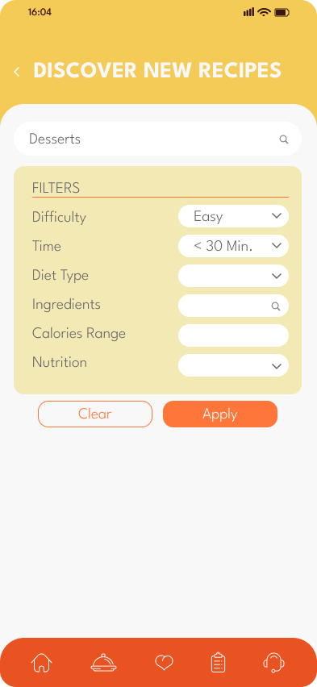 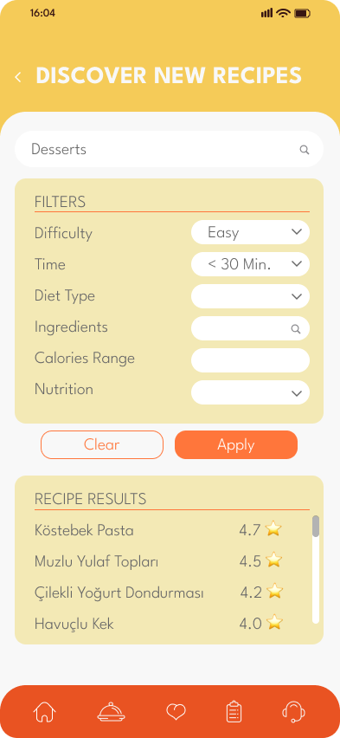

Scene 5 - 6

### Rate and Review a Recipe

### Selin (Health-Conscious Individual)

After a long day, Selin finally sits down to enjoy the “Bamya Çorbası” she prepared using a recipe she found on CookEase. The soup turns out to be absolutely delicious—flavorful, filling, and, most importantly, perfectly aligned with her gluten-free and vegetarian lifestyle. Pleased with how it turned out, she decides to leave a detailed review to help others with similar dietary preferences.

Selin opens the CookEase app and heads to the recipe page. She taps the "Rate&Review” part and starts filling out the rating fields. For taste, she gives it a full 10/10—she loved the unique blend of spices and the hearty texture. For healthiness, another 10/10—it was packed with nutrients and completely gluten-free. For difficulty, she rates it 3/10, noting that it took a bit of prep but nothing too complicated.

In the review box, she writes:  
 "Excellent healthy and filling soup! Perfect for a gluten-free vegetarian lunch. Will definitely make again!"

### 

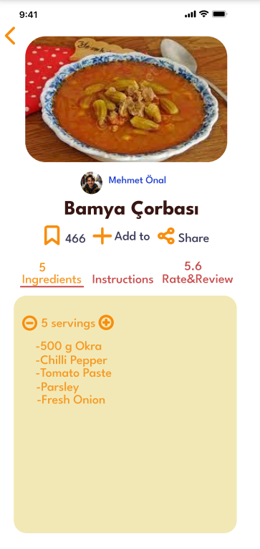 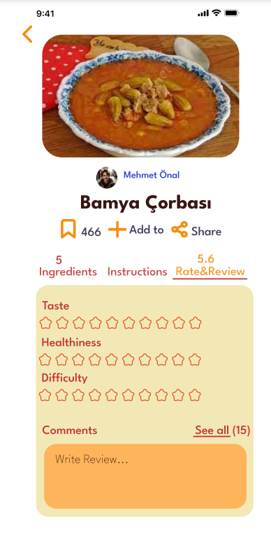

Scene 1 - 2

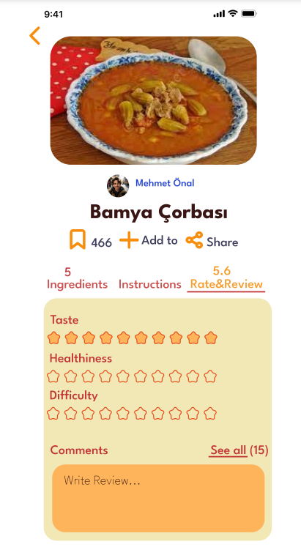 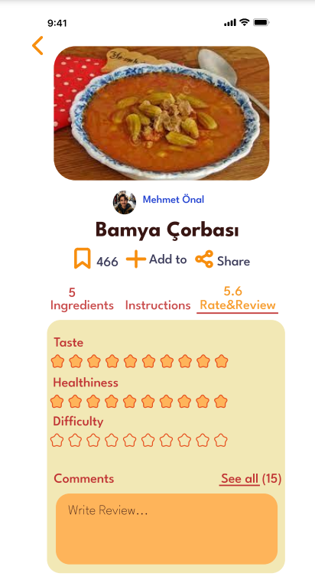

Scene 3 - 4

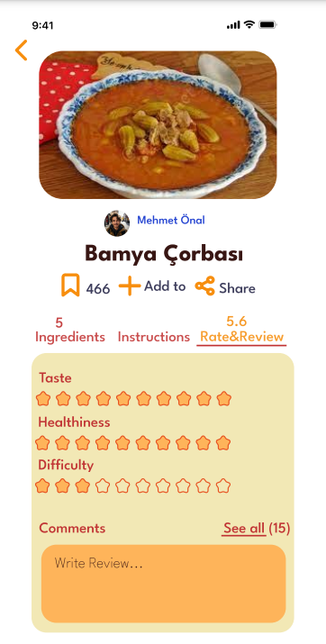 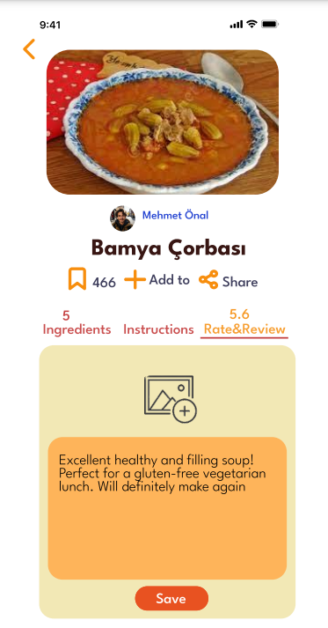

Scene 5 - 6

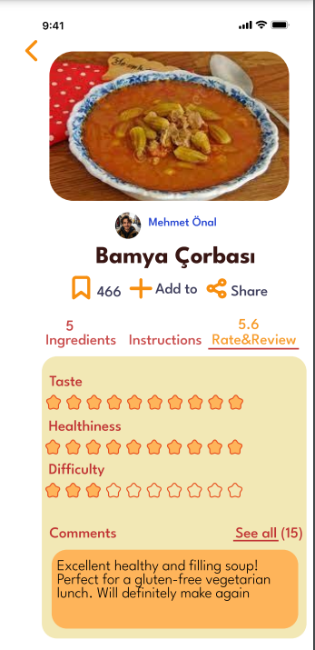

Scene 7

### Metaphors

* Calendar (Create a Weekly Plan)
* Filter (Discover and Filter Recipes)
* Star (Rate and Review a Recipe)
* Bookmark (Rate and Review a Recipe)
* Magnifying glass (Discover and Filter Recipes)

## Conclusion

This report has outlined the interface design process for CookEase, an AI-driven application aimed at simplifying meal planning and recipe discovery. Through the iterative process of sketching initial designs based on user needs analysis and refining them into final concepts, we have established the foundational user interfaces for key tasks: creating weekly meal plans, discovering and filtering recipes, and rating completed meals. The design choices prioritize good graphic design guideline incorporating familiar metaphors like calendars and filters to ensure user-friendliness. Our goal remains to create a tool that adapts to user preferences and makes the process of deciding, planning, and cooking meals a more enjoyable and less stressful experience.