CookEase

Nurten Çiftçioğlu 21050111027
Muhammed Enes Uğraş 23050151030
Emirhan Akbaş 23050151001

20/03/2025

CENG310 – Human Computer Interaction
Spring 2024/2025
PROJECT STAGE 2 | PROJECT STAGE 2
CookEase | Name or very short decription of your application

Introduction
CookEase simplifies meal planning by using artificial intelligence to generate personalized recipe suggestions based on available ingredients, user preferences, dietary restrictions, and past choices. It also features weekly meal planning, a favorites section, and a rating system to evaluate recipes on taste, healthiness, and difficulty. By continuously learning from user feedback, the app aims to make meal planning smarter and more efficient.

Persona & User Tasks

User Category 1: Busy Professionals

Persona 1: Göktürk
Ahmet is a 35-year-old marketing manager with a demanding work schedule, leaving him with little time for meal preparation. He often resorts to ordering food or cooking quick, simple meals at home. On weekends, he enjoys experimenting with new recipes when he has more time. While Ahmet tries to maintain a healthy lifestyle, he struggles to do so consistently due to his hectic work life. He seeks practical, healthy, and fast meal options that require minimal preparation time. He needs an app that provides quick recipes based on the ingredients he already has and helps him generate shopping lists for the week.

User Category 2: Health-Conscious Individuals

Persona 2: Selin
Selin, a 28-year-old fitness trainer, is highly health-conscious and follows a strict diet, typically vegetarian and gluten-free. She enjoys trying new healthy recipes but sometimes struggles to find options that align with her dietary restrictions. Selin seeks variety in her meals while sticking to her nutritional goals. She needs an app that can suggest meals based on her dietary preferences, provide nutritional information, and help her plan her weekly meals. The app should also allow her to customize recipes and track the meals she consumes.

User Category 3: Students

Persona 3: Ahmet
Ahmet is a 21-year-old computer science student living alone in a dorm. With a tight budget and limited time, he often opts for quick, affordable meals but wants to improve his eating habits by making healthier choices. He struggles with meal planning and often finds it challenging to decide what to cook. Ahmet needs an app that provides budget-friendly, easy-to-make meal suggestions based on the ingredients he already has. Additionally, he would benefit from a feature that helps him plan meals for the week without exceeding his budget.

User Category 4: Home Cooks/Food Enthusiasts

Persona 4: Elif
Elif is a 40-year-old graphic designer who enjoys cooking and trying new recipes. She spends a lot of time experimenting in the kitchen, but sometimes she struggles with meal planning or finding inspiration for new dishes. Elif needs an app that offers creative recipe suggestions, helps her plan meals for the week, and generates shopping lists based on the recipes she selects. The app should also allow her to save her favorite recipes and easily organize them for future use.

User Category 5: Families

Persona 5: Meryem & Olcay
Meryem (38) and Olcay (40) are parents of two children. They want to prepare healthy, quick meals during the week, but on weekends, they enjoy cooking as a family. They struggle to plan meals that cater to each family member's dietary preferences while maintaining a balanced, healthy diet. They need an app that suggests family-friendly recipes, helps them plan meals for the week, and generates shopping lists for the ingredients needed. The app should allow them to adjust meal plans based on the varying preferences and needs of their family members.

2- User Categories and Their Tasks

1. Busy Professionals
Tasks:
- Account/Profile Management:
  - CRUD (Create, Read, Update, Delete) an account.
  - Log in and log out.
  - Update personal profile (e.g., preferences for quick meals).
  - Set dietary restrictions (e.g., low-calorie, low-carb).
- Meal Planning:
  - View personalized meal suggestions based on available ingredients.
  - Filter recipes by time constraints (e.g., under 30 minutes).
  - Save favorite recipes for future use.
  - Create a weekly meal plan based on quick meal preferences.
  - Generate a shopping list based on the weekly plan.
- Recipe Recommendations:
  - Browse through recommended recipes based on past choices.
  - Rate recipes based on taste, healthiness, and preparation time.
  - Share favorite recipes with colleagues or friends.

2. Health-Conscious Individuals
Tasks:
- Account/Profile Management:
  - CRUD an account with dietary preferences (e.g., vegetarian, gluten-free).
  - Set specific diet-related preferences (e.g., high-protein, low-carb).
- Meal Planning and Recipe Discovery:
  - Search for healthy recipes based on specific dietary needs (e.g., gluten-free).
  - View nutritional information (calories, macronutrients) for recipes.
  - Save and categorize healthy recipes for easy access.
  - Create and customize weekly meal plans based on health goals.
- Shopping List and Tracking:
  - Generate shopping lists based on selected healthy meals.
  - Track the nutritional value of meals throughout the week.
- Community Engagement:
  - Share recipes and meal plans with others in health-focused communities.
  - Read reviews and ratings for recipes to ensure suitability for their diet.

3. Students
Tasks:
- Account/Profile Management:
  - CRUD an account with preferences (e.g., quick meals, budget-conscious).
  - Set dietary restrictions if any (e.g., vegetarian, low-budget).
- Quick Meal Suggestions:
  - Enter available ingredients to get quick meal suggestions.
  - Filter recipes based on preparation time and difficulty level.
  - Save quick and easy recipes for later use.
- Budget-Friendly Meal Planning:
  - Create a weekly meal plan with an emphasis on affordability.
  - Generate a shopping list that is budget-friendly and efficient.
- Recipe Rating and Sharing:
  - Rate recipes on ease of preparation and cost-effectiveness.
  - Share budget-friendly recipes with friends or on social media.

4. Home Cooks/Food Enthusiasts
Tasks:
- Account/Profile Management:
  - CRUD an account with food preferences and culinary interests.
  - Set preferences for types of cuisines (e.g., Italian, Mediterranean).
- Recipe Exploration:
  - Discover new and creative recipes based on preferences and ingredient availability.
  - Save, share, and organize favorite recipes.
  - Create custom recipes using existing ones as a base.
- Meal Planning:
  - Plan meals for the week with diverse and creative recipes.
  - Adjust meal plans based on available ingredients or specific cravings.
  - Generate a shopping list based on the weekly plan.
- Recipe Rating and Review:
  - Rate recipes based on taste, ease, and presentation.
  - Share feedback and modify recipes based on personal preferences.

5. Families
Tasks:
- Account/Profile Management:
  - CRUD an account for multiple users (e.g., parents and children with dietary needs).
  - Set family-wide preferences (e.g., meal preferences for kids, gluten-free, vegetarian).
- Family Meal Planning:
  - Create a weekly meal plan that accommodates different dietary needs.
  - Generate shopping lists based on the meal plan, accounting for family size.
  - Adjust the meal plan as needed for different family members.
- Recipe Suggestions:
  - Browse family-friendly recipes that are easy to prepare and meet various dietary restrictions.
  - Save recipes that are particularly well-liked by family members.
- Meal Customization and Sharing:
  - Modify meal recipes for family-specific needs (e.g., less spice for children).
  - Share successful meals with other family members or extended family.

Task Analysis
Make a detailed task analysis for 4 risky tasks with textual HTA descriptions PLUS make a simple task analysis for the remaining tasks. (Choose 4 risky tasks, the selected tasks should not be simple such as login/logout/sign in/sign out etc.)
Examples:
EXAMPLE for a detailed task (Should include Textual HTA Description)
TASK 1: Name of the Task
1 paragraph of the aim of the task that describes the actions people do.
HTA 1:
Don't draw the HTA diagram, only give textual HTA description as in lecture slides
EXAMPLE for a simple task
TASK 1: Name of the Task
1 paragraph of the aim of the task that describes the actions people do. You don't need to give the textual HTA description.

Domain Analysis
Make a domain analysis and draw the domain analysis diagram. You can use any tools for drawing the diagram.

UDesign's domain analysis:
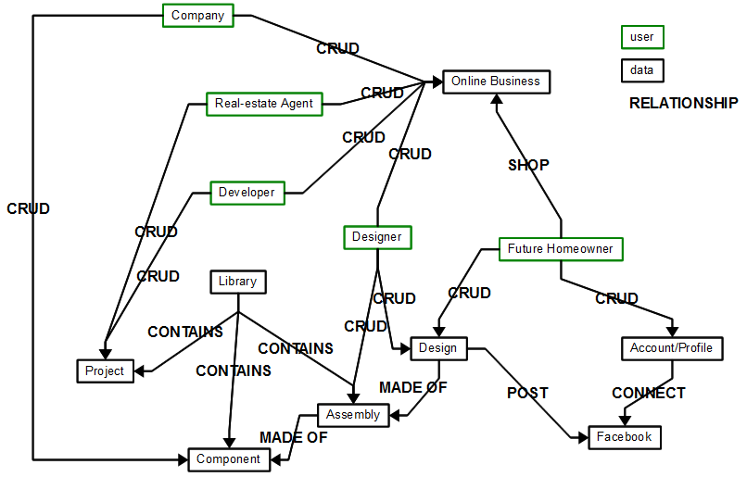

Usability Goals
Write 5 quantitative and 5 qualitative usability goals for your task. (1 sentence for each)
Type
Quantitative
Qualitative

Conclusion
…

Contributions
Contribution of each member (give percentages)

