JS-Saga: Requirements and Design Document

1. Project Overview
JS-Saga is an interactive web application designed to help users enhance their JavaScript coding skills through a gamified and structured learning experience. The platform provides:
A live coding environment where users can write and execute JavaScript code.
Multiple challenge levels that users can complete to improve their coding skills.
User progress tracking and a leaderboard system to enhance engagement.
An interactive UI, including a support page with an image gallery and a contact form.
User authentication, allowing registered users to track achievements and customize their experience.
The target audience includes beginner and intermediate programmers, students, and self-learners who want a structured and interactive way to improve their JavaScript skills.

2. Site Map
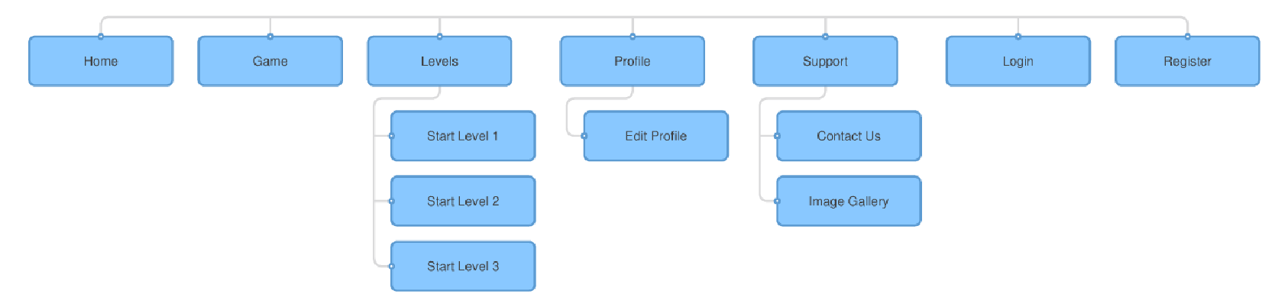
The JS-Saga website includes the following key pages, all accessible via a global navigation bar:
- Home Page (index.html)
- Game (game.html) - Live coding environment with challenges.
- Levels (level.html) - Challenge selection based on difficulty.
  - Start Level 1 (Dynamic Section).
  - Start Level 2 (Dynamic Section).
  - Start Level 3 (Dynamic Section).
- Profile (profile.html) - Displays user achievements and progress.
  - Edit Profile - Allows users to update their information.
  - Leaderboard - Displays top-ranked players.
- Support (support.html) - Contains a user contact form and interactive images.
  - Contact Us (Section inside support.html).
  - Image Gallery (Section inside support.html).
- Authentication System (login.html, register.html) - Handles user login, registration, and session management.
Each page includes a consistent navigation bar, a header and footer, and AJAX-based interactivity.

3. Page Design Documentation
Each page has a specific purpose and functionality:

index.html (Home Page)
- Purpose: Introduces JS-Saga and serves as the main navigation hub.
- Buttons & Actions: "Start Game" button redirects users to game.html.

game.html (Coding Interface)
- Purpose: Provides a live coding environment where users write and execute JavaScript.
- Buttons & Actions: "Run Code" button submits the user’s JavaScript to execute.php via AJAX.

level.html (Level Selection)
- Purpose: Allows users to select difficulty levels for JavaScript challenges.
- Buttons & Actions: Each level button directs users to game.html?level=x.

profile.html (User Profile)
- Purpose: Displays user achievements, current progress, and rankings.
- Buttons & Actions: "Edit Profile" button allows users to modify personal details.

support.html (Support & Gallery)
- Purpose: Provides a contact form and interactive gallery for user support.
- Buttons & Actions:
  - Contact form submits messages.
  - Gallery images open in a modal window.

login.html (Login Page)
- Purpose: Handles user authentication for login.
- Data Fields: Username, password.
- Buttons & Actions: Login button authenticates users; Register button redirects to sign-up.

register.html (Sign-Up Page)
- Purpose: Allows users to create an account.
- Data Fields: Username, email, password, confirm password.
- Buttons & Actions: Register button creates a new account.

4. Content Categories and Interactivity

Content Categories
Category | Description
Users | Players engaging in JavaScript coding challenges.
Events | JavaScript challenges, level progression, and leaderboard rankings.
Information | Guides, coding tips, and explanations on JavaScript concepts.
Gallery | A section in support.html displaying interactive images.

Interactivity & User Engagement
JS-Saga incorporates various interactive features to enhance the learning experience and user engagement:
AJAX Code Execution
- Users submit JavaScript code dynamically without needing to reload the page.
- Code is sent via AJAX to execute.php, which processes it and returns the result.
CodeMirror Integration
- A live JavaScript coding interface with syntax highlighting, error detection, and indentation.
Gamified Progression System
- Users unlock new levels and progress through challenges based on performance.
Leaderboard System
- Users are ranked based on challenge completion and accuracy.
Interactive Image Gallery
- Users can view coding-related visuals in a dynamic gallery on support.html.
Contact Form with Validation
- Users can submit feedback, inquiries, or issue reports through the contact form.

Inspiration from Existing Web Applications
JS-Saga’s interactive features and gamified learning experience are inspired by:
- JSFiddle – Provides a live JavaScript coding and execution environment.
- Khan Academy Programming – Implements interactive JavaScript tutorials and exercises.
- Codewars – Uses a challenge-based learning system where users complete coding problems to level up.

5. Dynamic Functionality
JS-Saga integrates JavaScript, AJAX, and jQuery UI to create an engaging, interactive coding experience.
- AJAX-Based Code Execution → Allows users to write JavaScript code, send it to execute.php, and receive real-time results.
- Live Code Editor → Powered by CodeMirror, providing syntax highlighting, auto-indentation, and error detection.
- Gamification → Users unlock levels, earn achievements, and track their progress.
- Leaderboard System → Users are ranked based on their JavaScript coding performance.
- jQuery UI Enhancements → Includes modal pop-ups for the image gallery, interactive UI elements, and enhanced form validation.
- Dynamic Form Validation → Ensures users enter valid data in forms (e.g., valid email format, required fields).

