**DOKUZ EYLÜL UNIVERSITY**

**ENGINEERING FACULTY**

**DEPARTMENT OF COMPUTER ENGINEERING**

**CME 2210**

**Object Oriented Analysis and Design**

**HOTEL RESERVATION AND MANAGEMENT**

**SYSTEM**

**by**

**Emirhan Bilge Bulut**

**Burcu Agdar**

**1. Introduction ....................................................................................4**

1.1 What the Problem is..............................................................................................................4

1.2 Goals for the Project.......................................................................................................4 1.3 Stakeholders...................................................................................................................5

1.4 Motivation for the Project...................................................................................................6 1.5 Process Flow Preview.....................................................................................................6

**2. Analysis and Design .......................................................................7**

2.1 Plan for Requirements Engineering ................................................................................7 -8 2.2 Functional Requirements............................................................................................8-9-10

2.3 Non Functional Requirements............................................................ 11-12-13-14-15-16

2.4 Use Cases....................................................................................................................17

2.5 Models.....................................................................................................................18-19-20

**3. Project Plan .................................................................................. 21**

3.1 Task Description..........................................................................................................21-22 3.2 Task Assignment ..........................................................................................................22-23

3.3 Project Schedule .........................................................................................................23

**4. Testing........................................................................................... 24**

4.1 Features to be Tested ........................................................................................................24 4.2 Test Cases ....................................................................................................................24

4.3 Testing Schedule .........................................................................................................24

**5. Conclusion..................................................................................... 25**

5.1 The Problem and Solution .................................................................................................25 5.2 The Team and the SE Process.....................................................................................25 5.3 Engagement of Umbrella Activities ...................................................................................25-26 The Stakeholder’s that Benefited .......................................................................................26

The Organization’s Benefits...............................................................................................26

**6. User Manual.................................................................................. 27**

6.1 Software Description .........................................................................................................27 6.2 How to use the Software ............................................................................................27-28 6.3 Troubleshooting Common Problems............................................................................28

* **Introduction**
  1. **What the Problem is**

There should be a system that allows users to make reservations quickly.Registration must be registered and the user must be over 18 years old.If registered, login must be done by mail and password.The user should be able to see the rooms in the hotel in this system.Necessary information such as number of beds in the rooms, room area, services in the room, price should be shown.Customer can search for different types of rooms.4 different searches should be added according to the increasing price, the decreasing price, the determined price range and the room capacity.The customer should be able to add extra service after choosing the room.The system must also contain employee information and be displayed on the system.After the customer makes a reservation, his / her information should be recorded in the system and customer information should be displayed on the screen.

* 1. **Goals for the Project**

The aim of the project is to provide the fastest access to all necessary information about the hotel for both customers and hotel employees.Keeping the information permanently in the system will be beneficial for the hotel.Hotel employees will be able to access all necessary information of their customers from the system.Employees with customer name, address, phone number, reservation dates, room and service information will provide faster service.The customer will be able to view the empty rooms from the system and find out if the room was booked at any time.They will also have the opportunity to search the rooms in the price range they set.It will be able to add service to the room it wishes to make a reservation.The system will ensure that users are over the age of 18 for more reliable service.

* 1. **Stakeholders**

The most important stakeholders of this software are those who demand the software and the software developers who carry out the software development process.Before starting the software business, we noted the hotel management's requests from us in this project.Then, as software members, we talked about the project.We planned how to prepare the project.We talked about the users of the project.Users are an important factor in the design of the software.The project should have been software for hotel employees, managers and customers.We frequently communicated with group members during the software development process.The fact that the project members inform each other has an important place in the project development.We have reported information about the project to the hotel management many times during the development process.In this way, we received information about whether the software's expectations were met.

One of the most important issues as project members is that it is a project developed by taking care that it is easy to learn and use for customers and employees.The software will be tested multiple times with inputs.Its use will be tested after the creation of the project.The test outputs will be as requested by the hotel management.Wrongs or unwanted printouts will go through the correction process.The project will be repairable, maintained, understandable, and will be paid attention in the software process.After the software is completed, it will be promoted and presented to the hotel management.Hotel staff will also be provided with the necessary information about its use.If problems occur during usage, it will be repaired by software members.The software will provide great convenience to hotel management and employees as well as customers looking for hotels.The customer will easily have information about the hotel and will be able to book the room that matches the qualities they are looking for.

* 1. **Motivation for the Project**

Our software team with the necessary software knowledge for the desired project will work with great devotion to develop the project.While developing the software, it will do the best and create the ones requested by the project owners exactly as desired.Team members have enough experience in communication, problem solving, and software development.Team members will always continue working to repair, maintain and update the program.Care will be taken to ensure that our software is more useful than other software and more attractive to the user.

* 1. **Process Flow Preview**

First of all, we had a detailed meeting with the hotel management for our process flow.We took note of the requests.We shared the notes we received with the hotel management and tested whether their requests were properly understood.Communication will continue during the project development process and care will be taken to avoid any missing details.Sample projects were presented to the hotel management and their opinions were received.Accordingly, their requests were understood and a draft was created for the appropriate design.Hotel management will be contacted at each stage of the project and test procedures will be carried out in order to avoid any overlooked details.In this way, the requirements will be well understood and a complete project will be created.We also plan to contact hotel staff who will use the system and have them test the system usage at each stage.

* **Analysis and Design**

**2.1 Plan for Requirements Engineering**

**Inception Task:**

Our first task is to handle and understand the project requested by the hotel management in detail.We want to understand who will use the software more frequently and for what purposes.We ask questions to the hotel management and staff for software retention.We take note of their ideas as there is a system that the hotel staff will use more.We are making additions considering that they will be used by the customer.Meanwhile, we ask the hotel management questions.

What are the functions you expect from the software?

Who will the software be used by?

Do you have any restrictions?

Do you have anything to add?

**Elicitation Task:**

At this stage, in order to better understand the project, team members meet and discuss the problems and the desired ones.We take note of everyone's ideas to develop better software.We plan meetings with hotel managers to avoid deficiencies and inaccuracies. We prepare reports to explain the parts of the software at the meetings.

**Elaboration Task:**

It is the stage where the information obtained from other stages is combined.Scenarios are created for the software and what outputs will be discussed against each condition.

What the people who will actively use the system (employees and customers) will do when using the system is considered and applied in these scenarios. The interconnection of the tasks in the system is understood.

**Negotiation Task:**

In this section, a table with the general content and requirements of the project will be created. Users, users' needs, additional information etc. will be created in the table. It will also be supported by modeling to provide an overview of the design.

**2.2 Functional Requirements**

**Hardware Requirements:**

The program is an application that can run on desktop and laptop regardless of operating system. Mouse, keyboard and screen are sufficient to use the application.

**Form Application Interface - Primary Tasks:**

* + Registration screen
* The user must register to enter the system.

-Name

-Last name

-Age

-Mail

-Creating a password

* Login screen
* If the user is registered, he / she must log in to the system by mail and password.
* User's mail and password information is taken from txt.
* Viewing rooms
* It is the screen that allows the user to see all the rooms and access the room information.

-Number of beds

-Room space

-Room price

-Room capacity

-Services in the room

* Customer viewing
* It is the screen where customer information is displayed for hotel employees.

-Customer name

-Customer surname

-Customer address

-Customer phone

* Employee monitoring
* It is the screen where employee information is kept

-The name of the employee

-Employee surname

-Employee's address

-Employee's remittance

* Service display
* Screen where customers view extra services

-Service name

-Service Price

* Search screen
* It is the screen where customers can search for rooms in different ways.

-Search by increasing price

-Search by decreasing price

-Search by specific price range

-Search by room capacity

**Form Application Interface - Secondary Tasks:**

* The reservation screen opens to the customer
  + It is the screen that allows the customer to make a reservation.
* Allows the customer to choose a room
  + The customer can select the desired room and click on the select button
* Allowing service selection
  + If you want to add additional service to the selected room, the buy button can be clicked on.
  + If you want to remove the selected service, click the delete button.
* Allows viewing extra services received
* Shows added services
* Deleted services are removed from the screen
* Allows to enter reservation dates
* Allows to enter the start and end dates of the reservation
* Returns 'Date is wrong' when there is an incorrect date entry
* Allows total price notation
* Display of the total price of the selected rooms and services

**2.3 Non Functional Requirements**

**Performance Requirements:**

* Being a fast working system
* To be able to carry out many transactions
* Posting an error message on wrong information
* Working fast regardless of operating system
* Price representation proportional to the number of days customers will stay
* Saving data in the background

**Security Requirements:**

* Checking birthdate information during registration to prevent the registration of minors under the age of 18
* Saving the user's email and password in the background and preventing incorrect information when entering.
* By changing the status of the rooms that customers have booked, to prevent the reservation of the same rooms again
* Checking the reservation dates entered by the user as month, day, year and publishing an error message in the wrong date entry

**Quality Attributes:**

* A system that is visually appealing and easy to use
* Easy to understand design by the user
* Maintain readable content
* To be used for registered users over the age of 18

**Screenshot Mockups:**

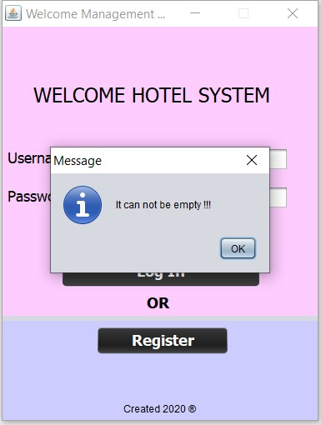

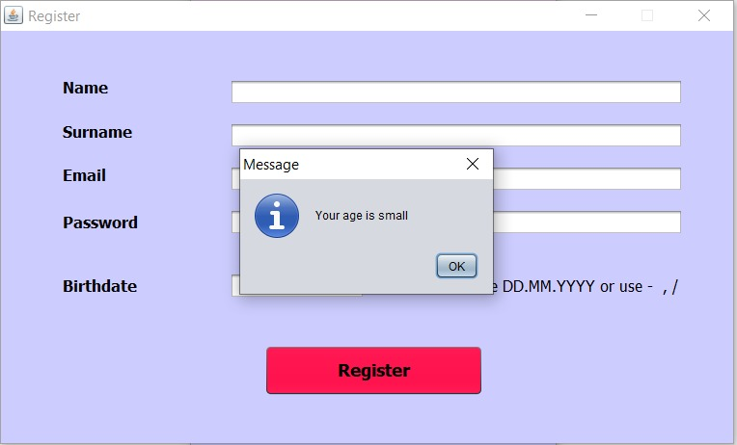

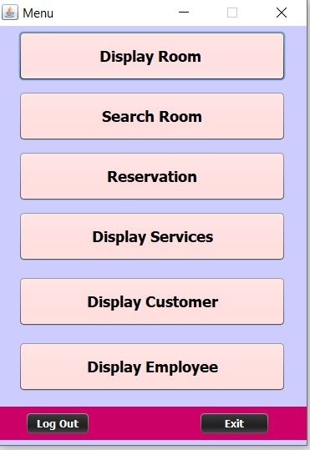

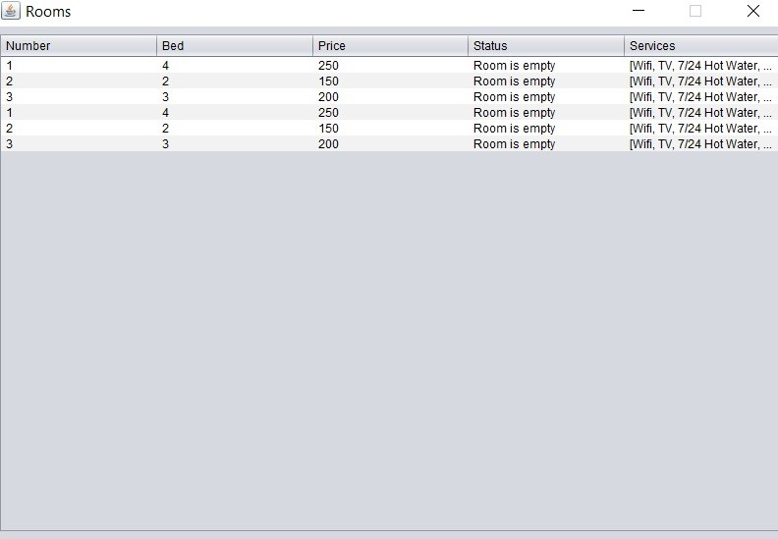

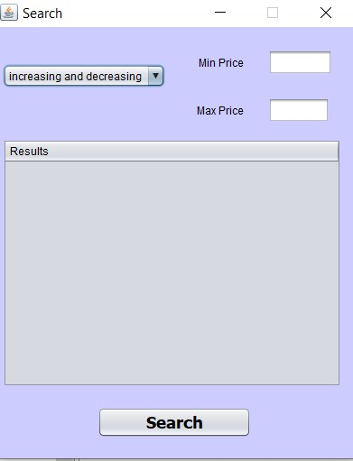

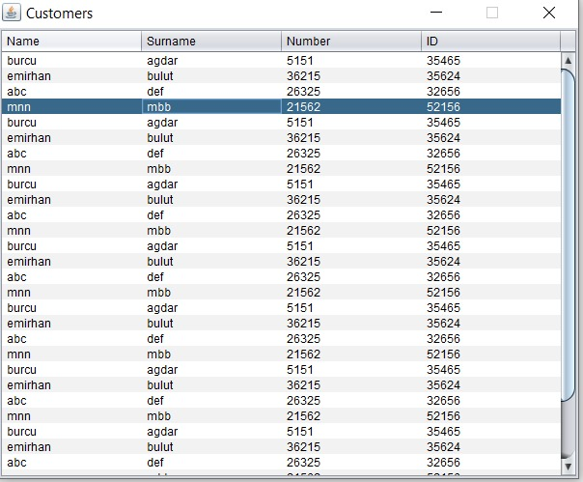

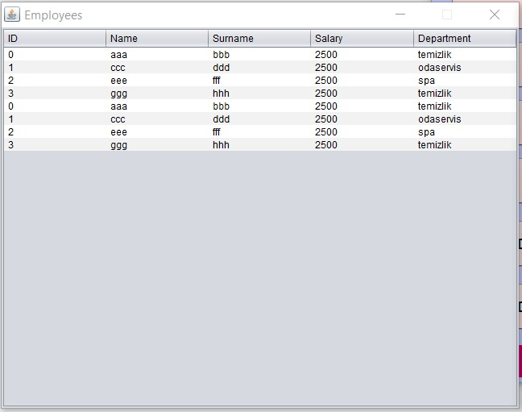

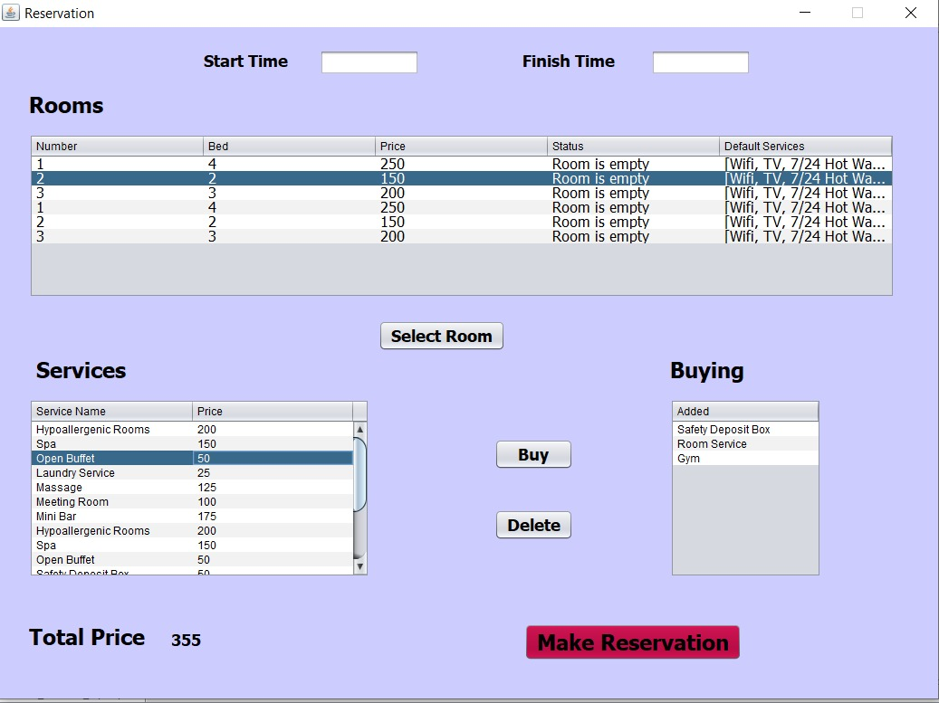

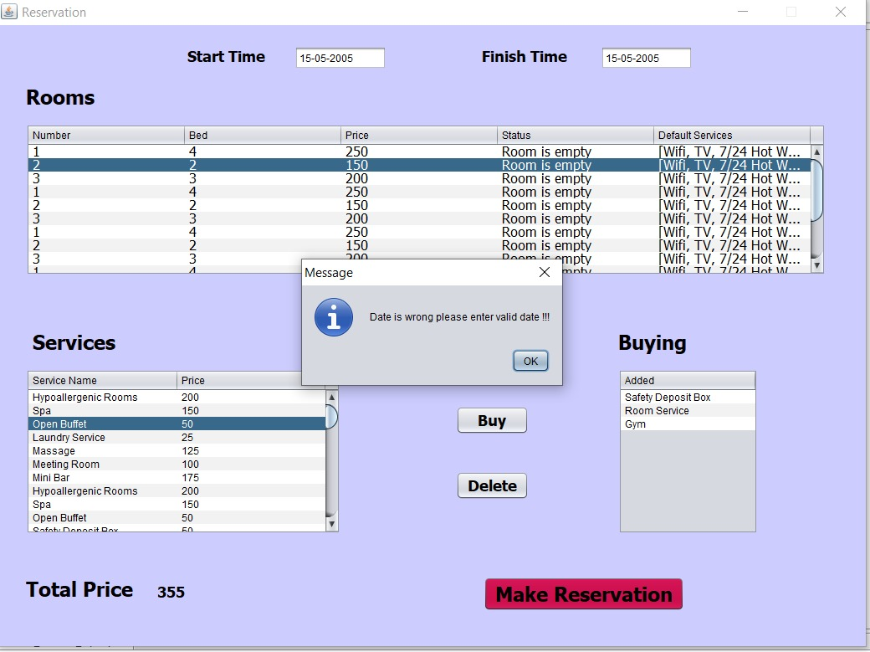

**2.4 Use Cases**

**Use Case :** Room Reservation

**Primary Actor:**Customer

**Goal in Context :** Book a room at the hotel.

**Preconditions:** The user must be registered in the system to make a reservation. If it is registered, it must be logged into the system.

**Trigger:** The system shows which rooms have been booked

**Scenario:**

1. Customer: Login to hotel management and reservation system application.
2. Customer: Registers to the application. If registered, logs in.
3. Customer: Clicks on the reservation button from the menu that appears.
4. Customer: Click on the room he/she wants and click on the ‘select room’ button.
5. Customer: If he / she wants to add extra service, he selects the service and clicks ‘buy’ button.
6. Customer: If he / she wants to remove the extra service he chooses, he clicks the ‘delete’ button.
7. Customer:The dates that he / she wants to make the reservation enters into the start date and finish date spaces.
8. Customer: Clicks on the ‘make reservation’ button and completes the reservation.

**Exceptions:**

1. If the user mail and password are wrong, a warning message is given and information is requested again
2. The user receives the message that he / she cannot log into the system if he / she is younger than 18 according to the date of birth entered while registering.
3. If the user enters the reservation date incorrectly, he / she receives an error message and enters the reservation dates again

**Open Issues:**

1. Should there be an option to cancel the reservation before the reservation date?
2. Should the customer be able to make two different reservations at the same time?
3. Should the user be able to postpone the reservation dates?

**2.5 Models**

**Sequence Diagram**

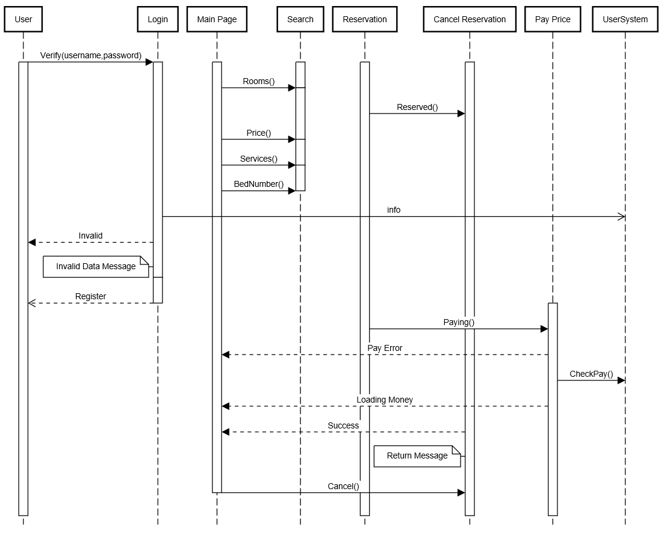

**Login Activity Diagram**

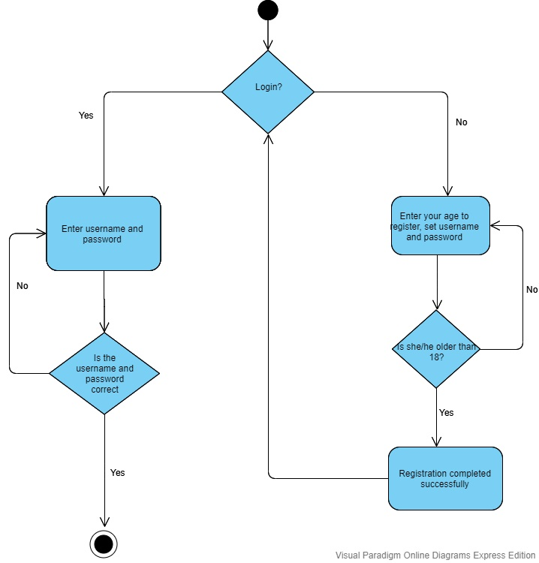

**State Diagram**

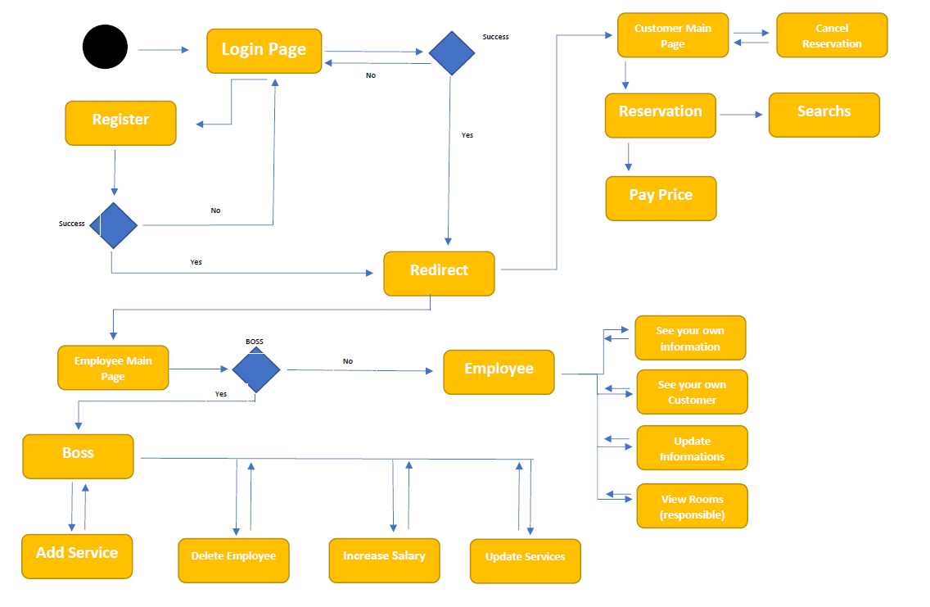

 **Project Plan**

* 1. **Task Descriptions**

**Stakeholder Meetings**

The hotel management and software development team holds meetings and discusses expectations from the project. The software group receives information from the hotel management about their expectations from the project, asks them questions and takes notes. These meetings also take place in the intermediate steps of the project. In this way, errors or deficiencies in the project are determined.

**Design Models and Mockups**

In order for the project to be clear, modeling should be created and presented to the hotel management. Insolent or unwanted features will be determined more easily. The project team should design the models together and exchange ideas.

**Database Creation**

User information, customer information, employee information, room information in the project are stored in the txt file and used during the testing phase.

**Website Creation**

The application will be created using the java programming language along with the prepared models and the exchange of ideas and ideas. It will provide the users to register, enter and provide various display and search facilities. The user will be able to book the room he likes. He can add and remove extra services to the room he/she wants to book.

**Testing**

All kinds of test scenarios will be prepared for the application and the application will be tested. These tests will be done by entering customer information, employee information and room information. Errors and deficiencies encountered after the test will be eliminated.

**Finalization and Reports**

The project is completed and all tests are completed at this stage. Guidelines and reports are created on how the users will use the application. Users are informed about the use of the application.

* 1. **Task Assignment**

Software group members shared the tasks of the project among themselves.

They developed the most suitable structure by exchanging ideas about the project. They performed the analysis of the project by eliminating every detail requested by the hotel managers.

Burcu:She determined the class attributes and made the connections of each

other by drawing the necessary diagram connections. She took part in coding by

confirming the accuracy of time controls. It provided the creation of sample data and functions to return the necessary things. She took part in display functions, updating functions and creating the required test environment.

Emirhan: The interface played a role in the design of the search function with

the creation of the overall design. By taking the necessary tests, he took part

in the elimination of errors and writing the functions of the user registration and

log in. He contributed to the writing of the date control function. He designed table formations and interface formations.

Berk:He checked the report controls and the correctness of the diagram drawings

The replacement of the constructer methods with the Getter setter methods and

the interface adaptation, the availability of services in stack implementation

contributed to how the system design should be in general research.

Reports were created throughout the process by all three group members and gathered to accurately and sufficiently create this final report.

* 1. **Project Schedule**

In the first month of the project, the software members held a meeting and talked about the requirements of the project. We took note of the requests from us. We exchanged ideas.

The next month, we went to the coding phase of the project. We started coding by distributing the task. We created our required classes and started to write our functions. We identified the shortcomings of the code and shared a task to overcome these shortcomings. Then we continued coding.

In the last month, we prepared the necessary data to complete and test the project's uninterrupted version. We tested the code and identified and corrected the errors. Finally, we presented our group members for the interface design process. We created the required structures and completed the interface phase. We prepared the necessary data for the project. We completed the code's deficiencies and finalized it. Finally, we prepared our final report and made the project ready for delivery.

* **Testing**

**4.1 Features to be tested**

We will start by using both static and dynamic testing strategies.The static strategies will include reviewing the basics of the application whereas the dynamic testing is based on actual code execution. In addition, it is provided to enter incorrect information in the system and to test the control systems.

The features we tested were as follows:

-User is over the age of 18

-Correct reservation dates

-User entering the information blank

-Incorrect registration requests

**4.2 Test Cases**

-Date times should be entered as day month year.

-Warning notification panels

-Data reset for user input correctly

- Check all frame for wrong input or button

-Checking all page data

**4.3 Testing Schedule**

The testing should begin right after the project itself begins. Keeping up on testing will ensure that any mistakes are caught early and corrected immediately. The errors encountered later will damage the project in large scale. Therefore, tests should be carried out with frequent intervals and the required amount of data.

* **Conclusion**

**5.1 The Problem and Solution**

Users and employees can manage the problems in the hotel without any difficulties,

providing the display of the results they are looking for in a simple and simple way,

ensuring that the reservation process is made quickly and data about the hotel - for example, hotel employees, customers, services etc. - easy to manage. Here, by checking some criteria, it is ensured that the process flow is obtained with minimum movement and maximum efficiency. It is designing a more attractive and effortless reservation for users and designing a fast system according to their wishes.The system was planned in categories to meet these requirements and divided into different sections to solve the problem.

**5.2 The Team and the SE Process**

The Software Engineering process we used was the spiral method. In this method, we start in the middle of the model, and spiral outward, allowing all departments working on the software to be an active part of every aspect of the engineering. Each individual department will be able to work and test during the concept development, system development, system enhancement, and system maintenance phases of development.

**5.3 Engagement of Umbrella Activities**

Four of the main Umbrella activities we used were as follows:

1. Software Project Management - Which was used to lead the project and ensure that the project was controlled, monitored, and on schedule.

2. Formal technical Reviews – This activity was essentially implemented for peer review.Having new and fresh eyes to view code and ensure that everything met the requirements.

3. Reusability Management - This activity was used to help us create flexible and generic assets that may be reused for future projects or for this project in other regions. This would cut down on cost and help with consistency.

4. Risk Management - This activity was used to assess and identify potential risks with creating the software such as ssuring that not too much money be spent in assets on the project.

**5.4 The Stakeholders that Benefited**

After release of the product, all of our active stakeholders benefited from th software. This list includes but is not limited to; the company shareholders, the customers, the project development team, upper management, line managers, consultants, and many more.

**5.5 The Organization's Benefits**

Our Organization benefitted greatly from the production of this software.We have built a report with this company and expect future projects to be assigned to our company. As well as a report with this business, word of our software will travel, and typically for a otel management system,they deal a lot with high class businessmen. If these high class businessmen get to see our software in action, we will more than likely receive future job offers from other companies as well.

 **User Manual**

**6.1 Software Description**

Customers or hotel staff can view the necessary transactions in a streamlined interface. In order to enter the interface part, it is directed directly to an interface where it can perform the necessary operations by registering previously. If the user or hotel staff is to register, this is done in the Register Screen. After registration, it is transferred to the Log In screen. User data, hotel staff, room and similar information are kept in txt data. In the background, hotel names or other private data are written on the console screen so that the IT staff of the company can edit it. Normal users do not see this interface. The status and information of the rooms can be displayed easily in the reservation and other processes of the users. Service prices and total costs of other products are calculated automatically. The situation of the room and other possible errors can be checked and displayed as information to the hotel employee or user. The program is a software designed for hotels that will easily reflect the hotel's information and reservation procedures.

**6.2 How to Use the Software**

The use of the software allows the reservation attendant or the user to quickly view information such as a vending machine or other room status service from vending machines.Users must login to access this information, if registered.If the user is going to register, after entering their information, they can go to the system by registering if they do not contain any incorrect information by passing the necessary checks.After logging in to the system, they can search the rooms from the menu interface and provide them with the necessary information about the room in detail.Employees, customers, services are easily displayed and listed through this interface.In the reservation section, the user enters the start date and the end date of the reservation. If there is an error in this information, feed back to the user. If the information is correct, it displays the rooms listed. Afterwards, you can simply add the services that you want to buy to your own service and the amount you have to pay daily is displayed on the screen instantly. Instant deletions and additions are reflected to the user after the services are purchased. While the reservation is confirmed, the total amount to be paid by the customer is shown. If the dates are incorrect, they are informed and the status of the room is updated as reserved.If serious changes are made, console interface is provided for IT staff. The IT staff can update the required hotel name and capacity from here.

**6.3 Troubleshooting Common Problems**

**Problem**: Empty or Incorrect Input status

In form applications, sometimes the form is printed more than once or in case there is no data, it may cause errors due to the lack of information from the user. To prevent this, the software automatically assigns the default values for some situations in the background. In case of errors that may arise from the user, the erroneous operation is prevented by giving warning messages in general.

**Problem:** Invalid Login

If the user enters an incorrect password or username, no action will be taken and an information message will be given to the user.

**Problem**: Entering wrong dates

The software provides two types of history-related controls. The first one calculates from the present time for users to be over the age of 18.The control process for the second time is that the reservation times are correct and the end date is also valid. The user views this information as anerror message and the process is expected to be repeated.