**CBOW:**

Training CBOW model with lr=0.01, epochs=10, embedding_dim=50, hidden_dim=0

Epoch 1/10, Loss: 0.5165786394122149

Dev Accuracy: 0.7533

Epoch 2/10, Loss: 0.27050446684230917

Dev Accuracy: 0.7333

Epoch 3/10, Loss: 0.16146085097762425

Dev Accuracy: 0.7280

Epoch 4/10, Loss: 0.11656234698531268

Dev Accuracy: 0.7320

Epoch 5/10, Loss: 0.08945304392362914

Dev Accuracy: 0.7353

Epoch 6/10, Loss: 0.0739613644227034

Dev Accuracy: 0.7320

Epoch 7/10, Loss: 0.06462137428667378

Dev Accuracy: 0.7220

Epoch 8/10, Loss: 0.06150313704679413

Dev Accuracy: 0.7333

Epoch 9/10, Loss: 0.05667848375110256

Dev Accuracy: 0.7287

Epoch 10/10, Loss: 0.053307788684115336

Dev Accuracy: 0.7293

Dev Accuracy: 0.7293

Training CBOW model with lr=0.01, epochs=10, embedding_dim=50, hidden_dim=50

Epoch 1/10, Loss: 0.5511306984986776

Dev Accuracy: 0.7433

Epoch 2/10, Loss: 0.3390480463539491

Dev Accuracy: 0.7260

Epoch 3/10, Loss: 0.2410285226328454

Dev Accuracy: 0.7240

Epoch 4/10, Loss: 0.21098279935933953

Dev Accuracy: 0.7233

Epoch 5/10, Loss: 0.17730388857414375

Dev Accuracy: 0.7480

Epoch 6/10, Loss: 0.14027525164670074

Dev Accuracy: 0.7347

Epoch 7/10, Loss: 0.16619379477424018

Dev Accuracy: 0.7553

Epoch 8/10, Loss: 0.1409255803427958

Dev Accuracy: 0.7540

Epoch 9/10, Loss: 0.1941116135296459

Dev Accuracy: 0.7420

Epoch 10/10, Loss: 0.16460359312466344

Dev Accuracy: 0.7367

Dev Accuracy: 0.7367

Training CBOW model with lr=0.01, epochs=10, embedding_dim=100, hidden_dim=0

Epoch 1/10, Loss: 0.5415665008881669

Dev Accuracy: 0.7460

Epoch 2/10, Loss: 0.24753059061892485

Dev Accuracy: 0.7100

Epoch 3/10, Loss: 0.14639545133089674

Dev Accuracy: 0.7113

Epoch 4/10, Loss: 0.1106085741893615

Dev Accuracy: 0.7200

Epoch 5/10, Loss: 0.09268158796125252

Dev Accuracy: 0.7347

Epoch 6/10, Loss: 0.08075379202337854

Dev Accuracy: 0.7387

Epoch 7/10, Loss: 0.07244760972457978

Dev Accuracy: 0.7440

Epoch 8/10, Loss: 0.0745498089807811

Dev Accuracy: 0.7440

Epoch 9/10, Loss: 0.06988308414843197

Dev Accuracy: 0.7427

Epoch 10/10, Loss: 0.06743418490225397

Dev Accuracy: 0.7367

Dev Accuracy: 0.7367

Training CBOW model with lr=0.01, epochs=10, embedding_dim=100, hidden_dim=50

Epoch 1/10, Loss: 0.5871418971721926

Dev Accuracy: 0.7407

Epoch 2/10, Loss: 0.3757085639386492

Dev Accuracy: 0.7433

Epoch 3/10, Loss: 0.29052213729993354

Dev Accuracy: 0.7347

Epoch 4/10, Loss: 0.27144368327190427

Dev Accuracy: 0.7580

Epoch 5/10, Loss: 0.24537216675526097

Dev Accuracy: 0.7473

Epoch 6/10, Loss: 0.2551113544615869

Dev Accuracy: 0.7447

Epoch 7/10, Loss: 0.31562706756013853

Dev Accuracy: 0.7360

Epoch 8/10, Loss: 0.20546048215675755

Dev Accuracy: 0.7380

Epoch 9/10, Loss: 0.2678594091291556

Dev Accuracy: 0.7333

Epoch 10/10, Loss: 0.2899734564228858

Dev Accuracy: 0.7387

Dev Accuracy: 0.7387

Training CBOW model with lr=0.01, epochs=20, embedding_dim=50, hidden_dim=0

Epoch 1/20, Loss: 0.510968571671393

Dev Accuracy: 0.7527

Epoch 2/20, Loss: 0.2667959136142238

Dev Accuracy: 0.7353

Epoch 3/20, Loss: 0.1582873563536705

Dev Accuracy: 0.7133

Epoch 4/20, Loss: 0.11487149742552913

Dev Accuracy: 0.7233

Epoch 5/20, Loss: 0.09221907395019213

Dev Accuracy: 0.7380

Epoch 6/20, Loss: 0.07606939590603982

Dev Accuracy: 0.7313

Epoch 7/20, Loss: 0.06816952320835334

Dev Accuracy: 0.7393

Epoch 8/20, Loss: 0.06261162841527748

Dev Accuracy: 0.7387

Epoch 9/20, Loss: 0.056757710030025235

Dev Accuracy: 0.7373

Epoch 10/20, Loss: 0.05422858069417299

Dev Accuracy: 0.7393

Epoch 11/20, Loss: 0.04918746576236115

Dev Accuracy: 0.7373

Epoch 12/20, Loss: 0.04726391016620832

Dev Accuracy: 0.7347

Epoch 13/20, Loss: 0.046755835111179984

Dev Accuracy: 0.7300

Epoch 14/20, Loss: 0.04307656835975787

Dev Accuracy: 0.7267

Epoch 15/20, Loss: 0.04423307956605096

Dev Accuracy: 0.7247

Epoch 16/20, Loss: 0.04111464868949118

Dev Accuracy: 0.7267

Epoch 17/20, Loss: 0.043650942618007504

Dev Accuracy: 0.7173

Epoch 18/20, Loss: 0.041288171282278435

Dev Accuracy: 0.7213

Epoch 19/20, Loss: 0.03697107042878166

Dev Accuracy: 0.7147

Epoch 20/20, Loss: 0.03777947546835345

Dev Accuracy: 0.7173

Dev Accuracy: 0.7173

Training CBOW model with lr=0.01, epochs=20, embedding_dim=50, hidden_dim=50

Epoch 1/20, Loss: 0.5508587974527124

Dev Accuracy: 0.7660

Epoch 2/20, Loss: 0.3325954856948348

Dev Accuracy: 0.7353

Epoch 3/20, Loss: 0.222813596638752

Dev Accuracy: 0.7287

Epoch 4/20, Loss: 0.20292055900193381

Dev Accuracy: 0.7533

Epoch 5/20, Loss: 0.19584479364479268

Dev Accuracy: 0.7333

Epoch 6/20, Loss: 0.1560430926621326

Dev Accuracy: 0.7313

Epoch 7/20, Loss: 0.12245292760699404

Dev Accuracy: 0.7153

Epoch 8/20, Loss: 0.14422476577203

Dev Accuracy: 0.7273

Epoch 9/20, Loss: 0.13705544346635648

Dev Accuracy: 0.7213

Epoch 10/20, Loss: 0.11305655301378308

Dev Accuracy: 0.7300

Epoch 11/20, Loss: 0.12704252431044352

Dev Accuracy: 0.7300

Epoch 12/20, Loss: 0.13039148395312178

Dev Accuracy: 0.7327

Epoch 13/20, Loss: 0.1561516175966791

Dev Accuracy: 0.7207

Epoch 14/20, Loss: 0.13201937139512446

Dev Accuracy: 0.7240

Epoch 15/20, Loss: 0.16640235748535184

Dev Accuracy: 0.7240

Epoch 16/20, Loss: 0.12459962143845638

Dev Accuracy: 0.7380

Epoch 17/20, Loss: 0.1640577437735799

Dev Accuracy: 0.7400

Epoch 18/20, Loss: 0.15451290882004565

Dev Accuracy: 0.7387

Epoch 19/20, Loss: 0.11996108116852049

Dev Accuracy: 0.7280

Epoch 20/20, Loss: 0.14869706996666845

Dev Accuracy: 0.7313

Dev Accuracy: 0.7313

Training CBOW model with lr=0.01, epochs=20, embedding_dim=100, hidden_dim=0

Epoch 1/20, Loss: 0.5390318858934448

Dev Accuracy: 0.7540

Epoch 2/20, Loss: 0.24732623562059328

Dev Accuracy: 0.7173

Epoch 3/20, Loss: 0.14704638779344728

Dev Accuracy: 0.7213

Epoch 4/20, Loss: 0.11041835815700173

Dev Accuracy: 0.7267

Epoch 5/20, Loss: 0.09330423522623398

Dev Accuracy: 0.7220

Epoch 6/20, Loss: 0.0819675831315006

Dev Accuracy: 0.7300

Epoch 7/20, Loss: 0.072161747408924

Dev Accuracy: 0.7313

Epoch 8/20, Loss: 0.06761891519106998

Dev Accuracy: 0.7293

Epoch 9/20, Loss: 0.07246464264093573

Dev Accuracy: 0.7273

Epoch 10/20, Loss: 0.07065815404977781

Dev Accuracy: 0.7327

Epoch 11/20, Loss: 0.07139951265551212

Dev Accuracy: 0.7200

Epoch 12/20, Loss: 0.06652310535395596

Dev Accuracy: 0.7287

Epoch 13/20, Loss: 0.06379028471130424

Dev Accuracy: 0.7313

Epoch 14/20, Loss: 0.060058739432472634

Dev Accuracy: 0.7293

Epoch 15/20, Loss: 0.06261495927618839

Dev Accuracy: 0.7293

Epoch 16/20, Loss: 0.05942831826386315

Dev Accuracy: 0.7220

Epoch 17/20, Loss: 0.05424881919258632

Dev Accuracy: 0.7220

Epoch 18/20, Loss: 0.06560062626421123

Dev Accuracy: 0.7213

Epoch 19/20, Loss: 0.05517841727900168

Dev Accuracy: 0.7207

Epoch 20/20, Loss: 0.060539747443052384

Dev Accuracy: 0.7127

Dev Accuracy: 0.7127

Training CBOW model with lr=0.01, epochs=20, embedding_dim=100, hidden_dim=50

Epoch 1/20, Loss: 0.5861404326680075

Dev Accuracy: 0.7400

Epoch 2/20, Loss: 0.3728127366972297

Dev Accuracy: 0.7447

Epoch 3/20, Loss: 0.30057823007770995

Dev Accuracy: 0.7440

Epoch 4/20, Loss: 0.26161147279606095

Dev Accuracy: 0.7407

Epoch 5/20, Loss: 0.2490702528072557

Dev Accuracy: 0.7420

Epoch 6/20, Loss: 0.24639382956743416

Dev Accuracy: 0.7360

Epoch 7/20, Loss: 0.21968764662168236

Dev Accuracy: 0.7200

Epoch 8/20, Loss: 0.3036296164817221

Dev Accuracy: 0.7233

Epoch 9/20, Loss: 0.3161626244317633

Dev Accuracy: 0.7533

Epoch 10/20, Loss: 0.22681186854081908

Dev Accuracy: 0.7453

Epoch 11/20, Loss: 0.2102336626847062

Dev Accuracy: 0.7300

Epoch 12/20, Loss: 0.2810257610614218

Dev Accuracy: 0.7473

Epoch 13/20, Loss: 0.2469538523657127

Dev Accuracy: 0.7607

Epoch 14/20, Loss: 0.20705979594101628

Dev Accuracy: 0.7393

Epoch 15/20, Loss: 0.2118365913366314

Dev Accuracy: 0.7567

Epoch 16/20, Loss: 0.19946690541999046

Dev Accuracy: 0.7507

Epoch 17/20, Loss: 0.27946233781189656

Dev Accuracy: 0.7647

Epoch 18/20, Loss: 0.18906131245808505

Dev Accuracy: 0.7640

Epoch 19/20, Loss: 0.22248692883509216

Dev Accuracy: 0.7580

Epoch 20/20, Loss: 0.26552101690833335

Dev Accuracy: 0.7560

Dev Accuracy: 0.7560

Training CBOW model with lr=0.001, epochs=10, embedding_dim=50, hidden_dim=0

Epoch 1/10, Loss: 0.5922268571988846

Dev Accuracy: 0.7333

Epoch 2/10, Loss: 0.4358107617305307

Dev Accuracy: 0.7540

Epoch 3/10, Loss: 0.3592324049776256

Dev Accuracy: 0.7553

Epoch 4/10, Loss: 0.3095877741145027

Dev Accuracy: 0.7500

Epoch 5/10, Loss: 0.2728205332684621

Dev Accuracy: 0.7567

Epoch 6/10, Loss: 0.24415881330868944

Dev Accuracy: 0.7533

Epoch 7/10, Loss: 0.22132866397118298

Dev Accuracy: 0.7507

Epoch 8/10, Loss: 0.2028645740070748

Dev Accuracy: 0.7473

Epoch 9/10, Loss: 0.18768135190239715

Dev Accuracy: 0.7453

Epoch 10/10, Loss: 0.17500014125758354

Dev Accuracy: 0.7453

Dev Accuracy: 0.7453

Training CBOW model with lr=0.001, epochs=10, embedding_dim=50, hidden_dim=50

Epoch 1/10, Loss: 0.58518431687967

Dev Accuracy: 0.7187

Epoch 2/10, Loss: 0.42986360398669254

Dev Accuracy: 0.7413

Epoch 3/10, Loss: 0.3416294339426571

Dev Accuracy: 0.7500

Epoch 4/10, Loss: 0.27585898222126365

Dev Accuracy: 0.7560

Epoch 5/10, Loss: 0.22128728200135162

Dev Accuracy: 0.7613

Epoch 6/10, Loss: 0.1749191012023102

Dev Accuracy: 0.7633

Epoch 7/10, Loss: 0.13605702342667833

Dev Accuracy: 0.7620

Epoch 8/10, Loss: 0.10381658340945811

Dev Accuracy: 0.7600

Epoch 9/10, Loss: 0.07813170635079937

Dev Accuracy: 0.7580

Epoch 10/10, Loss: 0.05853559292989972

Dev Accuracy: 0.7580

Dev Accuracy: 0.7580

Training CBOW model with lr=0.001, epochs=10, embedding_dim=100, hidden_dim=0

Epoch 1/10, Loss: 0.5654483781302406

Dev Accuracy: 0.7320

Epoch 2/10, Loss: 0.4025336635576608

Dev Accuracy: 0.7533

Epoch 3/10, Loss: 0.32515852975987297

Dev Accuracy: 0.7580

Epoch 4/10, Loss: 0.2759245952501595

Dev Accuracy: 0.7580

Epoch 5/10, Loss: 0.24085436644835237

Dev Accuracy: 0.7507

Epoch 6/10, Loss: 0.2146027856747358

Dev Accuracy: 0.7487

Epoch 7/10, Loss: 0.19431304346807565

Dev Accuracy: 0.7507

Epoch 8/10, Loss: 0.17820349968083446

Dev Accuracy: 0.7473

Epoch 9/10, Loss: 0.16511056814825306

Dev Accuracy: 0.7467

Epoch 10/10, Loss: 0.1542621867289653

Dev Accuracy: 0.7420

Dev Accuracy: 0.7420

Training CBOW model with lr=0.001, epochs=10, embedding_dim=100, hidden_dim=50

Epoch 1/10, Loss: 0.5565314298661765

Dev Accuracy: 0.7373

Epoch 2/10, Loss: 0.3940902476842309

Dev Accuracy: 0.7407

Epoch 3/10, Loss: 0.3026610193107789

Dev Accuracy: 0.7533

Epoch 4/10, Loss: 0.2315241132884286

Dev Accuracy: 0.7527

Epoch 5/10, Loss: 0.17393756989486134

Dev Accuracy: 0.7580

Epoch 6/10, Loss: 0.12702876527774556

Dev Accuracy: 0.7533

Epoch 7/10, Loss: 0.08963955907074789

Dev Accuracy: 0.7513

Epoch 8/10, Loss: 0.06288945930734416

Dev Accuracy: 0.7507

Epoch 9/10, Loss: 0.04686283832286359

Dev Accuracy: 0.7520

Epoch 10/10, Loss: 0.036728802535828824

Dev Accuracy: 0.7507

Dev Accuracy: 0.7507

Training CBOW model with lr=0.001, epochs=20, embedding_dim=50, hidden_dim=0

Epoch 1/20, Loss: 0.5895746650080546

Dev Accuracy: 0.7340

Epoch 2/20, Loss: 0.4394074438024971

Dev Accuracy: 0.7547

Epoch 3/20, Loss: 0.3656597171588168

Dev Accuracy: 0.7653

Epoch 4/20, Loss: 0.31684297312343745

Dev Accuracy: 0.7660

Epoch 5/20, Loss: 0.2804352521969454

Dev Accuracy: 0.7673

Epoch 6/20, Loss: 0.2518740089201057

Dev Accuracy: 0.7640

Epoch 7/20, Loss: 0.22880608387261117

Dev Accuracy: 0.7620

Epoch 8/20, Loss: 0.20980172189841442

Dev Accuracy: 0.7613

Epoch 9/20, Loss: 0.19394647347900393

Dev Accuracy: 0.7627

Epoch 10/20, Loss: 0.18059136878954668

Dev Accuracy: 0.7620

Epoch 11/20, Loss: 0.16923119301126086

Dev Accuracy: 0.7573

Epoch 12/20, Loss: 0.15946697978734864

Dev Accuracy: 0.7567

Epoch 13/20, Loss: 0.15099457454235293

Dev Accuracy: 0.7533

Epoch 14/20, Loss: 0.14361384690762083

Dev Accuracy: 0.7527

Epoch 15/20, Loss: 0.13717237170845392

Dev Accuracy: 0.7533

Epoch 16/20, Loss: 0.13150779779236335

Dev Accuracy: 0.7507

Epoch 17/20, Loss: 0.12647740491600357

Dev Accuracy: 0.7480

Epoch 18/20, Loss: 0.12197684599645144

Dev Accuracy: 0.7480

Epoch 19/20, Loss: 0.11793200266304327

Dev Accuracy: 0.7473

Epoch 20/20, Loss: 0.11427972138554009

Dev Accuracy: 0.7473

Dev Accuracy: 0.7473

Training CBOW model with lr=0.001, epochs=20, embedding_dim=50, hidden_dim=50

Epoch 1/20, Loss: 0.5718991842053173

Dev Accuracy: 0.7133

Epoch 2/20, Loss: 0.4170573627047083

Dev Accuracy: 0.7567

Epoch 3/20, Loss: 0.3316206563677977

Dev Accuracy: 0.7667

Epoch 4/20, Loss: 0.26971166220643267

Dev Accuracy: 0.7580

Epoch 5/20, Loss: 0.2196034024086667

Dev Accuracy: 0.7613

Epoch 6/20, Loss: 0.1767839328687163

Dev Accuracy: 0.7613

Epoch 7/20, Loss: 0.1403450790359422

Dev Accuracy: 0.7620

Epoch 8/20, Loss: 0.11003023973624305

Dev Accuracy: 0.7613

Epoch 9/20, Loss: 0.08426937658669481

Dev Accuracy: 0.7633

Epoch 10/20, Loss: 0.06360534985940954

Dev Accuracy: 0.7620

Epoch 11/20, Loss: 0.04836449829775274

Dev Accuracy: 0.7613

Epoch 12/20, Loss: 0.03706872106985627

Dev Accuracy: 0.7567

Epoch 13/20, Loss: 0.02923122220331737

Dev Accuracy: 0.7547

Epoch 14/20, Loss: 0.02452840374054974

Dev Accuracy: 0.7507

Epoch 15/20, Loss: 0.02129390950874843

Dev Accuracy: 0.7480

Epoch 16/20, Loss: 0.01915105660137045

Dev Accuracy: 0.7467

Epoch 17/20, Loss: 0.017117937739295715

Dev Accuracy: 0.7433

Epoch 18/20, Loss: 0.01567227099701128

Dev Accuracy: 0.7380

Epoch 19/20, Loss: 0.015530136728858175

Dev Accuracy: 0.7427

Epoch 20/20, Loss: 0.014448297665388288

Dev Accuracy: 0.7427

Dev Accuracy: 0.7427

Training CBOW model with lr=0.001, epochs=20, embedding_dim=100, hidden_dim=0

Epoch 1/20, Loss: 0.5738436538872442

Dev Accuracy: 0.7440

Epoch 2/20, Loss: 0.41487106849355515

Dev Accuracy: 0.7533

Epoch 3/20, Loss: 0.34045805050105765

Dev Accuracy: 0.7620

Epoch 4/20, Loss: 0.2917285961640885

Dev Accuracy: 0.7607

Epoch 5/20, Loss: 0.2557812140529307

Dev Accuracy: 0.7613

Epoch 6/20, Loss: 0.2278971259157651

Dev Accuracy: 0.7640

Epoch 7/20, Loss: 0.20580975761464806

Dev Accuracy: 0.7580

Epoch 8/20, Loss: 0.18808491054826249

Dev Accuracy: 0.7540

Epoch 9/20, Loss: 0.1736645337256908

Dev Accuracy: 0.7507

Epoch 10/20, Loss: 0.1617896296781244

Dev Accuracy: 0.7527

Epoch 11/20, Loss: 0.15186441169928516

Dev Accuracy: 0.7500

Epoch 12/20, Loss: 0.14344565780920776

Dev Accuracy: 0.7460

Epoch 13/20, Loss: 0.1361985167155507

Dev Accuracy: 0.7440

Epoch 14/20, Loss: 0.1298833536061525

Dev Accuracy: 0.7440

Epoch 15/20, Loss: 0.12432904704514945

Dev Accuracy: 0.7427

Epoch 16/20, Loss: 0.11939533743060325

Dev Accuracy: 0.7393

Epoch 17/20, Loss: 0.11498680797416753

Dev Accuracy: 0.7387

Epoch 18/20, Loss: 0.11103899690975204

Dev Accuracy: 0.7407

Epoch 19/20, Loss: 0.10749060933827921

Dev Accuracy: 0.7413

Epoch 20/20, Loss: 0.10430186986097328

Dev Accuracy: 0.7413

Dev Accuracy: 0.7413

Training CBOW model with lr=0.001, epochs=20, embedding_dim=100, hidden_dim=50

Epoch 1/20, Loss: 0.5514919232260509

Dev Accuracy: 0.7560

Epoch 2/20, Loss: 0.3952987090945094

Dev Accuracy: 0.7753

Epoch 3/20, Loss: 0.30583536756033614

Dev Accuracy: 0.7787

Epoch 4/20, Loss: 0.24000009791435734

Dev Accuracy: 0.7807

Epoch 5/20, Loss: 0.18632570624465875

Dev Accuracy: 0.7700

Epoch 6/20, Loss: 0.1414435185914907

Dev Accuracy: 0.7693

Epoch 7/20, Loss: 0.10321700237566588

Dev Accuracy: 0.7687

Epoch 8/20, Loss: 0.0738945370931827

Dev Accuracy: 0.7627

Epoch 9/20, Loss: 0.0527869411950534

Dev Accuracy: 0.7640

Epoch 10/20, Loss: 0.03925447975773436

Dev Accuracy: 0.7587

Epoch 11/20, Loss: 0.030356089601231394

Dev Accuracy: 0.7547

Epoch 12/20, Loss: 0.02456626233780895

Dev Accuracy: 0.7513

Epoch 13/20, Loss: 0.020328004335383936

Dev Accuracy: 0.7487

Epoch 14/20, Loss: 0.018996856553647776

Dev Accuracy: 0.7400

Epoch 15/20, Loss: 0.017176254261562864

Dev Accuracy: 0.7420

Epoch 16/20, Loss: 0.0158082040040814

Dev Accuracy: 0.7340

Epoch 17/20, Loss: 0.0149984702580904

Dev Accuracy: 0.7380

Epoch 18/20, Loss: 0.01420856610268412

Dev Accuracy: 0.7333

Epoch 19/20, Loss: 0.013378801828296438

Dev Accuracy: 0.7380

Epoch 20/20, Loss: 0.012999987381450435

Dev Accuracy: 0.7427

Dev Accuracy: 0.7427

Training CBOW model with lr=0.0001, epochs=10, embedding_dim=50, hidden_dim=0

Epoch 1/10, Loss: 0.6950523356710161

Dev Accuracy: 0.5747

Epoch 2/10, Loss: 0.6668729268738202

Dev Accuracy: 0.6100

Epoch 3/10, Loss: 0.6412004864279713

Dev Accuracy: 0.6273

Epoch 4/10, Loss: 0.6127417645677924

Dev Accuracy: 0.6513

Epoch 5/10, Loss: 0.5823887229114771

Dev Accuracy: 0.6733

Epoch 6/10, Loss: 0.5526664128013488

Dev Accuracy: 0.6887

Epoch 7/10, Loss: 0.5253700270136552

Dev Accuracy: 0.7060

Epoch 8/10, Loss: 0.5011003378897773

Dev Accuracy: 0.7193

Epoch 9/10, Loss: 0.47973685222238005

Dev Accuracy: 0.7287

Epoch 10/10, Loss: 0.46090766830396857

Dev Accuracy: 0.7387

Dev Accuracy: 0.7387

Training CBOW model with lr=0.0001, epochs=10, embedding_dim=50, hidden_dim=50

Epoch 1/10, Loss: 0.6817200537536825

Dev Accuracy: 0.6287

Epoch 2/10, Loss: 0.6421403939223715

Dev Accuracy: 0.6600

Epoch 3/10, Loss: 0.6004827441174004

Dev Accuracy: 0.6713

Epoch 4/10, Loss: 0.5650511855355663

Dev Accuracy: 0.6847

Epoch 5/10, Loss: 0.5349210466753741

Dev Accuracy: 0.6953

Epoch 6/10, Loss: 0.5083892987500555

Dev Accuracy: 0.6993

Epoch 7/10, Loss: 0.48459691456849757

Dev Accuracy: 0.7033

Epoch 8/10, Loss: 0.4630920671581599

Dev Accuracy: 0.7067

Epoch 9/10, Loss: 0.4435612764079998

Dev Accuracy: 0.7080

Epoch 10/10, Loss: 0.425669856525512

Dev Accuracy: 0.7173

Dev Accuracy: 0.7173

Training CBOW model with lr=0.0001, epochs=10, embedding_dim=100, hidden_dim=0

Epoch 1/10, Loss: 0.6739221802864755

Dev Accuracy: 0.6333

Epoch 2/10, Loss: 0.6280798626126988

Dev Accuracy: 0.6693

Epoch 3/10, Loss: 0.5889300439432263

Dev Accuracy: 0.6920

Epoch 4/10, Loss: 0.553102310662557

Dev Accuracy: 0.7100

Epoch 5/10, Loss: 0.5211670697950093

Dev Accuracy: 0.7113

Epoch 6/10, Loss: 0.4932118769865317

Dev Accuracy: 0.7167

Epoch 7/10, Loss: 0.4688261373170369

Dev Accuracy: 0.7260

Epoch 8/10, Loss: 0.44745421453247297

Dev Accuracy: 0.7327

Epoch 9/10, Loss: 0.428580986557677

Dev Accuracy: 0.7353

Epoch 10/10, Loss: 0.41177433291076576

Dev Accuracy: 0.7407

Dev Accuracy: 0.7407

Training CBOW model with lr=0.0001, epochs=10, embedding_dim=100, hidden_dim=50

Epoch 1/10, Loss: 0.66530779902637

Dev Accuracy: 0.6687

Epoch 2/10, Loss: 0.5905494239628315

Dev Accuracy: 0.6840

Epoch 3/10, Loss: 0.5355523017832144

Dev Accuracy: 0.7027

Epoch 4/10, Loss: 0.4968750122219

Dev Accuracy: 0.7127

Epoch 5/10, Loss: 0.46505337280085535

Dev Accuracy: 0.7193

Epoch 6/10, Loss: 0.4374594617693929

Dev Accuracy: 0.7267

Epoch 7/10, Loss: 0.4129022802696893

Dev Accuracy: 0.7313

Epoch 8/10, Loss: 0.39066693013583814

Dev Accuracy: 0.7373

Epoch 9/10, Loss: 0.37025429524892106

Dev Accuracy: 0.7433

Epoch 10/10, Loss: 0.3513895568293112

Dev Accuracy: 0.7453

Dev Accuracy: 0.7453

Training CBOW model with lr=0.0001, epochs=20, embedding_dim=50, hidden_dim=0

Epoch 1/20, Loss: 0.6791893566250801

Dev Accuracy: 0.6047

Epoch 2/20, Loss: 0.6518234832371984

Dev Accuracy: 0.6433

Epoch 3/20, Loss: 0.6233508814626506

Dev Accuracy: 0.6593

Epoch 4/20, Loss: 0.5939349334585879

Dev Accuracy: 0.6767

Epoch 5/20, Loss: 0.5653946651457143

Dev Accuracy: 0.6913

Epoch 6/20, Loss: 0.5391019755597891

Dev Accuracy: 0.6980

Epoch 7/20, Loss: 0.5155615159443446

Dev Accuracy: 0.7093

Epoch 8/20, Loss: 0.4946978514415428

Dev Accuracy: 0.7180

Epoch 9/20, Loss: 0.47619725836985993

Dev Accuracy: 0.7207

Epoch 10/20, Loss: 0.45969525914867493

Dev Accuracy: 0.7220

Epoch 11/20, Loss: 0.4448548189158417

Dev Accuracy: 0.7260

Epoch 12/20, Loss: 0.43139282860930717

Dev Accuracy: 0.7307

Epoch 13/20, Loss: 0.4190811283339279

Dev Accuracy: 0.7333

Epoch 14/20, Loss: 0.40773864961677125

Dev Accuracy: 0.7367

Epoch 15/20, Loss: 0.39722226922633

Dev Accuracy: 0.7380

Epoch 16/20, Loss: 0.3874179215164892

Dev Accuracy: 0.7407

Epoch 17/20, Loss: 0.37823380934795

Dev Accuracy: 0.7420

Epoch 18/20, Loss: 0.36959527620329324

Dev Accuracy: 0.7427

Epoch 19/20, Loss: 0.3614410964499832

Dev Accuracy: 0.7427

Epoch 20/20, Loss: 0.35372054707859274

Dev Accuracy: 0.7440

Dev Accuracy: 0.7440

Training CBOW model with lr=0.0001, epochs=20, embedding_dim=50, hidden_dim=50

Epoch 1/20, Loss: 0.6783943967606341

Dev Accuracy: 0.5953

Epoch 2/20, Loss: 0.6310495923353093

Dev Accuracy: 0.6293

Epoch 3/20, Loss: 0.5825380583990898

Dev Accuracy: 0.6467

Epoch 4/20, Loss: 0.5449907705696699

Dev Accuracy: 0.6687

Epoch 5/20, Loss: 0.5155927634361432

Dev Accuracy: 0.6907

Epoch 6/20, Loss: 0.49105685409114397

Dev Accuracy: 0.7007

Epoch 7/20, Loss: 0.46962737245614905

Dev Accuracy: 0.7120

Epoch 8/20, Loss: 0.4504527541438001

Dev Accuracy: 0.7220

Epoch 9/20, Loss: 0.4329804328678365

Dev Accuracy: 0.7247

Epoch 10/20, Loss: 0.41685001119405307

Dev Accuracy: 0.7280

Epoch 11/20, Loss: 0.4018411967029111

Dev Accuracy: 0.7340

Epoch 12/20, Loss: 0.387745845952601

Dev Accuracy: 0.7367

Epoch 13/20, Loss: 0.3744487823811388

Dev Accuracy: 0.7393

Epoch 14/20, Loss: 0.3617888035407099

Dev Accuracy: 0.7427

Epoch 15/20, Loss: 0.34968911328501845

Dev Accuracy: 0.7407

Epoch 16/20, Loss: 0.3381601880019015

Dev Accuracy: 0.7447

Epoch 17/20, Loss: 0.32706618534950543

Dev Accuracy: 0.7473

Epoch 18/20, Loss: 0.3164662643338136

Dev Accuracy: 0.7493

Epoch 19/20, Loss: 0.30625492327367204

Dev Accuracy: 0.7527

Epoch 20/20, Loss: 0.2964016506703191

Dev Accuracy: 0.7540

Dev Accuracy: 0.7540

Training CBOW model with lr=0.0001, epochs=20, embedding_dim=100, hidden_dim=0

Epoch 1/20, Loss: 0.6711818439130273

Dev Accuracy: 0.6407

Epoch 2/20, Loss: 0.6240857526856873

Dev Accuracy: 0.6767

Epoch 3/20, Loss: 0.5835038116023477

Dev Accuracy: 0.6900

Epoch 4/20, Loss: 0.5475956607750351

Dev Accuracy: 0.6980

Epoch 5/20, Loss: 0.5167866927893899

Dev Accuracy: 0.7073

Epoch 6/20, Loss: 0.49060587313016213

Dev Accuracy: 0.7153

Epoch 7/20, Loss: 0.4681367742227812

Dev Accuracy: 0.7240

Epoch 8/20, Loss: 0.4485237180150543

Dev Accuracy: 0.7273

Epoch 9/20, Loss: 0.43112284810907164

Dev Accuracy: 0.7347

Epoch 10/20, Loss: 0.41548006106792024

Dev Accuracy: 0.7440

Epoch 11/20, Loss: 0.40127513804457693

Dev Accuracy: 0.7500

Epoch 12/20, Loss: 0.38827476541511163

Dev Accuracy: 0.7553

Epoch 13/20, Loss: 0.3763021942814399

Dev Accuracy: 0.7553

Epoch 14/20, Loss: 0.36521787430198155

Dev Accuracy: 0.7520

Epoch 15/20, Loss: 0.35490902533974306

Dev Accuracy: 0.7547

Epoch 16/20, Loss: 0.3452822234743687

Dev Accuracy: 0.7580

Epoch 17/20, Loss: 0.3362589716476128

Dev Accuracy: 0.7620

Epoch 18/20, Loss: 0.32777319243641645

Dev Accuracy: 0.7620

Epoch 19/20, Loss: 0.3197691867024047

Dev Accuracy: 0.7627

Epoch 20/20, Loss: 0.3121995814634004

Dev Accuracy: 0.7607

Dev Accuracy: 0.7607

Training CBOW model with lr=0.0001, epochs=20, embedding_dim=100, hidden_dim=50

Epoch 1/20, Loss: 0.6661557826080493

Dev Accuracy: 0.6567

Epoch 2/20, Loss: 0.5948515299510743

Dev Accuracy: 0.6760

Epoch 3/20, Loss: 0.5428167420499709

Dev Accuracy: 0.6867

Epoch 4/20, Loss: 0.5045557601491969

Dev Accuracy: 0.6987

Epoch 5/20, Loss: 0.47286717921177246

Dev Accuracy: 0.7080

Epoch 6/20, Loss: 0.44530981195106506

Dev Accuracy: 0.7133

Epoch 7/20, Loss: 0.42071597030139857

Dev Accuracy: 0.7207

Epoch 8/20, Loss: 0.39841248471452334

Dev Accuracy: 0.7247

Epoch 9/20, Loss: 0.3780025891732296

Dev Accuracy: 0.7327

Epoch 10/20, Loss: 0.3591515520367925

Dev Accuracy: 0.7360

Epoch 11/20, Loss: 0.34167049230713226

Dev Accuracy: 0.7400

Epoch 12/20, Loss: 0.32527761181657194

Dev Accuracy: 0.7413

Epoch 13/20, Loss: 0.30971550932732733

Dev Accuracy: 0.7440

Epoch 14/20, Loss: 0.2949893595905789

Dev Accuracy: 0.7480

Epoch 15/20, Loss: 0.2810450909566553

Dev Accuracy: 0.7493

Epoch 16/20, Loss: 0.26773349165045035

Dev Accuracy: 0.7520

Epoch 17/20, Loss: 0.25497560768611793

Dev Accuracy: 0.7500

Epoch 18/20, Loss: 0.24278865056591806

Dev Accuracy: 0.7493

Epoch 19/20, Loss: 0.23105852078373598

Dev Accuracy: 0.7520

Epoch 20/20, Loss: 0.21980327189141657

Dev Accuracy: 0.7540

Dev Accuracy: 0.7540

**CNN:**

Training CNN model with lr=0.01, epochs=10, embedding_dim=50, num_filters=50, filter_sizes=[3, 4, 5]

Epoch 1/10, Loss: 2.273070574537455

Dev Accuracy: 0.6547

Epoch 2/10, Loss: 1.5081514444923159

Dev Accuracy: 0.6780

Epoch 3/10, Loss: 1.3723670302651172

Dev Accuracy: 0.6640

Epoch 4/10, Loss: 1.231664525783109

Dev Accuracy: 0.6667

Epoch 5/10, Loss: 0.9992570777382354

Dev Accuracy: 0.6800

Epoch 6/10, Loss: 1.0343595522481506

Dev Accuracy: 0.6873

Epoch 7/10, Loss: 0.8449242645858429

Dev Accuracy: 0.6900

Epoch 8/10, Loss: 1.0738239814753783

Dev Accuracy: 0.6860

Epoch 9/10, Loss: 0.696076725133979

Dev Accuracy: 0.6893

Epoch 10/10, Loss: 0.7737454880538229

Dev Accuracy: 0.6833

Dev Accuracy: 0.6833

Training CNN model with lr=0.01, epochs=10, embedding_dim=50, num_filters=50, filter_sizes=[2, 3]

Epoch 1/10, Loss: 1.5825160617979226

Dev Accuracy: 0.6627

Epoch 2/10, Loss: 1.3252298755256062

Dev Accuracy: 0.6933

Epoch 3/10, Loss: 1.2161560116779149

Dev Accuracy: 0.6907

Epoch 4/10, Loss: 1.1021913748137817

Dev Accuracy: 0.7127

Epoch 5/10, Loss: 0.9737028500937794

Dev Accuracy: 0.6567

Epoch 6/10, Loss: 0.8791376372962739

Dev Accuracy: 0.6953

Epoch 7/10, Loss: 0.9008396930999536

Dev Accuracy: 0.6820

Epoch 8/10, Loss: 0.6578014931227302

Dev Accuracy: 0.6880

Epoch 9/10, Loss: 0.9263318787725087

Dev Accuracy: 0.7253

Epoch 10/10, Loss: 0.9420689049647654

Dev Accuracy: 0.7020

Dev Accuracy: 0.7020

Training CNN model with lr=0.01, epochs=10, embedding_dim=50, num_filters=100, filter_sizes=[3, 4, 5]

Epoch 1/10, Loss: 5.5116993242591645

Dev Accuracy: 0.6580

Epoch 2/10, Loss: 2.707294174152356

Dev Accuracy: 0.6640

Epoch 3/10, Loss: 2.3996391895803306

Dev Accuracy: 0.6620

Epoch 4/10, Loss: 1.8012373134118655

Dev Accuracy: 0.6807

Epoch 5/10, Loss: 1.6632342870183914

Dev Accuracy: 0.6853

Epoch 6/10, Loss: 1.4242239843858404

Dev Accuracy: 0.6860

Epoch 7/10, Loss: 1.0868840576457306

Dev Accuracy: 0.6633

Epoch 8/10, Loss: 1.245351496412708

Dev Accuracy: 0.6880

Epoch 9/10, Loss: 1.0279038913911749

Dev Accuracy: 0.6713

Epoch 10/10, Loss: 0.9756587116036495

Dev Accuracy: 0.6827

Dev Accuracy: 0.6827

Training CNN model with lr=0.01, epochs=10, embedding_dim=50, num_filters=100, filter_sizes=[2, 3]

Epoch 1/10, Loss: 3.6791571257876106

Dev Accuracy: 0.6147

Epoch 2/10, Loss: 2.3771258355336875

Dev Accuracy: 0.6353

Epoch 3/10, Loss: 2.193928311869083

Dev Accuracy: 0.6607

Epoch 4/10, Loss: 1.9053579117435424

Dev Accuracy: 0.6900

Epoch 5/10, Loss: 1.7034724550208464

Dev Accuracy: 0.7060

Epoch 6/10, Loss: 1.4584599302668226

Dev Accuracy: 0.6987

Epoch 7/10, Loss: 1.2143265881382683

Dev Accuracy: 0.6973

Epoch 8/10, Loss: 1.1989040913245925

Dev Accuracy: 0.7167

Epoch 9/10, Loss: 1.1208466857971848

Dev Accuracy: 0.7080

Epoch 10/10, Loss: 1.268249119696366

Dev Accuracy: 0.6913

Dev Accuracy: 0.6913

Training CNN model with lr=0.01, epochs=10, embedding_dim=100, num_filters=50, filter_sizes=[3, 4, 5]

Epoch 1/10, Loss: 3.5456180703651086

Dev Accuracy: 0.5860

Epoch 2/10, Loss: 1.919268006395834

Dev Accuracy: 0.6373

Epoch 3/10, Loss: 1.8265566600067447

Dev Accuracy: 0.6240

Epoch 4/10, Loss: 1.6198634526445896

Dev Accuracy: 0.6373

Epoch 5/10, Loss: 1.4677062036422341

Dev Accuracy: 0.6527

Epoch 6/10, Loss: 1.1621898504745611

Dev Accuracy: 0.6587

Epoch 7/10, Loss: 1.1695101333036209

Dev Accuracy: 0.6627

Epoch 8/10, Loss: 1.187835054368336

Dev Accuracy: 0.6467

Epoch 9/10, Loss: 1.1506939165279828

Dev Accuracy: 0.6573

Epoch 10/10, Loss: 1.0691944613388626

Dev Accuracy: 0.6713

Dev Accuracy: 0.6713

Training CNN model with lr=0.01, epochs=10, embedding_dim=100, num_filters=50, filter_sizes=[2, 3]

Epoch 1/10, Loss: 2.3552638811018864

Dev Accuracy: 0.6607

Epoch 2/10, Loss: 1.8926727801352952

Dev Accuracy: 0.6653

Epoch 3/10, Loss: 1.8893125723082034

Dev Accuracy: 0.6653

Epoch 4/10, Loss: 1.6576983062292612

Dev Accuracy: 0.6733

Epoch 5/10, Loss: 1.3683181039558767

Dev Accuracy: 0.6633

Epoch 6/10, Loss: 1.2649830398094213

Dev Accuracy: 0.6740

Epoch 7/10, Loss: 1.3580609151803908

Dev Accuracy: 0.6620

Epoch 8/10, Loss: 0.9688908678694563

Dev Accuracy: 0.6793

Epoch 9/10, Loss: 1.2451356953725605

Dev Accuracy: 0.6420

Epoch 10/10, Loss: 1.1436177978976918

Dev Accuracy: 0.6993

Dev Accuracy: 0.6993

Training CNN model with lr=0.01, epochs=10, embedding_dim=100, num_filters=100, filter_sizes=[3, 4, 5]

Epoch 1/10, Loss: 7.835085882316187

Dev Accuracy: 0.6393

Epoch 2/10, Loss: 3.4315545017358238

Dev Accuracy: 0.6380

Epoch 3/10, Loss: 3.3747766272036808

Dev Accuracy: 0.6540

Epoch 4/10, Loss: 2.6979708745468183

Dev Accuracy: 0.6353

Epoch 5/10, Loss: 2.38113649016326

Dev Accuracy: 0.6707

Epoch 6/10, Loss: 1.8826409106365847

Dev Accuracy: 0.6720

Epoch 7/10, Loss: 1.7084611143544628

Dev Accuracy: 0.6867

Epoch 8/10, Loss: 1.5816416100842021

Dev Accuracy: 0.6707

Epoch 9/10, Loss: 1.2212265823212256

Dev Accuracy: 0.6713

Epoch 10/10, Loss: 1.5883260269446322

Dev Accuracy: 0.6633

Dev Accuracy: 0.6633

Training CNN model with lr=0.01, epochs=10, embedding_dim=100, num_filters=100, filter_sizes=[2, 3]

Epoch 1/10, Loss: 5.562007608576199

Dev Accuracy: 0.6400

Epoch 2/10, Loss: 3.7805228060025704

Dev Accuracy: 0.6867

Epoch 3/10, Loss: 3.650634190758768

Dev Accuracy: 0.6707

Epoch 4/10, Loss: 2.5104896512873514

Dev Accuracy: 0.6587

Epoch 5/10, Loss: 2.4417267653908867

Dev Accuracy: 0.6760

Epoch 6/10, Loss: 2.1845832417479705

Dev Accuracy: 0.6900

Epoch 7/10, Loss: 1.9390811100284684

Dev Accuracy: 0.6847

Epoch 8/10, Loss: 1.9554512109690227

Dev Accuracy: 0.6747

Epoch 9/10, Loss: 1.7669232651957063

Dev Accuracy: 0.6867

Epoch 10/10, Loss: 1.4455232379613192

Dev Accuracy: 0.6853

Dev Accuracy: 0.6853

Training CNN model with lr=0.01, epochs=20, embedding_dim=50, num_filters=50, filter_sizes=[3, 4, 5]

Epoch 1/20, Loss: 2.3138336127292907

Dev Accuracy: 0.6133

Epoch 2/20, Loss: 1.440834901682695

Dev Accuracy: 0.6307

Epoch 3/20, Loss: 1.2116413156463843

Dev Accuracy: 0.5967

Epoch 4/20, Loss: 1.3502329765074286

Dev Accuracy: 0.6680

Epoch 5/20, Loss: 0.9477189520921966

Dev Accuracy: 0.6653

Epoch 6/20, Loss: 1.1029040089428286

Dev Accuracy: 0.6620

Epoch 7/20, Loss: 0.9870906644237314

Dev Accuracy: 0.6673

Epoch 8/20, Loss: 1.0546132697167347

Dev Accuracy: 0.6687

Epoch 9/20, Loss: 0.983573695309692

Dev Accuracy: 0.6653

Epoch 10/20, Loss: 0.7478283884695841

Dev Accuracy: 0.6787

Epoch 11/20, Loss: 0.725982905458599

Dev Accuracy: 0.6933

Epoch 12/20, Loss: 0.9040719446826118

Dev Accuracy: 0.6767

Epoch 13/20, Loss: 0.729092979367655

Dev Accuracy: 0.6893

Epoch 14/20, Loss: 0.7248341333437056

Dev Accuracy: 0.6867

Epoch 15/20, Loss: 0.6185947279598442

Dev Accuracy: 0.6633

Epoch 16/20, Loss: 1.062612722341476

Dev Accuracy: 0.6687

Epoch 17/20, Loss: 0.7392486061328579

Dev Accuracy: 0.6787

Epoch 18/20, Loss: 0.6916032561149182

Dev Accuracy: 0.6700

Epoch 19/20, Loss: 0.7194769221621435

Dev Accuracy: 0.6647

Epoch 20/20, Loss: 1.0214627897582835

Dev Accuracy: 0.6847

Dev Accuracy: 0.6847

Training CNN model with lr=0.01, epochs=20, embedding_dim=50, num_filters=50, filter_sizes=[2, 3]

Epoch 1/20, Loss: 1.6497231685612084

Dev Accuracy: 0.6440

Epoch 2/20, Loss: 1.2672798992327545

Dev Accuracy: 0.6780

Epoch 3/20, Loss: 1.2476873414359015

Dev Accuracy: 0.7007

Epoch 4/20, Loss: 1.110292633265297

Dev Accuracy: 0.7133

Epoch 5/20, Loss: 1.0601978176959916

Dev Accuracy: 0.6853

Epoch 6/20, Loss: 0.9933466036967312

Dev Accuracy: 0.6880

Epoch 7/20, Loss: 0.8621012310269295

Dev Accuracy: 0.6940

Epoch 8/20, Loss: 0.9146202358500012

Dev Accuracy: 0.6927

Epoch 9/20, Loss: 0.7861985625869389

Dev Accuracy: 0.6893

Epoch 10/20, Loss: 0.7810403994523949

Dev Accuracy: 0.6940

Epoch 11/20, Loss: 0.7955668814543759

Dev Accuracy: 0.6940

Epoch 12/20, Loss: 0.8467718286334779

Dev Accuracy: 0.7013

Epoch 13/20, Loss: 0.8100771915448834

Dev Accuracy: 0.6940

Epoch 14/20, Loss: 0.7347108002099347

Dev Accuracy: 0.6940

Epoch 15/20, Loss: 0.8039575827680251

Dev Accuracy: 0.6927

Epoch 16/20, Loss: 0.7474583533689607

Dev Accuracy: 0.7087

Epoch 17/20, Loss: 0.8790052036090057

Dev Accuracy: 0.7113

Epoch 18/20, Loss: 0.5124622216125228

Dev Accuracy: 0.6793

Epoch 19/20, Loss: 0.7138575863951765

Dev Accuracy: 0.7087

Epoch 20/20, Loss: 0.6858427189992095

Dev Accuracy: 0.6987

Dev Accuracy: 0.6987

Training CNN model with lr=0.01, epochs=20, embedding_dim=50, num_filters=100, filter_sizes=[3, 4, 5]

Epoch 1/20, Loss: 6.271566348735122

Dev Accuracy: 0.6527

Epoch 2/20, Loss: 2.7573171288376477

Dev Accuracy: 0.6827

Epoch 3/20, Loss: 2.070882066021236

Dev Accuracy: 0.6540

Epoch 4/20, Loss: 2.0084031885289377

Dev Accuracy: 0.6647

Epoch 5/20, Loss: 1.6939584458079477

Dev Accuracy: 0.6607

Epoch 6/20, Loss: 1.4829779431215073

Dev Accuracy: 0.6840

Epoch 7/20, Loss: 1.424554875117121

Dev Accuracy: 0.6620

Epoch 8/20, Loss: 1.2206201850129312

Dev Accuracy: 0.6620

Epoch 9/20, Loss: 1.3251625794139075

Dev Accuracy: 0.6860

Epoch 10/20, Loss: 1.072306458162457

Dev Accuracy: 0.6973

Epoch 11/20, Loss: 1.1994075114671217

Dev Accuracy: 0.6913

Epoch 12/20, Loss: 0.9559576471016612

Dev Accuracy: 0.6887

Epoch 13/20, Loss: 0.7546220310948473

Dev Accuracy: 0.6880

Epoch 14/20, Loss: 1.1000844551005349

Dev Accuracy: 0.6820

Epoch 15/20, Loss: 1.3627037593530025

Dev Accuracy: 0.6960

Epoch 16/20, Loss: 1.2731633689331445

Dev Accuracy: 0.6887

Epoch 17/20, Loss: 0.7314204742741581

Dev Accuracy: 0.6887

Epoch 18/20, Loss: 0.8238413857708016

Dev Accuracy: 0.6947

Epoch 19/20, Loss: 0.8363225203313406

Dev Accuracy: 0.6953

Epoch 20/20, Loss: 0.6281692816403438

Dev Accuracy: 0.6847

Dev Accuracy: 0.6847

Training CNN model with lr=0.01, epochs=20, embedding_dim=50, num_filters=100, filter_sizes=[2, 3]

Epoch 1/20, Loss: 3.9481292103177696

Dev Accuracy: 0.6600

Epoch 2/20, Loss: 2.6912011877959507

Dev Accuracy: 0.6820

Epoch 3/20, Loss: 2.3595112148590403

Dev Accuracy: 0.7007

Epoch 4/20, Loss: 2.2661650102216218

Dev Accuracy: 0.6927

Epoch 5/20, Loss: 1.6212316205796742

Dev Accuracy: 0.6947

Epoch 6/20, Loss: 1.5586032891198034

Dev Accuracy: 0.6980

Epoch 7/20, Loss: 1.3657230408845062

Dev Accuracy: 0.7080

Epoch 8/20, Loss: 1.6691110062939127

Dev Accuracy: 0.6893

Epoch 9/20, Loss: 1.1842905827027086

Dev Accuracy: 0.6793

Epoch 10/20, Loss: 1.0482614154825667

Dev Accuracy: 0.6780

Epoch 11/20, Loss: 1.1181227999553651

Dev Accuracy: 0.7027

Epoch 12/20, Loss: 0.9659388548692625

Dev Accuracy: 0.7053

Epoch 13/20, Loss: 0.8200195973721355

Dev Accuracy: 0.6840

Epoch 14/20, Loss: 1.448746739786583

Dev Accuracy: 0.6987

Epoch 15/20, Loss: 0.8738535936390038

Dev Accuracy: 0.6987

Epoch 16/20, Loss: 0.6060653385466337

Dev Accuracy: 0.6800

Epoch 17/20, Loss: 0.920880417942788

Dev Accuracy: 0.6953

Epoch 18/20, Loss: 0.656279154223538

Dev Accuracy: 0.6913

Epoch 19/20, Loss: 0.9437457134231048

Dev Accuracy: 0.7153

Epoch 20/20, Loss: 0.9492778821020369

Dev Accuracy: 0.7120

Dev Accuracy: 0.7120

Training CNN model with lr=0.01, epochs=20, embedding_dim=100, num_filters=50, filter_sizes=[3, 4, 5]

Epoch 1/20, Loss: 3.5653263594849527

Dev Accuracy: 0.6087

Epoch 2/20, Loss: 2.0567517534915245

Dev Accuracy: 0.6273

Epoch 3/20, Loss: 1.6906211411064

Dev Accuracy: 0.6520

Epoch 4/20, Loss: 1.7015415127729718

Dev Accuracy: 0.6340

Epoch 5/20, Loss: 1.3827781275562625

Dev Accuracy: 0.6520

Epoch 6/20, Loss: 1.1659055848964825

Dev Accuracy: 0.6440

Epoch 7/20, Loss: 1.1068577549180294

Dev Accuracy: 0.6527

Epoch 8/20, Loss: 1.0785470036132059

Dev Accuracy: 0.6493

Epoch 9/20, Loss: 1.1294160919398817

Dev Accuracy: 0.6760

Epoch 10/20, Loss: 1.1912305115130024

Dev Accuracy: 0.6840

Epoch 11/20, Loss: 1.057016217201964

Dev Accuracy: 0.6693

Epoch 12/20, Loss: 0.9877534960107297

Dev Accuracy: 0.6700

Epoch 13/20, Loss: 1.305014308912034

Dev Accuracy: 0.6627

Epoch 14/20, Loss: 0.91869518316645

Dev Accuracy: 0.6520

Epoch 15/20, Loss: 1.0291782497388877

Dev Accuracy: 0.6767

Epoch 16/20, Loss: 0.6538602422267

Dev Accuracy: 0.6700

Epoch 17/20, Loss: 1.3961067492914472

Dev Accuracy: 0.6727

Epoch 18/20, Loss: 1.0769767220280106

Dev Accuracy: 0.6720

Epoch 19/20, Loss: 0.6913349426216963

Dev Accuracy: 0.6780

Epoch 20/20, Loss: 0.5968839466982254

Dev Accuracy: 0.6700

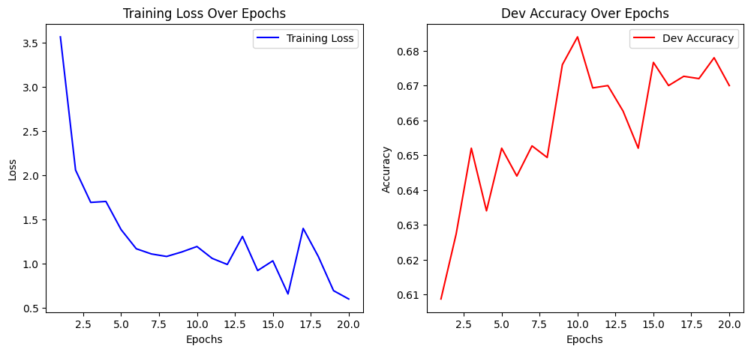

Dev Accuracy: 0.6700

Training CNN model with lr=0.01, epochs=20, embedding_dim=100, num_filters=50, filter_sizes=[2, 3]

Epoch 1/20, Loss: 2.290034623905576

Dev Accuracy: 0.6293

Epoch 2/20, Loss: 1.9216790774949262

Dev Accuracy: 0.5907

Epoch 3/20, Loss: 1.936807609554071

Dev Accuracy: 0.6380

Epoch 4/20, Loss: 1.760556071246254

Dev Accuracy: 0.6620

Epoch 5/20, Loss: 1.5098194937718858

Dev Accuracy: 0.6793

Epoch 6/20, Loss: 1.2208459884606782

Dev Accuracy: 0.6700

Epoch 7/20, Loss: 1.2890649566232033

Dev Accuracy: 0.6527

Epoch 8/20, Loss: 1.155519593915842

Dev Accuracy: 0.6553

Epoch 9/20, Loss: 1.1534903729315766

Dev Accuracy: 0.6407

Epoch 10/20, Loss: 1.0859917017188392

Dev Accuracy: 0.6467

Epoch 11/20, Loss: 0.7665400207314674

Dev Accuracy: 0.6853

Epoch 12/20, Loss: 1.1035382383932724

Dev Accuracy: 0.6580

Epoch 13/20, Loss: 0.8689857314645542

Dev Accuracy: 0.6800

Epoch 14/20, Loss: 1.4025447697442521

Dev Accuracy: 0.6880

Epoch 15/20, Loss: 1.3601942402429608

Dev Accuracy: 0.6987

Epoch 16/20, Loss: 0.7712973228033309

Dev Accuracy: 0.6573

Epoch 17/20, Loss: 0.7902527713459818

Dev Accuracy: 0.6613

Epoch 18/20, Loss: 1.026103442142331

Dev Accuracy: 0.6740

Epoch 19/20, Loss: 0.7770576751872205

Dev Accuracy: 0.6693

Epoch 20/20, Loss: 1.0689415078778075

Dev Accuracy: 0.6753

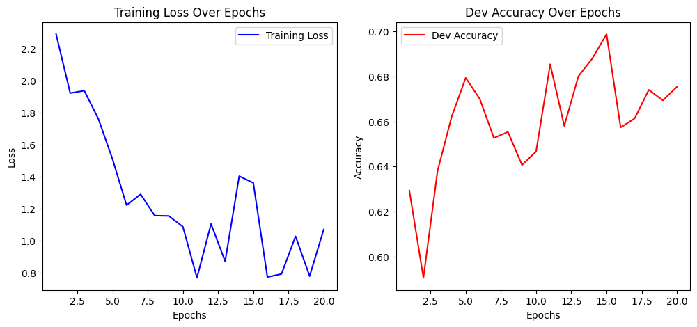

Dev Accuracy: 0.6753

Training CNN model with lr=0.01, epochs=20, embedding_dim=100, num_filters=100, filter_sizes=[3, 4, 5]

Epoch 1/20, Loss: 9.183319559387026

Dev Accuracy: 0.6913

Epoch 2/20, Loss: 3.5178880834243142

Dev Accuracy: 0.6753

Epoch 3/20, Loss: 3.5432816764419366

Dev Accuracy: 0.6667

Epoch 4/20, Loss: 2.653981931988151

Dev Accuracy: 0.6733

Epoch 5/20, Loss: 2.8238227127627717

Dev Accuracy: 0.7027

Epoch 6/20, Loss: 2.14147920625035

Dev Accuracy: 0.6887

Epoch 7/20, Loss: 1.6785506617118227

Dev Accuracy: 0.6913

Epoch 8/20, Loss: 1.3728650680586314

Dev Accuracy: 0.6960

Epoch 9/20, Loss: 1.3201763460198586

Dev Accuracy: 0.6893

Epoch 10/20, Loss: 1.451726541233622

Dev Accuracy: 0.6953

Epoch 11/20, Loss: 1.2470132090066846

Dev Accuracy: 0.6813

Epoch 12/20, Loss: 0.9824244161943942

Dev Accuracy: 0.6787

Epoch 13/20, Loss: 1.1161652455993878

Dev Accuracy: 0.6833

Epoch 14/20, Loss: 1.0653972138282954

Dev Accuracy: 0.6813

Epoch 15/20, Loss: 1.6200704166329276

Dev Accuracy: 0.6887

Epoch 16/20, Loss: 1.2690362904388455

Dev Accuracy: 0.6640

Epoch 17/20, Loss: 1.0571428719063325

Dev Accuracy: 0.6907

Epoch 18/20, Loss: 0.8532549152557912

Dev Accuracy: 0.6900

Epoch 19/20, Loss: 1.2584398499289255

Dev Accuracy: 0.6893

Epoch 20/20, Loss: 1.5886803392876443

Dev Accuracy: 0.6853

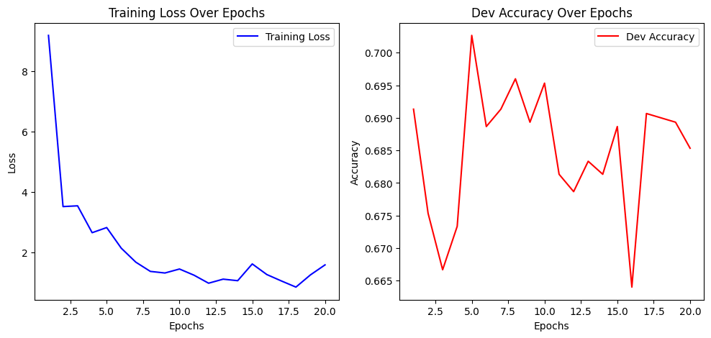

Dev Accuracy: 0.6853

Training CNN model with lr=0.01, epochs=20, embedding_dim=100, num_filters=100, filter_sizes=[2, 3]

Epoch 1/20, Loss: 6.00031459270868

Dev Accuracy: 0.6433

Epoch 2/20, Loss: 4.029385963985141

Dev Accuracy: 0.6740

Epoch 3/20, Loss: 3.5003825114183846

Dev Accuracy: 0.6840

Epoch 4/20, Loss: 3.0413036865004033

Dev Accuracy: 0.6887

Epoch 5/20, Loss: 2.6198091731633077

Dev Accuracy: 0.6800

Epoch 6/20, Loss: 1.9356280945029782

Dev Accuracy: 0.6567

Epoch 7/20, Loss: 1.8722246262055915

Dev Accuracy: 0.6727

Epoch 8/20, Loss: 2.046938124056498

Dev Accuracy: 0.6740

Epoch 9/20, Loss: 1.7164513136970374

Dev Accuracy: 0.6947

Epoch 10/20, Loss: 1.730630831096731

Dev Accuracy: 0.6647

Epoch 11/20, Loss: 1.8908048610811152

Dev Accuracy: 0.6827

Epoch 12/20, Loss: 1.5420056965321705

Dev Accuracy: 0.6800

Epoch 13/20, Loss: 1.1920473951101576

Dev Accuracy: 0.6827

Epoch 14/20, Loss: 1.2089050382763231

Dev Accuracy: 0.6773

Epoch 15/20, Loss: 0.908354253169047

Dev Accuracy: 0.6740

Epoch 16/20, Loss: 1.008703617414285

Dev Accuracy: 0.6853

Epoch 17/20, Loss: 0.9135880074226281

Dev Accuracy: 0.6800

Epoch 18/20, Loss: 0.9324302141408888

Dev Accuracy: 0.6887

Epoch 19/20, Loss: 0.9011934299182233

Dev Accuracy: 0.6900

Epoch 20/20, Loss: 0.8848939358235771

Dev Accuracy: 0.6760

Dev Accuracy: 0.6760

Training CNN model with lr=0.001, epochs=10, embedding_dim=50, num_filters=50, filter_sizes=[3, 4, 5]

Epoch 1/10, Loss: 0.6368564652393439

Dev Accuracy: 0.7307

Epoch 2/10, Loss: 0.4896754313333128

Dev Accuracy: 0.7287

Epoch 3/10, Loss: 0.3891828837615976

Dev Accuracy: 0.7367

Epoch 4/10, Loss: 0.3085835362848081

Dev Accuracy: 0.7493

Epoch 5/10, Loss: 0.244371950319856

Dev Accuracy: 0.7493

Epoch 6/10, Loss: 0.2011888231717772

Dev Accuracy: 0.7473

Epoch 7/10, Loss: 0.16475176880151443

Dev Accuracy: 0.7480

Epoch 8/10, Loss: 0.1385874678078478

Dev Accuracy: 0.7460

Epoch 9/10, Loss: 0.1099652715182304

Dev Accuracy: 0.7540

Epoch 10/10, Loss: 0.09240132497838624

Dev Accuracy: 0.7480

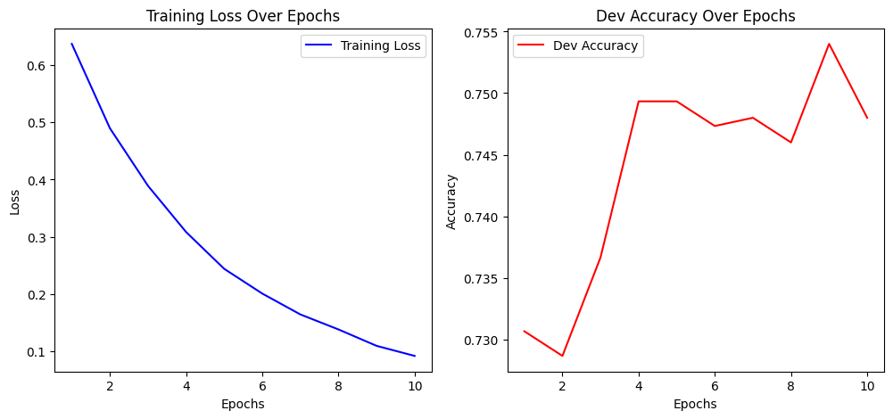

Dev Accuracy: 0.7480

Training CNN model with lr=0.001, epochs=10, embedding_dim=50, num_filters=50, filter_sizes=[2, 3]

Epoch 1/10, Loss: 0.6309715370787973

Dev Accuracy: 0.7053

Epoch 2/10, Loss: 0.4897479812658026

Dev Accuracy: 0.7373

Epoch 3/10, Loss: 0.4094428827490136

Dev Accuracy: 0.7493

Epoch 4/10, Loss: 0.3337446023681765

Dev Accuracy: 0.7493

Epoch 5/10, Loss: 0.28509578975076033

Dev Accuracy: 0.7493

Epoch 6/10, Loss: 0.2471020900141224

Dev Accuracy: 0.7573

Epoch 7/10, Loss: 0.20949196571239329

Dev Accuracy: 0.7380

Epoch 8/10, Loss: 0.17687847075619595

Dev Accuracy: 0.7567

Epoch 9/10, Loss: 0.13893129023845813

Dev Accuracy: 0.7347

Epoch 10/10, Loss: 0.13601747245411927

Dev Accuracy: 0.7540

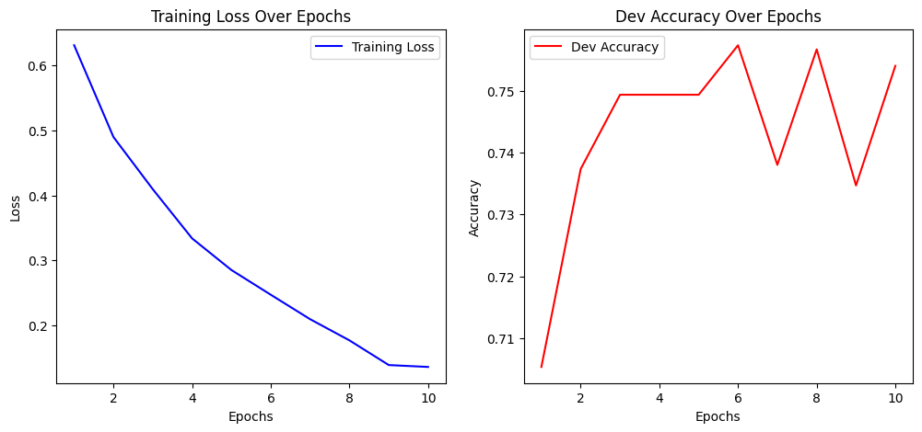

Dev Accuracy: 0.7540

Training CNN model with lr=0.001, epochs=10, embedding_dim=50, num_filters=100, filter_sizes=[3, 4, 5]

Epoch 1/10, Loss: 0.6699478111566444

Dev Accuracy: 0.6900

Epoch 2/10, Loss: 0.5248467200399733

Dev Accuracy: 0.7327

Epoch 3/10, Loss: 0.41307877327748105

Dev Accuracy: 0.7327

Epoch 4/10, Loss: 0.32350060953429094

Dev Accuracy: 0.7393

Epoch 5/10, Loss: 0.2675580143155949

Dev Accuracy: 0.7420

Epoch 6/10, Loss: 0.21400247773285602

Dev Accuracy: 0.7387

Epoch 7/10, Loss: 0.16553636572637723

Dev Accuracy: 0.7427

Epoch 8/10, Loss: 0.12734376051526802

Dev Accuracy: 0.7440

Epoch 9/10, Loss: 0.12832736846838846

Dev Accuracy: 0.7367

Epoch 10/10, Loss: 0.08822959596019535

Dev Accuracy: 0.7313

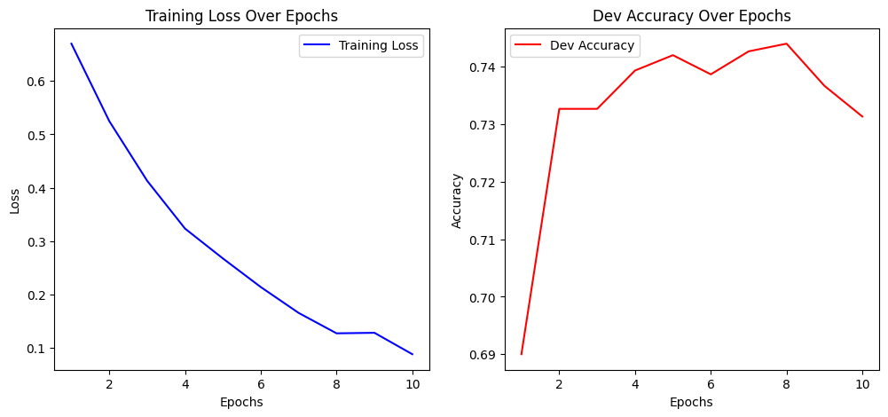

Dev Accuracy: 0.7313

Training CNN model with lr=0.001, epochs=10, embedding_dim=50, num_filters=100, filter_sizes=[2, 3]

Epoch 1/10, Loss: 0.6302875580316343

Dev Accuracy: 0.6713

Epoch 2/10, Loss: 0.5031414406127623

Dev Accuracy: 0.7107

Epoch 3/10, Loss: 0.41504763934528066

Dev Accuracy: 0.7307

Epoch 4/10, Loss: 0.3486074741459533

Dev Accuracy: 0.7420

Epoch 5/10, Loss: 0.29427252228858225

Dev Accuracy: 0.7367

Epoch 6/10, Loss: 0.23976519496137896

Dev Accuracy: 0.7567

Epoch 7/10, Loss: 0.20729869936100304

Dev Accuracy: 0.7560

Epoch 8/10, Loss: 0.1744346116116368

Dev Accuracy: 0.7593

Epoch 9/10, Loss: 0.14427568683170394

Dev Accuracy: 0.7547

Epoch 10/10, Loss: 0.13128860133003725

Dev Accuracy: 0.7540

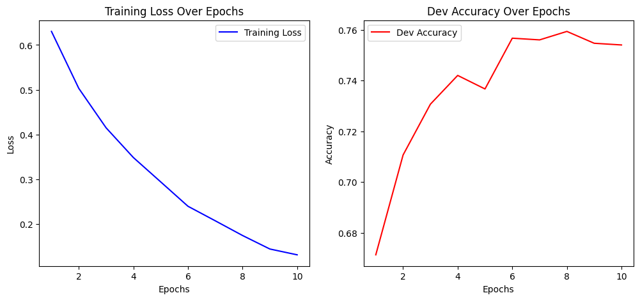

Dev Accuracy: 0.7540

Training CNN model with lr=0.001, epochs=10, embedding_dim=100, num_filters=50, filter_sizes=[3, 4, 5]

Epoch 1/10, Loss: 0.6331689904798737

Dev Accuracy: 0.7133

Epoch 2/10, Loss: 0.48391526617359204

Dev Accuracy: 0.7353

Epoch 3/10, Loss: 0.36238280145556817

Dev Accuracy: 0.7480

Epoch 4/10, Loss: 0.27408496909645697

Dev Accuracy: 0.7507

Epoch 5/10, Loss: 0.22129229822126692

Dev Accuracy: 0.7560

Epoch 6/10, Loss: 0.15991139844720106

Dev Accuracy: 0.7473

Epoch 7/10, Loss: 0.13206650636421033

Dev Accuracy: 0.7480

Epoch 8/10, Loss: 0.10912086024321836

Dev Accuracy: 0.7620

Epoch 9/10, Loss: 0.09095307941406708

Dev Accuracy: 0.7567

Epoch 10/10, Loss: 0.09010474866982038

Dev Accuracy: 0.7560

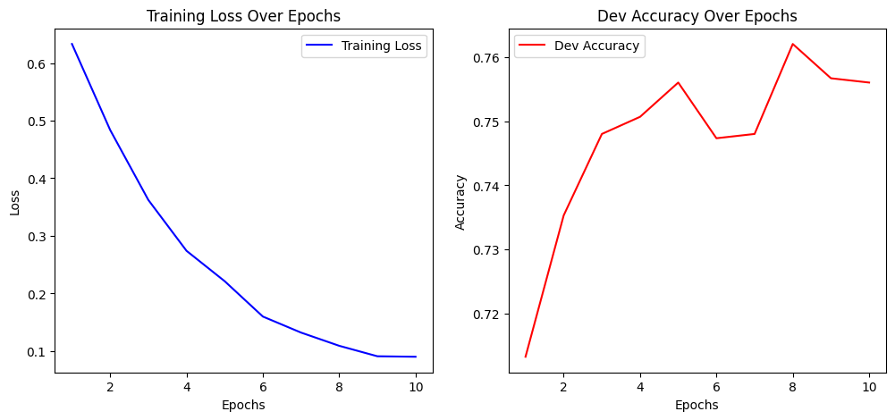

Dev Accuracy: 0.7560

Training CNN model with lr=0.001, epochs=10, embedding_dim=100, num_filters=50, filter_sizes=[2, 3]

Epoch 1/10, Loss: 0.6116669530783423

Dev Accuracy: 0.7327

Epoch 2/10, Loss: 0.47225797362775224

Dev Accuracy: 0.7473

Epoch 3/10, Loss: 0.36943107411245635

Dev Accuracy: 0.7587

Epoch 4/10, Loss: 0.3054290056300568

Dev Accuracy: 0.7653

Epoch 5/10, Loss: 0.23876778728294526

Dev Accuracy: 0.7660

Epoch 6/10, Loss: 0.1982554474262226

Dev Accuracy: 0.7627

Epoch 7/10, Loss: 0.15420861518273019

Dev Accuracy: 0.7513

Epoch 8/10, Loss: 0.1364844130271844

Dev Accuracy: 0.7573

Epoch 9/10, Loss: 0.1054332609584219

Dev Accuracy: 0.7493

Epoch 10/10, Loss: 0.09684798275702271

Dev Accuracy: 0.7387

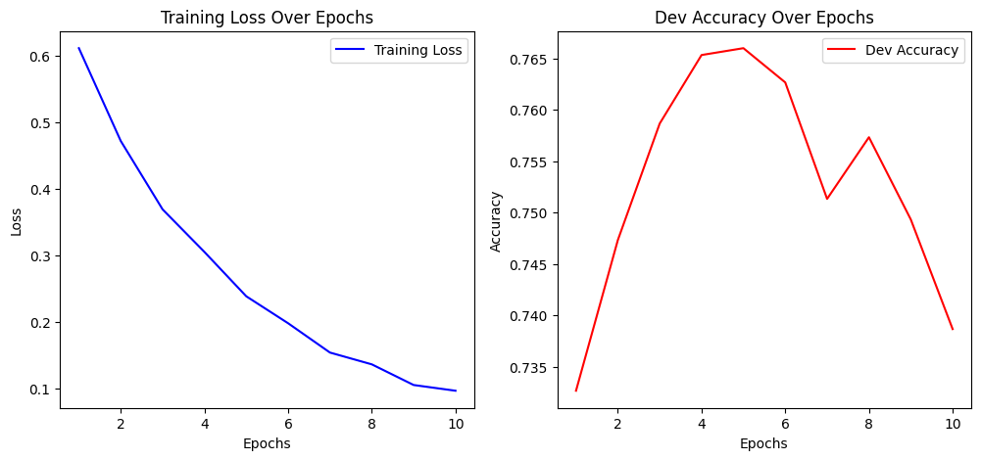

Dev Accuracy: 0.7387

Training CNN model with lr=0.001, epochs=10, embedding_dim=100, num_filters=100, filter_sizes=[3, 4, 5]

Epoch 1/10, Loss: 0.6678261705205343

Dev Accuracy: 0.6587

Epoch 2/10, Loss: 0.49990721220339074

Dev Accuracy: 0.7347

Epoch 3/10, Loss: 0.3807732748932656

Dev Accuracy: 0.7373

Epoch 4/10, Loss: 0.2853001223302569

Dev Accuracy: 0.7387

Epoch 5/10, Loss: 0.21753964394771003

Dev Accuracy: 0.7360

Epoch 6/10, Loss: 0.17663209741393351

Dev Accuracy: 0.7360

Epoch 7/10, Loss: 0.142778019087078

Dev Accuracy: 0.7507

Epoch 8/10, Loss: 0.1255306376959172

Dev Accuracy: 0.7447

Epoch 9/10, Loss: 0.11372911086345718

Dev Accuracy: 0.7393

Epoch 10/10, Loss: 0.09574547378681009

Dev Accuracy: 0.7440

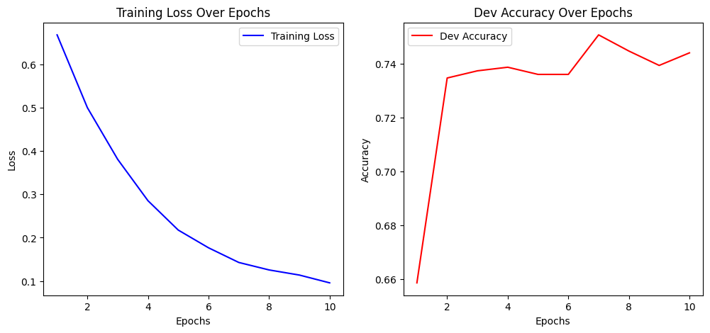

Dev Accuracy: 0.7440

Training CNN model with lr=0.001, epochs=10, embedding_dim=100, num_filters=100, filter_sizes=[2, 3]

Epoch 1/10, Loss: 0.631092110286525

Dev Accuracy: 0.7087

Epoch 2/10, Loss: 0.47176850113040075

Dev Accuracy: 0.7667

Epoch 3/10, Loss: 0.37558031154466

Dev Accuracy: 0.7440

Epoch 4/10, Loss: 0.3095460325069222

Dev Accuracy: 0.7560

Epoch 5/10, Loss: 0.2551745824612661

Dev Accuracy: 0.7660

Epoch 6/10, Loss: 0.2031989763962712

Dev Accuracy: 0.7627

Epoch 7/10, Loss: 0.16582491076007344

Dev Accuracy: 0.7640

Epoch 8/10, Loss: 0.1454831753192249

Dev Accuracy: 0.7527

Epoch 9/10, Loss: 0.12384439973575243

Dev Accuracy: 0.7593

Epoch 10/10, Loss: 0.09655259459209282

Dev Accuracy: 0.7580

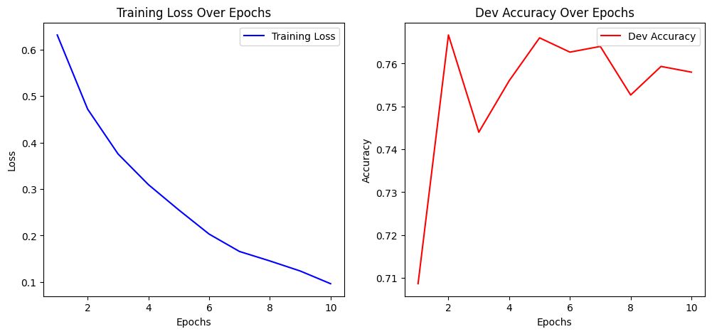

Dev Accuracy: 0.7580

Training CNN model with lr=0.001, epochs=20, embedding_dim=50, num_filters=50, filter_sizes=[3, 4, 5]

Epoch 1/20, Loss: 0.6359318373338652

Dev Accuracy: 0.7020

Epoch 2/20, Loss: 0.48848839691916096

Dev Accuracy: 0.7320

Epoch 3/20, Loss: 0.39357327735444997

Dev Accuracy: 0.7407

Epoch 4/20, Loss: 0.3215019118448125

Dev Accuracy: 0.7560

Epoch 5/20, Loss: 0.2610696319426899

Dev Accuracy: 0.7460

Epoch 6/20, Loss: 0.20955791929617626

Dev Accuracy: 0.7573

Epoch 7/20, Loss: 0.16268682325835412

Dev Accuracy: 0.7587

Epoch 8/20, Loss: 0.14576287069479055

Dev Accuracy: 0.7593

Epoch 9/20, Loss: 0.10499235783690125

Dev Accuracy: 0.7660

Epoch 10/20, Loss: 0.09735455582539436

Dev Accuracy: 0.7533

Epoch 11/20, Loss: 0.07865099787530992

Dev Accuracy: 0.7627

Epoch 12/20, Loss: 0.0695860924046252

Dev Accuracy: 0.7640

Epoch 13/20, Loss: 0.0601419617048753

Dev Accuracy: 0.7507

Epoch 14/20, Loss: 0.05774418250891427

Dev Accuracy: 0.7587

Epoch 15/20, Loss: 0.04592780512791334

Dev Accuracy: 0.7593

Epoch 16/20, Loss: 0.04150854952286199

Dev Accuracy: 0.7613

Epoch 17/20, Loss: 0.03876082188730337

Dev Accuracy: 0.7560

Epoch 18/20, Loss: 0.03888681583333889

Dev Accuracy: 0.7527

Epoch 19/20, Loss: 0.03524824328122871

Dev Accuracy: 0.7460

Epoch 20/20, Loss: 0.03505948135126299

Dev Accuracy: 0.7527

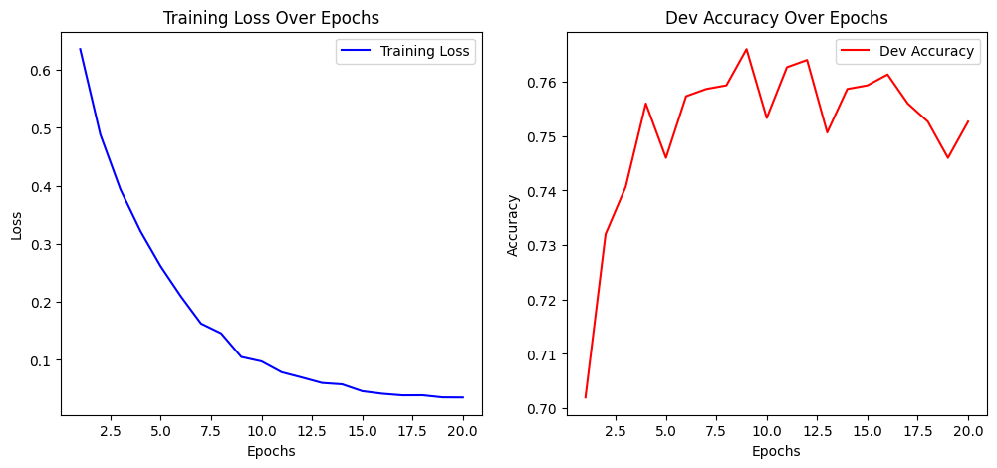

Dev Accuracy: 0.7527

Training CNN model with lr=0.001, epochs=20, embedding_dim=50, num_filters=50, filter_sizes=[2, 3]

Epoch 1/20, Loss: 0.632212146479836

Dev Accuracy: 0.7227

Epoch 2/20, Loss: 0.4953292074170749

Dev Accuracy: 0.7580

Epoch 3/20, Loss: 0.4137200657519692

Dev Accuracy: 0.7540

Epoch 4/20, Loss: 0.3485148674038446

Dev Accuracy: 0.7540

Epoch 5/20, Loss: 0.292673395150457

Dev Accuracy: 0.7567

Epoch 6/20, Loss: 0.24758307203565466

Dev Accuracy: 0.7560

Epoch 7/20, Loss: 0.19623626016227375

Dev Accuracy: 0.7473

Epoch 8/20, Loss: 0.1747606245114755

Dev Accuracy: 0.7540

Epoch 9/20, Loss: 0.14629659224238034

Dev Accuracy: 0.7440

Epoch 10/20, Loss: 0.11121879151991233

Dev Accuracy: 0.7493

Epoch 11/20, Loss: 0.09817824202990873

Dev Accuracy: 0.7487

Epoch 12/20, Loss: 0.08485205384332405

Dev Accuracy: 0.7407

Epoch 13/20, Loss: 0.08597646929684018

Dev Accuracy: 0.7393

Epoch 14/20, Loss: 0.06926946483979218

Dev Accuracy: 0.7433

Epoch 15/20, Loss: 0.06134873259499805

Dev Accuracy: 0.7380

Epoch 16/20, Loss: 0.05580794844018921

Dev Accuracy: 0.7367

Epoch 17/20, Loss: 0.055086403639382955

Dev Accuracy: 0.7400

Epoch 18/20, Loss: 0.04654317691496228

Dev Accuracy: 0.7447

Epoch 19/20, Loss: 0.044318005000210506

Dev Accuracy: 0.7440

Epoch 20/20, Loss: 0.04379637587030667

Dev Accuracy: 0.7407

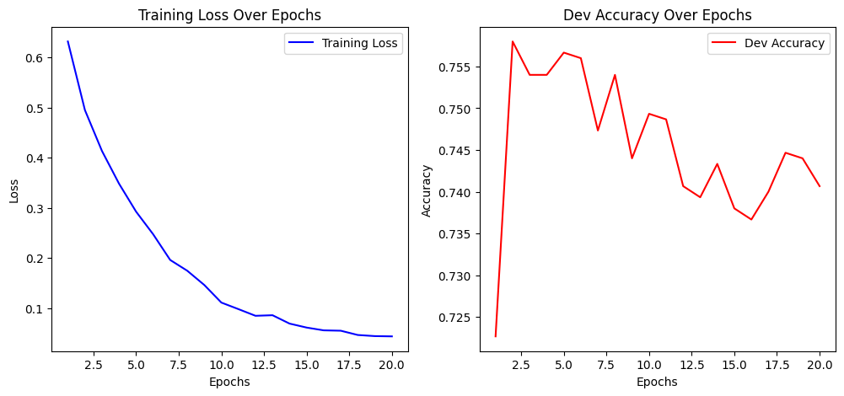

Dev Accuracy: 0.7407

Training CNN model with lr=0.001, epochs=20, embedding_dim=50, num_filters=100, filter_sizes=[3, 4, 5]

Epoch 1/20, Loss: 0.6590849947115472

Dev Accuracy: 0.7053

Epoch 2/20, Loss: 0.5051689831478311

Dev Accuracy: 0.7300

Epoch 3/20, Loss: 0.4081726950580327

Dev Accuracy: 0.7340

Epoch 4/20, Loss: 0.3251502114949717

Dev Accuracy: 0.7313

Epoch 5/20, Loss: 0.2541558324840714

Dev Accuracy: 0.7247

Epoch 6/20, Loss: 0.20029492852246375

Dev Accuracy: 0.7180

Epoch 7/20, Loss: 0.1594560443514484

Dev Accuracy: 0.7287

Epoch 8/20, Loss: 0.1483720064032193

Dev Accuracy: 0.7147

Epoch 9/20, Loss: 0.11960092685902153

Dev Accuracy: 0.7260

Epoch 10/20, Loss: 0.10428736060673256

Dev Accuracy: 0.7320

Epoch 11/20, Loss: 0.0717620842604031

Dev Accuracy: 0.7340

Epoch 12/20, Loss: 0.07988703528555481

Dev Accuracy: 0.7413

Epoch 13/20, Loss: 0.07667170060852428

Dev Accuracy: 0.7267

Epoch 14/20, Loss: 0.059536096190059264

Dev Accuracy: 0.7327

Epoch 15/20, Loss: 0.05051629320942907

Dev Accuracy: 0.7373

Epoch 16/20, Loss: 0.06336409036328876

Dev Accuracy: 0.7387

Epoch 17/20, Loss: 0.05003245052266492

Dev Accuracy: 0.7273

Epoch 18/20, Loss: 0.03764105475215399

Dev Accuracy: 0.7293

Epoch 19/20, Loss: 0.03742197032055378

Dev Accuracy: 0.7360

Epoch 20/20, Loss: 0.040130741824264966

Dev Accuracy: 0.7433

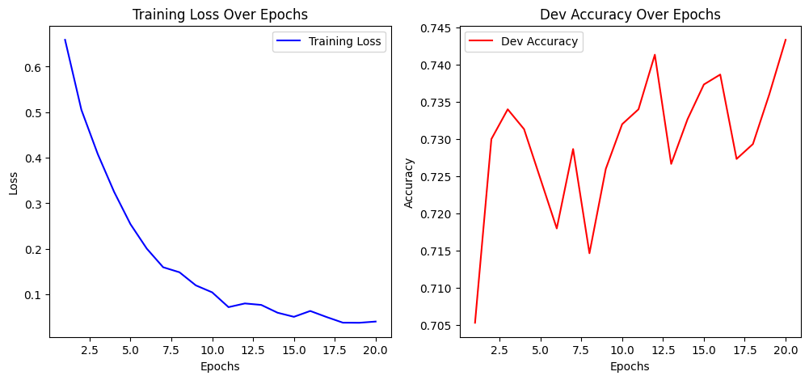

Dev Accuracy: 0.7433

Training CNN model with lr=0.001, epochs=20, embedding_dim=50, num_filters=100, filter_sizes=[2, 3]

Epoch 1/20, Loss: 0.6355882037496693

Dev Accuracy: 0.7160

Epoch 2/20, Loss: 0.4979736279705903

Dev Accuracy: 0.7213

Epoch 3/20, Loss: 0.41459417904564677

Dev Accuracy: 0.7500

Epoch 4/20, Loss: 0.3445275046910972

Dev Accuracy: 0.7593

Epoch 5/20, Loss: 0.2776260254522298

Dev Accuracy: 0.7627

Epoch 6/20, Loss: 0.2336877549074701

Dev Accuracy: 0.7653

Epoch 7/20, Loss: 0.1938936894151405

Dev Accuracy: 0.7520

Epoch 8/20, Loss: 0.16785324399426788

Dev Accuracy: 0.7567

Epoch 9/20, Loss: 0.13365217308696545

Dev Accuracy: 0.7560

Epoch 10/20, Loss: 0.12469476630666315

Dev Accuracy: 0.7647

Epoch 11/20, Loss: 0.10030659396449076

Dev Accuracy: 0.7640

Epoch 12/20, Loss: 0.08199433552017064

Dev Accuracy: 0.7660

Epoch 13/20, Loss: 0.07636073767183892

Dev Accuracy: 0.7613

Epoch 14/20, Loss: 0.06686761893386402

Dev Accuracy: 0.7620

Epoch 15/20, Loss: 0.05750803750738972

Dev Accuracy: 0.7600

Epoch 16/20, Loss: 0.05070332979136585

Dev Accuracy: 0.7613

Epoch 17/20, Loss: 0.045773930743528916

Dev Accuracy: 0.7573

Epoch 18/20, Loss: 0.046191862235261054

Dev Accuracy: 0.7647

Epoch 19/20, Loss: 0.05120382123776428

Dev Accuracy: 0.7647

Epoch 20/20, Loss: 0.04195594115293418

Dev Accuracy: 0.7600

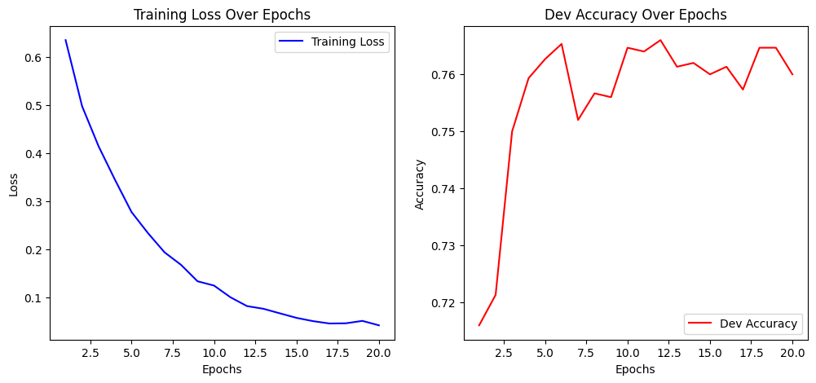

Dev Accuracy: 0.7600

Training CNN model with lr=0.001, epochs=20, embedding_dim=100, num_filters=50, filter_sizes=[3, 4, 5]

Epoch 1/20, Loss: 0.6385151350935255

Dev Accuracy: 0.6907

Epoch 2/20, Loss: 0.486076908382432

Dev Accuracy: 0.7087

Epoch 3/20, Loss: 0.3681358220774303

Dev Accuracy: 0.7373

Epoch 4/20, Loss: 0.2800267279000931

Dev Accuracy: 0.7560

Epoch 5/20, Loss: 0.20984141103925108

Dev Accuracy: 0.7507

Epoch 6/20, Loss: 0.17545702583324127

Dev Accuracy: 0.7540

Epoch 7/20, Loss: 0.13440637551621165

Dev Accuracy: 0.7387

Epoch 8/20, Loss: 0.10591548687734485

Dev Accuracy: 0.7520

Epoch 9/20, Loss: 0.10124247589505607

Dev Accuracy: 0.7533

Epoch 10/20, Loss: 0.0762039378135665

Dev Accuracy: 0.7580

Epoch 11/20, Loss: 0.07534693217771353

Dev Accuracy: 0.7533

Epoch 12/20, Loss: 0.056429124996955744

Dev Accuracy: 0.7440

Epoch 13/20, Loss: 0.058165060674698774

Dev Accuracy: 0.7427

Epoch 14/20, Loss: 0.056624536140884175

Dev Accuracy: 0.7507

Epoch 15/20, Loss: 0.05644205203038567

Dev Accuracy: 0.7520

Epoch 16/20, Loss: 0.04581181631098997

Dev Accuracy: 0.7440

Epoch 17/20, Loss: 0.04181752696938837

Dev Accuracy: 0.7593

Epoch 18/20, Loss: 0.030910342718961537

Dev Accuracy: 0.7473

Epoch 19/20, Loss: 0.0405753765423623

Dev Accuracy: 0.7440

Epoch 20/20, Loss: 0.037651807722389206

Dev Accuracy: 0.7553

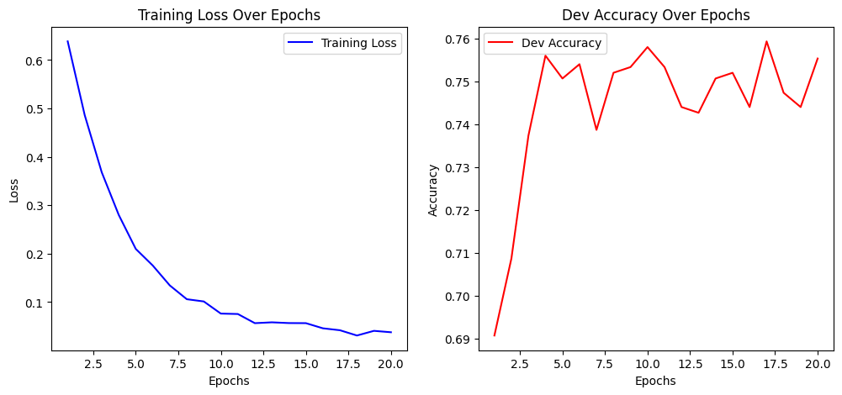

Dev Accuracy: 0.7553

Training CNN model with lr=0.001, epochs=20, embedding_dim=100, num_filters=50, filter_sizes=[2, 3]

Epoch 1/20, Loss: 0.6099443966338877

Dev Accuracy: 0.7600

Epoch 2/20, Loss: 0.4686939112411298

Dev Accuracy: 0.7567

Epoch 3/20, Loss: 0.37051576478619247

Dev Accuracy: 0.7620

Epoch 4/20, Loss: 0.2997997381225195

Dev Accuracy: 0.7627

Epoch 5/20, Loss: 0.2503546206039962

Dev Accuracy: 0.7507

Epoch 6/20, Loss: 0.19621787779388114

Dev Accuracy: 0.7573

Epoch 7/20, Loss: 0.16343940627753947

Dev Accuracy: 0.7593

Epoch 8/20, Loss: 0.12568396565916398

Dev Accuracy: 0.7520

Epoch 9/20, Loss: 0.12192592352370586

Dev Accuracy: 0.7513

Epoch 10/20, Loss: 0.10618608212449171

Dev Accuracy: 0.7480

Epoch 11/20, Loss: 0.07621916184893508

Dev Accuracy: 0.7487

Epoch 12/20, Loss: 0.07425760482764451

Dev Accuracy: 0.7487

Epoch 13/20, Loss: 0.07063695996762175

Dev Accuracy: 0.7433

Epoch 14/20, Loss: 0.0660744829124931

Dev Accuracy: 0.7473

Epoch 15/20, Loss: 0.06084276906037418

Dev Accuracy: 0.7420

Epoch 16/20, Loss: 0.05067313441347478

Dev Accuracy: 0.7507

Epoch 17/20, Loss: 0.048487035380841495

Dev Accuracy: 0.7507

Epoch 18/20, Loss: 0.056340698523849986

Dev Accuracy: 0.7407

Epoch 19/20, Loss: 0.03885016009614902

Dev Accuracy: 0.7427

Epoch 20/20, Loss: 0.04123389453398501

Dev Accuracy: 0.7447

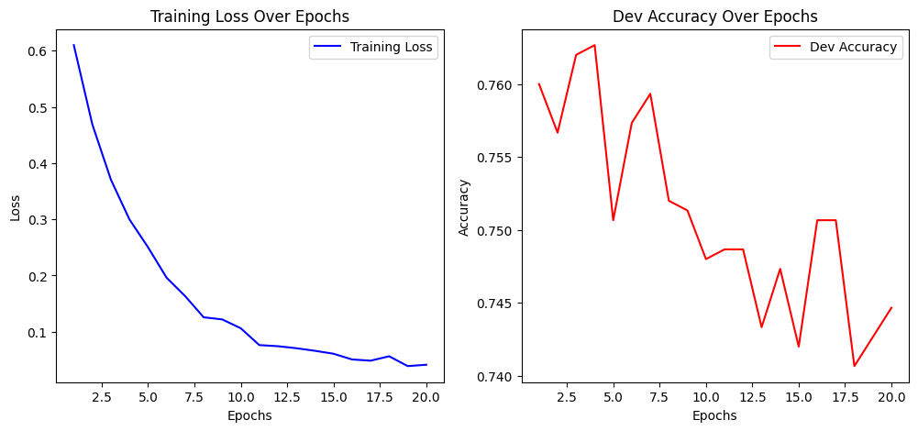

Dev Accuracy: 0.7447

Training CNN model with lr=0.001, epochs=20, embedding_dim=100, num_filters=100, filter_sizes=[3, 4, 5]

Epoch 1/20, Loss: 0.6843122808786679

Dev Accuracy: 0.6500

Epoch 2/20, Loss: 0.525403259631881

Dev Accuracy: 0.7307

Epoch 3/20, Loss: 0.401608964655678

Dev Accuracy: 0.7013

Epoch 4/20, Loss: 0.33223002589332534

Dev Accuracy: 0.7400

Epoch 5/20, Loss: 0.24587082599712545

Dev Accuracy: 0.7427

Epoch 6/20, Loss: 0.19399968523655362

Dev Accuracy: 0.7460

Epoch 7/20, Loss: 0.17579830665995994

Dev Accuracy: 0.7427

Epoch 8/20, Loss: 0.14251392024738097

Dev Accuracy: 0.7567

Epoch 9/20, Loss: 0.10081699565095607

Dev Accuracy: 0.7540

Epoch 10/20, Loss: 0.10143125781319937

Dev Accuracy: 0.7520

Epoch 11/20, Loss: 0.091697071026008

Dev Accuracy: 0.7540

Epoch 12/20, Loss: 0.09191353093799813

Dev Accuracy: 0.7433

Epoch 13/20, Loss: 0.08908426306022976

Dev Accuracy: 0.7567

Epoch 14/20, Loss: 0.0625349497804364

Dev Accuracy: 0.7567

Epoch 15/20, Loss: 0.08150723125101084

Dev Accuracy: 0.7547

Epoch 16/20, Loss: 0.0696712419317533

Dev Accuracy: 0.7460

Epoch 17/20, Loss: 0.061328574149670766

Dev Accuracy: 0.7447

Epoch 18/20, Loss: 0.0579791545107552

Dev Accuracy: 0.7513

Epoch 19/20, Loss: 0.051104205511937735

Dev Accuracy: 0.7500

Epoch 20/20, Loss: 0.05103031271804113

Dev Accuracy: 0.7547

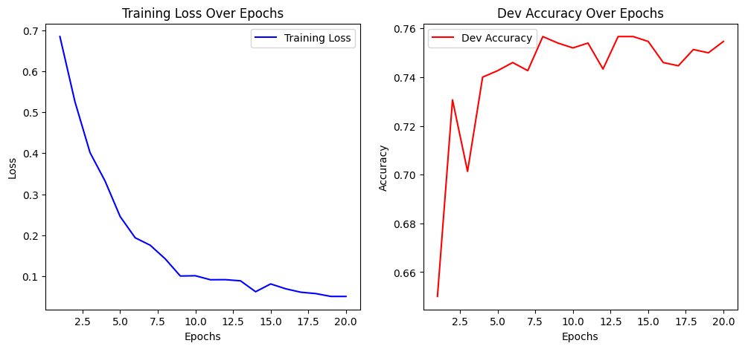

Dev Accuracy: 0.7547

Training CNN model with lr=0.001, epochs=20, embedding_dim=100, num_filters=100, filter_sizes=[2, 3]

Epoch 1/20, Loss: 0.6305260274572523

Dev Accuracy: 0.7380

Epoch 2/20, Loss: 0.4926139680536817

Dev Accuracy: 0.7400

Epoch 3/20, Loss: 0.3842497901024657

Dev Accuracy: 0.7327

Epoch 4/20, Loss: 0.3148610704302517

Dev Accuracy: 0.7507

Epoch 5/20, Loss: 0.2539730172114244

Dev Accuracy: 0.7460

Epoch 6/20, Loss: 0.19763985072900447

Dev Accuracy: 0.7520

Epoch 7/20, Loss: 0.1633050523315836

Dev Accuracy: 0.7480

Epoch 8/20, Loss: 0.1493065173520173

Dev Accuracy: 0.7407

Epoch 9/20, Loss: 0.11458314825602216

Dev Accuracy: 0.7520

Epoch 10/20, Loss: 0.09057091658503888

Dev Accuracy: 0.7540

Epoch 11/20, Loss: 0.0830746353043102

Dev Accuracy: 0.7407

Epoch 12/20, Loss: 0.07821839881215056

Dev Accuracy: 0.7533

Epoch 13/20, Loss: 0.07408967449273594

Dev Accuracy: 0.7460

Epoch 14/20, Loss: 0.06657853129508384

Dev Accuracy: 0.7440

Epoch 15/20, Loss: 0.05857546633243845

Dev Accuracy: 0.7520

Epoch 16/20, Loss: 0.05520931119649329

Dev Accuracy: 0.7507

Epoch 17/20, Loss: 0.051239817297449336

Dev Accuracy: 0.7513

Epoch 18/20, Loss: 0.04976974264820313

Dev Accuracy: 0.7520

Epoch 19/20, Loss: 0.05841371024378218

Dev Accuracy: 0.7493

Epoch 20/20, Loss: 0.04794208822485498

Dev Accuracy: 0.7547

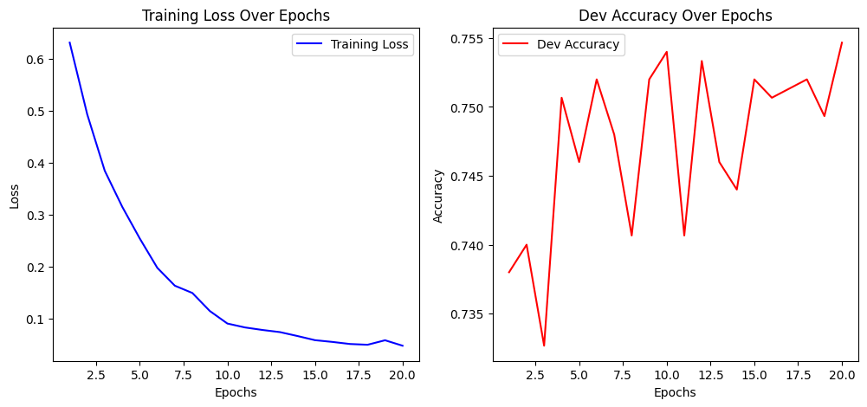

Dev Accuracy: 0.7547

Training CNN model with lr=0.0001, epochs=10, embedding_dim=50, num_filters=50, filter_sizes=[3, 4, 5]

Epoch 1/10, Loss: 0.6878682409343975

Dev Accuracy: 0.6460

Epoch 2/10, Loss: 0.626543064005673

Dev Accuracy: 0.6660

Epoch 3/10, Loss: 0.5806105543087636

Dev Accuracy: 0.6867

Epoch 4/10, Loss: 0.5402977360336643

Dev Accuracy: 0.7013

Epoch 5/10, Loss: 0.5010124869459708

Dev Accuracy: 0.7120

Epoch 6/10, Loss: 0.47113491239327204

Dev Accuracy: 0.7140

Epoch 7/10, Loss: 0.44021266705782286

Dev Accuracy: 0.7220

Epoch 8/10, Loss: 0.421036027809447

Dev Accuracy: 0.7253

Epoch 9/10, Loss: 0.3920124412166562

Dev Accuracy: 0.7327

Epoch 10/10, Loss: 0.36197828022452555

Dev Accuracy: 0.7340

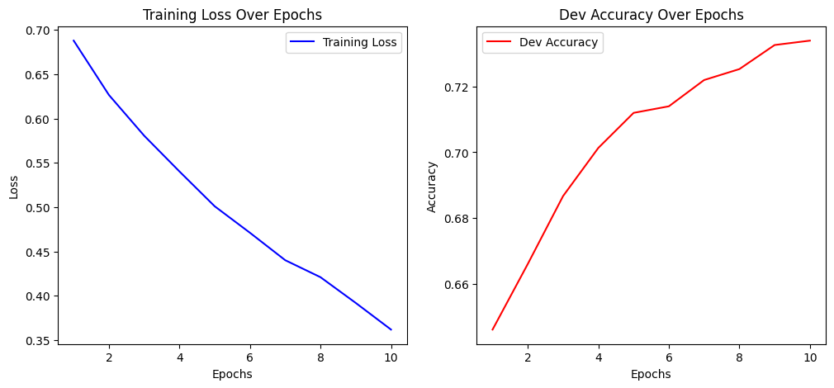

Dev Accuracy: 0.7340

Training CNN model with lr=0.0001, epochs=10, embedding_dim=50, num_filters=50, filter_sizes=[2, 3]

Epoch 1/10, Loss: 0.6948541195988656

Dev Accuracy: 0.6087

Epoch 2/10, Loss: 0.653650388084352

Dev Accuracy: 0.6267

Epoch 3/10, Loss: 0.6075573366098106

Dev Accuracy: 0.6393

Epoch 4/10, Loss: 0.5778019792836692

Dev Accuracy: 0.6540

Epoch 5/10, Loss: 0.546342903116851

Dev Accuracy: 0.6613

Epoch 6/10, Loss: 0.5209846727866014

Dev Accuracy: 0.6767

Epoch 7/10, Loss: 0.5013830828333073

Dev Accuracy: 0.6873

Epoch 8/10, Loss: 0.4753040132889624

Dev Accuracy: 0.7047

Epoch 9/10, Loss: 0.46384498490529535

Dev Accuracy: 0.7040

Epoch 10/10, Loss: 0.44594530010200106

Dev Accuracy: 0.7113

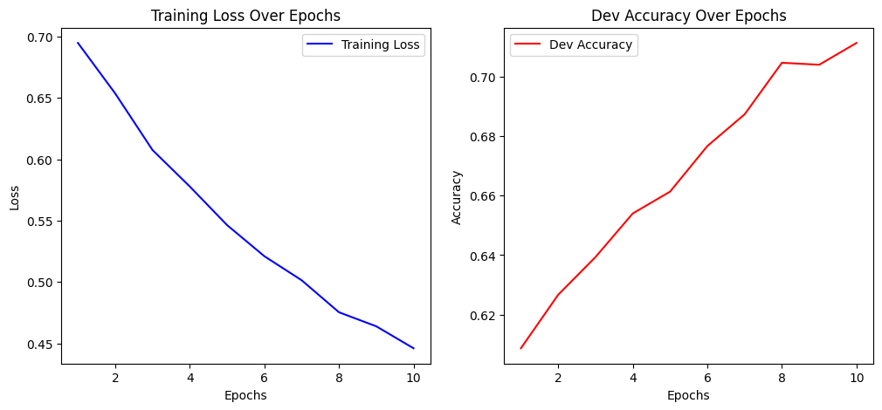

Dev Accuracy: 0.7113

Training CNN model with lr=0.0001, epochs=10, embedding_dim=50, num_filters=100, filter_sizes=[3, 4, 5]

Epoch 1/10, Loss: 0.6752266745322517

Dev Accuracy: 0.6387

Epoch 2/10, Loss: 0.5992835669687816

Dev Accuracy: 0.6700

Epoch 3/10, Loss: 0.537784420144212

Dev Accuracy: 0.6840

Epoch 4/10, Loss: 0.4919177271264073

Dev Accuracy: 0.6947

Epoch 5/10, Loss: 0.4501450693698134

Dev Accuracy: 0.7047

Epoch 6/10, Loss: 0.4101407191304856

Dev Accuracy: 0.7080

Epoch 7/10, Loss: 0.3760741116889029

Dev Accuracy: 0.7080

Epoch 8/10, Loss: 0.346846974826316

Dev Accuracy: 0.7093

Epoch 9/10, Loss: 0.31852497598039087

Dev Accuracy: 0.7107

Epoch 10/10, Loss: 0.29744423880454374

Dev Accuracy: 0.7140

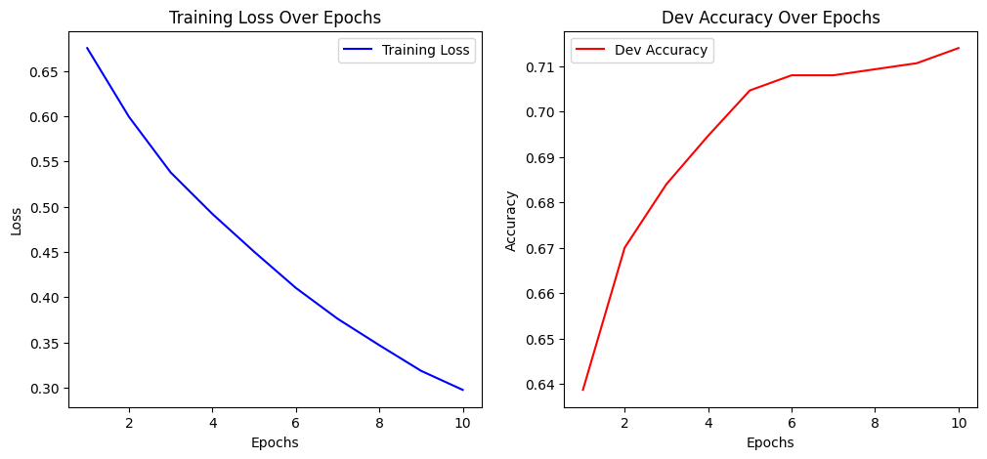

Dev Accuracy: 0.7140

Training CNN model with lr=0.0001, epochs=10, embedding_dim=50, num_filters=100, filter_sizes=[2, 3]

Epoch 1/10, Loss: 0.6828833529417004

Dev Accuracy: 0.6527

Epoch 2/10, Loss: 0.6289534691721201

Dev Accuracy: 0.6787

Epoch 3/10, Loss: 0.5829434167018959

Dev Accuracy: 0.6927

Epoch 4/10, Loss: 0.5495824369101652

Dev Accuracy: 0.7027

Epoch 5/10, Loss: 0.5189685127258168

Dev Accuracy: 0.7120

Epoch 6/10, Loss: 0.48561532189447565

Dev Accuracy: 0.7147

Epoch 7/10, Loss: 0.47036583431587287

Dev Accuracy: 0.7207

Epoch 8/10, Loss: 0.44243400585154136

Dev Accuracy: 0.7233

Epoch 9/10, Loss: 0.4195669755804286

Dev Accuracy: 0.7313

Epoch 10/10, Loss: 0.40142787255217055

Dev Accuracy: 0.7407

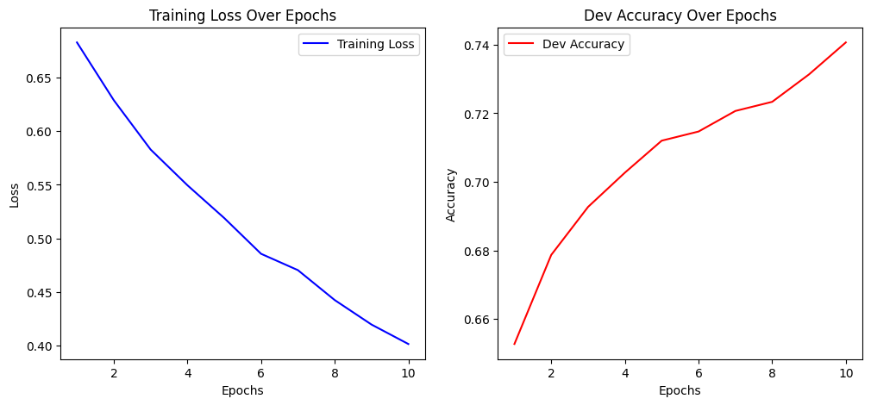

Dev Accuracy: 0.7407

Training CNN model with lr=0.0001, epochs=10, embedding_dim=100, num_filters=50, filter_sizes=[3, 4, 5]

Epoch 1/10, Loss: 0.6661321713019694

Dev Accuracy: 0.6607

Epoch 2/10, Loss: 0.5710443027459883

Dev Accuracy: 0.6820

Epoch 3/10, Loss: 0.5040734715181003

Dev Accuracy: 0.6873

Epoch 4/10, Loss: 0.45098844023778967

Dev Accuracy: 0.7067

Epoch 5/10, Loss: 0.39397868099511624

Dev Accuracy: 0.7093

Epoch 6/10, Loss: 0.35776773435673176

Dev Accuracy: 0.7193

Epoch 7/10, Loss: 0.3192395315374992

Dev Accuracy: 0.7193

Epoch 8/10, Loss: 0.2836909317294537

Dev Accuracy: 0.7220

Epoch 9/10, Loss: 0.25200605335861864

Dev Accuracy: 0.7293

Epoch 10/10, Loss: 0.22351646552513868

Dev Accuracy: 0.7267

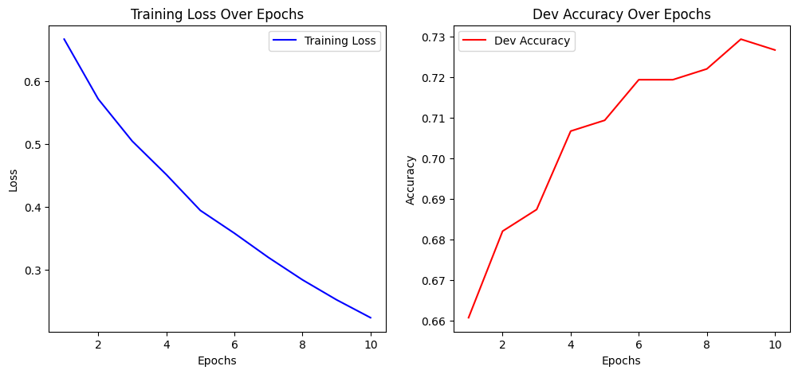

Dev Accuracy: 0.7267

Training CNN model with lr=0.0001, epochs=10, embedding_dim=100, num_filters=50, filter_sizes=[2, 3]

Epoch 1/10, Loss: 0.6672490801630275

Dev Accuracy: 0.6627

Epoch 2/10, Loss: 0.5892258007236357

Dev Accuracy: 0.6980

Epoch 3/10, Loss: 0.5351945693558082

Dev Accuracy: 0.7013

Epoch 4/10, Loss: 0.49045735497383536

Dev Accuracy: 0.7140

Epoch 5/10, Loss: 0.46451586826019253

Dev Accuracy: 0.7220

Epoch 6/10, Loss: 0.42299246731014656

Dev Accuracy: 0.7327

Epoch 7/10, Loss: 0.401122437802555

Dev Accuracy: 0.7373

Epoch 8/10, Loss: 0.37636807791938603

Dev Accuracy: 0.7380

Epoch 9/10, Loss: 0.35363641706904414

Dev Accuracy: 0.7367

Epoch 10/10, Loss: 0.33022880506017205

Dev Accuracy: 0.7480

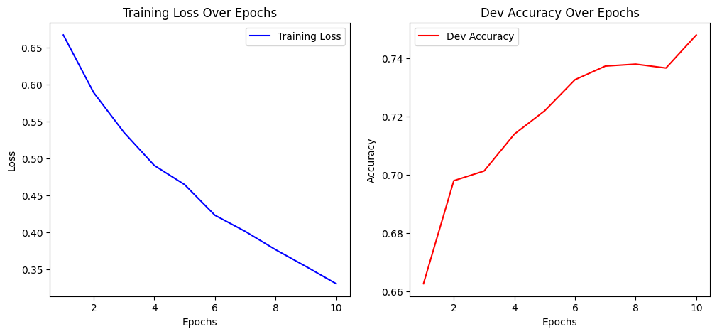

Dev Accuracy: 0.7480

Training CNN model with lr=0.0001, epochs=10, embedding_dim=100, num_filters=100, filter_sizes=[3, 4, 5]

Epoch 1/10, Loss: 0.6428184978663921

Dev Accuracy: 0.6727

Epoch 2/10, Loss: 0.5301217259289697

Dev Accuracy: 0.6927

Epoch 3/10, Loss: 0.4423803449772864

Dev Accuracy: 0.7067

Epoch 4/10, Loss: 0.3767750167234044

Dev Accuracy: 0.7100

Epoch 5/10, Loss: 0.3189088568609773

Dev Accuracy: 0.7147

Epoch 6/10, Loss: 0.27198627759589883

Dev Accuracy: 0.7120

Epoch 7/10, Loss: 0.2298706452547441

Dev Accuracy: 0.7180

Epoch 8/10, Loss: 0.20129106019337256

Dev Accuracy: 0.7167

Epoch 9/10, Loss: 0.17059313882487698

Dev Accuracy: 0.7233

Epoch 10/10, Loss: 0.14674865470565648

Dev Accuracy: 0.7220

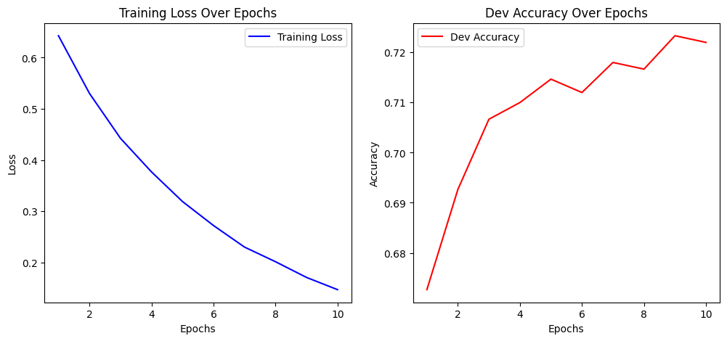

Dev Accuracy: 0.7220

Training CNN model with lr=0.0001, epochs=10, embedding_dim=100, num_filters=100, filter_sizes=[2, 3]

Epoch 1/10, Loss: 0.6638372449363981

Dev Accuracy: 0.6707

Epoch 2/10, Loss: 0.5605604007016601

Dev Accuracy: 0.6953

Epoch 3/10, Loss: 0.5014325337664091

Dev Accuracy: 0.7060

Epoch 4/10, Loss: 0.4526233571557594

Dev Accuracy: 0.7153

Epoch 5/10, Loss: 0.40942647737769894

Dev Accuracy: 0.7173

Epoch 6/10, Loss: 0.3740085865164833

Dev Accuracy: 0.7227

Epoch 7/10, Loss: 0.3452057467126599

Dev Accuracy: 0.7253

Epoch 8/10, Loss: 0.3216566662385303

Dev Accuracy: 0.7280

Epoch 9/10, Loss: 0.28748370448055566

Dev Accuracy: 0.7327

Epoch 10/10, Loss: 0.259541710176187

Dev Accuracy: 0.7313

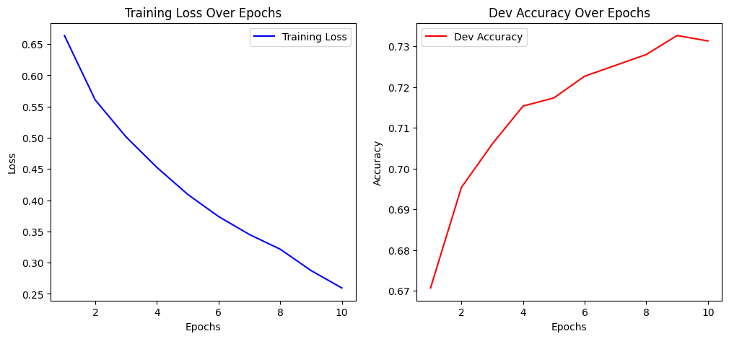

Dev Accuracy: 0.7313

Training CNN model with lr=0.0001, epochs=20, embedding_dim=50, num_filters=50, filter_sizes=[3, 4, 5]

Epoch 1/20, Loss: 0.6797875844474349

Dev Accuracy: 0.6673

Epoch 2/20, Loss: 0.6091902553396565

Dev Accuracy: 0.6800

Epoch 3/20, Loss: 0.5554025498636599

Dev Accuracy: 0.6853

Epoch 4/20, Loss: 0.5137166361615195

Dev Accuracy: 0.6953

Epoch 5/20, Loss: 0.4737639197527148

Dev Accuracy: 0.7000

Epoch 6/20, Loss: 0.43752236333816213

Dev Accuracy: 0.7020

Epoch 7/20, Loss: 0.4143310481090614

Dev Accuracy: 0.7113

Epoch 8/20, Loss: 0.3909212984658911

Dev Accuracy: 0.7133

Epoch 9/20, Loss: 0.3598471919065009

Dev Accuracy: 0.7180

Epoch 10/20, Loss: 0.3361628908029202

Dev Accuracy: 0.7247

Epoch 11/20, Loss: 0.30998860059297656

Dev Accuracy: 0.7280

Epoch 12/20, Loss: 0.3067161134597407

Dev Accuracy: 0.7213

Epoch 13/20, Loss: 0.2864367133683462

Dev Accuracy: 0.7313

Epoch 14/20, Loss: 0.2628221934634307

Dev Accuracy: 0.7233

Epoch 15/20, Loss: 0.2504837056177548

Dev Accuracy: 0.7327

Epoch 16/20, Loss: 0.24104348127423328

Dev Accuracy: 0.7360

Epoch 17/20, Loss: 0.22335477050436825

Dev Accuracy: 0.7413

Epoch 18/20, Loss: 0.20590816260006792

Dev Accuracy: 0.7380

Epoch 19/20, Loss: 0.1999660232245062

Dev Accuracy: 0.7380

Epoch 20/20, Loss: 0.18498171326269927

Dev Accuracy: 0.7413

Dev Accuracy: 0.7413

Training CNN model with lr=0.0001, epochs=20, embedding_dim=50, num_filters=50, filter_sizes=[2, 3]

Epoch 1/20, Loss: 0.6895681244837386

Dev Accuracy: 0.6453

Epoch 2/20, Loss: 0.6356151339214827

Dev Accuracy: 0.6953

Epoch 3/20, Loss: 0.5863705986051687

Dev Accuracy: 0.7020

Epoch 4/20, Loss: 0.5601118349758908

Dev Accuracy: 0.7067

Epoch 5/20, Loss: 0.5253396485866314

Dev Accuracy: 0.7193

Epoch 6/20, Loss: 0.5056536191095864

Dev Accuracy: 0.7173

Epoch 7/20, Loss: 0.4831367306871772

Dev Accuracy: 0.7207

Epoch 8/20, Loss: 0.4637207020429612

Dev Accuracy: 0.7227

Epoch 9/20, Loss: 0.4443614455231998

Dev Accuracy: 0.7273

Epoch 10/20, Loss: 0.42798630111961183

Dev Accuracy: 0.7313

Epoch 11/20, Loss: 0.41030955843173433

Dev Accuracy: 0.7360

Epoch 12/20, Loss: 0.39479722537157275

Dev Accuracy: 0.7313

Epoch 13/20, Loss: 0.37758611605781023

Dev Accuracy: 0.7333

Epoch 14/20, Loss: 0.36487326573260986

Dev Accuracy: 0.7393

Epoch 15/20, Loss: 0.3507622551233799

Dev Accuracy: 0.7433

Epoch 16/20, Loss: 0.34155266438698995

Dev Accuracy: 0.7440

Epoch 17/20, Loss: 0.3294006324611416

Dev Accuracy: 0.7473

Epoch 18/20, Loss: 0.32232432276977463

Dev Accuracy: 0.7500

Epoch 19/20, Loss: 0.3106043270434615

Dev Accuracy: 0.7473

Epoch 20/20, Loss: 0.29834767191973893

Dev Accuracy: 0.7453

Dev Accuracy: 0.7453

Training CNN model with lr=0.0001, epochs=20, embedding_dim=50, num_filters=100, filter_sizes=[3, 4, 5]

Epoch 1/20, Loss: 0.6735779573635331

Dev Accuracy: 0.6500

Epoch 2/20, Loss: 0.5866261257167373

Dev Accuracy: 0.6740

Epoch 3/20, Loss: 0.5289989222712549

Dev Accuracy: 0.6927

Epoch 4/20, Loss: 0.47742543677383636

Dev Accuracy: 0.7027

Epoch 5/20, Loss: 0.43162037980725704

Dev Accuracy: 0.7020

Epoch 6/20, Loss: 0.3946628040879732

Dev Accuracy: 0.7153

Epoch 7/20, Loss: 0.36307152412668803

Dev Accuracy: 0.7160

Epoch 8/20, Loss: 0.3260209688612626

Dev Accuracy: 0.7287

Epoch 9/20, Loss: 0.3047435738273424

Dev Accuracy: 0.7193

Epoch 10/20, Loss: 0.2734337724004633

Dev Accuracy: 0.7180

Epoch 11/20, Loss: 0.2588246358348729

Dev Accuracy: 0.7313

Epoch 12/20, Loss: 0.2402253601043019

Dev Accuracy: 0.7373

Epoch 13/20, Loss: 0.22060551752891278

Dev Accuracy: 0.7333

Epoch 14/20, Loss: 0.20746740881841824

Dev Accuracy: 0.7340

Epoch 15/20, Loss: 0.1852242879680485

Dev Accuracy: 0.7367

Epoch 16/20, Loss: 0.17962133410569245

Dev Accuracy: 0.7393

Epoch 17/20, Loss: 0.1608739478762292

Dev Accuracy: 0.7453

Epoch 18/20, Loss: 0.14970872080538997

Dev Accuracy: 0.7393

Epoch 19/20, Loss: 0.14148025744117082

Dev Accuracy: 0.7347

Epoch 20/20, Loss: 0.13989351392664878

Dev Accuracy: 0.7413

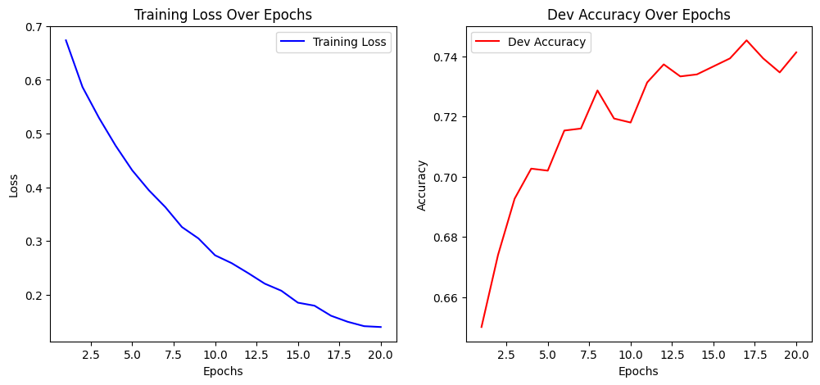

Dev Accuracy: 0.7413

Training CNN model with lr=0.0001, epochs=20, embedding_dim=50, num_filters=100, filter_sizes=[2, 3]

Epoch 1/20, Loss: 0.6830554144659212

Dev Accuracy: 0.6507

Epoch 2/20, Loss: 0.6154527541292565

Dev Accuracy: 0.6913

Epoch 3/20, Loss: 0.5676181516775063

Dev Accuracy: 0.7047

Epoch 4/20, Loss: 0.5300268974872306

Dev Accuracy: 0.7180

Epoch 5/20, Loss: 0.49134645434488944

Dev Accuracy: 0.7327

Epoch 6/20, Loss: 0.46898309030249113

Dev Accuracy: 0.7340

Epoch 7/20, Loss: 0.4386337489746844

Dev Accuracy: 0.7367

Epoch 8/20, Loss: 0.42548438136458366

Dev Accuracy: 0.7447

Epoch 9/20, Loss: 0.39271013107495883

Dev Accuracy: 0.7413

Epoch 10/20, Loss: 0.37124020355379306

Dev Accuracy: 0.7427

Epoch 11/20, Loss: 0.3495223884603989

Dev Accuracy: 0.7413

Epoch 12/20, Loss: 0.3429434134026398

Dev Accuracy: 0.7527

Epoch 13/20, Loss: 0.32202805313533905

Dev Accuracy: 0.7500

Epoch 14/20, Loss: 0.3084451044970252

Dev Accuracy: 0.7560

Epoch 15/20, Loss: 0.2843076509150058

Dev Accuracy: 0.7520

Epoch 16/20, Loss: 0.2802554738400122

Dev Accuracy: 0.7533

Epoch 17/20, Loss: 0.26618644870947694

Dev Accuracy: 0.7593

Epoch 18/20, Loss: 0.25246391086690806

Dev Accuracy: 0.7527

Epoch 19/20, Loss: 0.24536966114026645

Dev Accuracy: 0.7493

Epoch 20/20, Loss: 0.23113192577375832

Dev Accuracy: 0.7520

Dev Accuracy: 0.7520

Training CNN model with lr=0.0001, epochs=20, embedding_dim=100, num_filters=50, filter_sizes=[3, 4, 5]

Epoch 1/20, Loss: 0.6493492623727236

Dev Accuracy: 0.6867

Epoch 2/20, Loss: 0.5530104962073799

Dev Accuracy: 0.7087

Epoch 3/20, Loss: 0.4776627728538255

Dev Accuracy: 0.7253

Epoch 4/20, Loss: 0.4229203277133056

Dev Accuracy: 0.7347

Epoch 5/20, Loss: 0.37890824543261886

Dev Accuracy: 0.7353

Epoch 6/20, Loss: 0.3426067954007423

Dev Accuracy: 0.7353

Epoch 7/20, Loss: 0.3040126416435768

Dev Accuracy: 0.7367

Epoch 8/20, Loss: 0.26941335210704037

Dev Accuracy: 0.7273

Epoch 9/20, Loss: 0.24166665324390255

Dev Accuracy: 0.7413

Epoch 10/20, Loss: 0.21723275789766594

Dev Accuracy: 0.7473

Epoch 11/20, Loss: 0.20226164656240378

Dev Accuracy: 0.7387

Epoch 12/20, Loss: 0.1865352585228025

Dev Accuracy: 0.7413

Epoch 13/20, Loss: 0.15911748943303666

Dev Accuracy: 0.7467

Epoch 14/20, Loss: 0.15141230080691562

Dev Accuracy: 0.7447

Epoch 15/20, Loss: 0.1389255234205432

Dev Accuracy: 0.7453

Epoch 16/20, Loss: 0.12151241409100241

Dev Accuracy: 0.7467

Epoch 17/20, Loss: 0.11643459681727227

Dev Accuracy: 0.7473

Epoch 18/20, Loss: 0.10604985881410406

Dev Accuracy: 0.7433

Epoch 19/20, Loss: 0.10288497919121664

Dev Accuracy: 0.7487

Epoch 20/20, Loss: 0.08970707792798889

Dev Accuracy: 0.7540

Dev Accuracy: 0.7540

Training CNN model with lr=0.0001, epochs=20, embedding_dim=100, num_filters=50, filter_sizes=[2, 3]

Epoch 1/20, Loss: 0.6708808346731322

Dev Accuracy: 0.6633

Epoch 2/20, Loss: 0.5857645122439468

Dev Accuracy: 0.6960

Epoch 3/20, Loss: 0.5302043079180709

Dev Accuracy: 0.7100

Epoch 4/20, Loss: 0.4887938875278757

Dev Accuracy: 0.7187

Epoch 5/20, Loss: 0.45048462771018966

Dev Accuracy: 0.7240

Epoch 6/20, Loss: 0.4171263972527647

Dev Accuracy: 0.7273

Epoch 7/20, Loss: 0.391744252515936

Dev Accuracy: 0.7227

Epoch 8/20, Loss: 0.3627093340206588

Dev Accuracy: 0.7340

Epoch 9/20, Loss: 0.3380767431506764

Dev Accuracy: 0.7327

Epoch 10/20, Loss: 0.32333821011984054

Dev Accuracy: 0.7387

Epoch 11/20, Loss: 0.30320901655315147

Dev Accuracy: 0.7387

Epoch 12/20, Loss: 0.28501546641034775

Dev Accuracy: 0.7353

Epoch 13/20, Loss: 0.2681239741835144

Dev Accuracy: 0.7327

Epoch 14/20, Loss: 0.24782493103799583

Dev Accuracy: 0.7380

Epoch 15/20, Loss: 0.23801197407179184

Dev Accuracy: 0.7373

Epoch 16/20, Loss: 0.23284263195600874

Dev Accuracy: 0.7393

Epoch 17/20, Loss: 0.20928907591966378

Dev Accuracy: 0.7420

Epoch 18/20, Loss: 0.20026902090351678

Dev Accuracy: 0.7393

Epoch 19/20, Loss: 0.1943875373454585

Dev Accuracy: 0.7420

Epoch 20/20, Loss: 0.1778462633073183

Dev Accuracy: 0.7500

Dev Accuracy: 0.7500

Training CNN model with lr=0.0001, epochs=20, embedding_dim=100, num_filters=100, filter_sizes=[3, 4, 5]

Epoch 1/20, Loss: 0.6469740897523505

Dev Accuracy: 0.6787

Epoch 2/20, Loss: 0.5273731756483404

Dev Accuracy: 0.7067

Epoch 3/20, Loss: 0.44082682424402864

Dev Accuracy: 0.7120

Epoch 4/20, Loss: 0.36825425071869644

Dev Accuracy: 0.7153

Epoch 5/20, Loss: 0.31180723865306936

Dev Accuracy: 0.7240

Epoch 6/20, Loss: 0.2642513757204511

Dev Accuracy: 0.7307

Epoch 7/20, Loss: 0.2272935859947928

Dev Accuracy: 0.7260

Epoch 8/20, Loss: 0.19706139079640608

Dev Accuracy: 0.7293

Epoch 9/20, Loss: 0.16256808487450708

Dev Accuracy: 0.7307

Epoch 10/20, Loss: 0.14667386218999354

Dev Accuracy: 0.7340

Epoch 11/20, Loss: 0.12915166695192123

Dev Accuracy: 0.7393

Epoch 12/20, Loss: 0.11185343145743523

Dev Accuracy: 0.7340

Epoch 13/20, Loss: 0.09682097426117231

Dev Accuracy: 0.7387

Epoch 14/20, Loss: 0.08988232157061637

Dev Accuracy: 0.7460

Epoch 15/20, Loss: 0.08387701520348838

Dev Accuracy: 0.7420

Epoch 16/20, Loss: 0.07170707048532994

Dev Accuracy: 0.7300

Epoch 17/20, Loss: 0.06574669533017496

Dev Accuracy: 0.7373

Epoch 18/20, Loss: 0.06319218652359913

Dev Accuracy: 0.7413

Epoch 19/20, Loss: 0.05408396807770019

Dev Accuracy: 0.7493

Epoch 20/20, Loss: 0.04814137391943551

Dev Accuracy: 0.7440

Dev Accuracy: 0.7440

Training CNN model with lr=0.0001, epochs=20, embedding_dim=100, num_filters=100, filter_sizes=[2, 3]

Epoch 1/20, Loss: 0.6590565400400332

Dev Accuracy: 0.6960

Epoch 2/20, Loss: 0.5538716692822054

Dev Accuracy: 0.7260

Epoch 3/20, Loss: 0.49435489453335424

Dev Accuracy: 0.7287

Epoch 4/20, Loss: 0.45271043077226

Dev Accuracy: 0.7353

Epoch 5/20, Loss: 0.4025686909646112

Dev Accuracy: 0.7407

Epoch 6/20, Loss: 0.3688601181793368

Dev Accuracy: 0.7413

Epoch 7/20, Loss: 0.33750339100242543

Dev Accuracy: 0.7427

Epoch 8/20, Loss: 0.30693446670499336

Dev Accuracy: 0.7467

Epoch 9/20, Loss: 0.2872471712338593

Dev Accuracy: 0.7480

Epoch 10/20, Loss: 0.2632581263788709

Dev Accuracy: 0.7527

Epoch 11/20, Loss: 0.2390130247310411

Dev Accuracy: 0.7453

Epoch 12/20, Loss: 0.2229817354882051

Dev Accuracy: 0.7453

Epoch 13/20, Loss: 0.19885792470123245

Dev Accuracy: 0.7500

Epoch 14/20, Loss: 0.19103925514777487

Dev Accuracy: 0.7500

Epoch 15/20, Loss: 0.17118726535426684

Dev Accuracy: 0.7560

Epoch 16/20, Loss: 0.15873659785738897

Dev Accuracy: 0.7540

Epoch 17/20, Loss: 0.14590883227140794

Dev Accuracy: 0.7573

Epoch 18/20, Loss: 0.1368312350946827

Dev Accuracy: 0.7600

Epoch 19/20, Loss: 0.14318407343111977

Dev Accuracy: 0.7560

Epoch 20/20, Loss: 0.13112827514638953

Dev Accuracy: 0.7560

Dev Accuracy: 0.7560