

GEBZE TEKNİK ÜNİVERSİTESİ

ELECTRONICAL ENGINEERING

MAT214 NUMERICAL METHODS

2020 – 2021 FALL

PROJECT 2

Student’s

Number :1901022255

Name - Surname :Emirhan Köse

ABSTRACT

In this Project there were 4 current-time text files. Time and currents values have read from the files and used in the Project fort he find of RL circuits voltage. First current1.dat has read and time,current values applied the forward difference, backward difference and three point formula.
After, same steps has applied fort he other time -current datas and graphics have made. Converges analysis have made about the all of datas and some comments have made about the results.

INTRODUCTION

In this Project the problem is find the RL circuits voltage approximately. While the voltages finding forward difference method, backward difference method and threepoint formula have applied separately. Fort he converges of the voltages norm method has used. While making plots loglog and plot methods have used.

READING THE FILES.
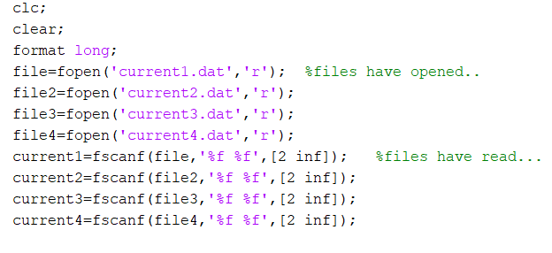
FORWARD DIFFERENCE
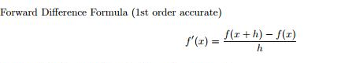
Formula used in forward difference method.

How to used in code.
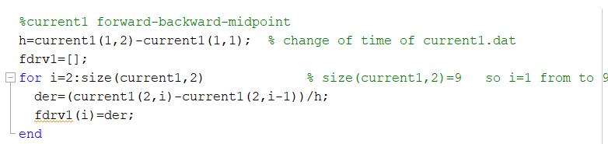
BACKWARD DIFFERENCE
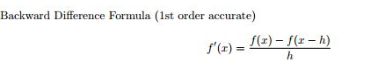
Formula used in backward difference

How to used in code.
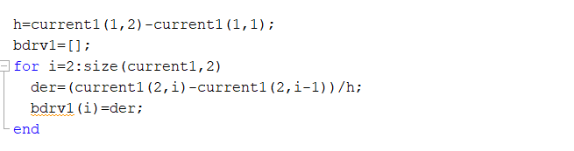

FIRST POINT FORMULA-END POINT FORMULA
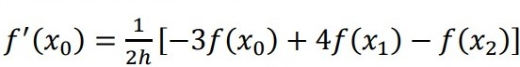
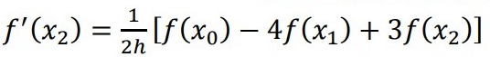

Formula used in first point formula.

How to used in code.

MIDPOINT FORMULA
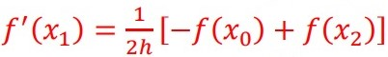

Formula used in midpoint .

How to used in code.

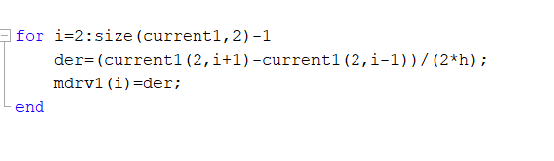

FINDING VOLTAGE
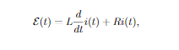

Formula used in finding voltage
How to used in code.

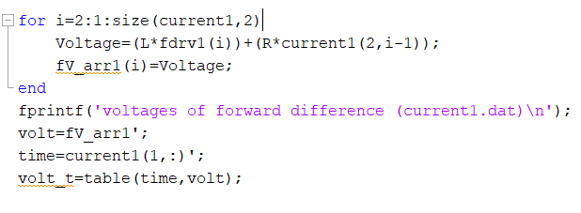
MAKING PLOT

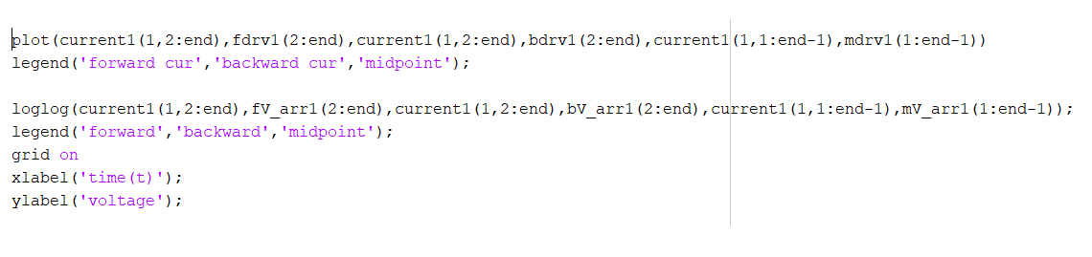

PLOTS FOR DATA-1
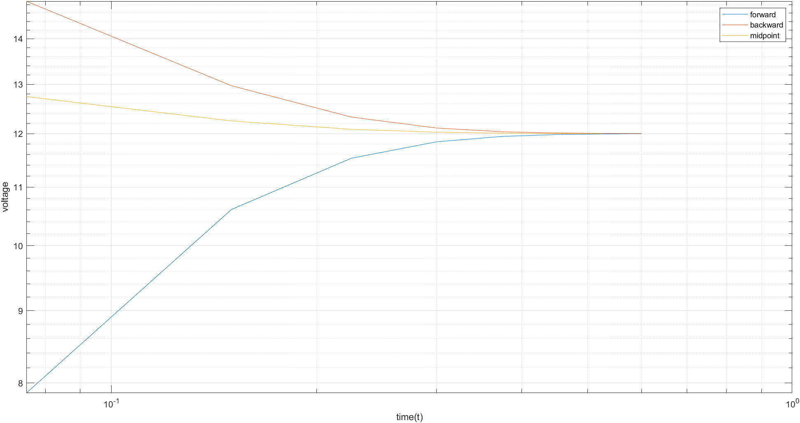
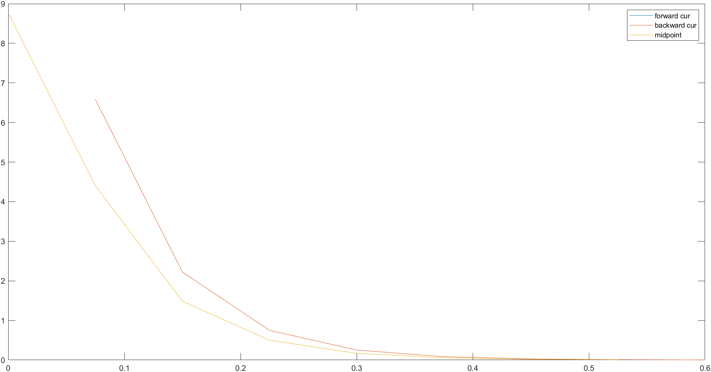

PLOTS FOR DATA-2
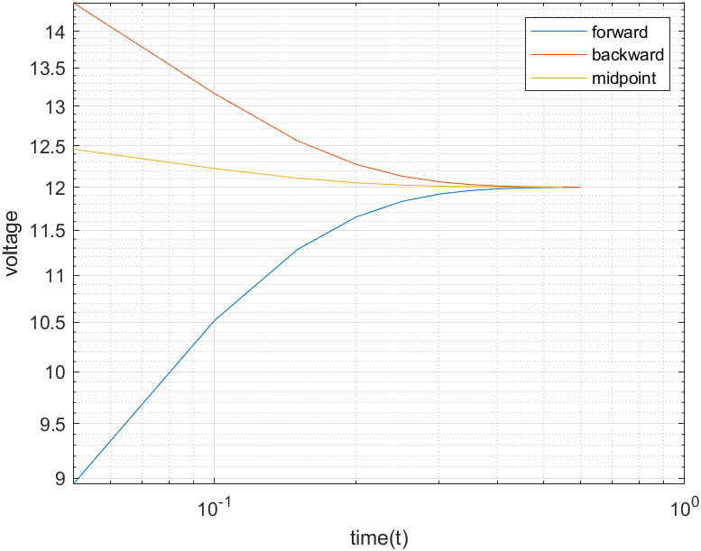
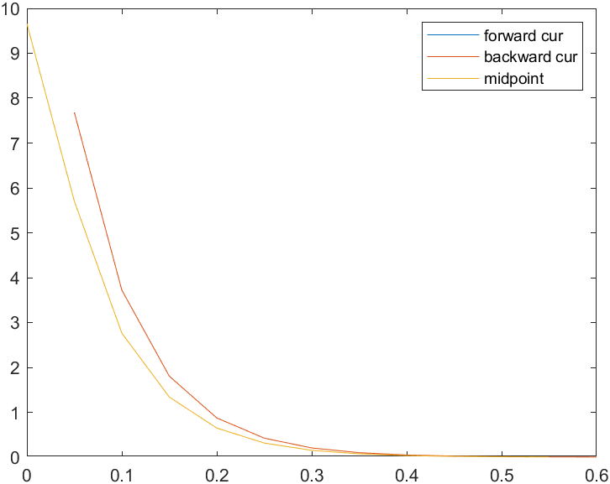
PLOTS FOR DATA-3
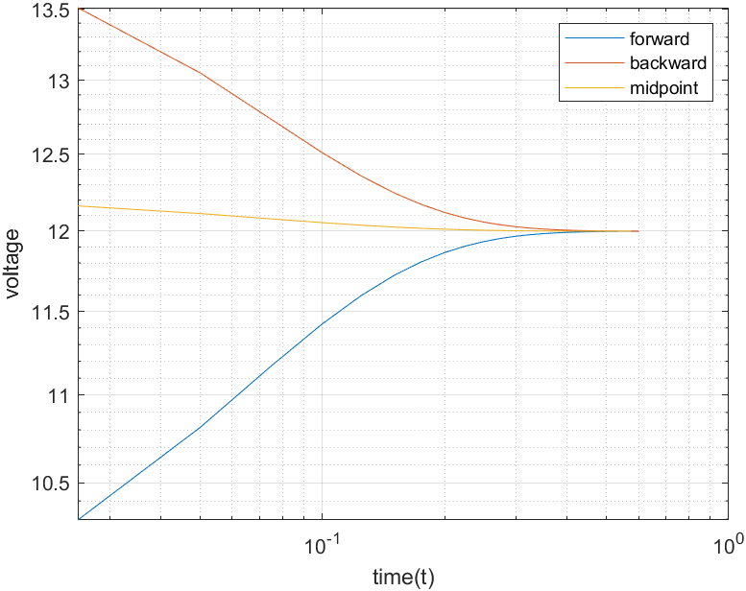
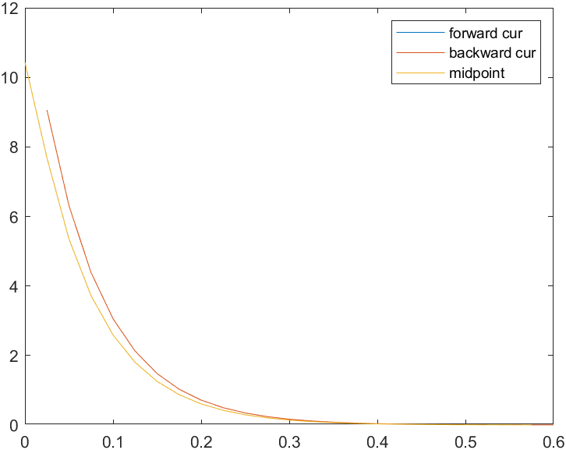
PLOTS FOR DATA-4
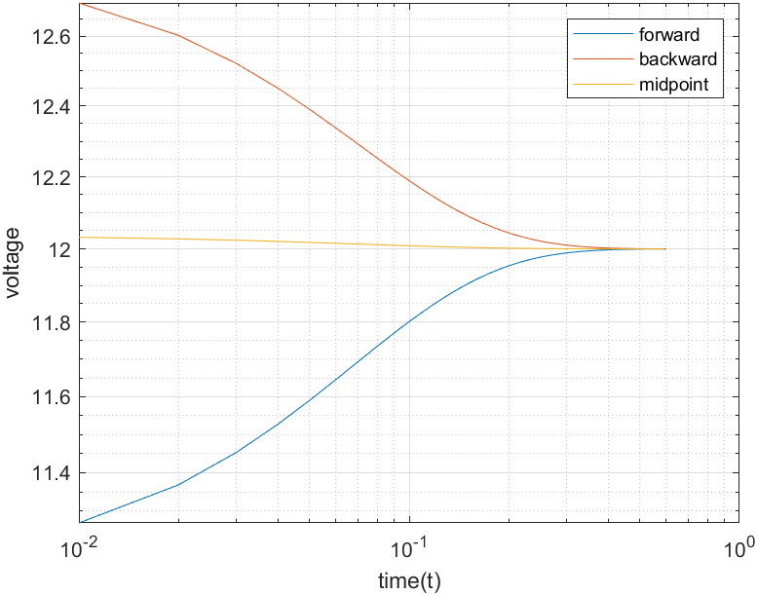
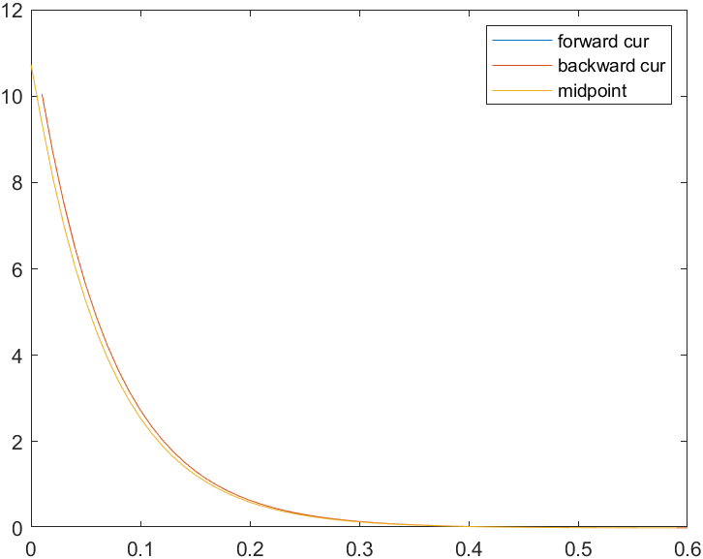
ERRORS:
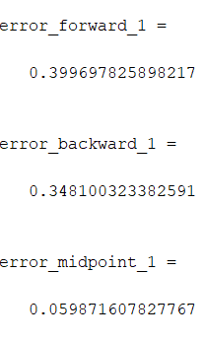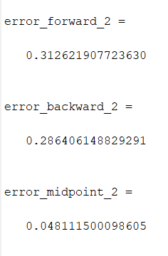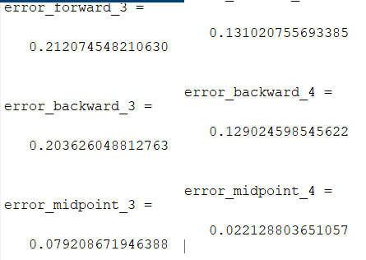

RESULTS:
- As you can see on the error part the most accurate method is mid point formula second accurate method is backward difference formula the last accurate method is forward difference formula.

- As you can see the on the error part the change of time of currents are decreasing file by file(current4.dat’s h< current3.dat’s h< current2.dat’s h< current1.dat’s h). So if you decrease the change of time of currents it gives you more accurate voltage values.

- As you can see on the plot part the derivative of currents are approximately same each other if you compare methods for derivatives forward and backward methods have the same derivative values. Midpoint method isa little bit different from them.If you compare them by file type. Current1.dat’s derivative currents plot is not so much smooth because count of Δt is less than other dat files. If you increase the count of Δt the derivative current plot is more smooth.

- As you can see on the plot part the current1.dat’s voltage plot is starting from so much far from the actual voltage but current2.dat’s voltage is more closer than current1.dat. The current4.dat’s initial voltage value is the closest value of the actual voltage value in every method.

Can you observe the expected convergence rates?
- Yes you can observe the converges by looking plots and voltages values.

If the endpoint formula is not used, how is the accuracy affected?

- I tried it in my code but ıt didn’t affect voltage value.

CODE:
