\*please make sure opencv is installed before running it!

if not, open the cmd to install it and paste the following: pip install opencv-python

\*\*

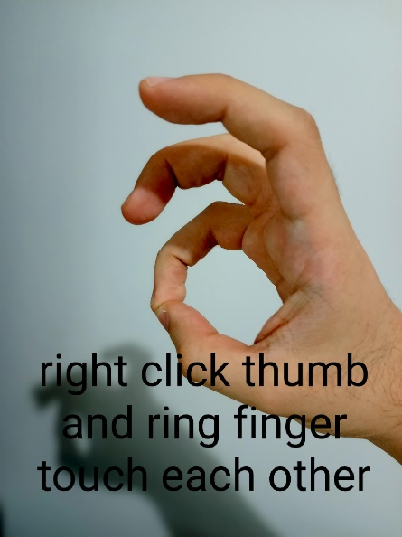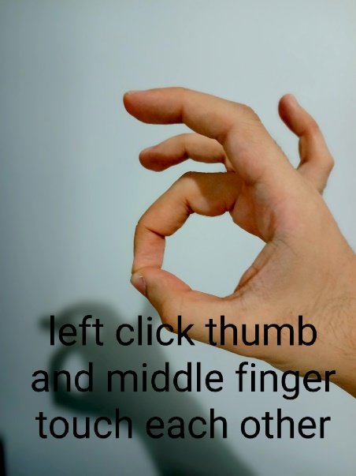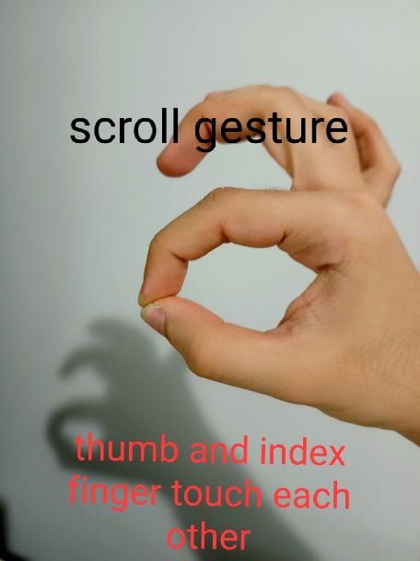

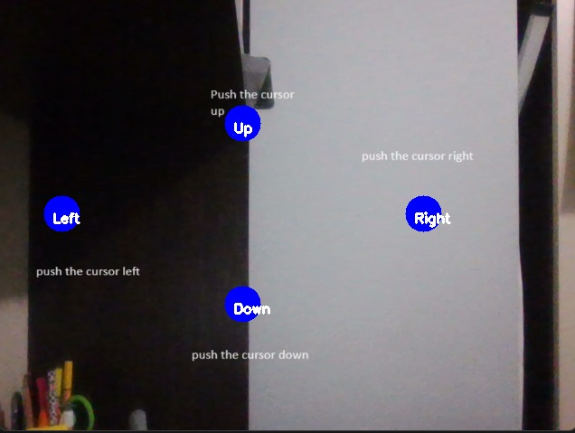

\*\*\* This program is still in beta state. Many functions are not stable.

\*\*\*\* If you would like to help develop it, you can make a request. I would love to develop together and learn innovations.