

CMSE318

**Principles of Programming Languages**

**LAB TASK 2**

**“Lexical Analyzer Application”**

**Team Members**

**Kadir Kaan Sert 19000096**

**Emir Sinan İşler 19000088**

**OUTLINE**

1. Problem Definition……………………………………………………………..…

2. Teamwork Distribution………………………………………………………...…

3. Menu for Lexical Analyzer…………………………………………………….…

4. Call Lex()…………………………………………………………………………

5. Show Symbol Table………………………………………………………………

6. Exit………………………………………………………………………………..

7. Error Message…………………………………………………………………….

8. Pyhton Codes……………………………………………………………………..

**PROBLEM DEFINITION**

This report will be about a Python program that lexical analyzer recognizes integers, floating point numbers, identifiers, keywords “if”, “for” and “while”, as well as relational operators “ < ”, “ <= ”, “ > ”, “ >= ” and “ == ”.

In this program, the user will be able to call lexical analyzer, show symbol table and exit from menu.

This report will include screenshots about program.

**TEAMWORK DESCRIPTION**

Teamwork distribution will be discussed by using several subtitles: (1) Meetings and (2) Work Distribution.

1. **Meetings:** The meetings arranged before and after each member made a change in the code**.** We met in Famagusta to solve our assignment.
2. **Work Distribution:**
3. We split each task to finish faster and efficiency way.

**Menu for Lexical Analyzer**

The user shall be able to (1) Call Lex (), (2) Show Symbol Table, (3) Exit.

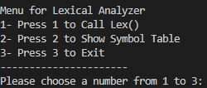

The console shall ask the user to enter a number 1 to 3.

**1 - Call Lex**

If user enters “1”, console shall ask the user to enter something to analyze it. 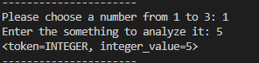 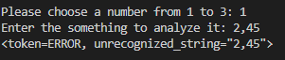

When user enters an input, the comsole shall display the user input in terms of token.

**2 – Show Symbol Table**

If the user enters ”2”, the console shall read input from .txt file and display symbol table.

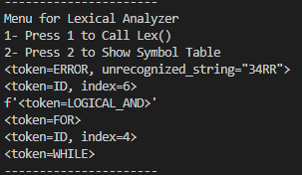

**3 – Exit**

If the user enters ”3”, the console shall exit from menu.

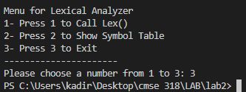

**Error Message**

If the user enters other than “1”, “2,” or “3”, console shall give “This is not valid number. Please select from 1 to 3!” error message.

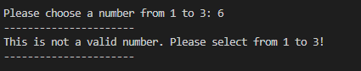

**Python Codes**

**1 – Menu Parts**

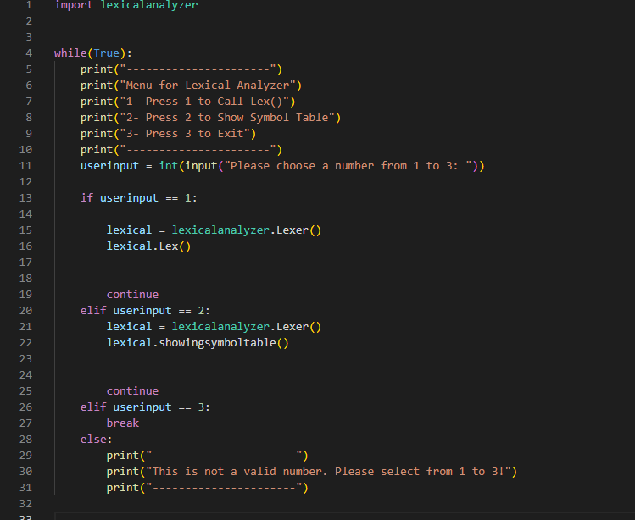

**2 – Lexicalanalyzer**

