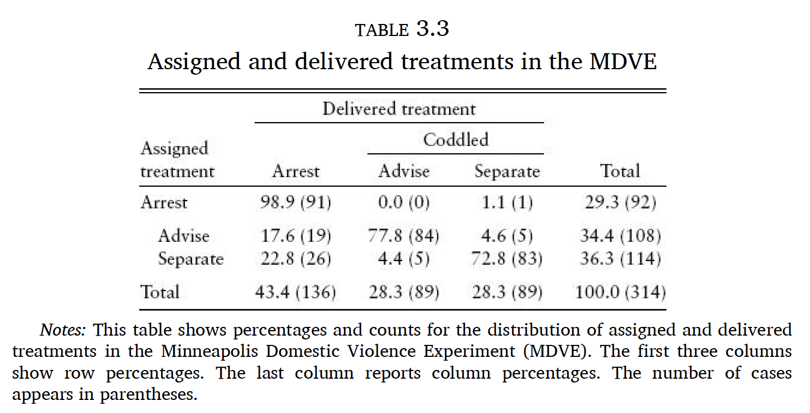

Let Zi indicate assignment to coddling, and let Di indicate incidents where coddling was delivered. The first stage for this setup is:

Recidivism was greater among suspects assigned to be coddled than among those assigned to be arrested. We learn this by calculating the effect of random assignment to coddling on an outcome variable, Yi, that indicates at least one post-treatment episode of suspected abuse:

Suppose we analyze the MDVE using information on treatment delivered, ignoring the nonrandom nature of decisions to comply with random assignment. The resulting analysis compares recidivism among those who were and were not coddled, with no further complications or adjustments:

