VERİTABANIYÖNETİM SİSTEMLERİ ÇETİN ERÇELİK

SQL : LİMİT

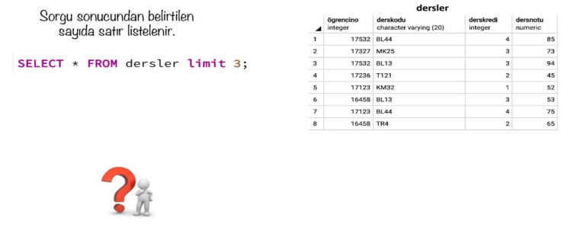

SQL : LİMİT

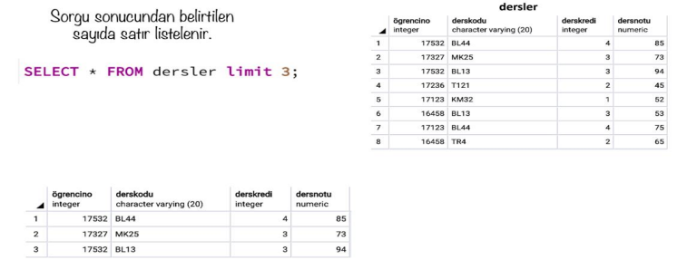

SQL : LİMİT - OFFSET

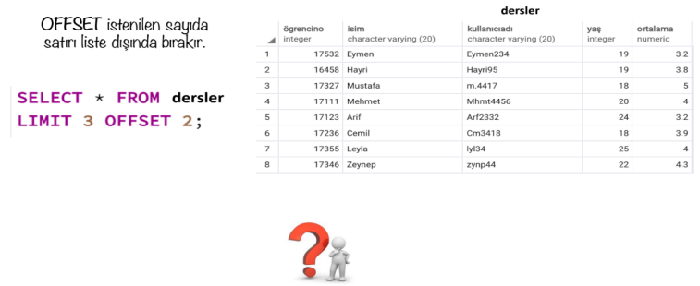

SQL : LİMİT - OFFSET

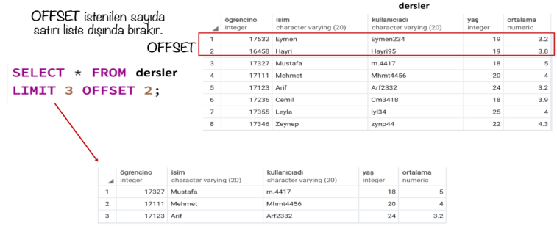

SQL : BETWEEN

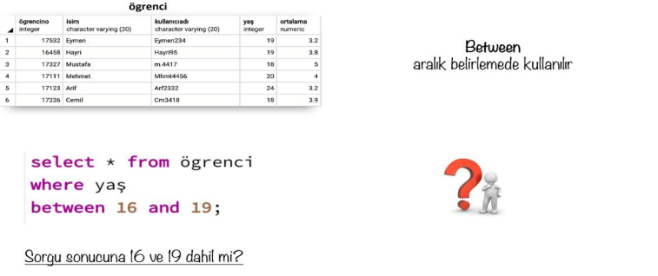

SQL : BETWEEN

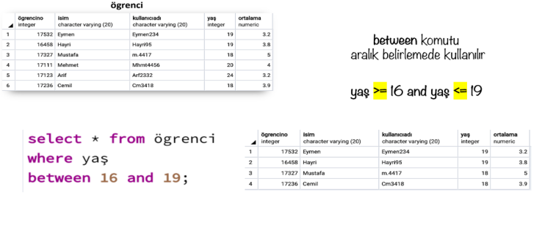

SQL : IN

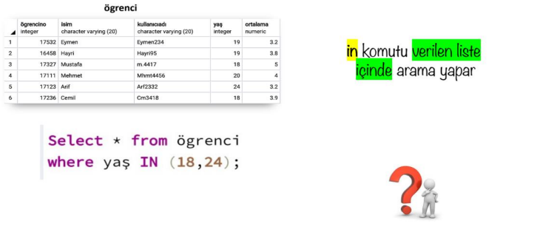

SQL : IN

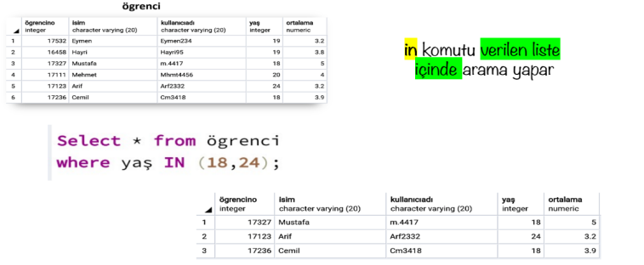

SQL : FETCH

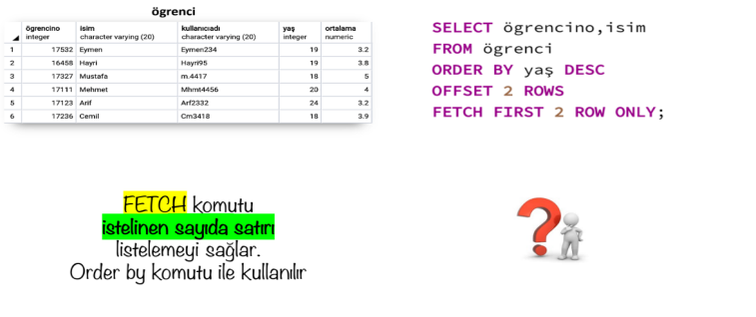

SQL : FETCH

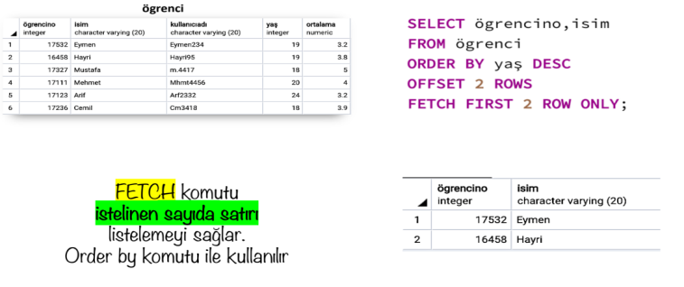

SQL : GROUP BY

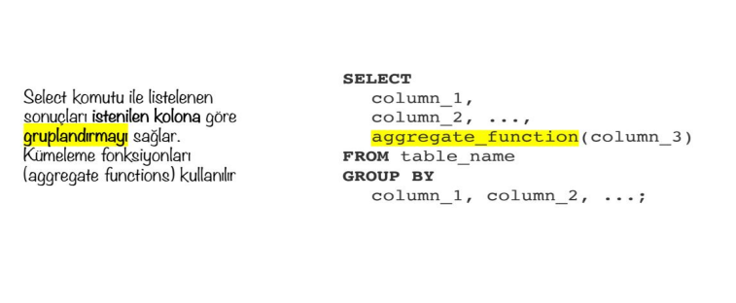

SQL : GROUP BY

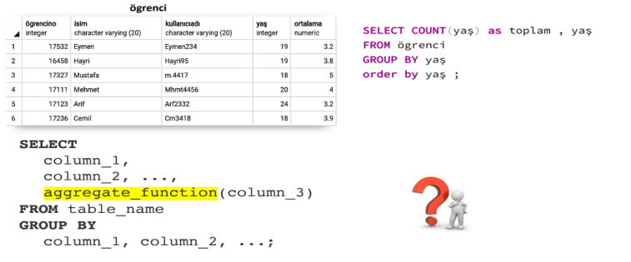

SQL : GROUP BY

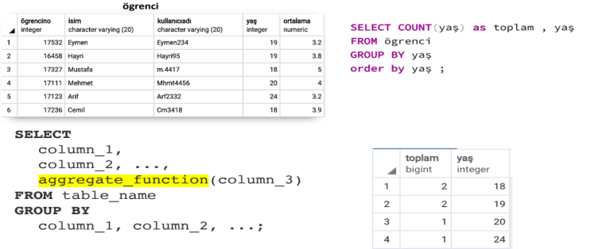

SQL : GROUP BY

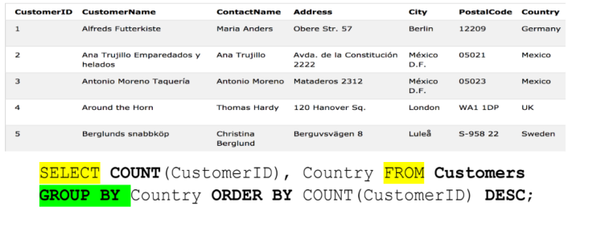

SQL : GROUP BY

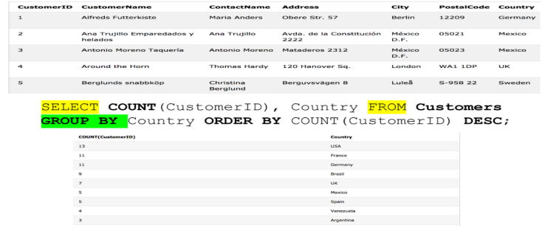

GROUP BY- HAVING - IŞLEM ÖNCELIĞI



GROUP BY- HAVING



GROUP BY- HAVING



GROUP BY- HAVING



GROUP BY- HAVING



GROUP BY- HAVING



GROUP BY- HAVING



GROUP BY- HAVING



KISITLAMALAR (CONSTRAİNTS)



KISITLAMALAR (CONSTRAİNTS)

