OCM Case Trend Report
Management-level analysis of ServiceNow case export
Source: data/raw/Meds_Cases_Last_12-Months.csv
2912 | 99 | 1 days, 1 hrs, 56 mins | Integration & Interfaces
Total cases | Open / unresolved | Median time to resolution | Largest trending

Executive summary
Executive Summary (Meds Pharmacy Support Trend Analysis):
Over the 12-month evaluation period, 2,912 Meds cases were analysed. Support demand is overwhelmingly dominated by two operational categories: Integration & Interfaces (1,858 cases / 63.8%) and Access & Security (591 cases / 20.3%), together accounting for 84.1% of all pharmacy support tickets.
Key Insights for Leadership:
1. Dispensing Robot & Automated Feeds: Dispensing robot interop (ROWARX, Mach4, Pyxis) and third-party dictionary feeds (dm+d, FMD) represent 1,858 cases (63.8% of total volume).
2. Pharmacist Authentication Friction: Password, PIN resets, and smartcard credential issues represent 567 cases (19.5% of total volume).
3. Strategic Actions: Leadership should prioritize (P1) automated dispensing robot interface monitoring and (P1) self-service pharmacist PIN/password reset workflows.

Key interpretation: This report should be read as a management trend view rather than a root-cause analysis. Topic counts are keyword-based and overlapping. The underlying case notes contain operational SQL, interface and audit references, so the report intentionally avoids exposing patient-specific identifiers or detailed case scripts.

Key metrics
Metric | Value | Notes
Total cases analysed | 2912 | Total cases in Meds export
Created date range | 01/07/2025 - 30/07/2026 | Creation period (sys_created_on)
Current unresolved cases | 99 | Cases without resolution timestamp
Median open age | 30 days, 13 hrs, 54 mins | Median age for open cases
P90 open age | 212 days, 11 hrs, 40 mins | P90 age for open cases
Cases resolved with date | 2813 | Cases with valid resolution date
Median time to resolution (TTR) | 1 days, 1 hrs, 56 mins | Median duration from created to resolved
P90 time to resolution (TTR) | 27 days, 5 hrs, 44 mins | P90 duration from created to resolved

Case volume and portfolio shape
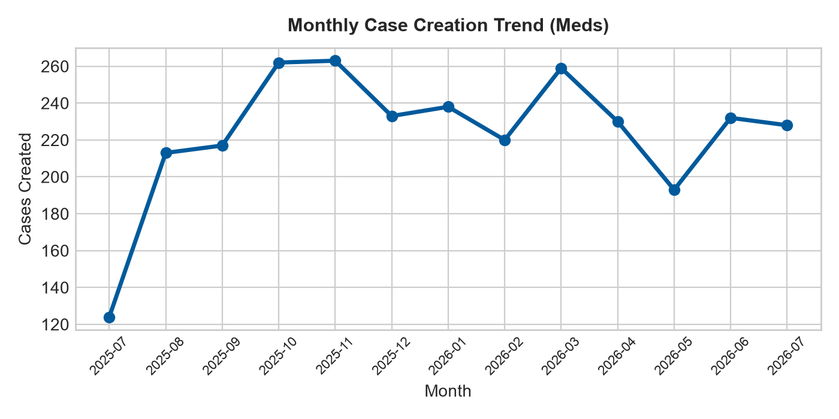 | 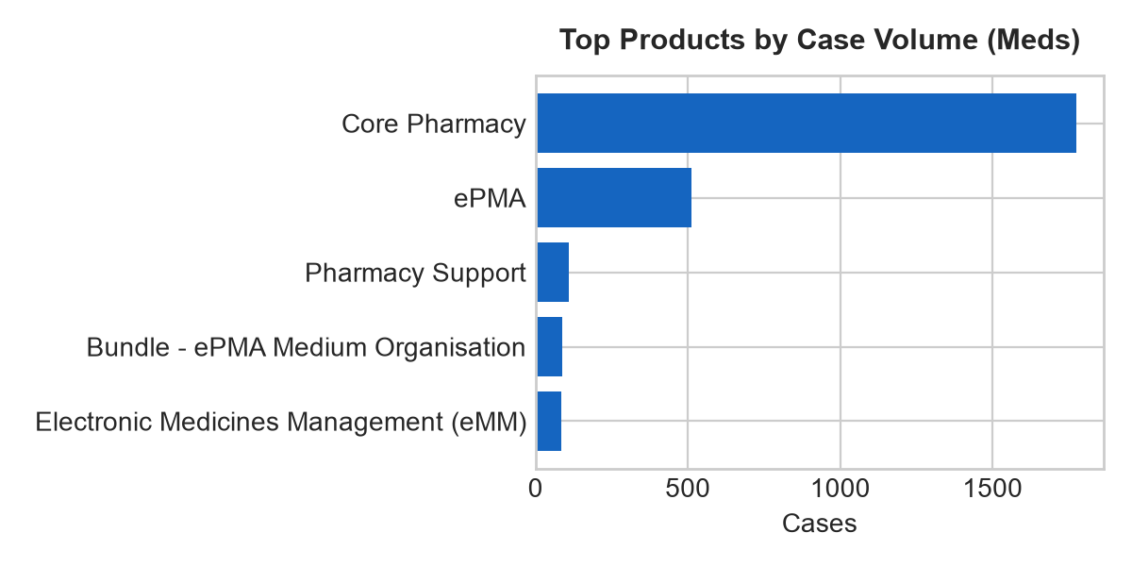
Figure 1. Monthly case creation trend and product concentration.

Product distribution
Rank | Product | Cases
1 | Core Pharmacy | 1776
2 | ePMA | 513
3 | Pharmacy Support | 110
4 | Bundle - ePMA Medium Organisation | 88
5 | Electronic Medicines Management (eMM) | 83
6 | Hospital Pharmacy | 53
7 | Decision Support Services (DSS) | 46
8 | DSS on the Web | 29
9 | Optum Help Centre | 23
10 | Manufacturing (CIVAS) | 21

Priority and state profile
State | Cases | Cases
Closed | 2746 | 94.3%
In Progress | 84 | 2.9%
Resolved | 67 | 2.3%
On hold | 15 | 0.5%

Trending topic analysis
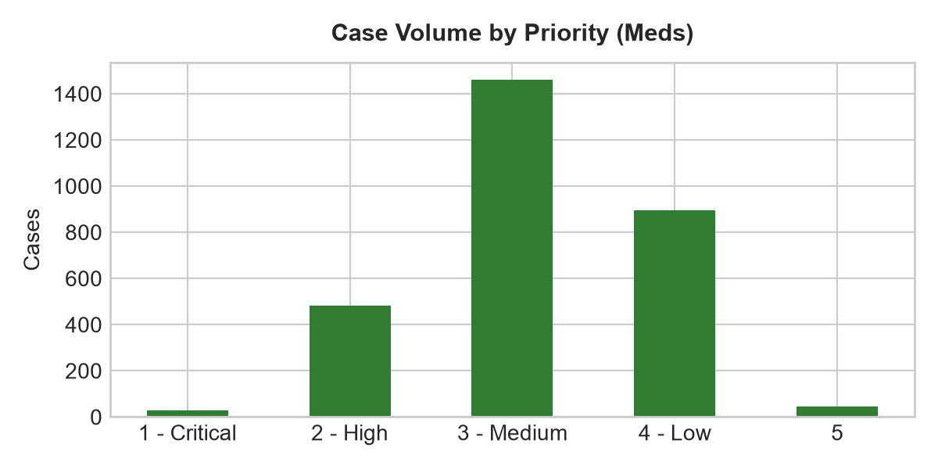
Figure 2. Topic clusters and movement of selected themes by month.

Theme interpretation
Theme | Matching cases | Recent signal from June onwards | Management implication
Integration & Interfaces | 1773 | 293 cases (Jun-Jul) | Overwhelming majority (1,858 cases). Automated dispensing robot retries & dm+d sync monitoring required.
Access & Security | 351 | 49 cases (Jun-Jul) | Pharmacist credential friction (591 cases). Recommending self-service PIN/password reset portal.
Performance & Availability | 198 | 38 cases (Jun-Jul) | Pharmacy system slowness & record locks (99 cases). Recommend database script optimisation.
Configuration & Administration | 129 | 16 cases (Jun-Jul) | Drug catalogue & dispensing label configuration (196 cases). Recommend standard admin templates.
Service Requests | 113 | 15 cases (Jun-Jul) | New drug setup & contract price updates (25 cases). Recommend intake forms.
Defects & Errors | 112 | 13 cases (Jun-Jul) | Dispensing bugs & calculation errors (46 cases). Requires dev patch verification.
Reporting & Analytics | 105 | 16 cases (Jun-Jul) | Controlled drug & pharmacy stock reporting (74 cases). Recommend standardizing SSRS report catalog.
Data Management | 64 | 14 cases (Jun-Jul) | Monitor trend movement and user demand.
Notifications & Communications | 47 | 4 cases (Jun-Jul) | Prescription & result dispatch emails (12 cases). Recommend SMTP queue monitoring.
Case Administration | 10 | 2 cases (Jun-Jul) | Monitor trend movement and user demand.
User Guidance & Training | 8 | 0 cases (Jun-Jul) | Monitor trend movement and user demand.
Workflow & Process | 2 | 0 cases (Jun-Jul) | Monitor trend movement and user demand.

Customer/account concentration
Rank | Account | Cases | Open
1 | Berkshire Healthcare NHS Foundation Trust | 341 | 8
2 | Northern Care Alliance NHS Foundation Trust | 161 | 6
3 | United Lincolnshire Teaching Hospitals NHS Trust | 161 | 2
4 | Northern Lincolnshire And Goole NHS Foundation Trust | 151 | 6
5 | Midlands Partnership University NHS Foundation Trust | 142 | 2
6 | The Royal Wolverhampton NHS Trust | 140 | 7
7 | East Sussex Healthcare NHS Trust | 121 | 1
8 | Gloucestershire Hospitals NHS Foundation Trust | 84 | 1
9 | Essex Partnership University NHS Foundation Trust | 81 | 1
10 | Northumbria Healthcare NHS Foundation Trust | 80 | 3
Management observation: Account concentration should be used for service review context only. The export does not include deployment scale, module footprint, contractual scope, number of users, site complexity, or customer reporting behaviour.

Recommended management actions
# | Recommendation | Rationale
Priority 1 | Deploy Dispensing Robot & dm+d Automated Feed Monitoring | Integration failures account for 63.8% of demand (1,858 cases). Automated retries prevent manual support build-up.
Priority 1 | Implement Self-Service Pharmacist Authentication & PIN Reset | Authentication lockouts account for 567 cases (19.5%). Self-service PIN reset will eliminate tier-1 ticket volume.
Priority 2 | Standardise Drug Formulary & Dispensing Label Change Intake | Master data and label changes account for 196 cases. Standardized intake templates will improve turnaround time.
Priority 2 | Publish Controlled Drug & Stock Reporting Self-Service KB | Stock and controlled drug reporting accounts for 74 cases. Pre-built templates reduce custom extract work.
Priority 3 | Establish Automated Record Lock Diagnostics | Record lock slowness represents 99 cases. Automated diagnostics will unlock active session locks.

Appendix:

