Symphony Case Trend Report
Management-level analysis of ServiceNow case export
Source: Symphony Cases This year.csv | Data range: 02/01/2026 09:48 to 22/07/2026 10:46 | Prepared for Lee Booth
438 | 14 | 2.0 days | Symphony
Total cases | Open / unresolved | Median time to resolution | Largest product stream

Executive summary
Executive summary
The Symphony case export shows a smaller but clinically sensitive support workload compared with the medicines case list, with demand concentrated around Symphony and related DAD/interface activity. The strongest recurring signals are DAD/HL7/interface messaging, audit and information governance requests, clinical workflow questions, data/configuration investigation, and performance or error handling. The management opportunity is to standardise repeat investigation patterns, keep DAD/interface runbooks current, and clearly separate audit/IG requests from operational incident demand.
Key interpretation: This report should be read as a management trend view rather than a root-cause analysis. Topic counts are keyword-based and overlapping. The underlying case notes contain operational SQL, interface and audit references, so the report intentionally avoids exposing patient-specific identifiers or detailed case scripts.

Key metrics
Metric | Value | Notes
Total cases analysed | 438 | All rows in the CSV export.
Created date range | 02/01/2026 09:48 to 22/07/2026 10:46 | Based on sys_created_on.
Current unresolved cases | 14 | Rows with no resolved_at value.
Median open age | 7.0 days | Calculated against 22/07/2026 12:05.
90th percentile open age | 19.9 days | Highlights stale open cases.
Resolved/closed with resolution date | 424 | Rows with resolved_at populated.
Median resolution duration | 2.0 days | Created-to-resolved duration.
90th percentile resolution duration | 14.8 days | Long-tail resolution indicator.

Case volume and portfolio shape
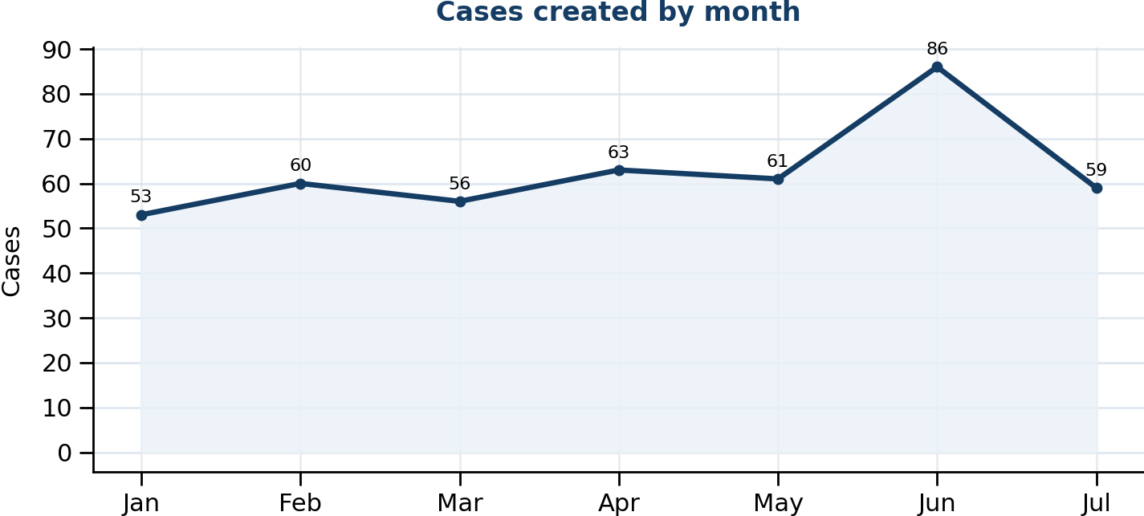 | 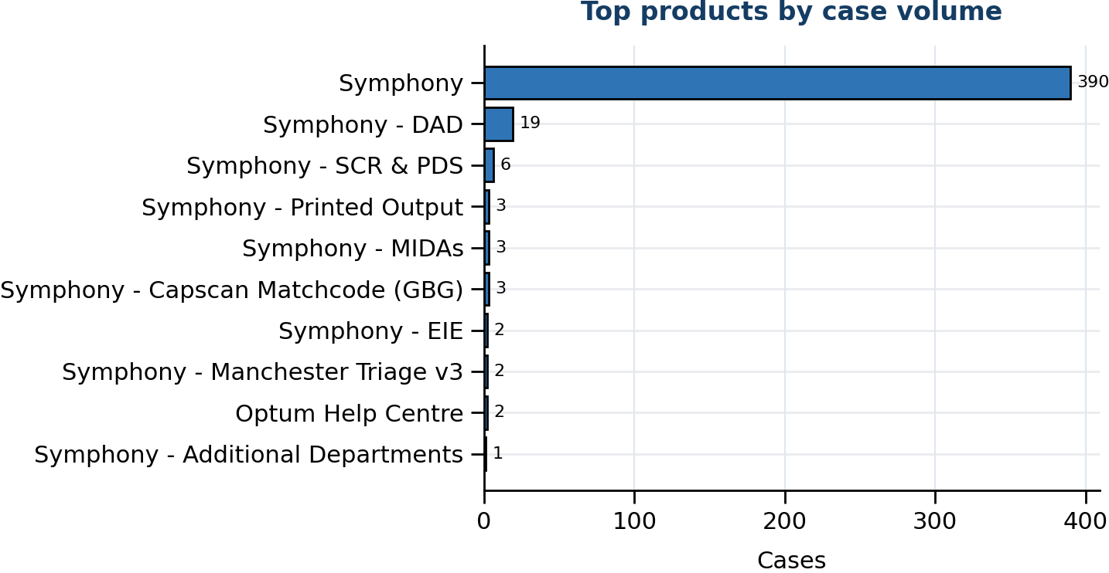
Figure 1. Monthly case creation trend and product concentration.
Management observation: Case demand is concentrated in the core Symphony product stream with related sub-products appearing through DAD, printed output, and Capscan/Matchcode. July is partial-month data and should not be compared with completed months without normalising.

Product distribution
Rank | Product | Cases
1 | Symphony | 390
2 | Symphony - DAD | 19
3 | Symphony - SCR & PDS | 6
4 | Symphony - Printed Output | 3
5 | Symphony - Capscan Matchcode (GBG) | 3
6 | Symphony - MIDAs | 3
7 | Optum Help Centre | 2
8 | Symphony - EIE | 2
9 | Symphony - Manchester Triage v3 | 2
10 | Symphony - Additional Departments | 1

Priority and state profile
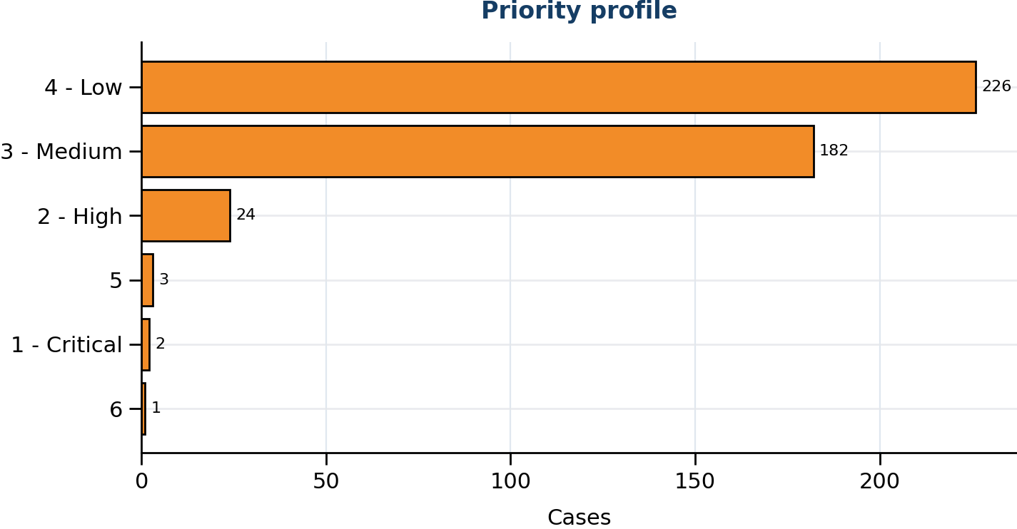 | 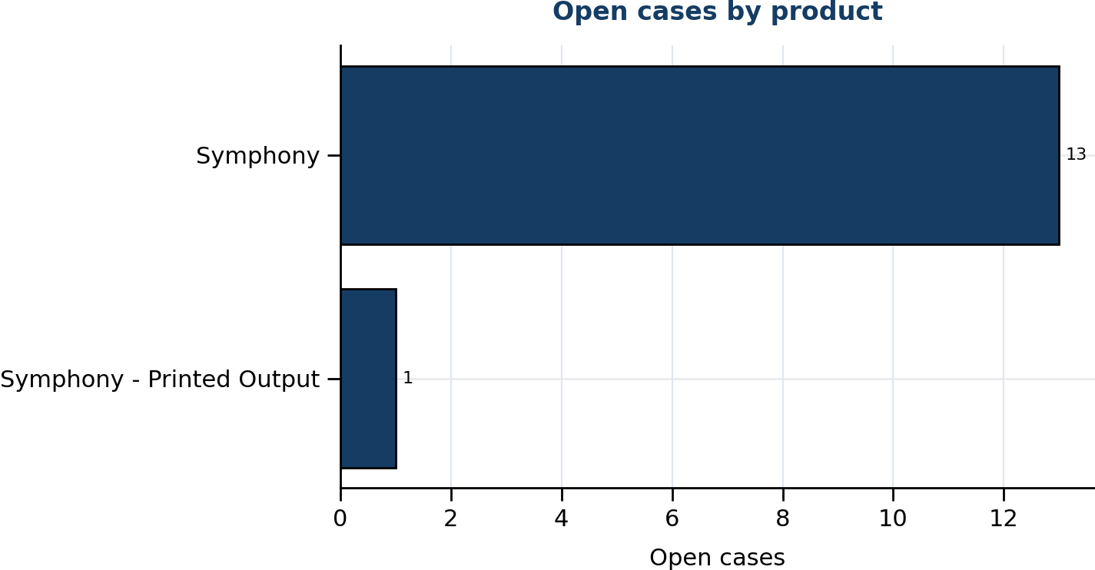
Figure 2. Priority distribution and open case concentration.
State | Cases | Priority | Cases
Closed | 395 | 4 - Low | 226
Resolved | 29 | 3 - Medium | 182
On hold | 9 | 2 - High | 24
In Progress | 5 | 5 | 3
 |  | 1 - Critical | 2
 |  | 6 | 1

Trending topic analysis
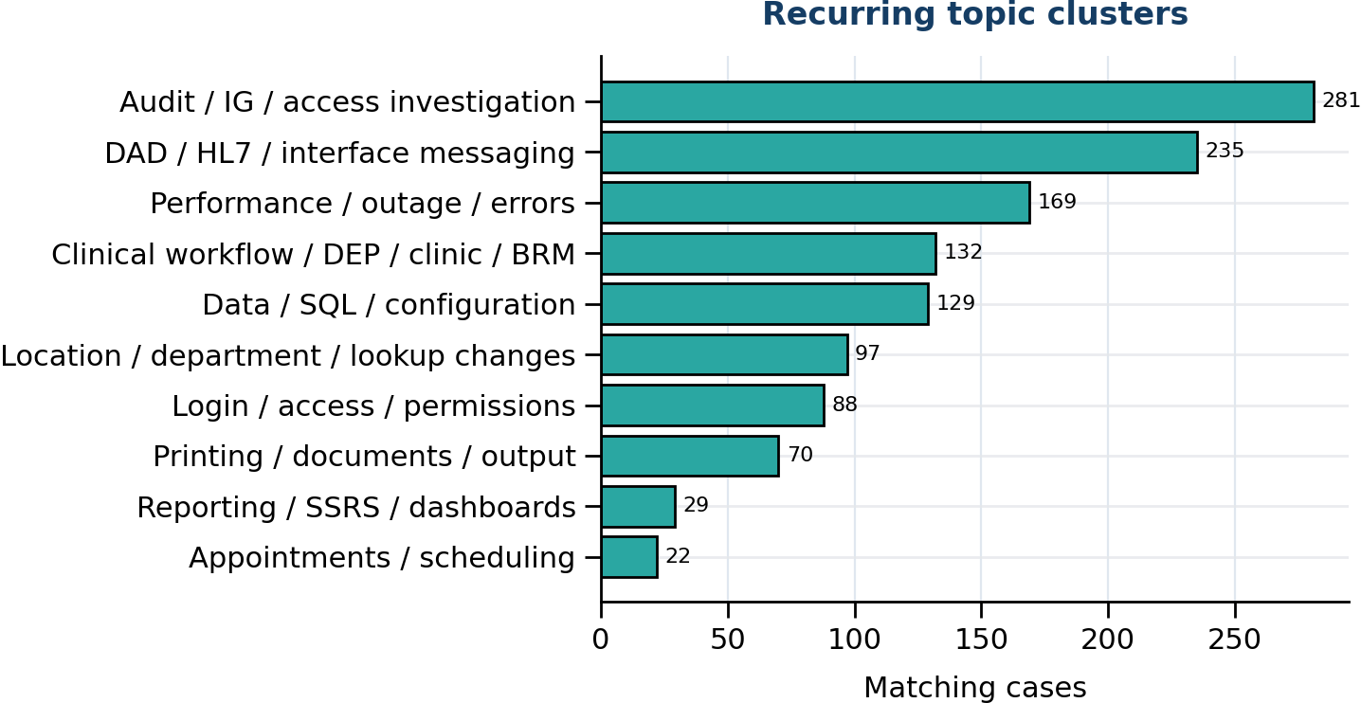 | 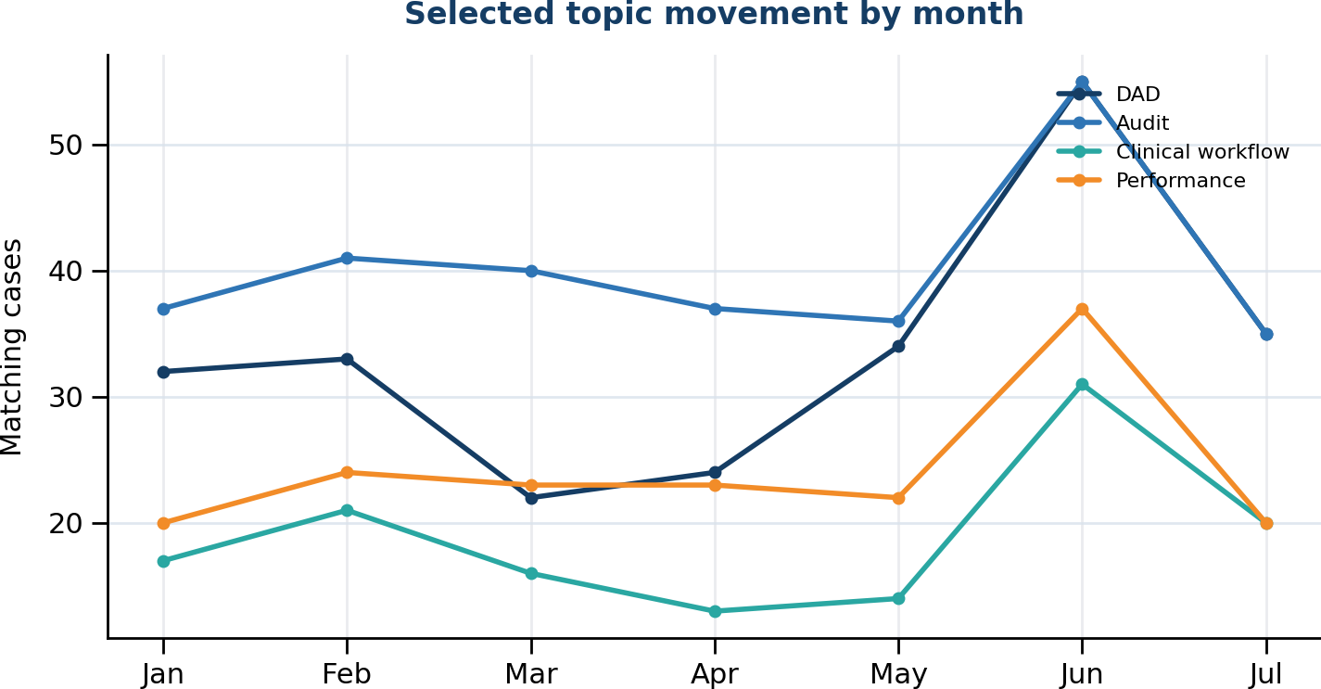
Figure 3. Topic clusters and movement of selected themes by month.

Theme interpretation
Theme | Matching cases | Recent signal from June onwards | Management implication
Audit / IG / access investigation | 281 | 90 | Separate audit/IG demand from incident demand and standardise safe evidence handling, outputs and redaction expectations.
DAD / HL7 / interface messaging | 235 | 90 | Maintain a clear DAD/HL7 runbook covering message queues, failed messages, event logs, restart evidence and escalation thresholds.
Performance / outage / errors | 169 | 57 | Use a rapid incident triage flow covering server availability, DAD status, front-end availability, locks, errors and repeated symptoms.
Clinical workflow / DEP / clinic / BRM | 132 | 51 | Create playbooks for DEP, clinic booking, BRM, discharge and attendance workflows where front-end behaviour depends on configuration/data state.
Data / SQL / configuration | 129 | 43 | Codify repeat SQL/configuration investigation steps while keeping patient identifiers out of management reporting.
Location / department / lookup changes | 97 | 39 | Track location, department, lookup and mapping changes as a known regression/incident contributor.
Login / access / permissions | 88 | 36 | Standardise access checks for user login failures, generic accounts, Citrix, permissions and environment availability.
Printing / documents / output | 70 | 24 | Refresh guidance for printed output, labels, e-docs, Midas and image/document-handling limitations.
Reporting / SSRS / dashboards | 29 | 10 | Retain a reporting/SSRS checklist, including folder availability, dashboard dependencies and recovery steps.
Appointments / scheduling | 22 | 7 | Treat appointment booking and clinic diary behaviours as configuration-sensitive workflows with repeatable diagnostic checks.

Customer/account concentration
Rank | Account | Cases | Open
1 | Mid Yorkshire Teaching NHS Trust | 40 | 1
2 | South Tees Hospitals NHS Foundation Trust | 39 | 1
3 | North West Anglia NHS Foundation Trust | 36 | 0
4 | Health Service Executive | 33 | 0
5 | North Cumbria Integrated Care NHS Foundation Trust | 26 | 1
6 | Swansea Bay University Health Board | 26 | 2
7 | Leeds Teaching Hospitals NHS Trust | 22 | 1
8 | Wye Valley NHS Trust | 21 | 0
9 | Isle Of Wight NHS Trust | 19 | 0
10 | Northern Lincolnshire And Goole NHS Foundation Trust | 18 | 1
11 | Betsi Cadwaladr University Healthboard | 17 | 1
12 | Doncaster and Bassetlaw Teaching Hospitals NHS Foundation Trust | 17 | 0
Management observation: Account concentration should be used for service review context only. The export does not include deployment scale, module footprint, contractual scope, number of users, site complexity, or customer reporting behaviour.

Recommended management actions
# | Recommendation | Rationale
1 | Create a DAD/interface operational runbook | DAD, HL7, TIE, PAS/IPM and failed/queued message references are one of the strongest repeated signals in the export.
2 | Separate audit/IG requests from incident reporting | Audit/access investigation demand is substantial and should be tracked separately so it does not distort operational incident trends.
3 | Standardise Symphony workflow triage packs | DEP, clinic, BRM, discharge and attendance workflows appear repeatedly and would benefit from consistent evidence requests and known diagnostic routes.
4 | Introduce controlled topic tagging in ServiceNow | A controlled set of Symphony tags would reduce reliance on keyword inference and improve future trend reporting.
5 | Create AI-assisted summarisation prompts for repeat cases | Useful prompt fields include symptom, affected workflow, customer/site, DAD/service evidence, SQL/configuration checks, suspected cause, workaround and next action.

Appendix: Method and caveats
- Source data: Symphony Cases This year.csv, containing ServiceNow-style case fields including number, account, priority, state, product, short_description and work_notes.
- Topic analysis used keyword matching across short_description, product and work_notes. Counts are directional and overlapping, not mutually exclusive.
- Open cases were identified where resolved_at was blank. Age calculations use 22/07/2026 12:05 as the reference point.
- July 2026 is a partial month in this export and should not be directly compared with full months without normalisation.
- The report deliberately avoids individual colleague performance comparisons and patient-specific examples. The purpose is service trend insight and process improvement.

