Symphony Management Report

Executive Summary
Total cases (last 12 months): 959
Average business duration: 93283.36 seconds (1.08 days)
Average SLA duration: 280933.80 seconds (3.25 days)

Monthly Trends
Monthly case counts are shown below:
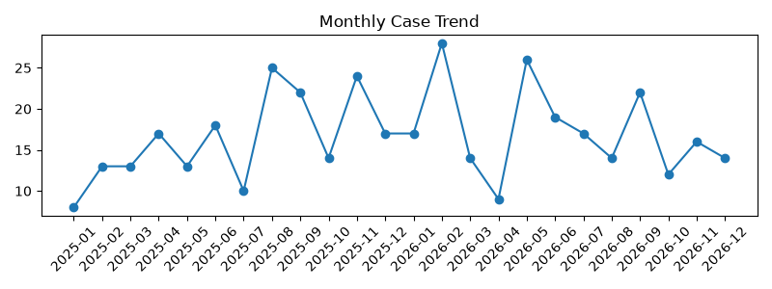

Average Timings
Average business duration: 93283 secs (1.08 days)
Average SLA duration: 280934 secs (3.25 days)

Top Problems
Problem | Count | AvgBusinessSecs | AvgSLAsecs
nan | 941 | 89873.75 | 271418.4
PRB0053699 | 5 | 156080.6 | 605360.6
PRB0053109 | 2 | 2131429.0 | 4208629.0
PRB0051862 | 1 | 307924.0 | 1353937.0
PRB0052368 | 1 | 0.0 | 0.0
PRB0052906 | 1 | 0.0 | 0.0
PRB0053078 | 1 | 417001.0 | 1518805.0
PRB0053079 | 1 | 0.0 | 0.0
PRB0053175 | 1 | 0.0 | 0.0
PRB0053237 | 1 | 0.0 | 0.0

P4 Cases
P4 case count: 469
P4 average business duration: 123800 secs (1.43 days)
P4 average SLA duration: 387178 secs (4.48 days)

Quick Wins (P4)
Problem: PRB0053699 — Count: 3 — Avg business days: 0.05
Recommended quick wins: create standard runbooks, knowledge base articles, automation for common fixes, and targeted training for support teams to reduce repeat P4 cases.

Management Recommendations
1. Knowledge base and self-service: Create KB articles for top recurring problems to deflect simple P4 issues.
2. Automation: Implement automated remediation for repetitive tasks (restarts, cache clears).
3. Triage and routing: Improve initial triage to assign problems to appropriate resolver groups earlier.
4. Monitoring and alerts: Add proactive monitoring for top problem indicators to reduce time-to-detect.
5. Process: Regularly review top problem trends and measure effectiveness of KB/automation with monthly KPIs.

