Symphony Case Trend Report
Management-level analysis of ServiceNow case export
Source:
 |  | days | Symphony
882 | 22 | 2 days, 19 mins, 8 secs | symphony

Executive summary
Total Symphony cases (last 12 months): 882
Open / unresolved: 22
P4 cases: 434
Top customers by case volume: Mid Yorkshire Teaching NHS Trust (69), Health Service Executive (67), Leeds Teaching Hospitals NHS Trust (65)
Key interpretation:

Key metrics
Metric | Value | Notes
Total cases | 882 | Last 12 months
Open / unresolved | 22 | Cases not closed or resolved
P4 cases | 434 | Priority 4
Average time to resolution | 7 days, 5 hrs, 49 mins, 4 secs | Mean of resolved cases
Median time to resolution | 2 days, 19 mins, 8 secs | Median of resolved cases
Average SLA business timing | 1 day, 56 mins, 59 secs | SLA business duration mean
Average SLA actual (SLA_Duration) | 3 days, 3 hrs, 4 mins, 11 secs | SLA elapsed time mean

Case volume and portfolio shape
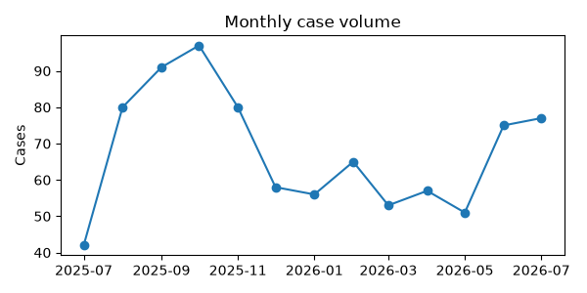 | 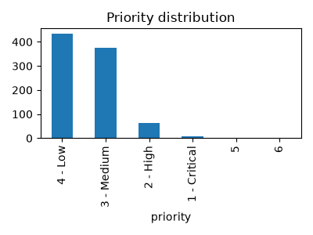
Figure 1. Monthly case creation trend and product concentration.
Management observation:

Product distribution
Rank | Product | Cases
1 | Symphony | 141
2 | Not | 93
3 | Audit | 92
4 | Patient | 81
5 | Dad | 74
6 | Messages | 52
7 | Unable | 44
8 | Error | 42
9 | Access | 39
10 | Test | 39

Priority and state profile
CHART HERE | CHART HERE
Figure 2. Priority distribution and open case concentration.
State | Cases | Priority | Cases
Closed | 842 | 4 - Low | 434
Resolved | 18 | 3 - Medium | 375
In Progress | 12 | 2 - High | 63
On hold | 9 | 1 - Critical | 7
New | 1 | 5 | 2
 |  | 6 | 1

Trending topic analysis
CHART HERE | CHART HERE
Figure 3. Topic clusters and movement of selected themes by month.

Theme interpretation
Theme | Matching cases | Recent signal from June onwards | Management implication
Symphony | 141 | 19 | Create KB article and run targeted training
Not | 93 | 13 | Create KB article and run targeted training
Audit | 92 | 36 | Create KB article and run targeted training
Patient | 81 | 21 | Create KB article and run targeted training
Dad | 74 | 8 | Create KB article and run targeted training
Messages | 52 | 6 | Create KB article and run targeted training
Unable | 44 | 10 | Create KB article and run targeted training
Error | 42 | 14 | Create KB article and run targeted training
Access | 39 | 14 | Create KB article and run targeted training
Test | 39 | 3 | Create KB article and run targeted training

Customer/account concentration
Rank | Account | Cases | Open
1 | Mid Yorkshire Teaching NHS Trust | 69 | symphony (24), audit (10), request (7)
2 | Health Service Executive | 67 | not (12), patient (9), symphony (6)
3 | Leeds Teaching Hospitals NHS Trust | 65 | brm (10), team (10), grey (9)
4 | South Tees Hospitals NHS Foundation Trust | 62 | patient (9), access (8), symphony (8)
5 | Swansea Bay University Health Board | 57 | messages (18), dad (14), outbound (13)
6 | North West Anglia NHS Foundation Trust | 53 | audit (18), scr (8), cpis (6)
7 | Wye Valley NHS Trust | 48 | dad (18), restart (15), symphony (8)
8 | North Cumbria Integrated Care NHS Foundation Trust | 44 | audit (8), patient (8), symphony (7)
9 | Doncaster and Bassetlaw Teaching Hospitals NHS Foundation Trust | 42 | audit (13), request (7), alert (6)
10 | Northern Lincolnshire And Goole NHS Foundation Trust | 40 | edocs (4), symphony (4), cpis (3)
Management observation: Account concentration should be used for service review context only. The export does not include deployment scale, module footprint, contractual scope, number of users, site complexity, or customer reporting behaviour.

Recommended management actions
# | Recommendation | Rationale
1 | Knowledgebase articles | Document fixes for top themes and link from ticket triage.
2 | Training | Deliver quick sessions for support on top 3 themes.
3 | Automation | Script routine fixes and add runbooks.
4 | Monitoring | Add alerts for repeat failures and key metrics.
5 | Triage | Introduce a P4 quick-win path to resolve in <4 hrs where possible.

Appendix: Method and caveats

