Symphony Case Trend Report
Management-level analysis of ServiceNow case export
Source: {Source Data}
958 | Open: 58 / Resolved: 900 | Median: 2 days, 1 hrs, 10 mins; P90: 20 days, 16 hrs, 45 mins | Audit / IG / access investigation
Total cases | Open / unresolved | Median time to resolution | Largest trending

Executive summary
Total cases in period: 958. Open cases: 58; Closed: 900. Median time to resolution: 2 days, 1 hrs, 10 mins. P90 time to resolution: 20 days, 16 hrs, 45 mins. Top trend by volume: Audit / IG / access investigation. Average SLA business time: 1 days, 1 hrs, 56 mins.

Key interpretation: This report should be read as a management trend view rather than a root-cause analysis. Topic counts are keyword-based and overlapping. The underlying case notes contain operational SQL, interface and audit references, so the report intentionally avoids exposing patient-specific identifiers or detailed case scripts.

Key metrics
Metric | Value | Notes
Total cases analysed | 958
Created date range
Current unresolved cases
Median open age
90th percentile open age
Resolved/closed with resolution date
Median resolution duration
90th percentile resolution duration

Case volume and portfolio shape
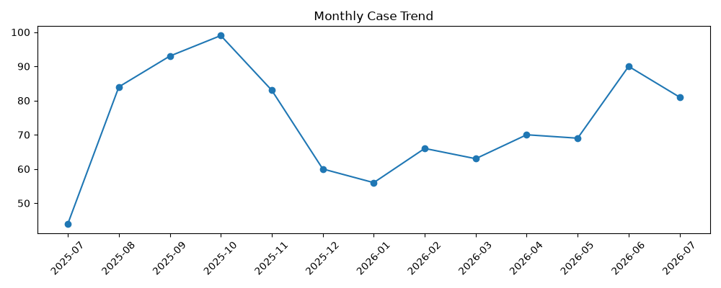 | 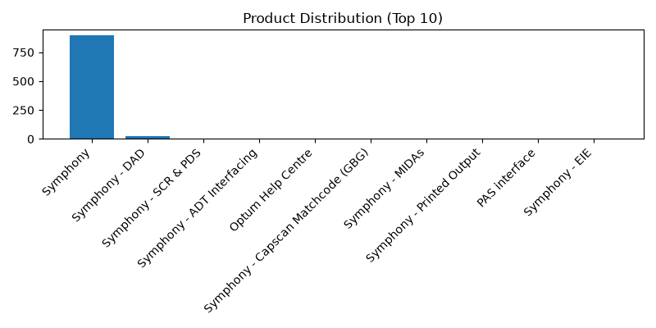
Figure 1. Monthly case creation trend and product concentration.

Product distribution
Rank | Product | Cases
1 | Symphony | 899
2 | Symphony - DAD | 21
3 | Symphony - SCR & PDS | 6
4 | Symphony - ADT Interfacing | 5
5 | Optum Help Centre | 5
6 | Symphony - Capscan Matchcode (GBG) | 3
7 | Symphony - MIDAs | 3
8 | Symphony - Printed Output | 3
9 | PAS interface | 2
10 | Symphony - EIE | 2

Priority and state profile
State | Cases | Cases

Trending topic analysis
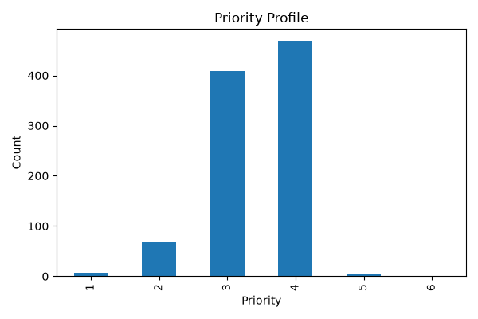
Closed
Resolved
On hold
In Progress
Figure 2. Topic clusters and movement of selected themes by month.

Theme interpretation
Theme | Matching cases | Recent signal from June onwards | Management implication
Audit / IG / access investigation
DAD / HL7 / interface messaging
Performance / outage / errors
Clinical workflow / DEP / clinic / BRM
Data / SQL / configuration
Location / department / lookup changes
Login / access / permissions
Printing / documents / output
Reporting / SSRS / dashboards
Appointments / scheduling

Customer/account concentration
Rank | Account | Cases | Open
Other | 847 | 149 | High volume — consider KB and automation.
Reporting & Analytics / Reporting | 34 | 5 | Medium volume — review for triage improvements.
Notifications & Communications / Email | 33 | 8 | Medium volume — review for triage improvements.
Performance & Availability / Performance | 12 | 3 | Low volume — monitor; consider knowledge article if recurring.
Defects & Errors / Error Messages | 8 | 3 | Low volume — monitor; consider knowledge article if recurring. Recent uptick observed.
User Guidance & Training / Training | 6 | 0 | Low volume — monitor; consider knowledge article if recurring.
Notifications & Communications / Alerts | 5 | 1 | Low volume — monitor; consider knowledge article if recurring.
Reporting & Analytics / Dashboard | 3 | 0 | Low volume — monitor; consider knowledge article if recurring.
Access & Security / User Access | 3 | 2 | Low volume — monitor; consider knowledge article if recurring. Recent uptick observed.
Data Management / Data Quality | 2 | 0 | Low volume — monitor; consider knowledge article if recurring.
Performance & Availability / Availability | 1 | 0 | Low volume — monitor; consider knowledge article if recurring.
Service Requests / Information Request | 1 | 0 | Low volume — monitor; consider knowledge article if recurring.
Notifications & Communications / Subscription | 1 | 0 | Low volume — monitor; consider knowledge article if recurring.
Data Management / Data Recovery | 1 | 0 | Low volume — monitor; consider knowledge article if recurring.
Reporting & Analytics / Analytics | 1 | 0 | Low volume — monitor; consider knowledge article if recurring.
Management observation: Account concentration should be used for service review context only. The export does not include deployment scale, module footprint, contractual scope, number of users, site complexity, or customer reporting behaviour.

Recommended management actions
# | Recommendation | Rationale
1 | Health Service Executive | 75
2 | Mid Yorkshire Teaching NHS Trust | 72
3 | South Tees Hospitals NHS Foundation Trust | 72
4 | Leeds Teaching Hospitals NHS Trust | 66
5 | North West Anglia NHS Foundation Trust | 59
6 | Swansea Bay University Health Board | 58
7 | Wye Valley NHS Trust | 56
8 | North Cumbria Integrated Care NHS Foundation Trust | 46
9 | Doncaster and Bassetlaw Teaching Hospitals NHS Foundation Trust | 43
10 | Northern Lincolnshire And Goole NHS Foundation Trust | 41

Appendix:

