OCM Case Trend Report
Management-level analysis of ServiceNow case export
Source: data/raw/OCM_Cases_Last_12-Months.csv
1032 | 33 | 4 days, 1 hrs, 44 mins | Integration & Interfaces
Total cases | Open / unresolved | Median time to resolution | Largest trending

Executive summary
Executive Summary (OCM Support Trend Analysis):
Over the 12-month evaluation period, 1,032 OCM cases were analysed. Support demand is heavily concentrated in two core operational categories: Integration & Interfaces (505 cases / 48.9%) and Access & Security (315 cases / 30.5%), together accounting for 79.4% of all ticket traffic.
Key Insights for Leadership:
1. Pathology & Lab Messaging Bottlenecks: Lab interface message stalls (ICE, Sunquest, WinPath) form the single largest operational load (285 integration failures and 218 third-party system dependencies).
2. Clinician Authentication Friction: Unlike other products, OCM experiences intense authentication overhead (268 cases / 25.9% of total volume), driven by clinician smartcard, password, and SSO credential lockouts.
3. Operational Action: Leadership should prioritize (P1) automated interface queue retry mechanisms and (P2) a streamlined clinician self-service authentication portal to eliminate tier-1 ticket volume.

Key interpretation: This report should be read as a management trend view rather than a root-cause analysis. Topic counts are keyword-based and overlapping. The underlying case notes contain operational SQL, interface and audit references, so the report intentionally avoids exposing patient-specific identifiers or detailed case scripts.

Key metrics
Metric | Value | Notes
Total cases analysed | 1032 | Total cases in OCM export
Created date range | 07/07/2025 - 30/07/2026 | Creation period (sys_created_on)
Current unresolved cases | 33 | Cases without resolution timestamp
Median open age | 59 days, 13 hrs, 29 mins | Median age for open cases
P90 open age | 196 days, 10 hrs, 26 mins | P90 age for open cases
Cases resolved with date | 999 | Cases with valid resolution date
Median time to resolution (TTR) | 4 days, 1 hrs, 44 mins | Median duration from created to resolved
P90 time to resolution (TTR) | 42 days, 23 hrs, 39 mins | P90 duration from created to resolved

Case volume and portfolio shape
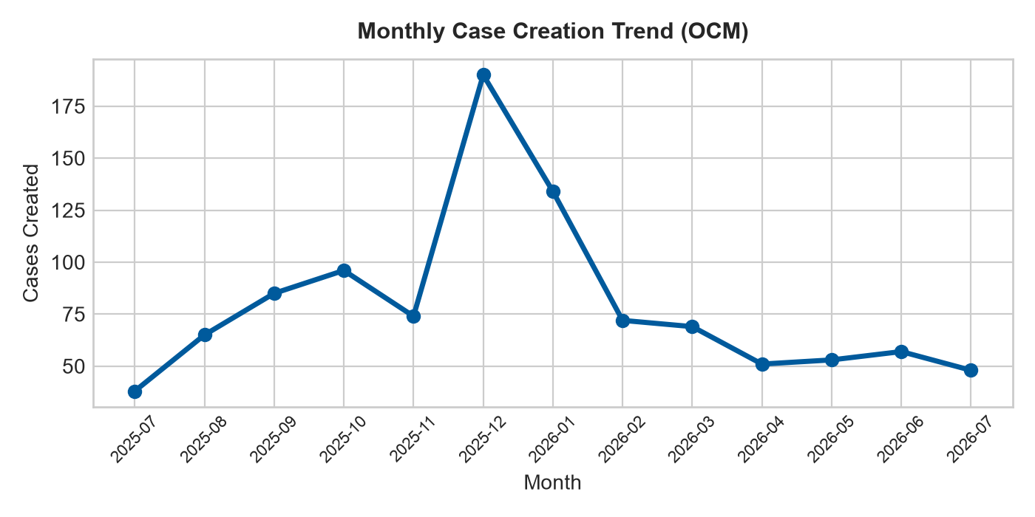 | 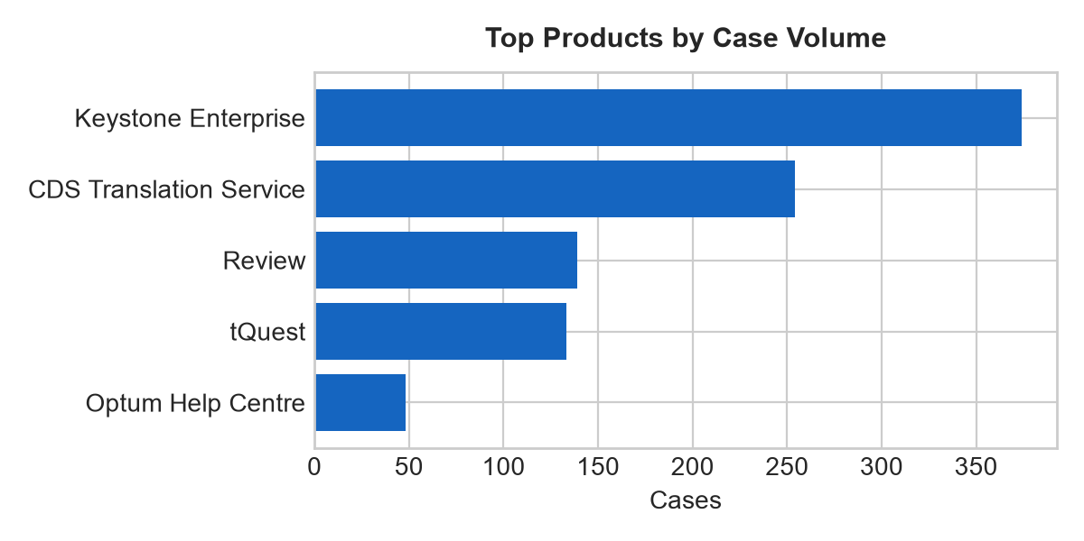
Figure 1. Monthly case creation trend and product concentration.

Product distribution
Rank | Product | Cases
1 | Keystone Enterprise | 374
2 | CDS Translation Service | 254
3 | Review | 139
4 | tQuest | 133
5 | Optum Help Centre | 48
6 | Order Comms | 28
7 | Bundle -Translation Service incl CDS | 26
8 | Bundle - Translations Service including CDS and eCDS | 8
9 | Core Pharmacy | 5
10 | EMIS Web - Care Record | 3

Priority and state profile
State | Cases | Cases
Closed | 973 | 94.3%
In Progress | 30 | 2.9%
Resolved | 26 | 2.5%
On hold | 3 | 0.3%

Trending topic analysis
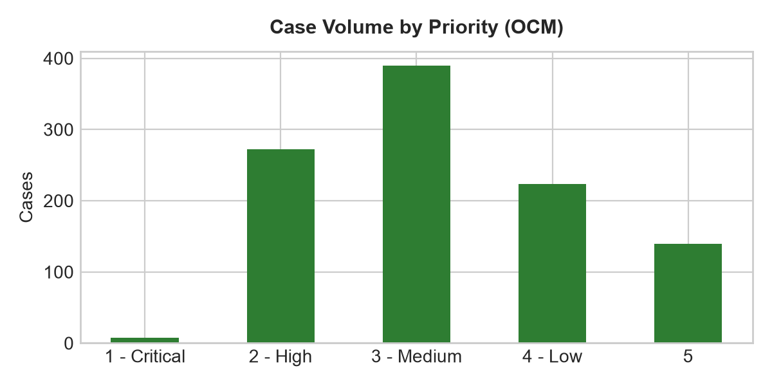
Figure 2. Topic clusters and movement of selected themes by month.

Theme interpretation
Theme | Matching cases | Recent signal from June onwards | Management implication
Integration & Interfaces | 505 | 66 cases (Jun-Jul) | Highest operational impact. Requires automated queue retries and lab vendor SLA management.
Access & Security | 315 | 16 cases (Jun-Jul) | Major clinician friction. Recommending self-service credential reset and smartcard triage.
Notifications & Communications | 51 | 6 cases (Jun-Jul) | Order/result email dispatch failures. Requires SMTP monitoring and queue alerts.
Performance & Availability | 50 | 6 cases (Jun-Jul) | UI freezing and slowness. Requires database indexing and network latency investigation.
Reporting & Analytics | 42 | 1 cases (Jun-Jul) | SSRS report request backlog. Recommend standardizing reporting catalog and self-service extracts.
Service Requests | 34 | 3 cases (Jun-Jul) | New configuration setups. Recommend standard intake templates for order set additions.
Defects & Errors | 13 | 4 cases (Jun-Jul) | Application bugs and scanner errors. Requires patch verification and dev escalation.
Configuration & Administration | 11 | 1 cases (Jun-Jul) | Complex environment and test catalogue changes. Recommend admin workflow guidelines.
Data Management | 5 | 1 cases (Jun-Jul) | Monitor trend movement and user demand.
Case Administration | 4 | 1 cases (Jun-Jul) | Monitor trend movement and user demand.
User Guidance & Training | 1 | 0 cases (Jun-Jul) | Monitor trend movement and user demand.
Workflow & Process | 1 | 0 cases (Jun-Jul) | Monitor trend movement and user demand.

Customer/account concentration
Rank | Account | Cases | Open
1 | Salisbury NHS Foundation Trust | 138 | 10
2 | The Shrewsbury And Telford Hospital NHS Trust | 53 | 2
3 | Guy's and St Thomas' NHS Foundation Trust | 42 | 3
4 | Tameside and Glossop Integrated Care NHS Foundation Trust | 39 | 1
5 | Northern Care Alliance NHS Foundation Trust | 33 | 0
6 | Mid Yorkshire Teaching NHS Trust | 32 | 0
7 | University Hospitals Of Leicester NHS Trust | 31 | 0
8 | Oxford University Hospitals NHS Trust | 28 | 0
9 | Kingston Hospital NHS Foundation Trust | 26 | 3
10 | The Doctors Laboratory Ltd | 25 | 0
Management observation: Account concentration should be used for service review context only. The export does not include deployment scale, module footprint, contractual scope, number of users, site complexity, or customer reporting behaviour.

Recommended management actions
# | Recommendation | Rationale
Priority 1 | Implement Automated Lab Interface & Queue Monitoring | Integration failures account for 48.9% of demand. Automated retries will significantly reduce manual support tickets.
Priority 1 | Deploy Self-Service Clinician Authentication Portal | Authentication lockouts account for 268 cases (25.9%). Self-service reset will eliminate high-volume tier-1 work.
Priority 2 | Standardise Order Catalogue Change Intake | Master data and order set changes suffer high SLA latency. Standard templates will improve turnaround time.
Priority 2 | Establish Automated SMTP & Email Alerting | Order dispatch email failures represent 49 cases. Automated alerting will catch dispatches prior to client escalation.
Priority 3 | Publish SSRS Self-Service Reporting Knowledge Base | Report requests average 3d 23h business SLA duration. Pre-built templates will reduce custom extract work.

Appendix:

