Symphony Case Trend Report
Management-level analysis of ServiceNow case export
Source: data/raw/Symphony_Casea_Last_12-Months.csv
958 | 30 | 2 days, 1 hrs, 10 mins | Integration & Interfaces
Total cases | Open / unresolved | Median time to resolution | Largest trending

Executive summary
Executive Summary (Symphony Support Trend Analysis):
Over the 12-month evaluation period, 958 Symphony cases were analysed. Support demand is heavily concentrated in two primary operational categories: Integration & Interfaces (500 cases / 52.2%) and Access & Security (228 cases / 23.8%), together accounting for 76.0% of all ticket volume.
Key Insights for Leadership:
1. Emergency & Acute Interface Demand: Integration failures (HL7 messaging / DAD interop) represent 268 cases, while external NHS dependencies (SCR, TIE, ODS, GP Import) account for 230 cases.
2. High Information Governance Audit Overhead: Record access history and IG viewing audits represent 151 cases (15.8% of overall volume), averaging 19h 2m SLA business duration.
3. Strategic Actions: Leadership should implement (P1) automated interface queue monitoring & retries and (P1) an automated self-service Information Governance audit extraction portal.

Key interpretation: This report should be read as a management trend view rather than a root-cause analysis. Topic counts are keyword-based and overlapping. The underlying case notes contain operational SQL, interface and audit references, so the report intentionally avoids exposing patient-specific identifiers or detailed case scripts.

Key metrics
Metric | Value | Notes
Total cases analysed | 958 | Total cases in Symphony export
Created date range | 03/07/2025 - 29/07/2026 | Creation period (sys_created_on)
Current unresolved cases | 30 | Cases without resolution timestamp
Median open age | 16 days, 9 hrs, 15 mins | Median age for open cases
P90 open age | 310 days, 8 hrs, 43 mins | P90 age for open cases
Cases resolved with date | 928 | Cases with valid resolution date
Median time to resolution (TTR) | 2 days, 1 hrs, 10 mins | Median duration from created to resolved
P90 time to resolution (TTR) | 20 days, 15 hrs, 54 mins | P90 duration from created to resolved

Case volume and portfolio shape
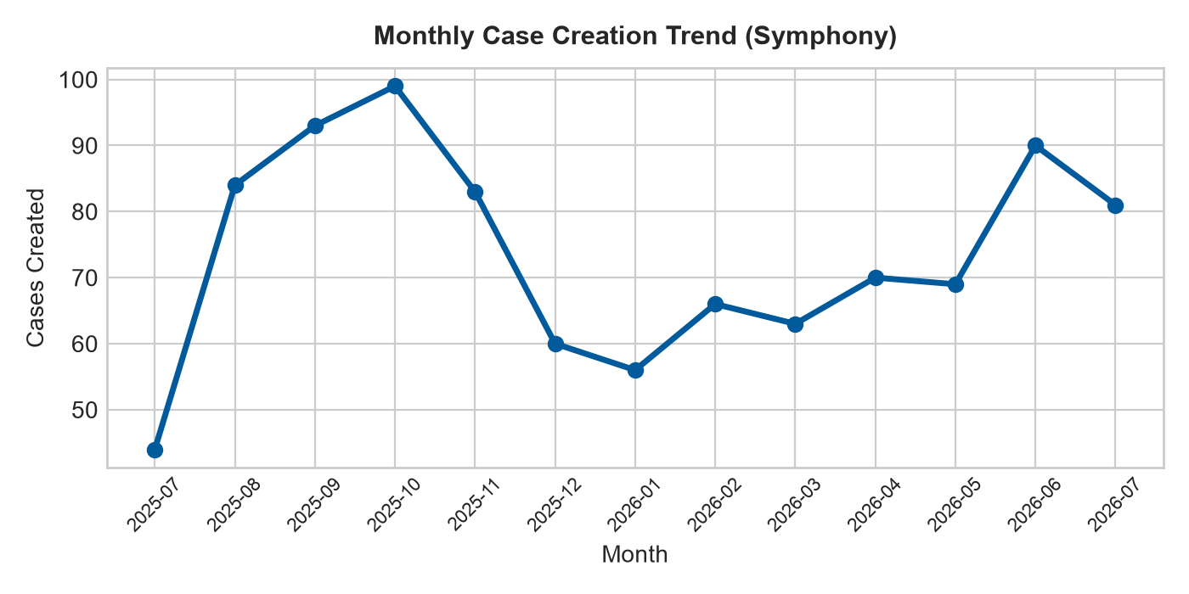 | 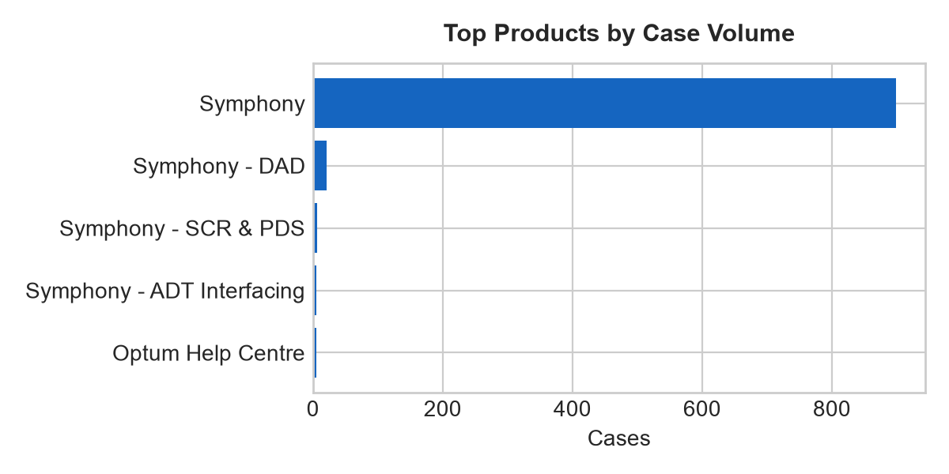
Figure 1. Monthly case creation trend and product concentration.

Product distribution
Rank | Product | Cases
1 | Symphony | 899
2 | Symphony - DAD | 21
3 | Symphony - SCR & PDS | 6
4 | Symphony - ADT Interfacing | 5
5 | Optum Help Centre | 5
6 | Symphony - Capscan Matchcode (GBG) | 3
7 | Symphony - MIDAs | 3
8 | Symphony - Printed Output | 3
9 | PAS interface | 2
10 | Symphony - EIE | 2

Priority and state profile
State | Cases | Cases
Closed | 900 | 93.9%
Resolved | 28 | 2.9%
On hold | 19 | 2.0%
In Progress | 11 | 1.1%

Trending topic analysis
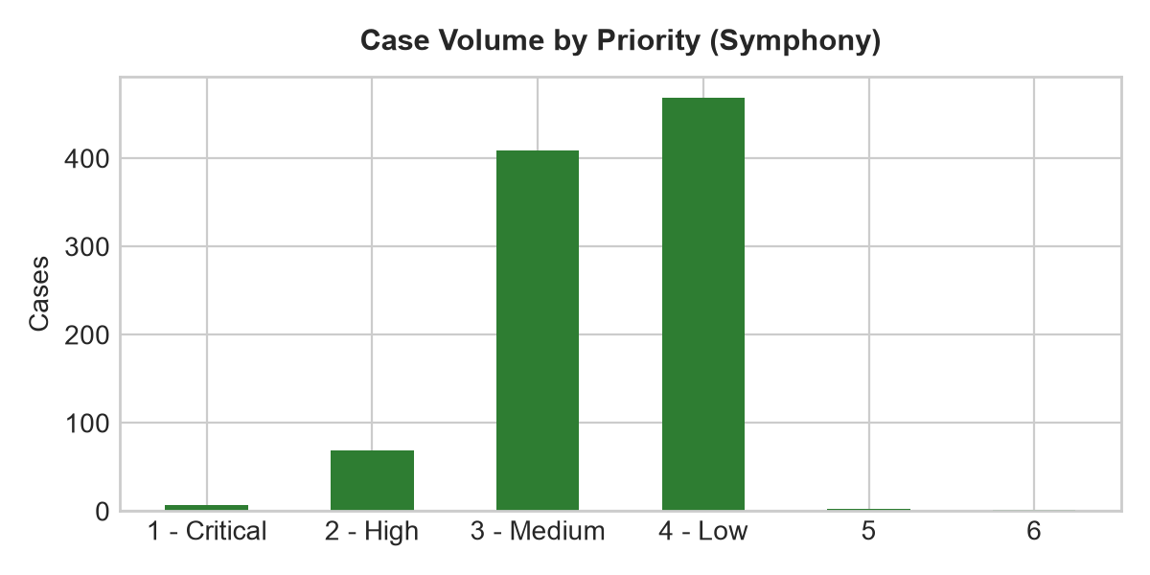
Figure 2. Topic clusters and movement of selected themes by month.

Theme interpretation
Theme | Matching cases | Recent signal from June onwards | Management implication
Integration & Interfaces | 500 | 73 cases (Jun-Jul) | Highest operational impact (HL7/DAD messaging). Automated queue retries and interop monitoring required.
Access & Security | 228 | 60 cases (Jun-Jul) | Driven by IG Audit & Compliance requests (151 cases). Recommending automated self-service audit extraction portal.
Configuration & Administration | 80 | 13 cases (Jun-Jul) | Master data and departmental lookup changes (41 cases). Recommend standard admin change templates.
Performance & Availability | 40 | 6 cases (Jun-Jul) | UI freezing and slowness. Requires database script optimisation and client network checks.
Reporting & Analytics | 35 | 7 cases (Jun-Jul) | SSRS report generation & data extracts (31 cases). Recommend publishing standard reporting catalog.
Defects & Errors | 20 | 5 cases (Jun-Jul) | Functional errors and scanning blank pages. Requires development patch verification.
Service Requests | 18 | 3 cases (Jun-Jul) | New setup and quote requests. Recommend standard service catalog intake templates.
Data Management | 15 | 1 cases (Jun-Jul) | Database data corrections and SQL fixes. Recommend tier-2 script library.
Notifications & Communications | 12 | 1 cases (Jun-Jul) | Monitor trend movement and user demand.
Workflow & Process | 5 | 1 cases (Jun-Jul) | Monitor trend movement and user demand.
User Guidance & Training | 4 | 1 cases (Jun-Jul) | Monitor trend movement and user demand.
Case Administration | 1 | 0 cases (Jun-Jul) | Monitor trend movement and user demand.

Customer/account concentration
Rank | Account | Cases | Open
1 | Health Service Executive | 75 | 0
2 | South Tees Hospitals NHS Foundation Trust | 72 | 1
3 | Mid Yorkshire Teaching NHS Trust | 72 | 1
4 | Leeds Teaching Hospitals NHS Trust | 66 | 3
5 | North West Anglia NHS Foundation Trust | 59 | 2
6 | Swansea Bay University Health Board | 58 | 2
7 | Wye Valley NHS Trust | 56 | 0
8 | North Cumbria Integrated Care NHS Foundation Trust | 46 | 1
9 | Doncaster and Bassetlaw Teaching Hospitals NHS Foundation Trust | 43 | 4
10 | Northern Lincolnshire And Goole NHS Foundation Trust | 41 | 3
Management observation: Account concentration should be used for service review context only. The export does not include deployment scale, module footprint, contractual scope, number of users, site complexity, or customer reporting behaviour.

Recommended management actions
# | Recommendation | Rationale
Priority 1 | Implement Automated HL7 & DAD Interface Queue Retry | Integration failures represent 52.2% of demand (500 cases). Automated retries will prevent manual support queue build-up.
Priority 1 | Deploy Self-Service Information Governance Audit Portal | Audit & IG requests account for 151 cases (15.8%). An automated portal will eliminate tier-2 manual SQL audit extraction.
Priority 2 | Standardise Departmental & Ward Lookup Change Requests | Master data changes represent 41 cases. Standardized intake forms will improve change turnaround times.
Priority 2 | Publish SSRS Self-Service Reporting Knowledge Base | Reporting & data extracts account for 31 cases with high SLA duration (2d 3h). Pre-built templates reduce custom extract work.
Priority 3 | Establish Automated Printer & Output Configuration Guidance | Batch printing issues represent 28 cases. KB articles and automated diagnostics will resolve client output issues.

Appendix:

