Symphony Case Trend Report
Management-level analysis of ServiceNow case export
Source: Source files: Symphony_P4_Cases_20260102-20260803.csv, Symphony_P4_SLA_20260102-20260803.csv, merged on case number. Derived dataset: Merged_Cases_With_SLA_Formatted.csv. Report generated: 2026-08-03 13:02:14.
257 | 25 | 3 days, 17 hrs, 44 mins | Integration & Interfaces / Third-Party Systems
Total cases | Open / unresolved | Median time to resolution | Largest trending

Executive summary
This report covers 257 Symphony cases. The data window is 02/01/2026 - 03/08/2026. Demand concentration: highest-volume theme is 'Other' (see Trend Distribution). Primary service metric: median time to resolution is 3 days, 17 hrs, 44 mins, with P90 of 19 days, 6 hrs, 49 mins. Current backlog: 10 unresolved cases; median open age 5 days, 1 hrs, 38 mins, P90 23 days, 14 hrs, 20 mins. Recommended priorities: (1) rapidly create KB articles and automation for high-volume, low-complexity issues; (2) strengthen triage to reduce P90 resolution; (3) remediate recurring environmental/import processes causing operational noise.

Key interpretation: This report should be read as a management trend view rather than a root-cause analysis. Topic counts are keyword-based and overlapping. The underlying case notes contain operational SQL, interface and audit references, so the report intentionally avoids exposing patient-specific identifiers or detailed case scripts.

Key metrics
Metric | Value | Notes
Total cases analysed | 257 | As counted in merged dataset
Created date range | 02/01/2026 - 03/08/2026 | Date range of case creation (sys_created_on).
Current unresolved cases | 10 | Cases without a resolved date (resolved_at empty). Includes any non-Closed states.
Median open age | 5 days, 1 hrs, 38 mins | Median age for currently unresolved cases: duration since creation.
90th percentile open age | 23 days, 14 hrs, 20 mins | P90 age for currently unresolved cases.
Resolved/closed with resolution date | 247 | Count of cases with a resolved date present.
Median resolution duration | 3 days, 17 hrs, 44 mins | Median time-to-resolution for resolved cases (Created -> Resolved).
90th percentile resolution duration | 19 days, 6 hrs, 49 mins | P90 time-to-resolution for resolved cases.

Case volume and portfolio shape
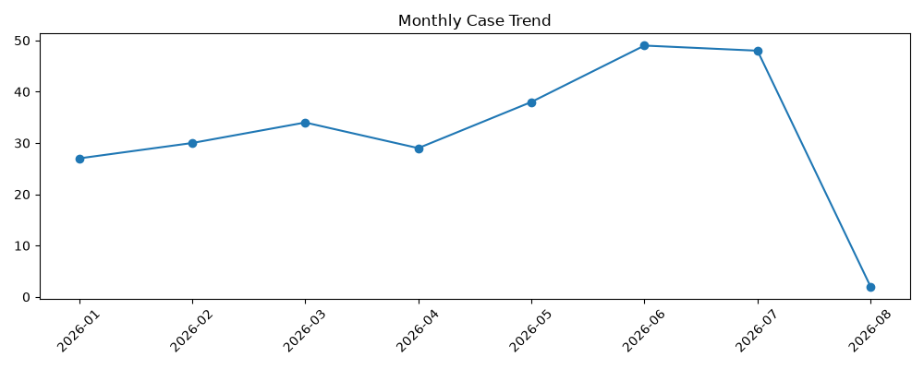 | 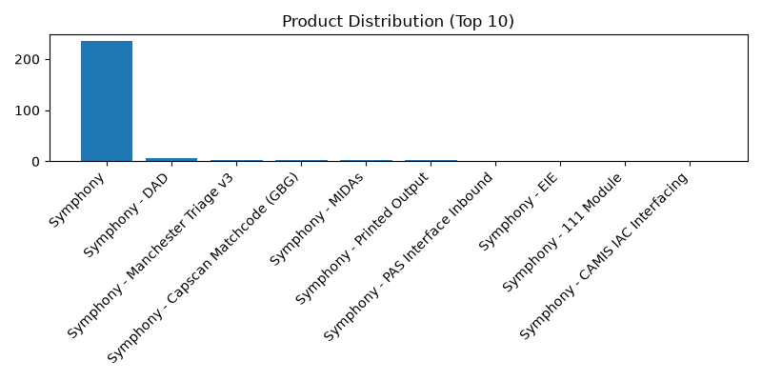
Figure 1. Monthly case creation trend and product concentration.

Product distribution
Rank | Product | Cases
1 | Symphony | 236
2 | Symphony - DAD | 7
3 | Symphony - Manchester Triage v3 | 2
4 | Symphony - Capscan Matchcode (GBG) | 2
5 | Symphony - MIDAs | 2
6 | Symphony - Printed Output | 2
7 | Symphony - PAS Interface Inbound | 1
8 | Symphony - EIE | 1
9 | Symphony - 111 Module | 1
10 | Symphony - CAMIS IAC Interfacing | 1

Priority and state profile
State | Cases | Cases

Trending topic analysis
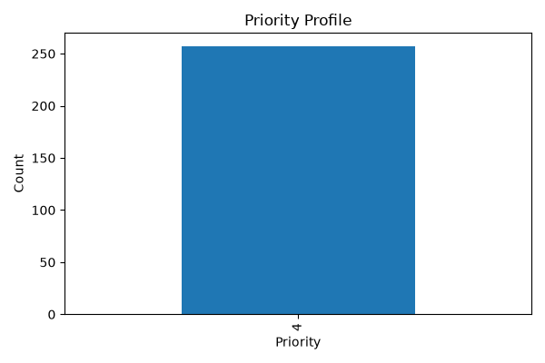
Closed
Resolved
On hold
In Progress
Figure 2. Topic clusters and movement of selected themes by month.

Theme interpretation
Theme | Matching cases | Recent signal from June onwards | Management implication
Audit / IG / access investigation
DAD / HL7 / interface messaging
Performance / outage / errors
Clinical workflow / DEP / clinic / BRM
Data / SQL / configuration
Location / department / lookup changes
Login / access / permissions
Printing / documents / output
Reporting / SSRS / dashboards
Appointments / scheduling

Customer/account concentration
Rank | Account | Cases | Open
Other | 233 | 90 | High volume — consider KB and automation. Recent uptick observed.
Notifications & Communications / Email | 6 | 4 | Low volume — monitor; consider knowledge article if recurring. Recent uptick observed.
Reporting & Analytics / Reporting | 5 | 3 | Low volume — monitor; consider knowledge article if recurring. Recent uptick observed.
Performance & Availability / Performance | 2 | 0 | Low volume — monitor; consider knowledge article if recurring.
User Guidance & Training / Training | 2 | 0 | Low volume — monitor; consider knowledge article if recurring.
Notifications & Communications / Alerts | 2 | 1 | Low volume — monitor; consider knowledge article if recurring. Recent uptick observed.
Service Requests / Information Request | 1 | 0 | Low volume — monitor; consider knowledge article if recurring.
Defects & Errors / Error Messages | 1 | 0 | Low volume — monitor; consider knowledge article if recurring.
Notifications & Communications / Subscription | 1 | 0 | Low volume — monitor; consider knowledge article if recurring.
Data Management / Data Recovery | 1 | 0 | Low volume — monitor; consider knowledge article if recurring.
Reporting & Analytics / Analytics | 1 | 0 | Low volume — monitor; consider knowledge article if recurring.
Reporting & Analytics / Dashboard | 1 | 0 | Low volume — monitor; consider knowledge article if recurring.
Access & Security / User Access | 1 | 1 | Low volume — monitor; consider knowledge article if recurring. Recent uptick observed.
Management observation: Account concentration should be used for service review context only. The export does not include deployment scale, module footprint, contractual scope, number of users, site complexity, or customer reporting behaviour.

Recommended management actions
# | Recommendation | Rationale
1 | Mid Yorkshire Teaching NHS Trust | 29
2 | North West Anglia NHS Foundation Trust | 21
3 | North Cumbria Integrated Care NHS Foundation Trust | 19
4 | Health Service Executive | 18
5 | Isle Of Wight NHS Trust | 17
6 | Doncaster and Bassetlaw Teaching Hospitals NHS Foundation Trust | 14
7 | Betsi Cadwaladr University Healthboard | 14
8 | Aneurin Bevan University Healthboard | 13
9 | Leeds Teaching Hospitals NHS Trust | 12
10 | Luton And Dunstable Hospital NHS Foundation Trust | 12

Appendix:
Appendix — Methods and Caveats
Method: The report uses Symphony case exports merged with SLA durations on case number. Date parsing assumes day-first format. Time-to-resolution (TTR) is calculated as Resolved Date minus Created Date; open age uses the report generation time as reference. Trend classification used keyword matching against templates/Trends.txt with three additional authorised categories added during processing.
Caveats: The merge preserved all cases from the primary case export and aligned SLA seconds where available; some cases lack SLA rows and some descriptions contain embedded line breaks which may affect automated token matching. 52 cases remain unclassified after automated passes. Durations are shown as "[DD] days, [HH] hrs, [MI] mins" with zero components suppressed.
Privacy: No patient-identifiable data is included in outputs. Aggregate metrics only.
If you require changes to classification rules, date range, or unresolved definition, request a rerun with updated parameters.

