OCM Case Trend Report
Management-level analysis of ServiceNow case export
Source: {Source Data}
2912 | 166 | 1 days, 3 hrs, 57 mins | Integration & Interfaces / Third-Party Systems
Total cases | Open / unresolved | Median time to resolution | Largest trending

Executive summary
{Executive summary}

Key interpretation: This report should be read as a management trend view rather than a root-cause analysis. Topic counts are keyword-based and overlapping. The underlying case notes contain operational SQL, interface and audit references, so the report intentionally avoids exposing patient-specific identifiers or detailed case scripts.

Key metrics
Metric | Value | Notes
Total cases analysed | 2912
Created date range
Current unresolved cases
Median open age
90th percentile open age
Resolved/closed with resolution date
Median resolution duration
90th percentile resolution duration

Case volume and portfolio shape
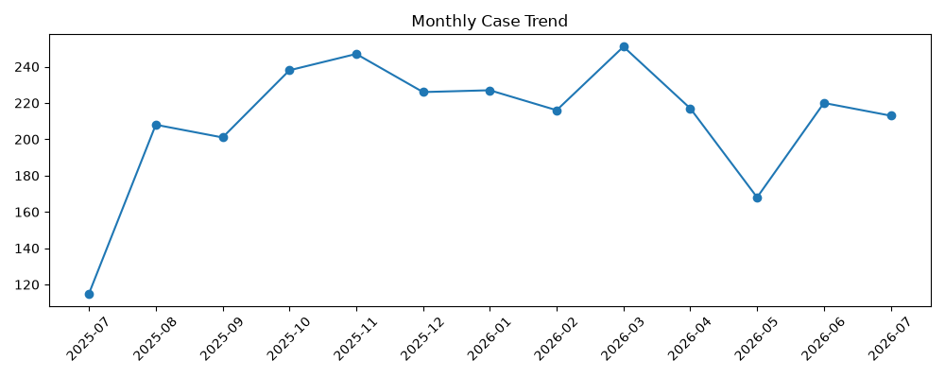 | 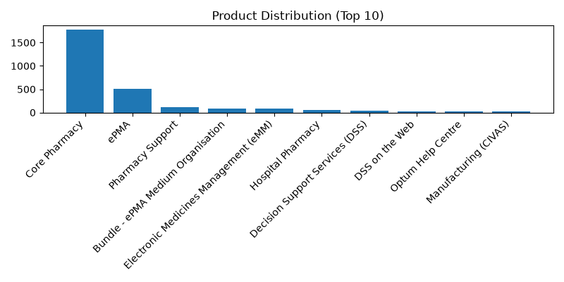
Figure 1. Monthly case creation trend and product concentration.

Product distribution
Rank | Product | Cases
1 | Core Pharmacy | 1776
2 | ePMA | 513
3 | Pharmacy Support | 110
4 | Bundle - ePMA Medium Organisation | 88
5 | Electronic Medicines Management (eMM) | 83
6 | Hospital Pharmacy | 53
7 | Decision Support Services (DSS) | 46
8 | DSS on the Web | 29
9 | Optum Help Centre | 23
10 | Manufacturing (CIVAS) | 21

Priority and state profile
State | Cases | Cases

Trending topic analysis
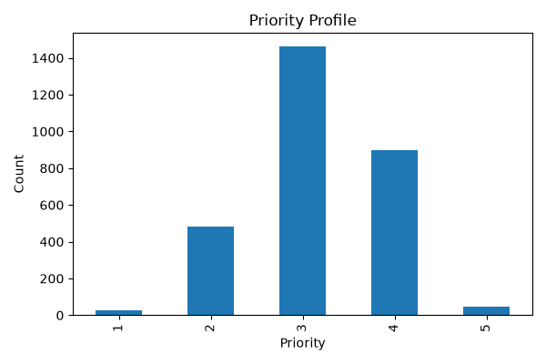
Closed
In Progress
Resolved
On hold
Figure 2. Topic clusters and movement of selected themes by month.

Theme interpretation
Theme | Matching cases | Recent signal from June onwards | Management implication
Audit / IG / access investigation
DAD / HL7 / interface messaging
Performance / outage / errors
Clinical workflow / DEP / clinic / BRM
Data / SQL / configuration
Location / department / lookup changes
Login / access / permissions
Printing / documents / output
Reporting / SSRS / dashboards
Appointments / scheduling

Customer/account concentration
Rank | Account | Cases | Open
Other | 2479 | 362 | High volume — consider KB and automation.
Notifications & Communications / Email | 169 | 19 | Medium volume — review for triage improvements.
Reporting & Analytics / Reporting | 94 | 14 | Medium volume — review for triage improvements.
Performance & Availability / Performance | 74 | 25 | Low volume — monitor; consider knowledge article if recurring. Recent uptick observed.
Defects & Errors / Error Messages | 25 | 4 | Low volume — monitor; consider knowledge article if recurring.
User Guidance & Training / Training | 18 | 4 | Low volume — monitor; consider knowledge article if recurring.
Notifications & Communications / Alerts | 17 | 2 | Low volume — monitor; consider knowledge article if recurring.
Performance & Availability / Availability | 12 | 0 | Low volume — monitor; consider knowledge article if recurring.
Access & Security / Authentication | 12 | 1 | Low volume — monitor; consider knowledge article if recurring.
Data Management / Data Quality | 3 | 0 | Low volume — monitor; consider knowledge article if recurring.
Configuration & Administration / Configuration Change | 3 | 1 | Low volume — monitor; consider knowledge article if recurring. Recent uptick observed.
Service Requests / Change Request | 2 | 0 | Low volume — monitor; consider knowledge article if recurring.
Configuration & Administration / System Administration | 1 | 0 | Low volume — monitor; consider knowledge article if recurring.
Reporting & Analytics / Analytics | 1 | 0 | Low volume — monitor; consider knowledge article if recurring.
Workflow & Process / Workflow Issue | 1 | 0 | Low volume — monitor; consider knowledge article if recurring.
Access & Security / Security Concern | 1 | 1 | Low volume — monitor; consider knowledge article if recurring. Recent uptick observed.
Management observation: Account concentration should be used for service review context only. The export does not include deployment scale, module footprint, contractual scope, number of users, site complexity, or customer reporting behaviour.

Recommended management actions
# | Recommendation | Rationale
1 | Berkshire Healthcare NHS Foundation Trust | 341
2 | United Lincolnshire Teaching Hospitals NHS Trust | 161
3 | Northern Care Alliance NHS Foundation Trust | 161
4 | Northern Lincolnshire And Goole NHS Foundation Trust | 151
5 | Midlands Partnership University NHS Foundation Trust | 142
6 | The Royal Wolverhampton NHS Trust | 140
7 | East Sussex Healthcare NHS Trust | 121
8 | Gloucestershire Hospitals NHS Foundation Trust | 84
9 | Essex Partnership University NHS Foundation Trust | 81
10 | Northumbria Healthcare NHS Foundation Trust | 80

Appendix:

