OCM Case Trend Report
Management-level analysis of ServiceNow case export
Source: {Source Data}
1032 | 59 | 4 days, 1 hrs, 44 mins | Integration & Interfaces / Third-Party Systems
Total cases | Open / unresolved | Median time to resolution | Largest trending

Executive summary
{Executive summary}

Key interpretation: This report should be read as a management trend view rather than a root-cause analysis. Topic counts are keyword-based and overlapping. The underlying case notes contain operational SQL, interface and audit references, so the report intentionally avoids exposing patient-specific identifiers or detailed case scripts.

Key metrics
Metric | Value | Notes
Total cases analysed | 1032
Created date range
Current unresolved cases
Median open age
90th percentile open age
Resolved/closed with resolution date
Median resolution duration
90th percentile resolution duration

Case volume and portfolio shape
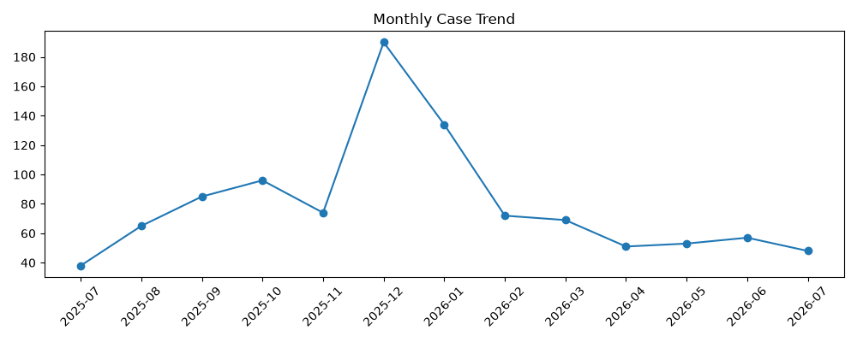 | 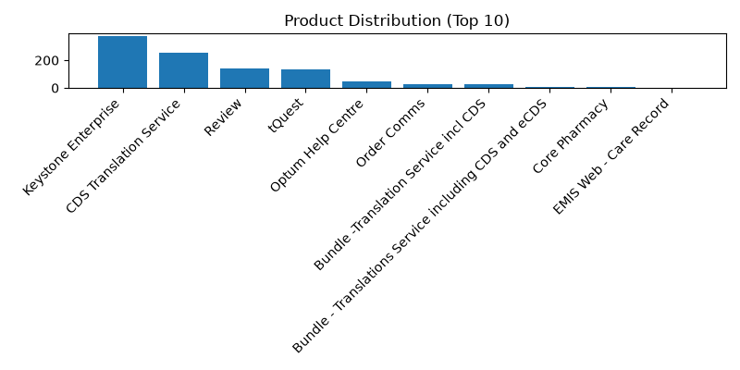
Figure 1. Monthly case creation trend and product concentration.

Product distribution
Rank | Product | Cases
1 | Keystone Enterprise | 374
2 | CDS Translation Service | 254
3 | Review | 139
4 | tQuest | 133
5 | Optum Help Centre | 48
6 | Order Comms | 28
7 | Bundle -Translation Service incl CDS | 26
8 | Bundle - Translations Service including CDS and eCDS | 8
9 | Core Pharmacy | 5
10 | EMIS Web - Care Record | 3

Priority and state profile
State | Cases | Cases

Trending topic analysis
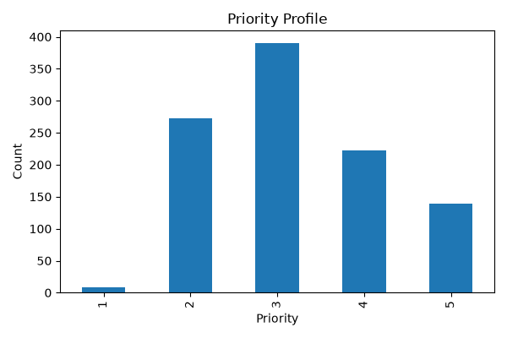
Closed
In Progress
Resolved
On hold
Figure 2. Topic clusters and movement of selected themes by month.

Theme interpretation
Theme | Matching cases | Recent signal from June onwards | Management implication
Audit / IG / access investigation
DAD / HL7 / interface messaging
Performance / outage / errors
Clinical workflow / DEP / clinic / BRM
Data / SQL / configuration
Location / department / lookup changes
Login / access / permissions
Printing / documents / output
Reporting / SSRS / dashboards
Appointments / scheduling

Customer/account concentration
Rank | Account | Cases | Open
Other | 722 | 91 | High volume — consider KB and automation.
Notifications & Communications / Email | 233 | 7 | High volume — consider KB and automation.
Reporting & Analytics / Reporting | 22 | 3 | Low volume — monitor; consider knowledge article if recurring.
Access & Security / Authentication | 15 | 1 | Low volume — monitor; consider knowledge article if recurring.
Defects & Errors / Error Messages | 14 | 1 | Low volume — monitor; consider knowledge article if recurring.
Performance & Availability / Availability | 9 | 1 | Low volume — monitor; consider knowledge article if recurring.
Performance & Availability / Performance | 7 | 0 | Low volume — monitor; consider knowledge article if recurring.
Workflow & Process / Assignment | 2 | 0 | Low volume — monitor; consider knowledge article if recurring.
Notifications & Communications / Alerts | 2 | 0 | Low volume — monitor; consider knowledge article if recurring.
Data Management / Data Quality | 2 | 1 | Low volume — monitor; consider knowledge article if recurring. Recent uptick observed.
Reporting & Analytics / Dashboard | 2 | 0 | Low volume — monitor; consider knowledge article if recurring.
User Guidance & Training / Training | 1 | 0 | Low volume — monitor; consider knowledge article if recurring.
Reporting & Analytics / Analytics | 1 | 0 | Low volume — monitor; consider knowledge article if recurring.
Management observation: Account concentration should be used for service review context only. The export does not include deployment scale, module footprint, contractual scope, number of users, site complexity, or customer reporting behaviour.

Recommended management actions
# | Recommendation | Rationale
1 | Salisbury NHS Foundation Trust | 138
2 | The Shrewsbury And Telford Hospital NHS Trust | 53
3 | Guy's and St Thomas' NHS Foundation Trust | 42
4 | Tameside and Glossop Integrated Care NHS Foundation Trust | 39
5 | Northern Care Alliance NHS Foundation Trust | 33
6 | Mid Yorkshire Teaching NHS Trust | 32
7 | University Hospitals Of Leicester NHS Trust | 31
8 | Oxford University Hospitals NHS Trust | 28
9 | Kingston Hospital NHS Foundation Trust | 26
10 | The Doctors Laboratory Ltd | 25

Appendix:

