Apologies in advance as this is not organised properly. Candidates do not have an option when 48h start and I had other pre-planned commitments in last 2 days.

Few types of unscripted, exploratory testing has been done as a result

* Usability
* Functional UI
* Performance (JMeter)
* Functional API (Playwright)

Assumption – all required projects have been deployed, services are up and running, everything should work.

**Testing notes:**

* JWT authorisation token contains password – not good
* buy API response message could be JSON instead of flat text

**Performance:**

API is scalable and 3 endpoints under the test (/orders /energy and /buy) remained responsive with thousands of simultaneous users. I did not want to push it to the limit as other people might be using it.

**UI Bugs:**

<https://ensekautomationcandidatetest.azurewebsites.net/>

Typo in 'Got some surpless energy?' - should be ‘surplus’

<https://ensekautomationcandidatetest.azurewebsites.net/Home/About>

Info outdated. Presentation is not the best from [readability and] marketing POV.

Found out more URL is broken - <https://ensek.com/about> shows 404. Should be <https://ensek.com/about-us> instead

<https://ensekautomationcandidatetest.azurewebsites.net/Home/Contact>

Error message - not good. And it has typo in image (Erorr) - even worse

<https://ensekautomationcandidatetest.azurewebsites.net/Energy/Sell>

Maintenance - not a professional message.

<https://ensekautomationcandidatetest.azurewebsites.net/Account/Register>

POST call returns 500 and user unfriendly error message is shown

<https://ensekautomationcandidatetest.azurewebsites.net/Account/Login>

There are no external authentication services configured - not good, don't show it then.

Try to login – it breaks, returns 500 and user unfriendly error message is shown

Layout issue on mobile device portrait mode – remember me is out of screen borders

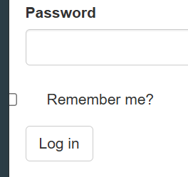

<https://ensekautomationcandidatetest.azurewebsites.net/Energy/Buy>

Can access and make purchases without log-in? Not good

'...press that buy button' - typo? should it be 'the Buy button' instead?

MW vs MWh/kWh. Is the price accurate if it really is MWh?

'per Litres' vs 'per Litre' or something closer to industry standard like tonne or barrel?

Can purchase without log in - VERY strange. Who did the purchase? Where's the money? Where do you send invoice?

Can purchase 0 units

Can purchase negative units, e.g. -10. Quantity of units gets increased.

Can purchase more than total units available. Available units go to negative amount.

No validation on fields, can enter char or space instead of number and get not user friendly error message. No try catch in code as well as it seems

UI is not responsive. Mobile device in portrait mode – fields looks strange

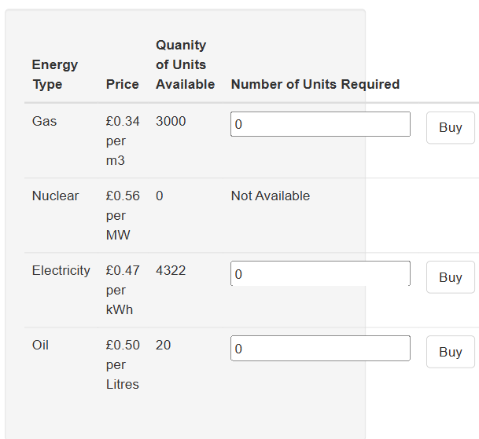

Buy page table size does not match discount panel

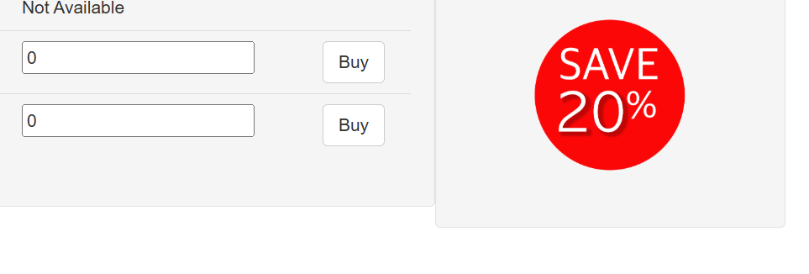Discount mismatch in text and image – 20 vs 30



Time shown is GMT. No indication regarding time zone, not converted to user’s local time zone.

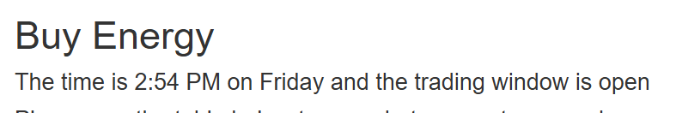

Some headers have dot at the end - looks strange, not consistent over all pages. Some paragraphs do not have full stop at the end when it should.

Logo in header is blurred, zoomed in, use SVG instead

**API Bugs:**

API and UI does not click together. API response and info on web does not match - where does web site gets the info from?

GET https://qacandidatetest.ensek.io/ENSEK/energy

JSON could be updated so schema is significantly simplified (~100 vs ~40 lines)

"electric": {

"energy_id": 3,

"price_per_unit": 0.47,

"quantity_of_units": -43,

"unit_type": "kWh"

}

use this instead

"energy": [

{

"energy_id": 3,

"name" : "electric",

"price_per_unit": 0.47,

"quantity_of_units": -43,

"unit_type": "kWh"

},

/ENSEK/orders

problem: JSON records have different schemas, keys and values.

Id vs id

values: oil vs Oil, Elec vs electric

price [and currency] is missing from transactions

currency is not used anywhere. is it £, $ or €?

API accepts 0 - not OK

API allows to purchase more than existing quantity - not OK

**gas**

PUT /ENSEK/buy/1/10

{

"message": "You have purchased 2947 m³ at a cost of 3.4000000000000004 there are 10 units remaining. Your order id is bd8715ac-499f-4b2d-bf52-64d08eaf347a."

}

Problems: purchased amount is not correct, remaining amount is not correct (mixed up variables on API output). cost looks correct, but needs rounding to 2 decimals

**electricity**

/ENSEK/buy/3/10

{

"message": "You have purchased 10 kWh at a cost of 4.699999999999999 there are 4295 units remaining. Your order id is 1d84abbf-ef09-4ade-b23a-087ee2ae575c."

}

Problems: rounding - should be 4.7 instead of 4.699999999999999

**oil**

/ENSEK/buy/4/10

{

"message": "You have purchased 10 Litres at a cost of 6.0 there are -7 units remaining. Your orderid is af9e8791-2492-458b-8bab-12a772e58307."

}

Problems: cost is not correct - should be 0.5, but 0.6 is used instead. 'orderid' vs 'order id' as in other messages