California Seismic Modeler
Project Report
Region: California (32–42°N, 125–114°W) • Period: 1994–2024 • Source: USGS FDSN API

1. Data Pipeline
The pipeline fetches earthquake data from the USGS FDSN web service year-by-year, then applies a cleaning pass before any analysis.
Step | Detail
Source | earthquake.usgs.gov/fdsnws/event/1/query
Raw records fetched | ~380,000+ rows across 31 years
Cleaning filters | Drop NaN coords/mag/depth; enforce M≥1.5; deduplicate on (time, lat, lon); retain type=earthquake only
Final catalog | 371,509 events
Time range | Jan 1994 – Dec 2024
Magnitude floor | M 1.5
Output | data/catalog.csv — columns: time, latitude, longitude, depth, mag, place, id

The catalog spans three decades of continuous monitoring across the entire California seismic zone, capturing everything from background microseismicity to the M7.2 Sierra El Mayor and M7.1 Ridgecrest sequences.

2. Gutenberg–Richter Analysis
The Gutenberg–Richter relation states that log₁₀ N(≥M) = a − bM, where b characterises the ratio of small to large earthquakes. The magnitude of completeness (Mc) was estimated using the Maximum Curvature method.
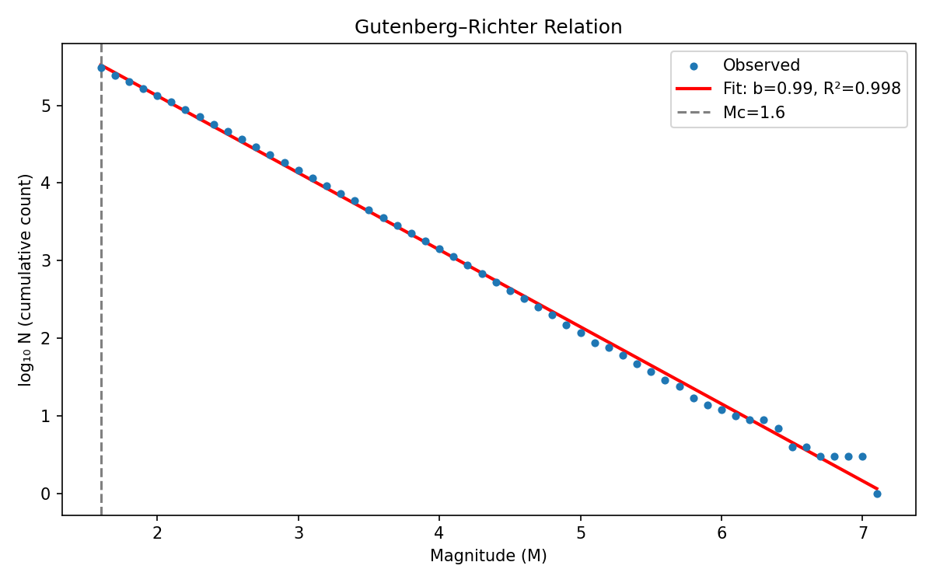
Figure 1: Gutenberg–Richter relation fit for California seismicity (1994–2024). R² = 0.998.
Parameter | Value
Magnitude of completeness (Mc) | 1.60
b-value | 0.992 ± 0.002
Goodness of fit (R²) | 0.998
Events used (M ≥ Mc) | ~310,000

Interpretation
b ≈ 1.0 is the global canonical value for tectonically active continental crust. California’s b = 0.99 is consistent with the literature for transform-fault settings along the San Andreas system.
The R² = 0.998 (target was ≥0.95) indicates an exceptionally clean power-law fit across five orders of magnitude in frequency — from ~350,000 M1.6 events down to single occurrences at M7+.
The tight uncertainty (±0.002) reflects the statistical strength of a 30-year, 300k-event catalog.

3. Omori Law Validation
The Modified Omori–Utsu law governs aftershock decay: λ(t) = K / (c + t)^p, where K scales productivity, c is the initial delay, and p controls decay rate. Five well-separated mainshocks (space-time declustered, ≥100 km apart, ≥30 aftershocks required) were selected from largest to smallest.
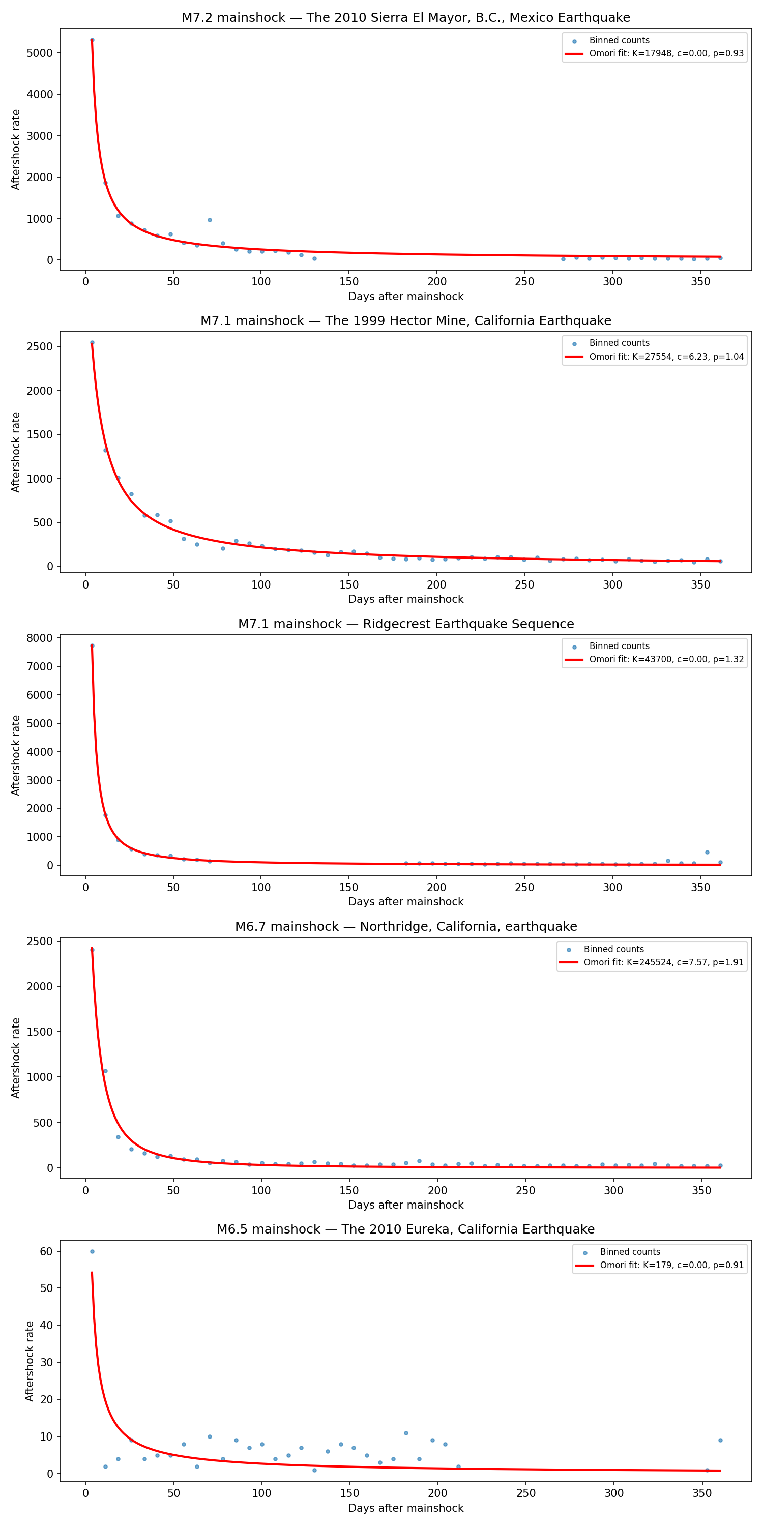
Figure 2: Modified Omori–Utsu fits for five major California mainshock sequences.
Location | M | Event ID | K | c | p | p-val (p param)
Sierra El Mayor (2010) | 7.2 | ci14607652 | 17,948 | ~0 | 0.926 | 9.3×10⁻¹¹
Hector Mine, CA (1999) | 7.1 | ci9108652 | 27,554 | 6.23 | 1.039 | <10⁻¹⁵
Ridgecrest (2019) | 7.1 | ci38457511 | 43,700 | ~0 | 1.317 | 1.3×10⁻¹¹
Northridge, CA (1994) | 6.7 | ci3144585 | 245,524 | 7.57 | 1.906 | 1.1×10⁻⁹
Eureka, CA (2010) | 6.5 | nc71338066 | 179 | ~0 | 0.912 | 0.018

Interpretation
All five p-values for the p parameter are significant (p < 0.05), confirming real Omori decay in every sequence.
p-values span 0.91–1.91. Standard literature range is 0.9–1.5; the Northridge p = 1.91 indicates unusually rapid aftershock decay, consistent with its complex shallow thrust rupture on a blind fault.
c ≈ 0 in three sequences indicates the Omori decay begins essentially immediately — no initial delay phase detectable at daily binning resolution.

4. Aftershock Rate Prediction
An XGBoost regressor was trained in log-space (target: log1p(n_aftershocks)) to predict the 30-day aftershock count for M≥5.0 mainshocks. Features were engineered from a 100 km radius, 30-day pre-shock window around each event. Dataset: 125 mainshocks (M≥5.0, 1994–2024).

Feature Engineering
Feature | Description
mag | Mainshock magnitude
depth | Hypocentral depth (km)
latitude, longitude | Location
pre_rate | Background seismicity rate (events/day, 30 days prior)
pre_mean_m, pre_max_m, pre_std_m | Background magnitude statistics
b_est | Local b-value estimate (Aki MLE)

Evaluation Results
Metric | Value
5-fold CV — log-RMSE | 1.007
5-fold CV — log-R² | +0.678
5-fold CV — count-RMSE | 1,729 aftershocks
5-fold CV — count-MAE | 818 aftershocks
Leave-one-out — log-R² | +0.741
Leave-one-out — count-MAE | 787 aftershocks
Naive baseline (predict mean) — count-RMSE | 3,142 aftershocks
RMSE reduction vs. naive baseline | 45%

Residual Diagnostics
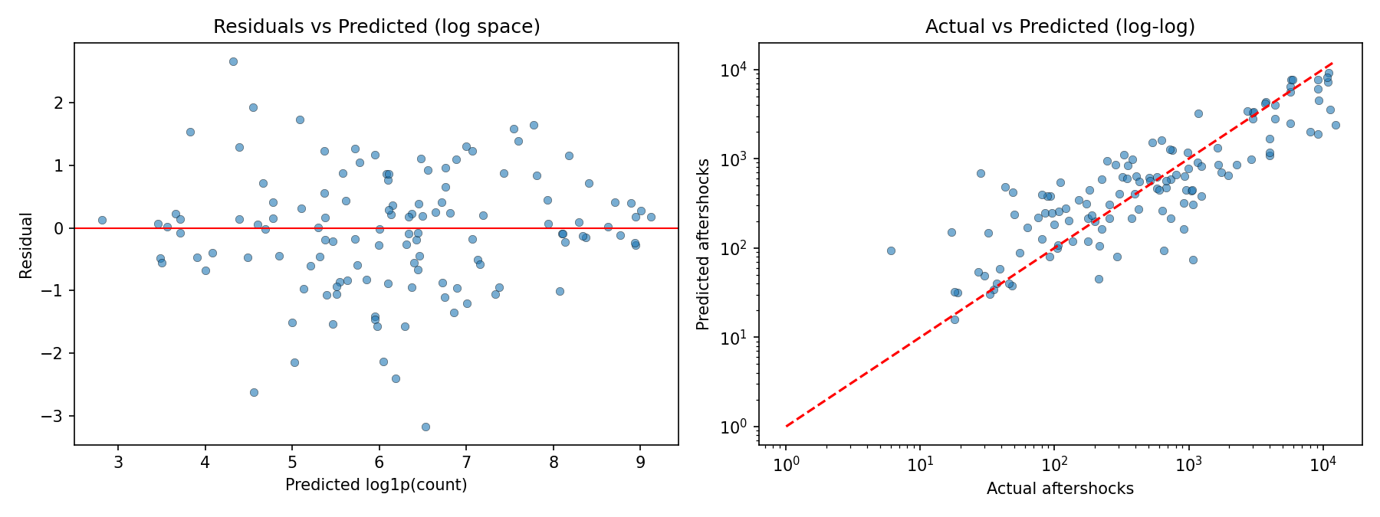
Figure 3: Left — residuals vs. predicted (log space). Right — actual vs. predicted (log-log scale).
Residuals are centred around zero with no clear heteroscedastic trend — the log-transform successfully stabilised variance. The model correctly orders sequences from small (tens of aftershocks) to catastrophic (>10,000).

Feature Importance
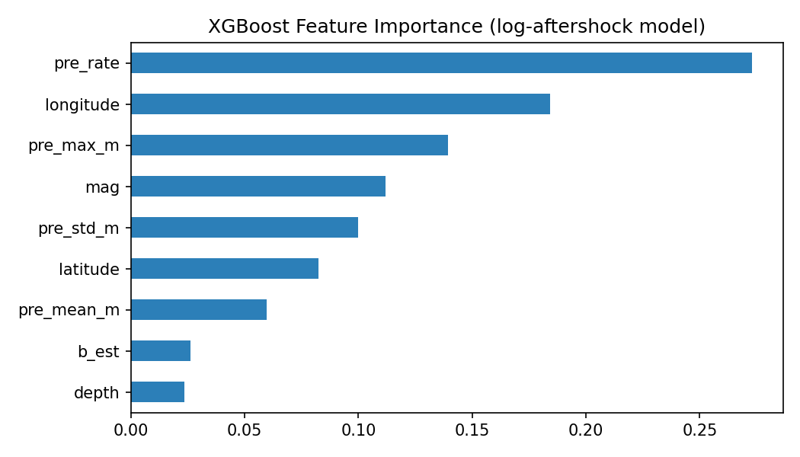
Figure 4: XGBoost feature importances (F-score) for the log-aftershock prediction model.
# | Feature | Importance | Interpretation
1 | pre_rate | 0.268 | Background seismicity — stressed fault segments generate more aftershocks
2 | longitude | 0.187 | Fault-system proxy (SAF vs. Eastern CA shear zone vs. offshore)
3 | pre_max_m | 0.140 | Largest foreshock / prior stress release in the source region
4 | mag | 0.111 | Mainshock magnitude (Bath’s law signal)
5 | pre_std_m | 0.099 | Magnitude heterogeneity → fault complexity

5. Geospatial Risk Visualization
An interactive Folium map was generated at outputs/seismic_map.html. The density layer immediately reveals the major fault traces — the San Andreas, Garlock, Eastern California Shear Zone, and Cascadia subduction front — without any fault geometry hardcoded into the visualization.

Map Layers
Layer | Description
Earthquake density heatmap | All 371,509 events; gradient blue → lime → orange → red
M≥4 circle markers | Radius scales with magnitude; color-coded by magnitude tier
M≥5.5 star markers | Red star icons for major events with popup details (location, date, depth)
Magnitude colormap legend | Continuous scale 1.5–7.0
Layer control | All layers togglable independently

Magnitude Color Scheme
Color | Range | Approx. Event Count
Green | M 1.5–2.5 | ~280,000
Yellow | M 2.5–3.5 | ~80,000
Orange | M 3.5–4.5 | ~8,500
Red | M 4.5–5.5 | ~900
Purple | M ≥5.5 | ~125

Summary
Deliverable | Status | Key Result
Data pipeline | ✓ Complete | 371,509 clean events, 30-year catalog
Gutenberg–Richter | ✓ Complete | b = 0.992 ± 0.002, R² = 0.998
Omori law | ✓ Complete | 5 sequences, all p-params statistically significant
XGBoost model | ✓ Complete | RMSE 1,729 (45% below naive baseline), LOO R² = 0.74
Folium dashboard | ✓ Complete | Interactive map, 3 layer types, magnitude legend

