

Lab Exercise Guide

Technical Enablement Specialists
Leigh Compton, Steve Fowlkes, Eric Higgins
lcompton@us.ibm.com, fowlkes@us.ibm.com, erichiggins@us.ibm.com

Using the web browser, access the lab using the following URL: https://emitchj.github.io/WSC-CICSzVA-Registration/

Using the web browser, access the lab guide using the following URL. This lab guide is in Git Hub.
Lab exercise Guide: https://github.com/IBMTechSales/klp-think2022-labs/tree/master/1152-Mono2Micro-refactorJavaAppsToMicroservices

Lab Environment Connection Instructions

Open a browser window and enter URL https://emitchj.github.io/WSC-CICSzVA-Registration/

From this site you will see links to various materials.

The first link on the page points to this document which contains information on how to access the lab environments as well as information on using a 3270 emulator in the environment.

The next section contains links to instruction workbooks for each the various lab exercises. Click on the link of the exercise that you want to do and download the lab exercise workbook to your desktop. You will use the workbook to guide you through the lab. Note: for the SHARE workshop, hardcopy versions of the workbooks will be available.

The last section is used to obtain credentials for your personal virtual lab environment. At your workstation located a note that identifies your student id. (i.e.. student1@ibm.com)

Under the section entitled “Accessing the hands-on lab,” enter your assigned lab student id in the form and click “Submit.”
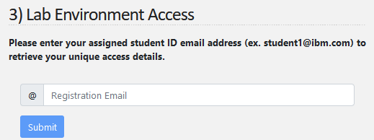

You will see connection details that look like this:
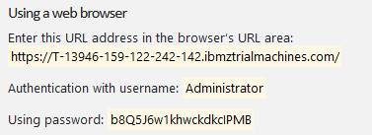

Here is how to use the credentials:
- Copy the address that appears beneath “URL” in the connection details and paste it into the address bar of your browser.
- The web page will then present a login window.
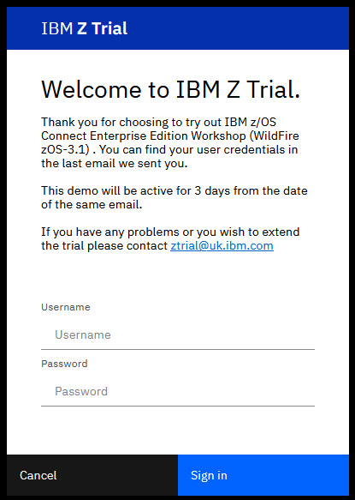

- Use the username that appears under "User ID for Web browser" in the connection details.
- Use the password that appears under "Password" and click "Log in".
- We recommend using copy/paste for the password to avoid typing errors.

Available Lab Exercises

99998: Modernizing CICS applications with Java
- L20 – SOAP based web services.
- L90 – JSON based web services.
- L93 – RESTful JSON with LINK to COBOL program using JSON and JAX-RS

99999: Connectivity and interoperability for CICS Applications
- L34 – How to deploy a CICS application program coded in Java using the OSGi JVM
- L72 – Java Servlet with LINK to COBOL program
- L93 – RESTful JSON with LINK to COBOL program using JSON and JAX-RS

NOTE1:
Hardcopies of the labs exercise documents are available at the event. Your instructors will make them available to you.

“Softcopies” are available. Use this URL to download PDF versions for the exercises:
https://github.com/ibm-wsc/CICS-Wildfire-Workshops/tree/main

NOTE2:
To assist with entering various input fields during the lab exercises, there are copy/paste files that contain the input text for various steps in the exercise.
Use the text in these files to avoid manually typing input, especially the longer and more complex items. This will help avoid typos and other mistakes.

The copy/paste files are in the virtual image at C:\CICSLAB\CopyPasteFiles.

Lab Exercise Key:
(z/OS Userids, Password, Port, etc.)

The labs have symbols which you will need to substitute. Symbols look like this:
<zOS_userid>.CICSLAB.UTIL

You will substitute using one of these values:

- <zOS_userid> : USER1
- <zOS_Password> : USER1
- <CICS_Port : 1423 (used for all labs except Liberty labs)
- <CICS_APPLID> : CICS1
- <Servlet_JSP_Port> : 1424 (used for Liberty labs)
- <zOS_DNS_Name> : ws31.washington.ibm.com

Results:
USER1.CICSLAB.UTIL

Note: Screen shots are NOT 100% accurate. Follow the text explanations rather than what you see in the screen shot.

Personal Communications Emulator Tips

Note: The 3270-terminal sessions for TSO and OMVS screen shots in these exercises are in reverse video simply for printing purposes.

There are 3270-emulator keyboard mapping issues encountered when using a web browser to access Windows desktop. As a result, not all keyboard mappings described in this document may not work as intended.

Below is a guide to help you resolve issues if you have inconsistent or non-working 3270 keys.

Any references to the Enter key in non-3270 windows, OMVS terminal session, etc. refers to the key labeled Enter on the keyboard.

- The 3270-emulator used for this workshop (IBM Personal Communication) maps the 3270 enter key to the right Ctrl key (see below). If the right Ctrl key does not work, try using the key labeled Enter or Return on your keyboard.
- The 3270 newline key has been mapped to the Shift-Enter key sequence.
- The 3270 clear key has been mapped to the Cntl-Enter key sequence.
- If all else fails, select Actions on the 3270-emulator tool bar and then select the Display Popup Keypad option. This displays the popup below where you select various keys.
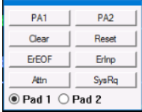

- z/OS Updates Different 3270-terminal emulators will display an icon like the ‘Personal Communications’ icon below at the bottom of the screen when the keyboard is locked. If this occurs use the left Ctrl key to reset or free the keyboard.
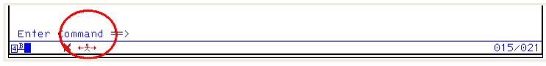

Configuring the Keyboard with Mac keyboards
- To reconfigure the IBM Personal Communications keyboard when using a Mac keyboard, click on View on the tool bar and select the Tool Bar option. Next click on the Remap Keyboard functions icon (see below).
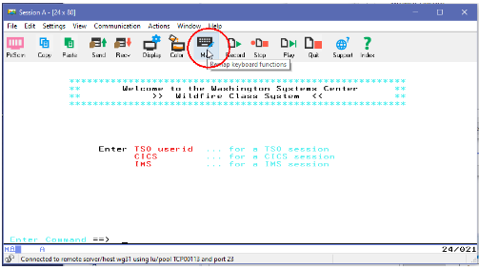

- To set the Return key to perform the enter function, click on the Return (1) key, use the pull down arrow to select Enter from the function list menu (2), and then in the Change Current Actions for Selected Key section, click on the arrow to the left of Base (3) to set the default function of pressing the Return key to [enter] (refer to the picture below)
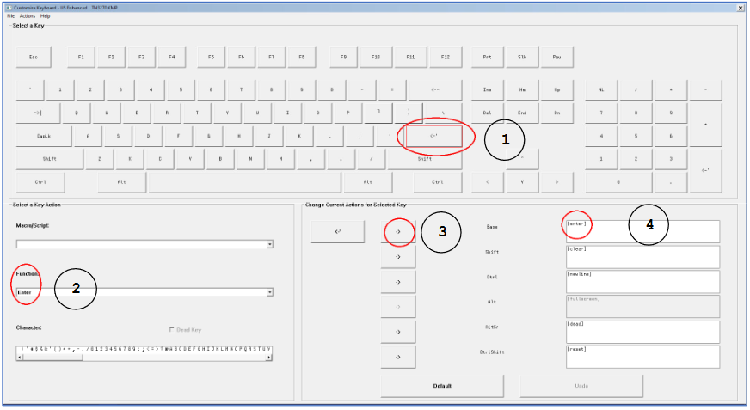

- To set the Return key to perform the clear the screen function, click on the Return (1) key, use the pull down arrow to select Clear Screen from the function list menu (2), and then in the Change Current Actions for Selected Key section, click on the arrow to the left of Shift (3) to set the default function of pressing the Shift-Return key sequence [clear].

- To set the Return key to perform the new line function, click on the Return (1) key, use the pull down arrow to select New Line from the function list menu (2), and then in the Change Current Actions for Selected Key section, click on the arrow to the left of Ctrl (3) to set the default function of pressing the Ctrl-Return key sequence to move the cursor down a line [newline].

- To set the Return key to reset a locked keyboard, click on the Return (1) key, use the pull down arrow to select Reset from the function list menu (2), and then in the Change Current Actions for Selected Key section, click on the arrow to the left of CtrlShift (3) to set the default function of pressing the Ctrl-Shift-Return key sequence to reset or unlock a key board [reset].

- When finished, your keyboard actions for the Return key should match the picture above.

- To set the Ctrl-C key sequence to perform the copy function, click on the C key (1) and then in the Change Current Actions for Selected Key section, click on the arrow to the left of Ctrl (2) to set the default function of pressing the Ctrl-C key sequence to [edit-copy] (3) (refer to the picture below).

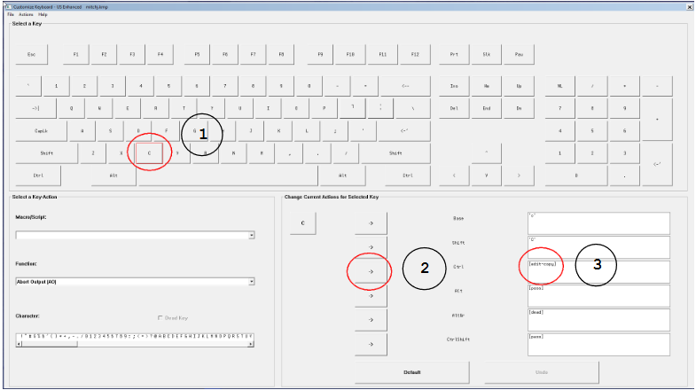

- To set the Ctrl-V key sequence to perform the paste function, click on the V key (1) and then in the Change Current Actions for Selected Key section, click on the arrow to the left of Ctrl (2) to set the default function of pressing the Ctrl-V key sequence to [edit-paste] (3) (refer to the picture below).
