

Lab Exercise Guide

Simplifying Z Configuration - Harness the power of config as code
Enforcing a Zero Trust Strategy in CICS using Security Discovery

Technical Enablement Specialists:
Leigh Compton: lcompton@us.ibm.com
Steve Fowlkes: fowlkes@us.ibm.com
Eric Higgins: erichiggins@us.ibm.com
Ezriel Gross: ezriel@ibm.com
Andrew Smithson: SMITHSON@uk.ibm.com

Access the lab using the following URL: https://emitchj.github.io/WSC-CICSzVA-Registration/ ise Guide: https://githu
Lab Environment Connection Instructions

- Go to website https://emitchj.github.io/WSC-CICSzVA-Registration/

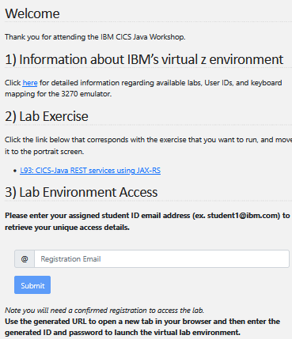

- Click the link in section #1 to read detailed instructions about accessing and using the IBM virtual environment.

- Click the link in section #2 to access a PDF copy of the lab instructions. You may save a copy of these instructions on your own desktop for reference. There are hard-copies available for SHARE.

- Use section #3 to obtain access information and credentials for the virtual environment. Enter the student ID email address from the sheet of paper in the “Registration Email” box and hit Submit.

- You will be presented with a URL, user ID, and password for the virtual environment that looks like this image:

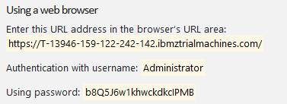

- Use the URL that was returned in step #5 to initiate the virtual image sign-on page a web page. It may take a few seconds for the sign-on page to appear.

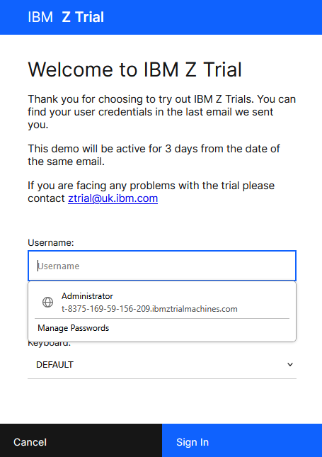

- Enter the user ID and password that was returned in step #5, and click on Sign In.
  - Use copy/paste for the password to avoid typos.

- Once the image starts, you will be presented with a virtual image in a web browser that looks like this:

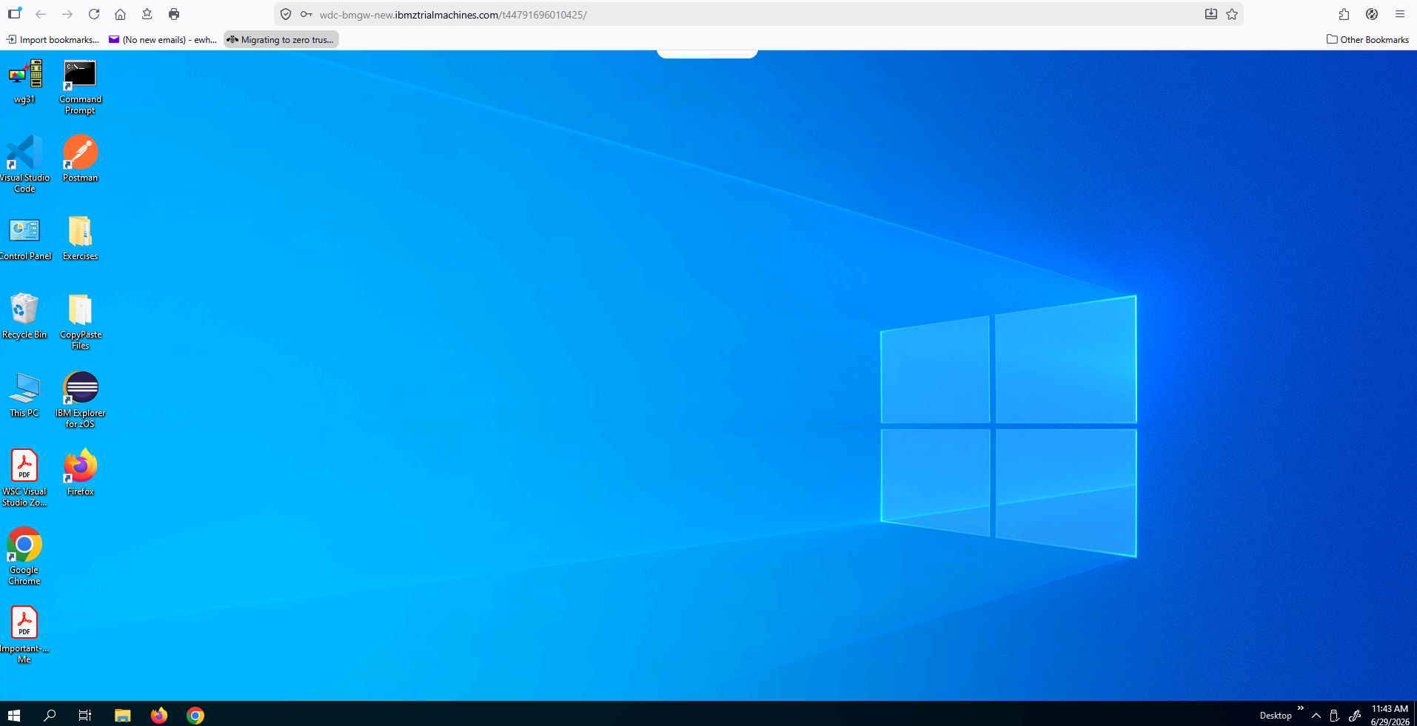

- Note, it may take a minute or two for the virtual environment to activate.

- You are now ready to start following the step-by-step instructions in the lab guide.
Available Lab Exercises

- Simplifying Z Configuration - Harness the Power of Config as Code
- Enforcing a Zero Trust Strategy in CICS using Security Discovery

NOTE1:
Hardcopies of the lab exercise documents are available at the event. Your instructors will make them available to you.

PDF versions are available for download. They are located at: https://github.com/ibm-wsc/CICS-Conference-Labs

NOTE2:
To assist with entering various input fields during the lab exercises, there may be copy/paste files that contain the input text for various steps in the exercise.
Use the text in these files to avoid manually typing input, especially the longer and more complex items. This will help avoid typos and other mistakes.

The copy/paste files are located on the desktop of the virtual windows image with the folder name of copy/paste.


Lab Exercise Key:
(z/OS Userids, Password, Port, etc.)

The labs have symbols which you will need to substitute. Symbols look like this:
<zOS_userid>.CICSLAB.UTIL

You will substitute using one of these values:

- <zOS_userid> : USER1
- <zOS_Password> : USER1
- <CICS_Port : 1423 (used for all labs except Liberty labs)
- <CICS_APPLID> : CICS1
- <Servlet_JSP_Port> : 1424 (used for Liberty labs)
- <zOS_DNS_Name> : ws31.washington.ibm.com

Results:
USER1.CICSLAB.UTIL

Note: Screen shots are NOT 100% accurate. Follow the text explanations rather than what you see in the screen shot.

Personal Communications Emulator Tips

Note: The 3270-terminal sessions for TSO and OMVS screen shots in these exercises are in reverse video simply for printing purposes.

There are 3270-emulator keyboard mapping issues encountered when using a web browser to access Windows desktop. As a result, not all keyboard mappings described in this document may not work as intended.

Below is a guide to help you resolve issues if you have inconsistent or non-working 3270 keys.

Any references to the Enter key in non-3270 windows, OMVS terminal session, etc. refers to the key labeled Enter on the keyboard.

- The 3270-emulator used for this workshop (IBM Personal Communication) maps the 3270 enter key to the right Ctrl key (see below). If the right Ctrl key does not work, try using the key labeled Enter or Return on your keyboard.
- The 3270 newline key has been mapped to the Shift-Enter key sequence.
- The 3270 clear key has been mapped to the Cntl-Enter key sequence.
- If all else fails, select Actions on the 3270-emulator tool bar and then select the Display Popup Keypad option. This displays the popup below where you select various keys.
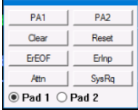

- z/OS Updates Different 3270-terminal emulators will display an icon like the ‘Personal Communications’ icon below at the bottom of the screen when the keyboard is locked. If this occurs use the left Ctrl key to reset or free the keyboard.
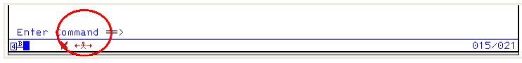

Configuring the Keyboard with Mac keyboards
- To reconfigure the IBM Personal Communications keyboard when using a Mac keyboard, click on View on the tool bar and select the Tool Bar option. Next click on the Remap Keyboard functions icon (see below).
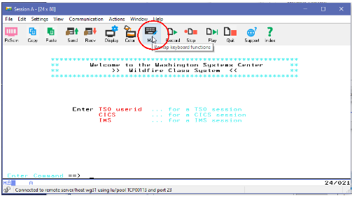

- To set the Return key to perform the enter function, click on the Return (1) key, use the pull down arrow to select Enter from the function list menu (2), and then in the Change Current Actions for Selected Key section, click on the arrow to the left of Base (3) to set the default function of pressing the Return key to [enter] (refer to the picture below)
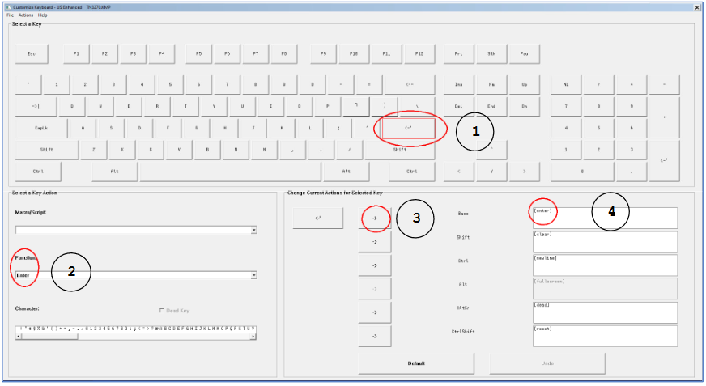

- To set the Return key to perform the clear the screen function, click on the Return (1) key, use the pull down arrow to select Clear Screen from the function list menu (2), and then in the Change Current Actions for Selected Key section, click on the arrow to the left of Shift (3) to set the default function of pressing the Shift-Return key sequence [clear].

- To set the Return key to perform the new line function, click on the Return (1) key, use the pull down arrow to select New Line from the function list menu (2), and then in the Change Current Actions for Selected Key section, click on the arrow to the left of Ctrl (3) to set the default function of pressing the Ctrl-Return key sequence to move the cursor down a line [newline].

- To set the Return key to reset a locked keyboard, click on the Return (1) key, use the pull down arrow to select Reset from the function list menu (2), and then in the Change Current Actions for Selected Key section, click on the arrow to the left of CtrlShift (3) to set the default function of pressing the Ctrl-Shift-Return key sequence to reset or unlock a key board [reset].

- When finished, your keyboard actions for the Return key should match the picture above.To set the Ctrl-C key sequence to perform the copy function, click on the C key (1) and then in the Change Current Actions for Selected Key section, click on the arrow to the left of Ctrl (2) to set the default function of pressing the Ctrl-C key sequence to [edit-copy] (3) (refer to the picture below).

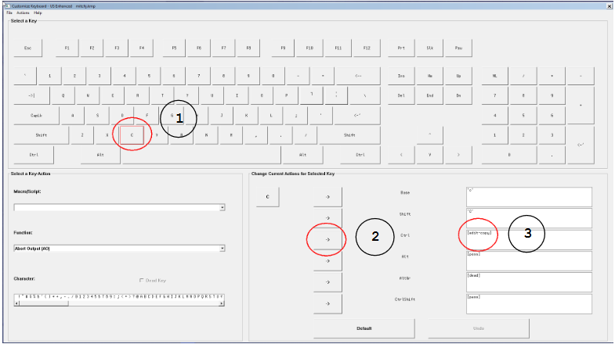

- To set the Ctrl-V key sequence to perform the paste function, click on the V key (1) and then in the Change Current Actions for Selected Key section, click on the arrow to the left of Ctrl (2) to set the default function of pressing the Ctrl-V key sequence to [edit-paste] (3) (refer to the picture below).

