Netball

Netball is a game between two 2 teams, A and B. Each team during a game has 7 players who hold different positions namely Center, Wind Attacker, Wind Defender, Goal Attacker, Goalkeeper, Goal Defender & Goal Scorer. In total, 14 players are in the netball field during a match.

Netball is commonly played by females. In the case of a male playing in a match, each team MUST have an equal number of males and an equal number of females during a match.

If Team A has 3 males, Team B should also have 3 males during a match.

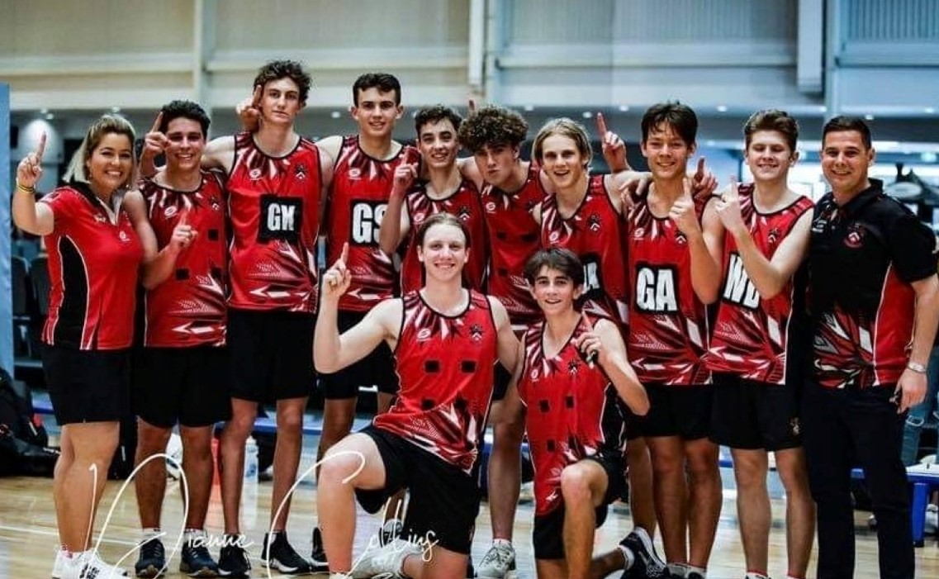

[This Photo](https://www.bundabergnow.com/2021/07/20/two-local-boys-netball-teams-off-to-state-championship/) by Unknown Author is licensed under [CC BY](https://creativecommons.org/licenses/by/3.0/)

Equipment:

* Uniform ~ Skirt and T-Shirt or a dress, socks, training shoes, cap, bib/jersey
* Balls
* Ankle support
* A painted netball field 

Gameplay:

* A full game is 60 minutes, split into four 15minute intervals.
* A game has two umpires

How To Play

* At the beginning of the game, a toss is done to determine which side will hold the ball first. The toss is done between the Center players for each team. After the toss, the team that won the toss breaks the game.
* The ball must be thrown among teammates and scored at the goal post.
* A player can only hold the ball in their hands for a maximum of 3 seconds.
* The ball is scored when the player is inside the semi-circle, nowhere else.
* If the ball is caught by a player, the player holding the ball should not move the ball in their fingers, the player should not move their hands and they should not move their feet.
* Players have specified areas in which they can move. Free movement in these areas is allowed when a player is not holding any ball.
* No dribbling is allowed. A player holding the ball should not be touched and must be given 3 meters of space. The ball can be defended only if it is the air. The person defending the ball should avoid touching the opposing team’s player.
* The ball is considered ‘out of court’ if it bounces out of the field. The ball is thrown inside by the opposing team player. Substitution of players happens during the match quarters or in the match breaks.
* With every score in the ball post, the team earns a point.
* Half time interval in a match is 4 minutes.

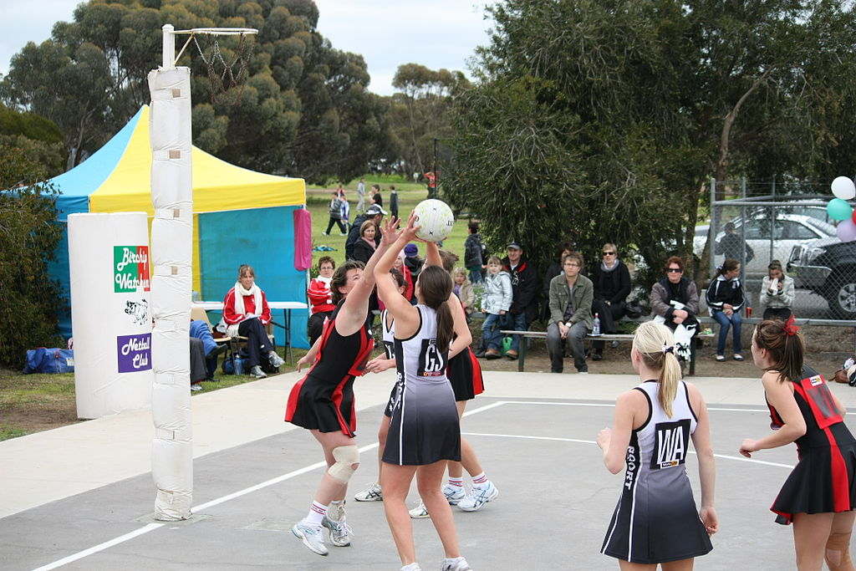

[This Photo](https://commons.wikimedia.org/wiki/File:North_Central_Netball_Victoria.jpg) by Unknown Author is licensed under [CC BY-SA](https://creativecommons.org/licenses/by-sa/3.0/)

How to Win a Match:

The team with the biggest score total wins the game.

Tournaments:

* The biggest netball tournament is Netball World Cup (NWC) which hosts most national netball teams from around the world. NETBALL WORLD CUP 2023 WILL BE HOSTED IN SOUTH AFRICA, CAPE TOWN!
* A participant in the tournament should be 16 years or older.
* A team should have 10 players in total, including the substitutes.
* Structure:

The tournament is played in 4 stages.

* 1. The teams participating in the tournament will get to play a match before any tournament movements are performed.
  2. The teams with most points from the matches in Stage 1 advance to stage 2. In stage 2, matches are played, and winners are determined. Winners in this stage move to the next playing stage.
  3. Teams which win their matches in this stage advance to the next stage, Stage 4.
  4. This is the final stage, winners in this stage win the tournament and get prizes.
* Locations: The tournament is played in one city. Different stadiums can be used for multiple matches.

South African Netball

Netball South Africa (NSA) is the overall governing body for netball in South Africa.

Each province has its front teams. 9 provincial teams are available in SA.

NSA manages 47 regional netball teams.

NSA also manages Municipal/Regional teams, ward teams & teams from Schools.

Actions:

EASTERN CAPE ALOES VS COMETS

TELKOM NETBALL LEAGUE

**Match Date**: 30 APRIL 2022

**FINAL SCORE** = ALOES : COMETS

35 : 32

**LOCATION:** Olive Convention Center, DBN.

|  |  |  |
| --- | --- | --- |
| MATCH QUARTER | Comets | Aloes |
| #1 | 8 | 11 |
| #2 | 11 | 10 |
| #3 | 6 | 7 |
| #4 | 7 | 7 |
| TOTAL | 32 | 35 |

Telkom Netball LEAGUE STANDINGS (7 June 2022)

|  |  |  |
| --- | --- | --- |
| ALOES |  | COMETS |
| 18 | Points | 1 |
| 9 | Total Matches Played | 10 |
| 9 | Win | 4 |
| 0 | Lose | 5 |
| 0 | Draw | 1 |