Netball

Netball is a game between two 2 teams, A and B. Each team during a game has 7 players who hold different positions namely Center (C), Wind Attacker (WA), Wind Defender (WD), Goal Attacker (GA), Goalkeeper (GK), Goal Defender (GD) & Goal Shooter (GS). In total, 14 players are in the netball field during a match.

Netball is commonly played by females. In the case of a male playing in a match, each team MUST have an equal number of males and an equal number of females during a match.

If Team A has 3 males, Team B should also have 3 males during a match.

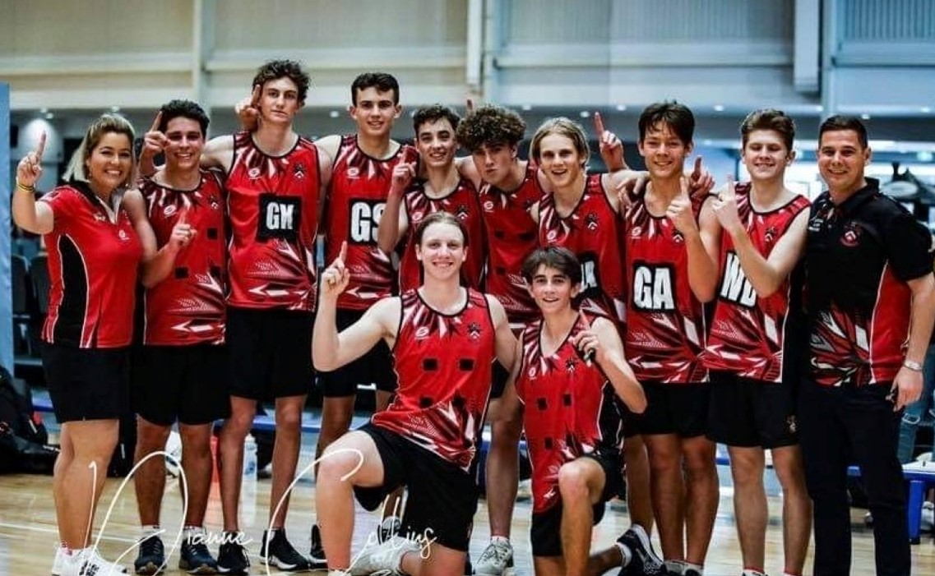

[This Photo](https://www.bundabergnow.com/2021/07/20/two-local-boys-netball-teams-off-to-state-championship/) by Unknown Author is licensed under [CC BY](https://creativecommons.org/licenses/by/3.0/)

Equipment:

* Uniform ~ Skirt and T-Shirt or a dress, socks, training shoes, cap, bib/jersey
* Balls
* Ankle support
* A painted netball field 

Gameplay:

* A full game is 60 minutes, split into four 15minute intervals.
* A game has two umpires

How To Play

* At the beginning of the game, a toss is done to determine which side will hold the ball first. The toss is done between the Center players for each team. After the toss, the team that won the toss breaks the game.
* The ball must be thrown among teammates and scored at the goal post.
* A player can only hold the ball in their hands for a maximum of 3 seconds.
* The ball is scored when the player is inside the semi-circle, nowhere else.
* If the ball is caught by a player, the player holding the ball should not move the ball in their fingers, the player should not move their hands and they should not move their feet.
* Players have specified areas in which they can move. Free movement in these areas is allowed when a player is not holding any ball.
* No dribbling is allowed. A player holding the ball should not be touched and must be given 3 meters of space. The ball can be defended only if it is the air. The person defending the ball should avoid touching the opposing team’s player.
* The ball is considered ‘out of court’ if it bounces out of the field. The ball is thrown inside by the opposing team player. Substitution of players happens during the match quarters or in the match breaks.
* With every score in the ball post, the team earns a point.
* Half time interval in a match is 4 minutes.

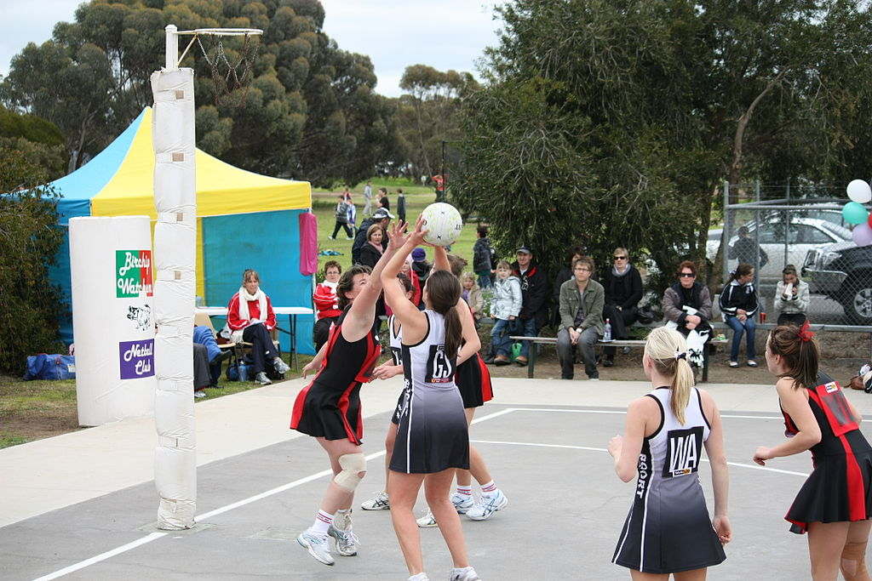

[This Photo](https://commons.wikimedia.org/wiki/File:North_Central_Netball_Victoria.jpg) by Unknown Author is licensed under [CC BY-SA](https://creativecommons.org/licenses/by-sa/3.0/)

How to Win a Match:

The team with the biggest score total wins the game.

Tournaments:

* The biggest netball tournament is Netball World Cup (NWC) which hosts most national netball teams from around the world. NETBALL WORLD CUP 2023 WILL BE HOSTED IN SOUTH AFRICA, CAPE TOWN!
* A participant in the tournament should be 16 years or older.
* A team should have 10 players in total, including the substitutes.
* Structure:

The tournament is played in 4 stages.

* 1. The teams participating in the tournament will get to play a match before any tournament movements are performed.
  2. The teams with most points from the matches in Stage 1 advance to stage 2. In stage 2, matches are played, and winners are determined. Winners in this stage move to the next playing stage.
  3. Teams which win their matches in this stage advance to the next stage, Stage 4.
  4. This is the final stage, winners in this stage win the tournament and get prizes.
* Locations: The tournament is played in one city. Different stadiums can be used for multiple matches.

South African Netball

Netball South Africa (NSA) is the overall governing body for netball in South Africa.

Each province has its front teams. 9 provincial teams are available in SA.

NSA manages 47 regional netball teams.

NSA also manages Municipal/Regional teams, ward teams & teams from Schools.

Actions:

Match 1:

EASTERN CAPE ALOES VS COMETS

TELKOM NETBALL LEAGUE

**Match Date**: 30 APRIL 2022

**FINAL SCORE** = ALOES : COMETS

35 : 32

**LOCATION:** Olive Convention Center, DBN.

|  |  |  |
| --- | --- | --- |
| **Eastern Cape Aloes** **Coach: Sameshia Esau** | | |
| **Player’s Name** | **Position** | **Goals Scored** |
| 1. Noluthando Maliehe | Wing Defender | 0 |
| 1. Busisiwe Mevana | Center | 0 |
| 1. Kaylin Coetzer | Goal Shooter | 24 |
| 1. Juanita Van Tonder | Goal Attacker | 9 |
| 1. Nomxolisi Luvuno | Goal Attacker | 2 |
| 1. Mothira Mohammad | Wing Attacker | 0 |
| 1. Jeanie Steyn | Goal Defender | 0 |
| 1. Zandre Smit | Goal Keeper | 0 |
| 1. Yandiswa Makasi | Bench | 0 |
| 1. Siphosethu Kilani | Bench | 0 |
| 1. Sinathi Bantom | Bench | 0 |
| 1. Siyamthanda Dingiswayo | Bench | 0 |
| 1. Mitha Sinxo | Bench | 0 |
| 1. Mihlali Mgweba | Bench | 0 |

|  |  |  |
| --- | --- | --- |
| **Eastern Cape Comets Coach: Wendy Higson** | | |
| **Player’s Name** | **Position** | **Goals Scored** |
| 1. Asekho Njeza | Goal Attacker | 21 |
| 1. Princess Kanetsi | Goal Shooter | 10 |
| 1. Qamisa Jonas | Center | 0 |
| 1. Bongise Wete | Goal Keeper | 0 |
| 1. Nwabisa Maseni | Goal Defender | 0 |
| 1. Britney Van Der Merwe | Wing Defender | 0 |
| 1. Carla Viviers | Wing Attacker | 0 |
| 1. Bianca Blom | Goal Shooter | 1 |
| 1. Tammy-Leigh Jonas | Bench | 0 |
| 1. Kelly Du Toit | Bench | 0 |
| 1. Jamie-Leigh Goeda | Bench | 0 |
| 1. Ziyeza Mjoja | Bench | 0 |
| 1. Hanniska van Huuren | Bench | 0 |
| 1. Athenkosi Mbengashe | Bench | 0 |

|  |  |  |
| --- | --- | --- |
| **MATCH QUARTER** | **Comets** | **Aloes** |
| #1 | 8 | 11 |
| #2 | 11 | 10 |
| #3 | 6 | 7 |
| #4 | 7 | 7 |
| TOTAL | 32 | 35 |

Telkom Netball LEAGUE STANDINGS (7 June 2022)

|  |  |  |
| --- | --- | --- |
| ALOES |  | COMETS |
| 18 | Points | 1 |
| 9 | Total Matches Played | 10 |
| 9 | Win | 4 |
| 0 | Lose | 5 |
| 0 | Draw | 1 |

Match 2:

30 April 2022 : Sunbirds Vs Tornados

Olive Convention Center, Durban

|  |  |  |
| --- | --- | --- |
| Mpumalanga Sunbirds **Coach: Thembi Mtshali** | | |
| **Player’s Name** | **Position** | **Goals Scored** |
| 1. Maryke Mbukwana | Bench | 0 |
| 1. Atacia Mabuyane | Goal Attacker | 25 |
| 1. Hope Sibiya | Center | 0 |
| 1. Sylvia Lebelo | Center | 0 |
| 1. Zanele Mokoena | Bench | 0 |
| 1. Nkateko Rikhotso | Bench | 0 |
| 1. Tumelo Nkoe | Goal Defender | 0 |
| 1. Bianca Pienaar | Goal Shooter | 23 |
| 1. Bhongolethu Bakwane | Bench | 0 |
| 1. Jani Bargh | Wing attacker | 0 |
| 1. Philicia Kgaabi | Wing defender | 0 |
| 1. Swelihle Ngidi | Bench | 0 |

|  |  |  |
| --- | --- | --- |
| Western Cape Tornados **Coach: Danlee Mathews** | | |
| **Player’s Name** | **Position** | **Goals Scored** |
| 1. Yeukai Chamba | Goal Keeper | 0 |
| 1. Adri Kannemeyer | Goal Attacker | 7 |
| 1. Rochelle Rossouw | Bench | 0 |
| 1. Seneste Ponie | Center | 0 |
| 1. Dominique Wepener | Goal Defender | 0 |
| 1. Frances Olivier | Goal Attacker | 5 |
| 1. Liandre Schoeman | Bench | 0 |
| 1. Lauren Adendorf | Goal Shooter | 9 |
| 1. Caitlin Brouckaert | Bench | 0 |
| 1. Amber Coraizin | Wind Attacker | 0 |
| 1. Shevonne Hoffman | Goal Shooter | 9 |
| 1. Heidi Kuzatjike | Wing Defender | 0 |
| 1. Anja Liebenberg | Goal Keeper | 0 |
| 1. Renisha Daniels | Bench | 0 |

**OTHER**

|  |  |  |
| --- | --- | --- |
| **Sunbirds** |  | **Tornados** |
| 48 | **Final Score** | 34 |
| 26 | **Total Fouls** | 28 |
| 1 | **Total Substitutions** | 3 |