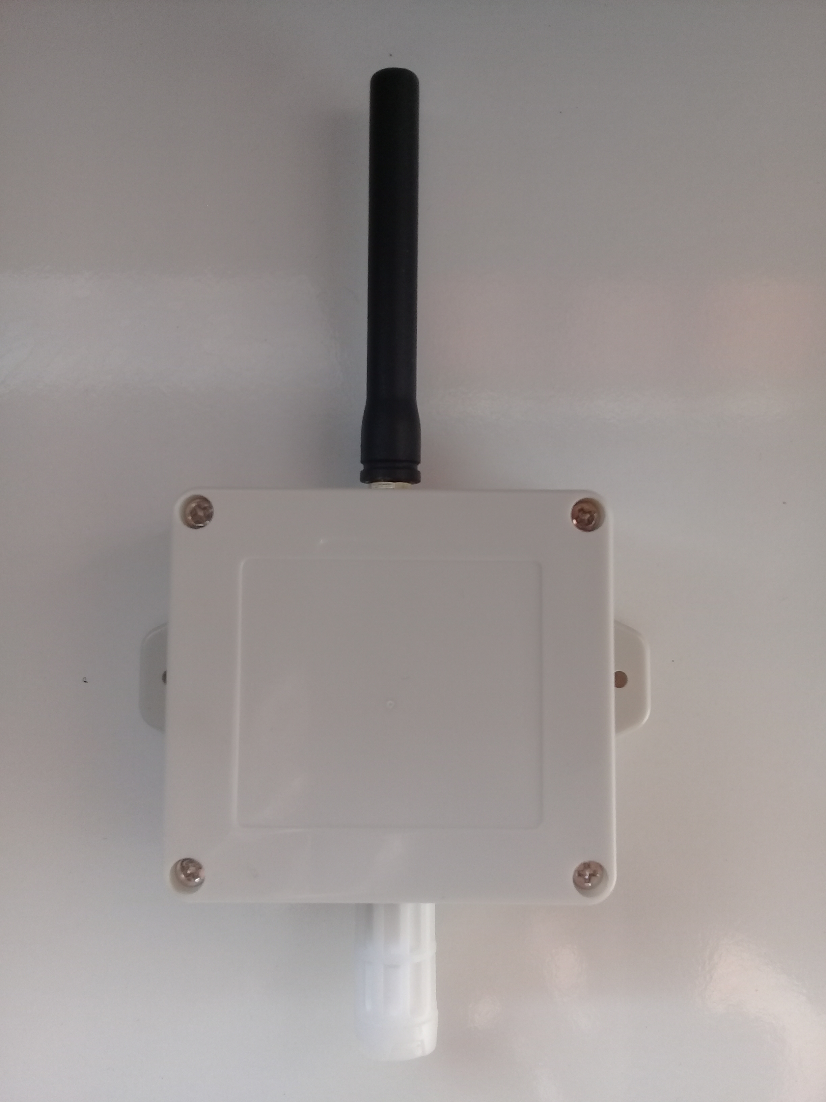

**LoRaWAN TH**

**Outdoor Temperature & Humidity Sensor**

**SENSOR**

**Temperature;**

Range -40 to +125 C

Resolution 0.01 C

Accuracy tolerance +-0.2 C

**Humidity;**

Range 0 to 100 %RH

Resolution 0.01 %RH

Accuracy tolerance +-2 %RH

**RADIO**

LoRaWAN 1.0.2 Class A

Licence Free ISM Bands (EU868, US915..), Default EU868, 8 Channel

Up to 100mW (20dbm) output power

High sensitivity -148dbm

3dbi External Antenna

Long Range, greater than 10km line of sight

**POWER**

3.6V 9000mah ER26500 C Size LiSClO2

10uA sleep current

Up to 5 years battery life depending on send interval

Low battery alarm

**CONFIGURATION**

Configuration via USB, Pc, Phone, Tablet

Send Interval, 5min to 24h

High and Low Alarm thresholds

Full LoRaWAN parameters access

Over The Air Activation (OTAA) with DevEUI, AppEUI, AppKEY

**PHYSICAL**

Outdoor IP65 waterproof enclosure

Mounting flanges

76X70X40mm