Strongly Strongly
disagree agree
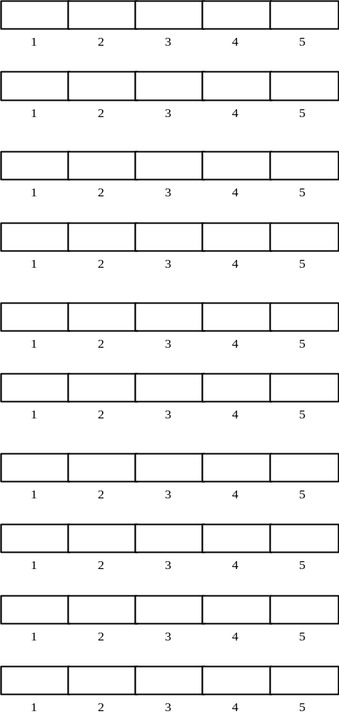
1. I think that I would like to
use this system frequently

2. I found the system unnecessarily
complex

3. I thought the system was easy
to use

4. I think that I would need the
support of a technical person to
be able to use this system

5. I found the various functions in
this system were well integrated

6. I thought there was too much
inconsistency in this system

7. I would imagine that most people
would learn to use this system
very quickly

8. I found the system very
cumbersome to use

9. I felt very confident using the
system

10. I needed to learn a lot of
things before I could get going
with this system

