**2. Background**

**2.1. Worked examples**

**2.1.1. Definition Worked Examples**

Clark defines a worked example as “a step-by-step demonstration of how to perform a task or how to solve a problem" (Clark, Nguyen, Sweller, 2006, p. 190). Another definition for worked examples is given by Atkinson as “instructional devices that provide an expert's problem solution for a learner to study.”(Learning from Examples: Instructional Principles from the Worked Examples Research). An effective worked example consists of a problem description, steps towards the solution and instructions at each step representing an expert’s process of thinking (Renkl, 2005). Of key importance is the step-by-step guidance for reaching the solution. It encourages the learner to form their own explanation for the undertaken step (Renkl et al, 2004) as well as think about what might follow next before they proceed. In essence, worked examples help novices to build an understanding of a concept so that in later stages they are able to effectively apply this understanding to solve other problems related to this concept.

**2.1.2. Worked Examples and Learning**

The common assumption that the best learning is by practicing solving problems is not necessarily true for learning Computing Science. Renkl(2005) argues that without being exposed to worked examples first, novices have a very restricted knowledge on the domain to be able to effectively reach a solution. Solving problems involves a lot of working memory resources. However, the memory capacity of beginners should be used for building new knowledge. Clark argues that solving practice problems leads to using too much memory capacity thus not leaving enough of it for learning new knowledge (e-Learning and the Science of Instruction: Proven Guidelines for Consumers – Ruth C. Clark, Richard E. Mayer p.204).

Studying worked examples “is one of the earliest and probably the best known cognitive load reducing techniques” (Paas et al., 2003). It has proven to be effective in learning how to solve problems (van Merriënboer, 1997). While worked examples reduce the cognitive load, they also provide a better understanding of the concepts under consideration. This builds up the necessary expertise required to solve a particular type of problem effectively.

**2.1.3. Worked Examples in Computing Science Context**

Having conversations with teachers throughout the years, Professor Quintin Cutts, who is the supervisor of this project and who has been working with the computing science school teacher community across Scotland for ten years and has recently been awarded the MBE for services to computing science (<http://www.gla.ac.uk/news/headline_385680_en.html>), has identified that the traditional methods of teaching Computing Science in schools across the UK do not include the best proven method to learn a cognitive skill described above. Often in schools, Computing Science concepts are introduced by explaining what the concept is, followed by a simple example. Then students are presented with a problem to solve themselves. The importance of worked examples has not influenced the teaching methods. Keeping in mind that teachers are often limited time- and money-wise, a possible reason for this is because there is no easy means of finding and adapting existing worked examples to the specific needs of a teacher.

As part of his research project, the former Glasgow University PhD student in Philosophy Dr. Yulun Song developed software to facilitate the creation and viewing of worked examples. The thesis statement for the research outlines the basic aims for the project. The system developed is such that it:

* “delivers usable, best practice interactive worked examples to students in a computing science context;”
* “enables teachers to create such interactive worked examples without bespoke programming, and to evolve them on the basis of feedback from the students.”

Dr. Song is particularly interested in Computing Science problems due to their transformation-based nature. They involve the analysis and the transformation of one representation of the problem, such as text definition or a diagram, into another representation, i.e. the solution. An example described in the research thesis is building a database system from a specific set of requirements expressed in the form of a problem description in human language. The text describing the problem needs to be transformed into a graphical representation of the same problem - an ER diagram, which is then translated into a machine language such as SQL. Judgement and decision-making play a huge role in solving such a problem. However, these only come with experience and in order to gain such experience Reed & Bolstad (1991) claims that one example- which is the typical case in schools- might be insufficient. In his research, Dr. Song argues that a system that enables the user to view multiple worked examples would prove efficient in such a context. He aims to develop a tool for the provision of worked examples in Computing Science so that the user is exposed to more than one of those examples.

**2.1.4. Problems with existing methods for delivering worked examples**

One can argue that worked examples can be found in many books and lectures so at first it may seem questionable what value would software bring to the existing provision. The thesis, however, raises some strong arguments to be taken into consideration.

* The worked examples in books or lectures are not interactive enough. The readers of books or the attendees of a lecture are presented with some examples, but often the process of thinking why a particular action is undertaken or is a better option for reaching a solution remains unexplained. One can argue that the university context has some grounds for interactivity or discussions. Yet many students may not exploit this due to shyness or simply because they might not know what questions to ask. Even if some interaction happens, this is not recorded or captured as part of the teaching process so the students cannot go back and review it.
* The worked examples present may not fit well enough to the teaching needs. Books aim to target a large portion of potential readers so they need to be general enough to fit every reader’s needs. However, this means that one particular reader may need to adjust their studying or teaching around this general example. What would be more beneficial- and Dr. Song aims to address- is to adjust the worked examples depending on the teaching or learning needed.
* Worked examples in books provide little or no feedback to the author or to teachers who benefit from using such examples in their teaching on how they were used. For example, the only available information for a book would be the number of copies sold. This would not provide any insight on the value the examples brought to the reader. What is desired is information about how a particular worked example was used, were there any problematic areas and how the readers benefited from it. Such information would allow the authors to improve their future work at constructing worked examples. In addition, this information could be beneficial to teachers or lecturers who could use them for assessing what parts of the example were problematic and adapting their teaching accordingly.

**2.1.5. How does a computer-based application solve the problems with the traditional methods of delivering worked examples?**

The piece of software proposed and developed as part of Dr Song's work aims to address all the issues mentioned above. The student becomes actively involved with the material since revealing the steps required to reach a solution is under their control. The entire problem solving process can be fully captured and the students can easily go and review parts causing confusion. Complete explanation of every step is provided, enabling the student to follow the process of thinking of an expert. Revealing the solution step by step encourages thinking about the next logical step and guides the student towards the correct direction of thinking before they get confused. In addition, usage data can easily be captured to give feedback on how these worked examples were used. Data intended to be collected includes time spent at each step and answers to any questions present in the examples. Such information can be beneficial to two groups of people:

* Authors of worked examples. They could benefit from the knowledge of the time the majority of the students spend at each step. If this time exceeds dramatically the expected time for this step, this can be an indication that the step is unclear and brings confusion. Knowing this, authors could update the example by including a better explanation or by breaking this step into more than one steps and examine the effect this has. This way authors will learn how to build their examples and this will also bring benefits to the reader in terms of provision of improved worked examples.
* Teachers. The knowledge that their students visit a step multiple times or spend too long before proceeding would indicate to the teacher that their students do not understand the material for this step well enough and they might need to revisit it in class.

**2.2. Interactive Worked Examples Tool**

Dr. Song’s research product is called *Interactive Worked Examples (IWE)*. It is in the form of a Java standalone application. The following sections provide more information about the tool.

**2.2.1. Intended Flow of Interaction**

There are two well-distinguished groups of users – authors of examples and students. Each group is serviced by a separate interface of the application. The flow of interaction of these groups with the system, as presented in the thesis, is shown on Figure 1. The original figure can be found in Song’s thesis as Figure 2.6 (p.57).

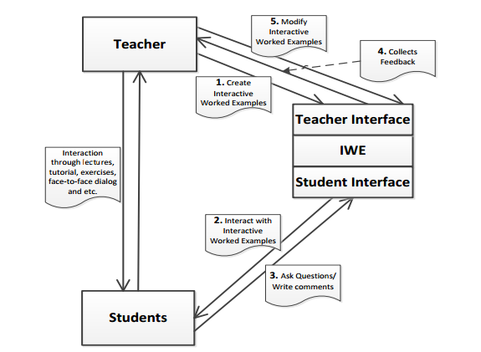Figure 1.

Authors can create and modify interactive worked examples through the authoe interface. This interface also presents them with any student feedback on these examples.

The student interface serves as a worked examples viewer where students are given the opportunity to ask questions and write comments.

The interaction between teachers and students is direct rather than through the system.

**2.2.2. Structure of IWE**

IWE stores the worked examples in XML files. There are three types of files that are of particular interest for this Level 4 project- Documents.xml, Applications.xml, and Processes.xml. The structure of those files is graphically represented on Figure 2.

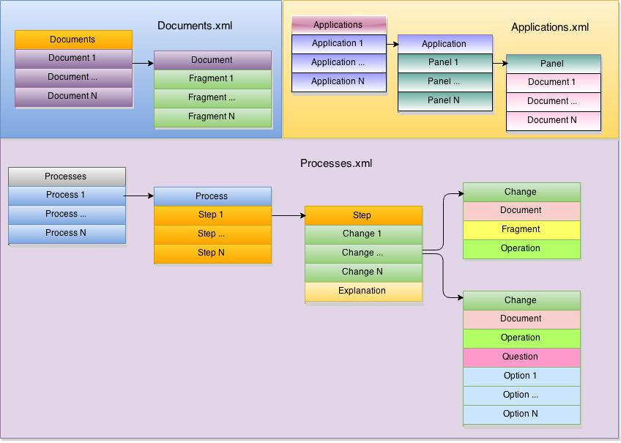

Figure 2.

The Documents.xml file stores the collection of documents created by an author. A document represents a problem involved in a particular worked example. It is split into fragments which are small logically separated portions of the document. The reason for splitting the document into fragments is so that relevant parts of it can be revealed gradually as part of the step-by-step problem solving process.

The Applications.xml file stores layout information about worked examples. There is a set of panels containing particular documents for each worked example.

The Processes.xml file defines the steps for the worked examples. For each step there are a number of changes and an explanation of those changes. There are two types of changes. The first type specifies which fragment of a document is involved in this change. These fragments can be shown, hidden or highlighted depending on the effect the author is aiming to achieve. The second type of changes corresponds to a question and possibly a set of options the user can select from in an attempt to answer it.

There is one more type of XML files which is not shown on Figure 2. It contains information about different styles that can be used for the worked examples. There is no need this file to be discussed in any detail. However, the reader needs to know that documents have styles associated with them depending on the type of document.

**2.2.3. Main Features of IWE’s Student Interface**

The student interface aims to provide of a good and easy to use worked examples viewer. A screenshot of the final version of Dr. Song’s prototype can be seen on Figure 3. The most important characteristics are labelled with numbers and are detailed below.

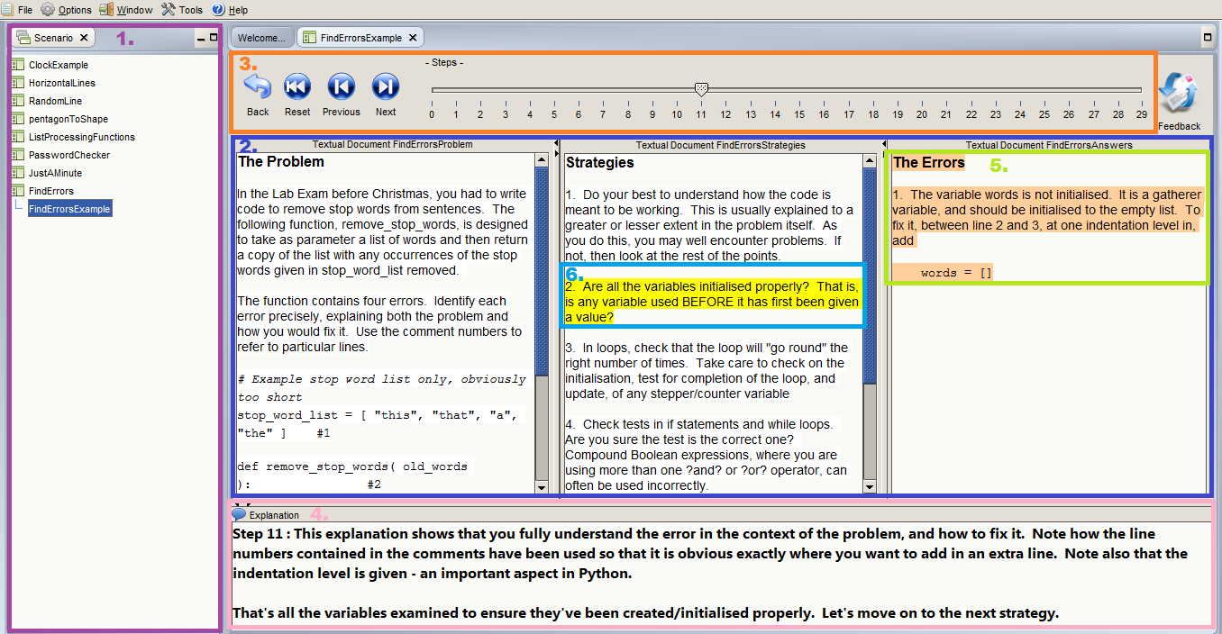 Figure 3.

1. An area for showing the worked examples installed on the system and enabling the user to choose an example to work on.

2. Panels showing different documents for a particular worked example.

3. An area for controlling transitions between steps.

4. An explanation area where the expert’s process of thinking involved on the current step is shown.

5. Highlighting of the newly appeared text at a particular step for drawing the user’s attention to the new content relevant for the current step.

6. Highlighting of fragments of interest for a particular step.

Other features of IWE, which are not shown on the screenshot, are the ability of the tool to ask the user questions and to record data such as time spent at each step and answers to questions.

**2.2.4. Relation of IWE to this Level 4 project**

The evaluation on IWE conducted as part of Dr. Song’s research clearly shows the benefits of the tool. It has proven to be well accepted and valuable as a technique to enhance a student’s learning experience. It also achieved its goal to enable teachers to more easily and quickly develop worked examples to fit their needs. The aim of this prototype, however, doesn’t cover deployment of the software in educational institutes but rather it proves that it would bring benefit to both students and teachers.

The motivation for this Level 4 project is to make use of the findings in Dr. Song’s research and take a step forward in deploying the software in schools across the UK. The focus of the project will be reconstructing the student interface of IWE into a web-based form as well as providing a new interface for teachers to separate them as a different group of users to the group of authors. The authoring interface of IWE is beyond the scope of this project and no understanding of any of its aspects is needed by the reader to follow this dissertation.

For the rest of the dissertation, the reader’s attention will be drawn to the transition process of the Java standalone application IWE into a deployable online version called *Worked Examples Viewer (WEAVE)*.